Data description:
The original data set contains 53 examples of participants who range in expertise and experience with performing CPR. Each example was recorded from 6 angles with a checkerboard in view to allow for 3D reconstruction. Participants were asked to perform 4 sets of 30 chest compressions with a short pause in between to rest. The faces of each participant have been blurred to reduce the likelihood of identification. The identity of any other individuals within the frame has also been blurred.
The CPR performances are accompanied by the demographics of the participants and the evaluation data. The evaluation data consists of an evaluation by two expert raters who teach Basic Life Support at a UK university and their agreed rating. Participants also provided self-reported confidence in performing CPR and self-reported frequency of practice.
Participants were able to elect for their data to be included in the available database or restricted to the research team only. Consent was given for video data and evaluation data separately (Information Sheet, Consent Form and Debrief provided). Thus, this data contains video data from 40 participants and evaluation data from 41 participants.
Video data:
Each person was recorded using 6 Go-Pro Cameras. The first camera was set up to have a wide frontal view (see Figure 1). Cameras 2 and 3 were placed behind the participant, offset to the right and left. Camera 4 was placed in front of Camera 1 to provide a lower and closer frontal view. Cameras 5 and 6 were placed perpendicularly to the direction the participant was facing in line with the participant. A checkerboard was placed in front of the manikin and in view of all six cameras as a landmark. The CPR space was defined for the participant with two foam mats. One for them to kneel on, the manikin was placed on the other.
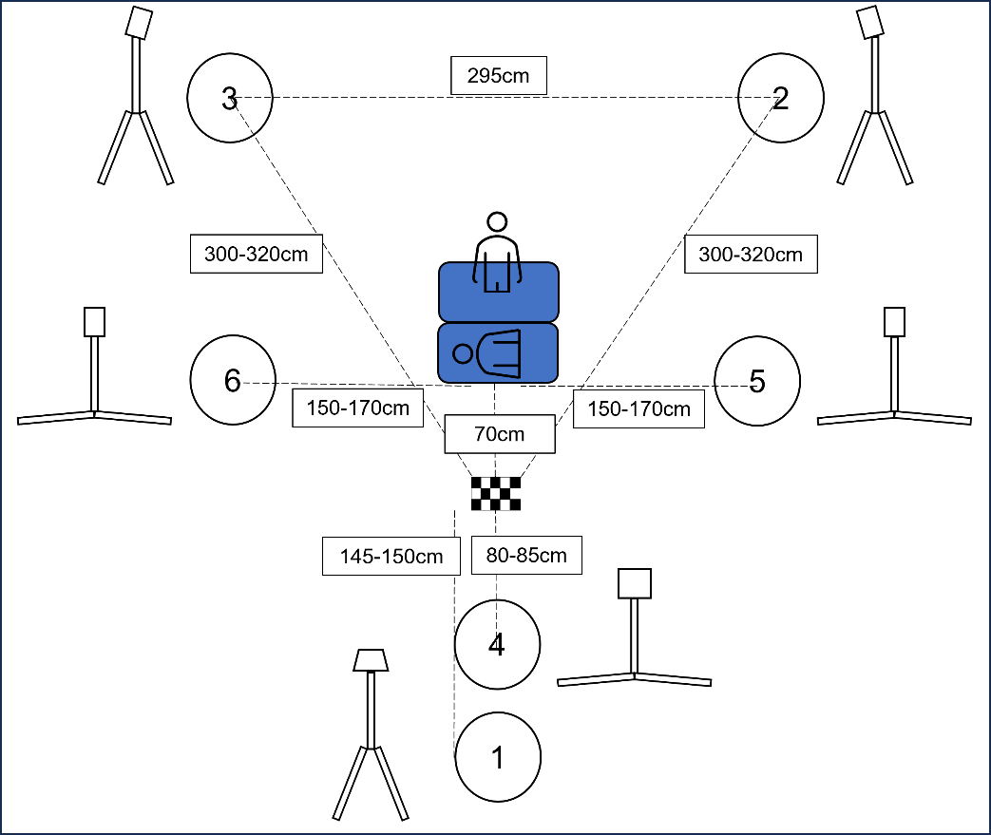
Figure 1. The recording space. Distances are approximate lengths and may differed slightly on each recording day. Cameras are numbered to reference the angle of the video files.
Participants were asked to perform 4 sets of 30 chest compressions for each recording with a short pause in between to rest. A clap sync was used to calibrate cameras in time.
File names are named according to the Participant Number and Angle (Participant001_Angle1.mp4). Due to recording failures at the end of one recording day the data from the following participants are missing:
Participant52_Angle5.mp4
Participant53_Angle2.mp4
Participant53_Angle4.mp4
Participant53_Angle6.mp4
Participant54_Angle2.mp4
Participant54_Angle3.mp4
Participant54_Angle4.mp4
Participant54_Angle5.mp4
Participant54_Angle6.mp4
Given full capture of at least one angle, all participants were able to be evaluated and analysed.
Participant06_Angle6.mp4 is also not present due to anonymisation difficulties.
Evaluation Data (CPR Collated Individual and Joint Ratings.xlsx):
An evaluative framework (see Evaluation Checklist) was developed in consultation with the BLS experts on the team. Given that the present data was collected within the UK educational system, the dimensions were informed by guidelines from the Resuscitation Council UK (2021). Additional evaluative dimensions were included to reflect good posture and technique taught to maintain endurance and prevent fatigue. Each evaluative dimension represented a factor that would be currently instructed in the educational setting; nevertheless, in practice, each factor is not equally important for patient outcomes as indicated by the International Liaison Committee on Resuscitation's recommendations, which are updated yearly based on cumulative science (Berg et al., 2023). Two expert raters rated each cycle of CPR (4 per participant) for each dimension and provided an overall rating for each cycle. An overall rating for each participant was also provided. The raters initially rated alone and then resolved any discrepancies to provide an agreed rating.
Participants evaluated their confidence in performing CPR (Very confident – very unconfident), and the frequency with which they practised CPR (Very frequently – very infrequently) along a 5-point Likert scale. They provided their demographics and these ratings prior to performing the CPR.
Participants and associated sharable demographics are provided in the spreadsheet: Consent and Shareable Demographics.xlsx

