Supplementary Table 1
Risk of Bias Domains and their Underlying Criteria for Ratings of Low, Unclear, and High Risk
Domain | Details | Risk of Bias
Selection Bias | The selection reflects the target population, and the selection methods and participant characteristics are described adequately. The study sample is representative of that for which the MIES was designed, specifically US Military Personnel. | - The sample characteristics are (Low), or unclear (Unclear), or not (High) representative of the scale's target population with less than 50% US Military Personnel.  - Study population characteristics are (Low), or unclearly (Unclear), or not (High) reported or defined, and the recruitment method is (Low), or unclearly (Unclear), or not (High) systematic.  - The response rate is >15% (Low), or unclear (Unclear), or $≤$15% (High).  - The sample is not (Low), or unclearly (Unclear), or is (High) selectively screened for possible moral injury.
Performance Bias | Between/within-group differences in the participants’ motivation to complete the test. | - Responses are (Low), or unclearly (Unclear), or not (High) confidential or anonymous.  - Participants are not (Low), or is unclear (Unclear), or are (High) told which questionnaires they are completing and why along with any proposed hypotheses.  - There were (Low), or unclear (Unclear), or no (High) validity checks in place (e.g., attentive responding, comprehension).  - Participants are not (Low), or unclearly (Unclear), or are (High) asked to speak about or justify their responses.
Detection Bias | The paper takes into consideration any alterations made to the original measure and the use of the scale. Was the MIES delivered in its original or agreed format? | - The full version of the scale is used, either the original version or a version approved by the scale's developer (e.g., language variant) and scored appropriately (Low). Minor (1-2 words) changes (Unclear) or Major (>2 words) (High) changes to the test, including wording and/or scoring (changes made to the scoring matrix (i.e., changed from 5-point to 3-point scale or starting from 0).  - The Administration, completion, and scores are (Low), or unclearly (Unclear), or not (High) rated consistently across participants (e.g., single administration method; self/interviewer).  - The full scale was (Low), or unclearly (Unclear), or not (High) administered, translated, or was an approved version (e.g., only select items or single sub-scales administered without validation; states it has been translated but does not detail how this was done, or notes problems in translation).  - The rationale for choosing the MIES is (Low), or is unclear (Unclear), or not evident and appropriate (High) (i.e., to measure moral injury exposure/experience; to measure PTSD/Trauma/Shame/Guilt).  - No (Low), or unclear (Unclear), or definite priming (High) for Moral Injury or other factors (e.g., shame/guilt).  - The MIES including its sub-scales is not (Low), or is unclearly (Unclear), or is (High) combined or integrated with a different test.
Statistical Bias | The reporting of statistical information, relating to the reliability coefficient. It considers the information reported in terms of its completeness and accuracy and whether any data is adjusted. | - The reliability or validity statistics are based on the full sample (Low) or are not reported or data is missing (Unclear), or are on adjusted data or a sub-sample only (High).  - The attrition rate is acceptable (<50%) (Low), is unclear (Unclear) or unacceptable ($≥$50%) (High).  - There is <5% (Low), or unclear or 5-20% with something done to rectify (Unclear), or >20% or 5-20% without something done to rectify (High) missing data.
Reporting Bias | Captures the completeness of the reporting within the study, around measure and descriptive statistics and outcomes. | - There is a complete account of the measure and descriptive statistics, with all results reported in full and appropriately without mistakes (Low)  - Item wording changes of the MIES are reported but it is unclear how (Unclear) or are not reported but are likely (High) (e.g., for non-US Military samples, wording change is necessary).  - Measure outcomes and descriptive statistics are reported but only partially reported or mistakes are unclear (Unclear), or there are no descriptive statistics or important data is missing within the reported dataset (High) (e.g., data they said they were going to report has not been included, only a subsample of results are detailed, or only significant results are reported).  - There is a description (narrative) of the results but no statistics or there are minor mistakes in descriptive information (e.g., small changes from figures or possible score ranges stated incorrectly) (Unclear) or either Statistical or procedural information is omitted as indicated by other sources (High) (e.g., linked papers, supplementary table).
Generalisability | Captures the sample size and the ability to transfer findings to the wider population. Ratings were determined solely by sample size given the heterogeneous nature of the samples involved along with the other category criteria to limit repeat ratings. | - The sample contains more than 50 participants (Low), between 30 and 50 participants (Unclear), or fewer than 30 participants (High)

Supplementary Table 2

Subgroup Analysis by Factors at Full-Scale and Sub-Scales

 | Level | k | I² | ⍺ | 95% CI |  | X² | p
Full Scale
Setting^{1a} | Clinic | 5 | 54.9% | .89 | [.87; | .91] | 0.01 | .928
 | Community | 22 | 96.9% | .89 | [.87; | .90]
Assessment Format^{2a} | Online | 17 | 97.3% | .88 | [.86; | .90] | 2.96 | .085
 | Not Online | 9 | 68.9% | .90 | [.89; | .91]
Modified MIES items^{3a} | Yes | 6 | 94.2% | .84 | [.80; | .88] | 7.42 | .007**
 | No | 15 | 96.8% | .90 | [.89; | .91]
Factor Model^{4a} | 2 | 7 | 75.4% | .89 | [.88; | .91] | 0.04 | .848
 | 3 | 15 | 97.4% | .89 | [.87; | .91]
Payment^{5a} | Paid | 13 | 97.7% | .89 | [.88; | .91] | 2.45 | .118
 | Not Paid | 11 | 91.0% | .87 | [.84; | .89]
Population | Military | 18 | 96.4% | .90 | [.89; | .91] | 11.34 | <.001**
 | Non-Military | 11 | 89.0% | .85 | [.83; | .88]
Location | US | 21 | 96.4% | .89 | [.88; | .90] | 4.4 | .036*
 | Non-US | 8 | 92.2% | .85 | [.82; | .89]
Transgression-Self
Setting | Clinic | 3 | 95.1% | .91 | [.85; | .97] | 0.06 | .806
 | Community | 16 | 96.1% | .92 | [.91; | .93]
Assessment Format^{2b} | Online | 10 | 95.6% | .91 | [.89; | .92] | 2.61 | .106
 | Not Online | 6 | 91.5% | .93 | [.91; | .94]
Modified MIES items | Yes | 6 | 89.0% | .91 | [.89; | .93] | 0.33 | .564
 | No | 13 | 97.0% | .92 | [.91; | .93]
Payment^{5b} | Paid | 10 | 96.8% | .92 | [.91; | .93] | 1.32 | .518
 | Partial | 2 | 98.6% | .81 | [.60; | 1.00]
 | Not Paid | 3 | 93.7% | .93 | [.89; | .96]
Population | Military | 12 | 96.3% | .92 | [.91; | .93] | 5.34 | .021*
 | Non-Military | 7 | 96.0% | .88 | [.85; | .92]
Location | US | 17 | 96.2% | .92 | [.91; | .93] | 1.66 | .197
 | Non-US | 2 | 90.3% | .89 | [.84; | .94]
Transgression-Other
Setting | Clinic | 3 | 2.8% | .83 | [.80; | .86] | 0.04 | .851
 | Community | 16 | 97.8% | .83 | [.79; | .86]
Assessment Format^{2c} | Online | 10 | 95.8% | .86 | [.83; | .90] | 5.72 | .017*
 | Not Online | 6 | 77.8% | .80 | [.77; | .83]
Modified MIES items | Yes | 6 | 97.5% | .81 | [.73; | .89] | 0.31 | .580
 | No | 13 | 95.5% | .83 | [.80; | .86]
Payment^{5c} | Paid | 10 | 98.5% | .82 | [.78; | .86] | 11.5 | .003**
 | Partial | 2 | 69.7% | .89 | [.87; | .92]
 | Not Paid | 3 | 91.5% | .77 | [.65; | .88]
Population | Military | 12 | 96.0% | .81 | [.78; | .84] | 2.56 | .110
 | Non-Military | 7 | 95.9% | .86 | [.81; | .91]
Location | US | 17 | 95.5% | .82 | [.80; | .85] | 0.53 | .467
 | Non-US | 2 | 97.7% | .88 | [.73; | 1.00]
Betrayal
Setting^{1d} | Clinic | 4 | 88.7% | .84 | [.77; | .90] | 0.54 | .462
 | Community | 17 | 96.5% | .81 | [.79; | .83]
Assessment Format^{2d} | Online | 9 | 95.3% | .79 | [.75; | .84] | 2.32 | .128
 | Not Online | 8 | 94.8% | .84 | [.80; | .87]
Modified MIES items | Yes | 6 | 82.2% | .78 | [.74; | .82] | 3.32 | .068
 | No | 16 | 96.9% | .83 | [.80; | .85]
Factor Model | 2 | 4 | 22.8% | .82 | [.81; | .84] | 0.53 | .468
 | 3 | 18 | 96.7% | .81 | [.78; | .84]
Payment^{5d} | Paid | 10 | 97.9% | .81 | [.78; | .84] | 0.71 | .701
 | Partial | 2 | 17.8% | .82 | [.79; | .85]
 | Not Paid | 5 | 64.9% | .83 | [.80; | .85]
Population | Military | 16 | 96.9% | .83 | [.80; | .85] | 3.28 | .070
 | Non-Military | 6 | 83.4% | .78 | [.74; | .82]
Location | US | 20 | 96.3% | .82 | [.80; | .84] | 0.92 | .337
 | Non-US | 2 | 91.6% | .76 | [.65; | .88]
Note. ⍺=Alpha coefficient; 95% CI: Confidence Interval; k: Number of studies; X²: Test statistic; p-value; I²: Higgin’s I²
¹Setting: ‘Clinic & Community’ ª(k=2) d (k=1); ²Assessment Format: ’Mixed/Unclear’ ^{a,b,c}(k=3), ^{d}(k=5); ³Modified items: ª‘Unclear’ (k=8); ⁴Factor Model: ªN/A/Unclear (k=7); ⁵Payment: ª‘Unclear’ (k=4) & ‘Partial’ (k=1), ^{b,c}‘Unclear’ (k=4), ^{d}‘Unclear’ (k=5).
**p≤.01; *p≤.05

Supplementary Table 3

Meta-Regression of Continuous Moderators at Full-Scale and Sub-Scales

 | Full-Scale |  |  |  |  |  |  |  |  |  | Transgression-Self |  |  |  |  |  |  | Transgression-Other |  |  |  |  |  |  | Betrayal
 | k |  | Coefficient |  | Std Error |  | z |  | p | R² (%) |  | k | Coefficient | Std Error | z | p | R² (%) |  | k | Coefficient | Std Error | z | p | R² (%) |  | k | Coefficient | Std Error | z | p | R² (%)
Year | 29 |  | -.003 |  | .003 |  | -.929 |  | .353 | .00 |  | 19 | -.003 | .002 | -1.38 | .169 | 15.6 |  | 19 | .004 | .008 | 0.57 | .569 | .00 |  | 22 | -.006 | .004 | -1.58 | .113 | 28.2
Number of Metrics | 29 |  | .003 |  | .003 |  | 1.10 |  | .269 | .00 |  | 19 | -.004 | .003 | -1.24 | .216 | .00 |  | 19 | .005 | .008 | 0.64 | .521 | 3.7 |  | 22 | -.002 | .006 | -0.38 | .702 | .00
Response Rate | 15 |  | -.024 |  | .020 |  | -1.16 |  | .245 | .00 |  | 9 | -.050 | .024 | -2.07 | .039* | 8.8 |  | 9 | .098 | .055 | 1.79 | .073 | 66.6 |  | 10 | -.030 | .042 | -0.71 | .477 | .00
Attrition Rate | 16 |  | -.024 |  | .028 |  | -.853 |  | .394 | .00 |  | 9 | -.011 | .030 | -0.36 | .718 | 6.7 |  | 9 | -.188 | .149 | -1.26 | .207 | .00 |  | 12 | .097 | .091 | 1.07 | .284 | .00
Age (Years) | 23 |  | .001 |  | .001 |  | .702 |  | .483 | .00 |  | 13 | .001 | .001 | 1.14 | .253 | .00 |  | 13 | .001 | .002 | 0.51 | .610 | .00 |  | 16 | -.001 | .001 | -0.54 | .587 | .00
Male (%) | 28 |  | .048 |  | .020 |  | 2.44 |  | .015* | .00 |  | 19 | .035 | .017 | 2.08 | .038* | .00 |  | 19 | -.097 | .043 | -2.27 | .023* | 22.5 |  | 22 | .060 | .043 | 1.40 | .161 | .00
Ethnicity (% White/Caucasian) | 20 |  | -.050 |  | .036 |  | -1.39 |  | .165 | .00 |  | 16 | .052 | .043 | 1.21 | .226 | .00 |  | 16 | .030 | .097 | 0.31 | .753 | 2.9 |  | 18 | -.178 | .084 | -2.13 | .034* | 15.2
Education (% College/University) | 10 |  | -.068 |  | .022 |  | -3.10 |  | .002* | 58.7 |  | 8 | -.072 | .032 | -2.22 | .026* | .00 |  | 8 | .018 | .037 | 0.49 | .625 | .00 |  | 8 | .039 | .058 | 0.69 | .493 | .00
Married (% Currently) | 14 |  | .083 |  | .041 |  | 2.01 |  | .044* | 6.5 |  | 11 | -.010 | .032 | -0.33 | .740 | 1.1 |  | 11 | .123 | .088 | 1.40 | .161 | 16.1 |  | 12 | -.049 | .086 | -0.56 | .572 | .00
Religion (% Agnostic/None) | 5 |  | -.102 |  | .070 |  | -1.46 |  | .145 | 54.7 |  | 3 | -.060 | .087 | -0.69 | .492 | .00 |  | 3 | .458 | .299 | 1.53 | .126 | 20.2 |  | 3 | -.117 | .208 | -0.56 | .574 | .00
Time in Service (Years) | 6 |  | -.006 |  | .006 |  | -1.12 |  | .261 | .00 |  | 3 | -.001 | .001 | -0.85 | .396 | .00 |  | 3 | .022 | .004 | 6.02 | <.001** | 98.9 |  | 5 | .001 | .002 | 0.69 | .491 | .00
Deployed at least once (%) | 9 |  | .030 |  | .022 |  | 1.40 |  | .162 | .00 |  | 8 | .005 | .030 | 0.17 | .865 | .00 |  | 8 | .170 | .111 | 1.53 | .127 | .00 |  | 11 | -.040 | .063 | -0.63 | .532 | .00
Combat Exposure (%) | 3 |  | -.051 |  | .048 |  | -1.08 |  | .282 | .00 |  | 4 | -.023 | .027 | -0.88 | .380 | 12.7 |  | 4 | .181 | .042 | 4.25 | <.001** | 81.8 |  | 5 | -.051 | .053 | -0.96 | .338 | .00
Unemployed (%) | 16 |  | .062 |  | .076 |  | .822 |  | .411 | .00 |  | 10 | -.054 | .038 | -1.40 | .162 | .00 |  | 10 | .028 | .116 | 0.24 | .810 | 4.4 |  | 10 | .133 | .108 | 1.24 | .216 | 11.5
Military branch (% Army) | 15 |  | .055 |  | .033 |  | 1.67 |  | .096 | .00 |  | 12 | -.016 | .018 | -0.90 | .366 | .00 |  | 12 | .091 | .052 | 1.76 | .078 | 4.2 |  | 14 | .026 | .044 | 0.58 | .559 | .00
PTSD (%) | 9 |  | -.056 |  | .052 |  | -1.07 |  | .285 | .00 |  | 7 | -.040 | .019 | -2.07 | .038* | 41.5 |  | 7 | .076 | .066 | 1.16 | .247 | 13.5 |  | 7 | .003 | .058 | 0.06 | .955 | 62.6
Depression (%) | 6 |  | -.099 |  | .025 |  | -3.90 |  | <.001** | 82.8 |  | 6 | .061 | .153 | 0.40 | .693 | .00 |  | 6 | .606 | .343 | 1.77 | .077 | 42.7 |  | 5 | -.871 | .187 | -4.67 | <.001** | .00
Alcohol/Substance Use (%) | 5 |  | -.041 |  | .041 |  | -1.01 |  | .313 | .00 |  | 3 | .131 | .130 | 1.01 | .314 | .00 |  | 3 | .012 | .042 | 0.30 | .767 | .00 |  | 3 | -.390 | .334 | -1.17 | .243 | .00
Income (>$60,000) | 6 |  | -.126 |  | .087 |  | -1.45 |  | .147 | .00 |  | 8 | .015 | .031 | 0.50 | .618 | .00 |  | 8 | .026 | .079 | 0.33 | .742 | .00 |  | 8 | -.082 | .103 | -0.79 | .430 | .89
Note. k: Number of studies reporting relevant data; Std Error: Standard Error; z-score; p-value; R² : amount of heterogeneity accounted for
**p≤.01; *p≤.05

Supplementary Table 4
The Effects of Risk of Bias in the Primary Studies at Full-Scale and Sub-Scales
 |  | Low Risk |  |  |  | Any Risk
 | k | ⍺ | 95% CI |  | I² | k | ⍺ | 95% CI |  | I² |  | X² |  | p
Full-Scale
Selection bias | 6 | .91 | [.90; | .93] | 97.7% | 23 | .87 | [.85; | .89] | 95.3% |  | 12.25 |  | <.001**
Performance bias | 22 | .88 | [.87; | .90] | 96.8% | 7 | .89 | [.87; | 1.00] | 77.0% |  | .42 |  | .516
Detection bias | 9 | .91 | [.89; | .93] | 97.4% | 20 | .87 | [.86; | .88] | 91.3% |  | 10.28 |  | ≤.001**
Statistical bias | 15 | .89 | [.87; | .90] | 97.3% | 14 | .88 | [.86; | .89] | 92.4% |  | 0.59 |  | .443
Reporting bias | 10 | .90 | [.88; | .92] | 97.9% | 19 | .87 | [.86; | .89] | 93.3% |  | 3.61 |  | .058
Generalisability bias | 28 | .88 | [.87; | .89] | 96.1% | 1 | .85 | [.78; | .92] | - |  | 0.79 |  | .374
Transgression-Self
Selection bias | 3 | .92 | [.91; | .94] | 94.4% | 16 | .91 | [.90; | .92] | 98.4% |  | 1.43 |  | .232
Performance bias | 13 | .91 | [.89; | .92] | 96.7% | 6 | .93 | [.92; | .94] | 73.2% |  | 5.02 |  | .025*
Detection bias | 8 | .93 | [.92; | .94] | 93.6% | 11 | .90 | [.89; | .92] | 95.0% |  | 7.14 |  | .008**
Statistical bias | 10 | .91 | [.90; | .92] | 95.2% | 9 | .92 | [.91; | .93] | 94.7% |  | 1.15 |  | .283
Reporting bias | 8 | .90 | [.88; | .92] | 96.5% | 11 | .93 | [.92; | .93] | 90.0% |  | 6.55 |  | 011*
Generalisability bias | 18 | .92 | [.91; | .93] | 96.2% | 1 | .88 | [.81; | .95] | - |  | 1.10 |  | .315
Transgression-Other
Selection bias | 3 | .83 | [.76; | .89] | 99.1% | 16 | .82 | [.79; | .86] | 95.8% |  | 0.00 |  | .959
Performance bias | 13 | .84 | [.82; | .87] | 96.4% | 6 | .79 | [.74; | .83] | 87.6% |  | 5.15 |  | .023*
Detection bias | 8 | .82 | [.78; | .86] | 94.8% | 11 | .83 | [.80; | .87] | 97.2% |  | 0.38 |  | .539
Statistical bias | 10 | .83 | [.79; | .87] | 97.1% | 9 | .82 | [.77; | .87] | 97.0% |  | 0.03 |  | .853
Reporting bias | 8 | .86 | [.84; | .88] | 82.5% | 11 | .80 | [.74; | .86] | 98.4% |  | 2.89 |  | .089
Generalisability bias | 18 | .83 | [.80; | .85] | 97.5% | 1 | .83 | [.71; | .95] | - |  | 0.00 |  | .947
Betrayal
Selection bias | 4 | .79 | [.76; | .82] | 96.2% | 18 | .82 | [.80; | .85] | 93.1% |  | 2.19 |  | .139
Performance bias | 14 | .81 | [.78; | .84] | 95.9% | 8 | .83 | [.80; | .86] | 93.6% |  | 1.01 |  | .316
Detection bias | 9 | .83 | [.80; | .87] | 96.7% | 13 | .81 | [.78; | .83] | 89.7% |  | 1.37 |  | .241
Statistical bias | 11 | .80 | [.76; | .84] | 96.7% | 11 | .83 | [.80; | .85] | 92.5% |  | .82 |  | .365
Reporting bias | 10 | .81 | [.77; | .84] | 95.6% | 12 | .82 | [.79; | .85] | 94.9% |  | .39 |  | .533
Generalisability bias | 21 | .82 | [.80; | .84] | 96.2% | 1 | .69 | [.50; | .88] | - |  | 1.68 |  | .195
Note. ⍺=Alpha coefficient; 95% CI: Confidence Interval; k: Number of studies; X²: Test statistic; p-value
**p≤.01; *p≤.05

Supplementary Table 5

Results of Comparing the MIES Test Scores, Age, Gender, and Ethnicity of Studies that Induce and Report Reliability

 | Estimating |  |  | Inducing/Omitting
Variable | k | n | M (SD) | k | n | M (SD) |  | t (df) | p |  |  | d
MIES Score Calculation: HS=MI
Full-Scale (M) | 14 | 4391 | 21.2 (13.78) | 4 | 2460 |  | 16.9 (9.33) | -.577 (16) |  | .572 | -.288
Full-Scale (SD) | 14 | 4499 | 8.3 (4.45) | 3 | 121 |  | 7.4 (5.60) | -.306 (15) |  | .764 | -.195
Transgression-Self (M) | 15 | 237 | 5.6 (4.58) | 2 | 6086 |  | 7.5 (3.81) | .556 (15) |  | .586 | .419
Transgression-Self (SD) | 14 | 237 | 3.0 (2.27) | 2 | 5844 |  | 3.5 (3.15) | .290 (14) |  | .776 | .219
Transgression-Other (M) | 14 | 76 | 5.5 (3.59) | 1 | 5751 |  | 4.4 (-) | -.278 (13) |  | .785 | -.288
Transgression-Other (SD) | 13 | 76 | 2.3 (1.14) | 1 | 5509 |  | 1.2 (-) | -.953 (12) |  | .359 | -.989
Betrayal (M) | 15 | 887 | 6.4 (3.99) | 4 | 5704 |  | 7.0 (1.55) | .485 (13.8) |  | .635 | .273
Betrayal (SD) | 14 | 887 | 3.0 (1.66) | 4 | 5462 |  | 3.7 (1.79) | .780 (16) |  | .447 | .442
MIES Score Calculation: LS=MI
Full-Scale (M) | 2 | 479 | 15.3 (16.92) | 4 | 493 |  | 30.6 (6.40) | 1.24 (1.1) | .412 |  |  | 1.07
Full-Scale (SD) | 2 | 493 | 3.7 (3.97) | 4 | 479 |  | 11.4 (1.11) | 2.70 (1.1) | .211 |  |  | 2.34
Transgression-Self (M) | - | - | - | 1 | 182 |  | 9.8 (-) | - | - |  |  | -
Transgression-Self (SD) | - | - | - | 1 | 182 |  | 6.1 (-) | - | - |  |  | -
Transgression-Other (M) | - | - | - | 1 | 182 |  | 7.0 (-) | - | - |  |  | -
Transgression-Other (SD) | - | - | - | 1 | 182 |  | 3.0 (-) | - | - |  |  | -
Betrayal (M) | 2 | 196 | 7.4 (4.01) | 2 | 872 |  | 8.4 (0.61) | .357 (2) | .755 |  |  | .357
Betrayal (SD) | 2 | 196 | 3.3 (2.34) | 2 | 872 |  | 3.7 (1.47) | .202 (2) | .859 |  |  | .202
Other Continuous Variables
Age (M) | 34 | 775 | 38.9 (9.99) | 8 | 11167 |  | 46.1 (9.41) | 1.86 (40) | .069 |  |  | .731
Age (SD) | 33 | 761 | 8.9 (3.37) | 7 | 10964 |  | 11.2 (2.73) | 1.62 (38) | .112 |  |  | .674
Gender (% Male) | 41 | 1399 | 65.4 (29.10) | 9 | 34116 |  | 85.1 (10.75) | 3.42 (35.9) | .002* |  |  | 1.26
Ethnicity (% White/Caucasian) | 28 | 1297 | 68.9 (17.62) | 7 | 30724 |  | 71.4 (19.33) | .333 (33) | .741 |  |  | .141
Note. HS=MI: Higher Scores=Higher Moral Injury rating; HS=MI: Lower Scores=Lower Moral Injury rating
k: number of studies; n=sample size; t=Test Statistic; df=Degrees of Freedom; p-value; d=standard mean difference
**p≤.01; *p≤.05

Supplementary Figure 1

Funnel Plot of Alpha Coefficients at MIES Full-Scale and Sub-Scale Levels. The 95% Confidence Interval of the Expected Distribution of Alpha Coefficients is Shown as an Inverted “Funnel”
Full-Scale ª | Transgression-Self ^{b}
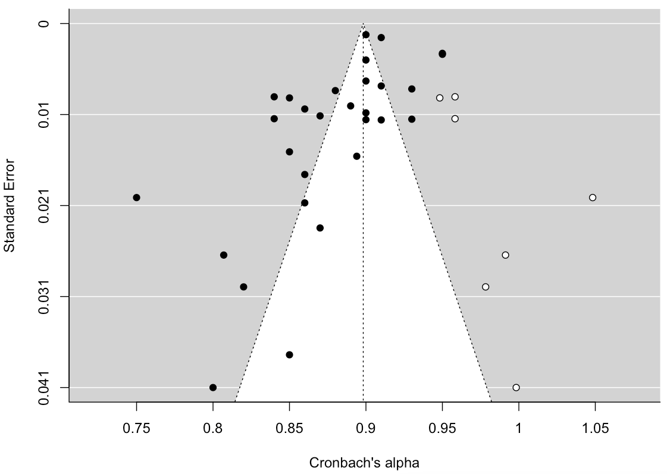 | 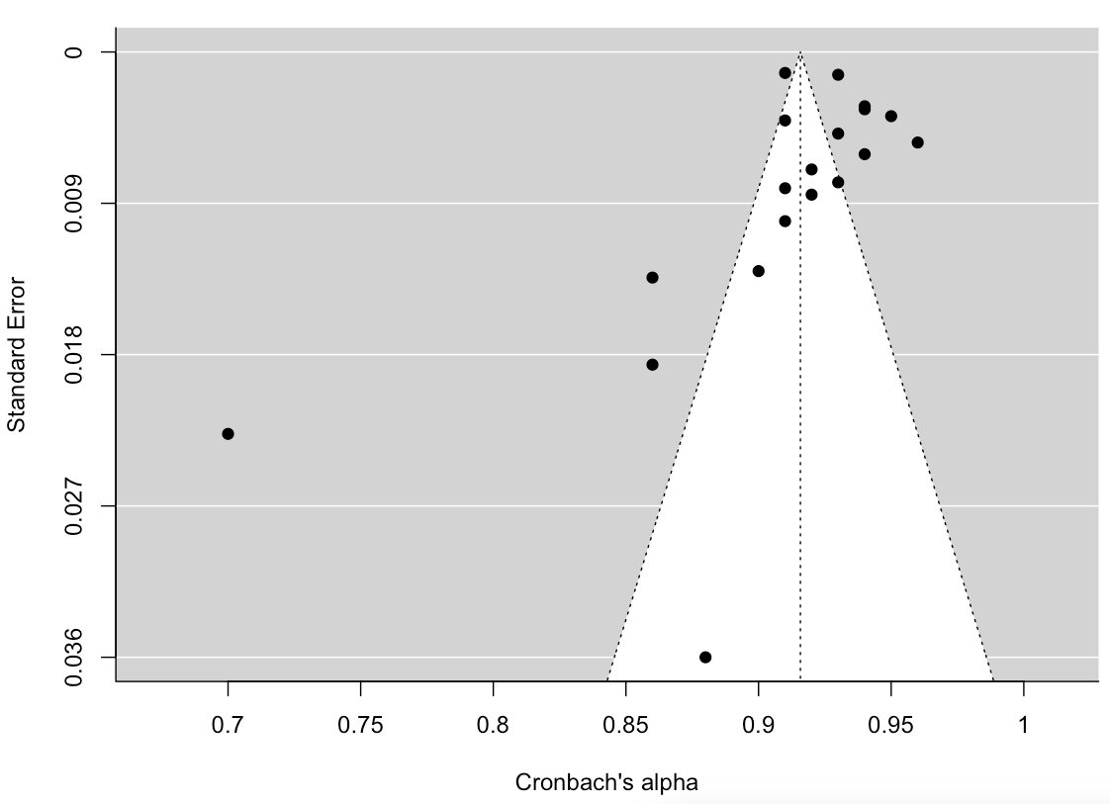
Transgression-Other ^{c} | Betrayal ^{d}
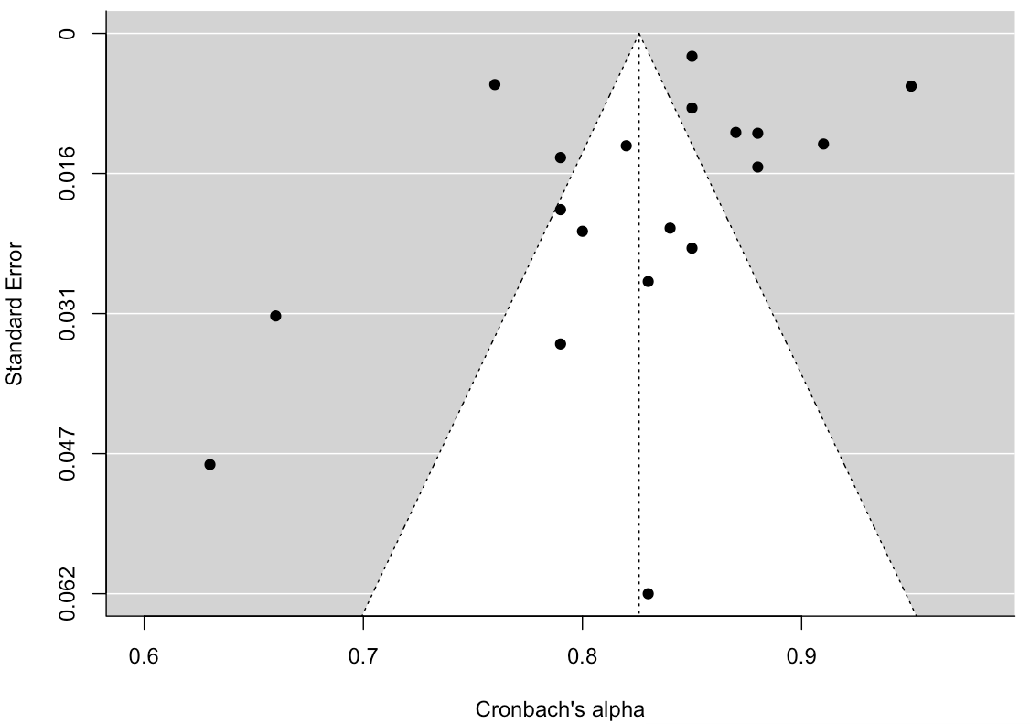 | 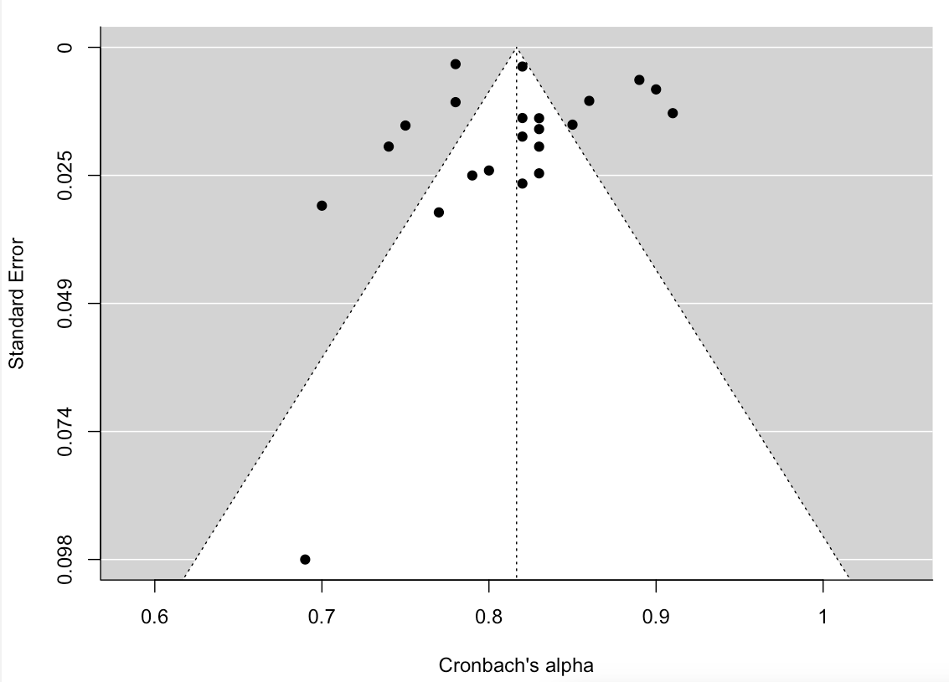
Note. Adjusted estimates: ª⍺=.90 (95% CI: .88-.91), +1.70%; ^{b}⍺=.91 (95% CI: .91-.93), 0.00%; ^{c}⍺=.83 (95% CI: .80-.85), 0.00%; ª⍺=.82 (95% CI: .79-.85), +0.25%

In the above funnel plots, the observed studies are shown as dark circles while the empty circles reflect imputed studies using the Trim and Fill method (Duval and Tweedie, 2000a, 2000b). Without publication bias, the effects of small-sampled studies scatter more widely at the bottom than larger samples at the top, creating symmetrical funnel shapes. Trim and Fill iteratively removes extreme small studies with positive effects from one side of the funnel plot, recalculating the effect size each time until the plot becomes symmetric around the new effect size. This process aims to provide an unbiased estimate. However, this trimming not only yields the adjusted effect size but also reduces effect variance, resulting in a narrower confidence interval. To address this, the algorithm reintegrates the original studies and adds a mirrored representation for each, correcting the variance without affecting the point estimate. As the Full-Scale funnel plot is asymmetrical, this indicates marked heterogeneity and variable small study effects across levels. No such effects can be observed in the Sub-Scales.

