Schneiders – Energy Trading

_______

November 2018

|  |  |
| --- | --- |
| Client | Schneiders |
| Project | Energy Trading |
| Fieldwork | Nov’18 |
| Methodology | Online omnibus 2,000 UK |
|  |  |

# Questionnaire

**[FREE TEXT SLIDE]**

This first section of the Omnibus survey aims to find out what people think about new ways of buying energy. This should take about 5 minutes to fill in and then you can proceed to the next sections of the survey.

Your responses will be shared with the UCL researchers anonymously and used for research purposes. This completely anonymous data will also be added to a global database for other researchers to use.

By continuing with the survey you are consenting to the use of your responses for this purpose – you are free to withdraw at any time up until you submit the final survey.

**The next pages will show you details of some new ways of buying your energy. Please read them carefully imagining they are on offer you now, and answer the questions.**

**[ASK ALL]**

1**. Are you financially responsible or jointly financially responsible for paying the electricity bills in your household?**

**[SINGLE CODE]**

1. Yes, solely responsible
2. Yes, jointly responsible
3. No

**[SPLIT SAMPLE INTO 9 EACH SHOWN 1 OF THE FOLLOWING SCENARIOS]**

A new energy offer is available which allows you to buy energy **directly** from homes and businesses with their own **solar panels**.

Energy bought this way is slightly **cheaper** than what you get from your usual supplier.

If you participate:

**[SHOW TEXT IF ALLOCATED SCENARIO 1]** – You could meet around a **quarter (25%)** of your household’s electricity needs through the offer. You would buy electricity **directly** from homes and businesses **located on streets in your neighbourhood**.

**[SHOW TEXT IF ALLOCATED SCENARIO 2]** – You could meet around a **half (50%)** of your household’s electricity needs through the offer. You would buy electricity **directly** from homes and businesses **located on streets in your neighbourhood**.

**[SHOW TEXT IF ALLOCATED SCENARIO 3]** – You could meet around **three-quarters (75%)** of your household’s electricity needs through the offer. You would buy electricity **directly** from homes and businesses **located on streets in your neighbourhood**.

**[SHOW TEXT IF ALLOCATED SCENARIO 4]** – You could meet around a **quarter (25%)** of your household’s electricity needs through the offer. You would buy electricity **directly** from homes and businesses **located in the town, city or region that you live in**.

**[SHOW TEXT IF ALLOCATED SCENARIO 5]** – You could meet around a **half (50%)** of your household’s electricity needs through the offer. You would buy electricity **directly** from homes and businesses **located in the town, city or region that you live in**.

**[SHOW TEXT IF ALLOCATED SCENARIO 6]** – You could meet around **three-quarters (75%)** of your household’s electricity needs through the offer. You would buy electricity **directly** from homes and businesses **located in the town, city or region that you live in**.

**[SHOW TEXT IF ALLOCATED SCENARIO 7**] – You could meet around a **quarter (25%)** of your household’s electricity needs through the offer. You would buy electricity **directly** from homes and businesses **located across the whole country.**

**[SHOW TEXT IF ALLOCATED SCENARIO 8]** – You could meet around a **half (50%)** of your household’s electricity needs through the offer. You would buy electricity **directly** from homes and businesses **located across the whole country.**

**[SHOW TEXT IF ALLOCATED SCENARIO 9**] – You could meet around **three-quarters (75%)** of your household’s electricity needs through the offer. You would buy electricity **directly** from homes and businesses **located across the whole country.**

[SHOW IMAGE FOR SCENARIO 1,2 AND 3] 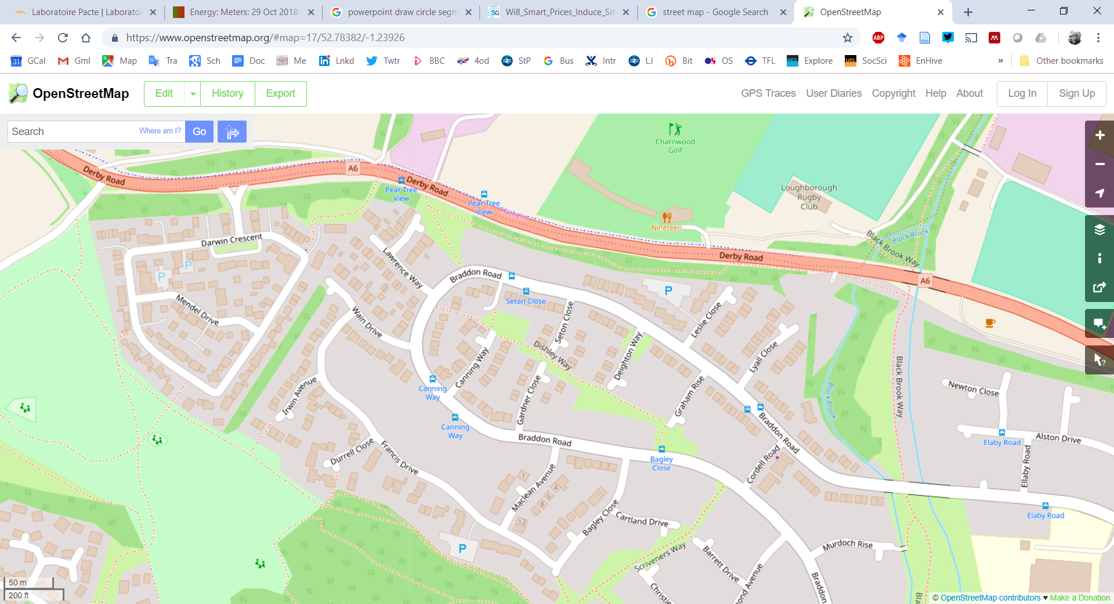

[SHOW IMAGE FOR SCENARIO 4,5 AND 6]

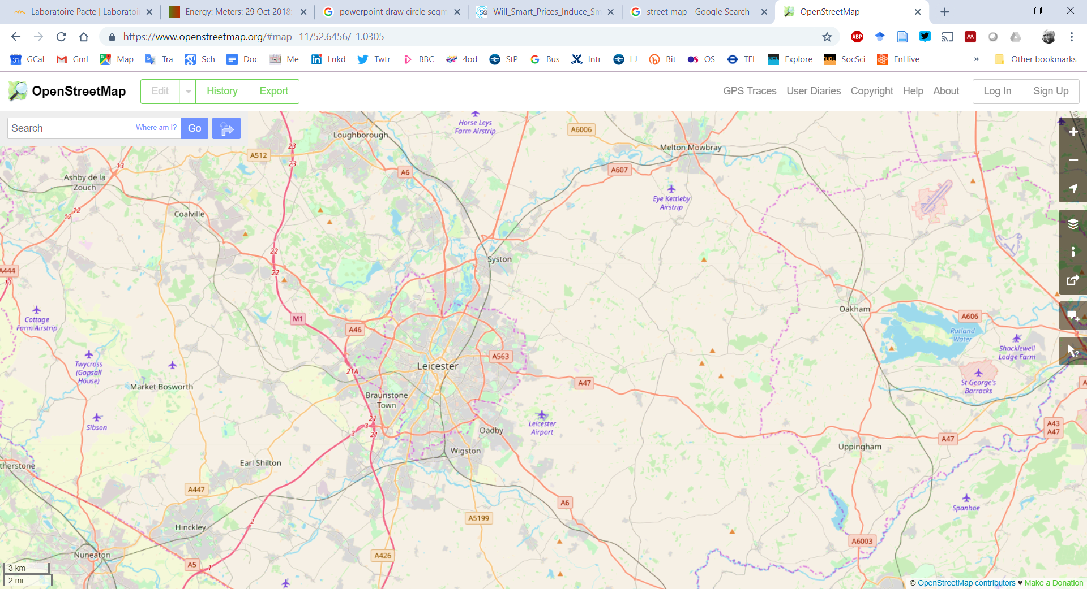

[SHOW IMAGE FOR SCENARIO 7,8 AND 9]

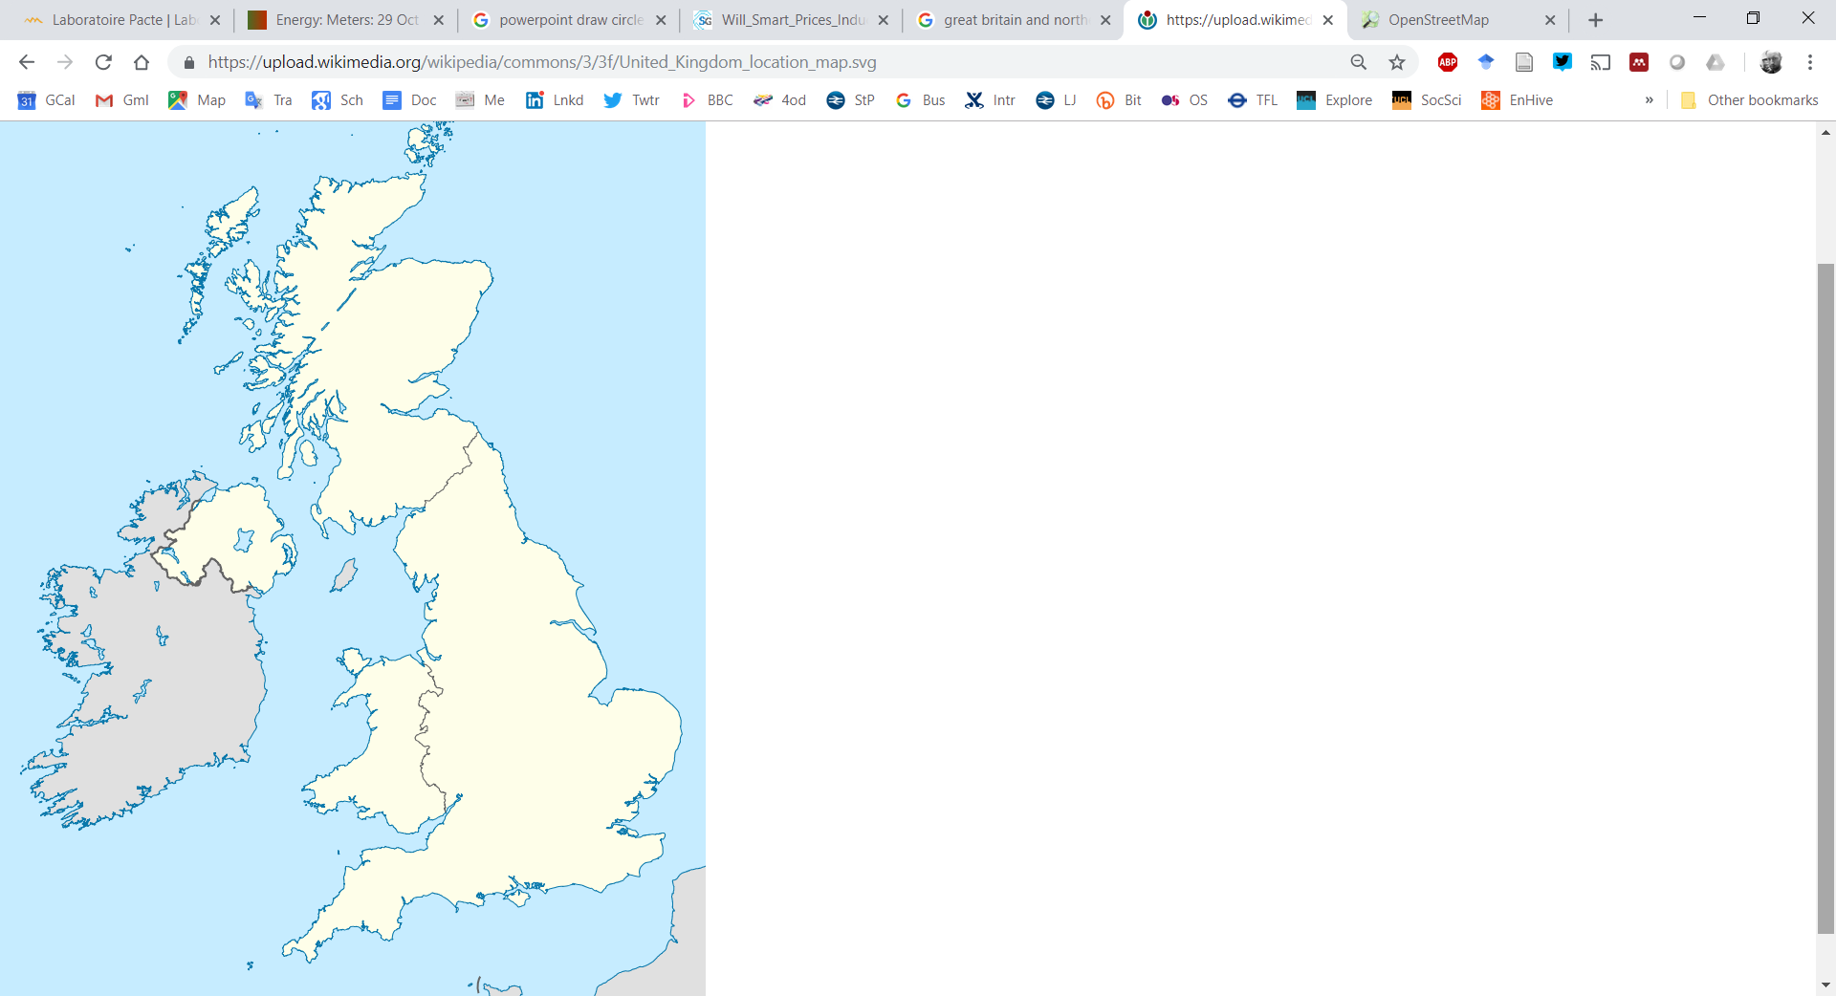

[SHOW IMAGE FOR SCENARIO 1,4 AND 7]

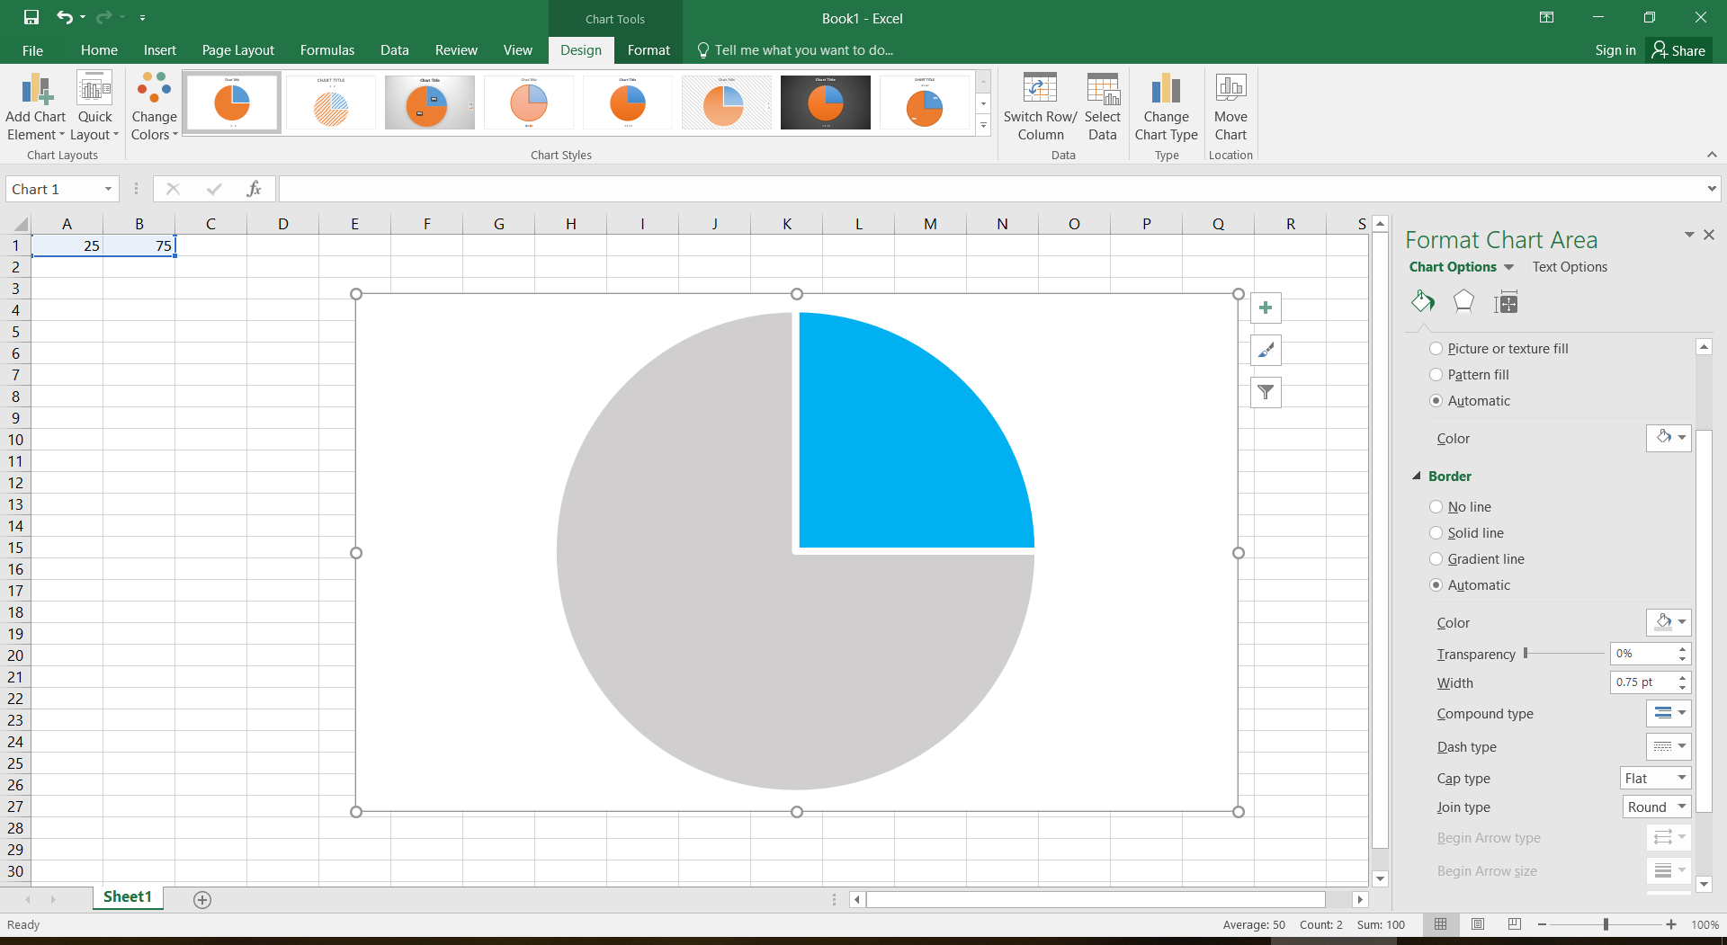

**25%**

[SHOW IMAGE FOR SCENARIO 2, 5 AND 8]

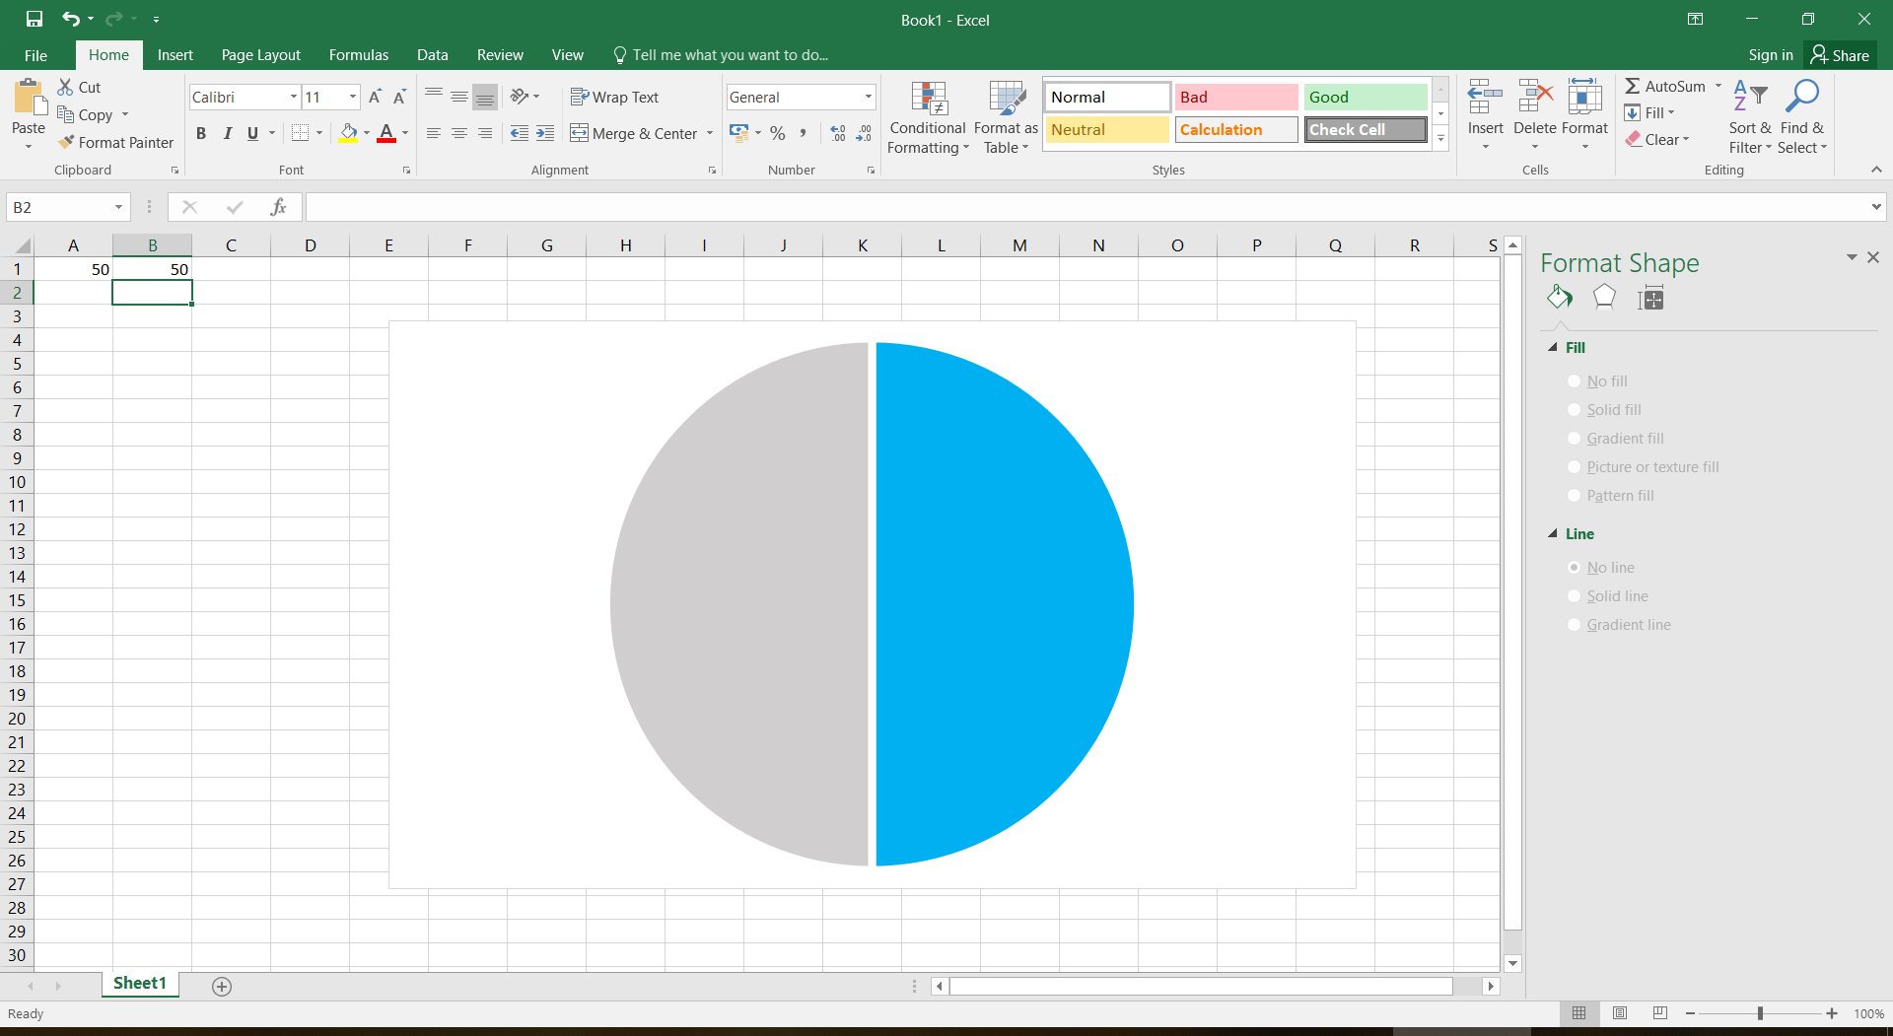

**50%**

[SHOW IMAGE FOR SCENARIO 3,6 AND 9]

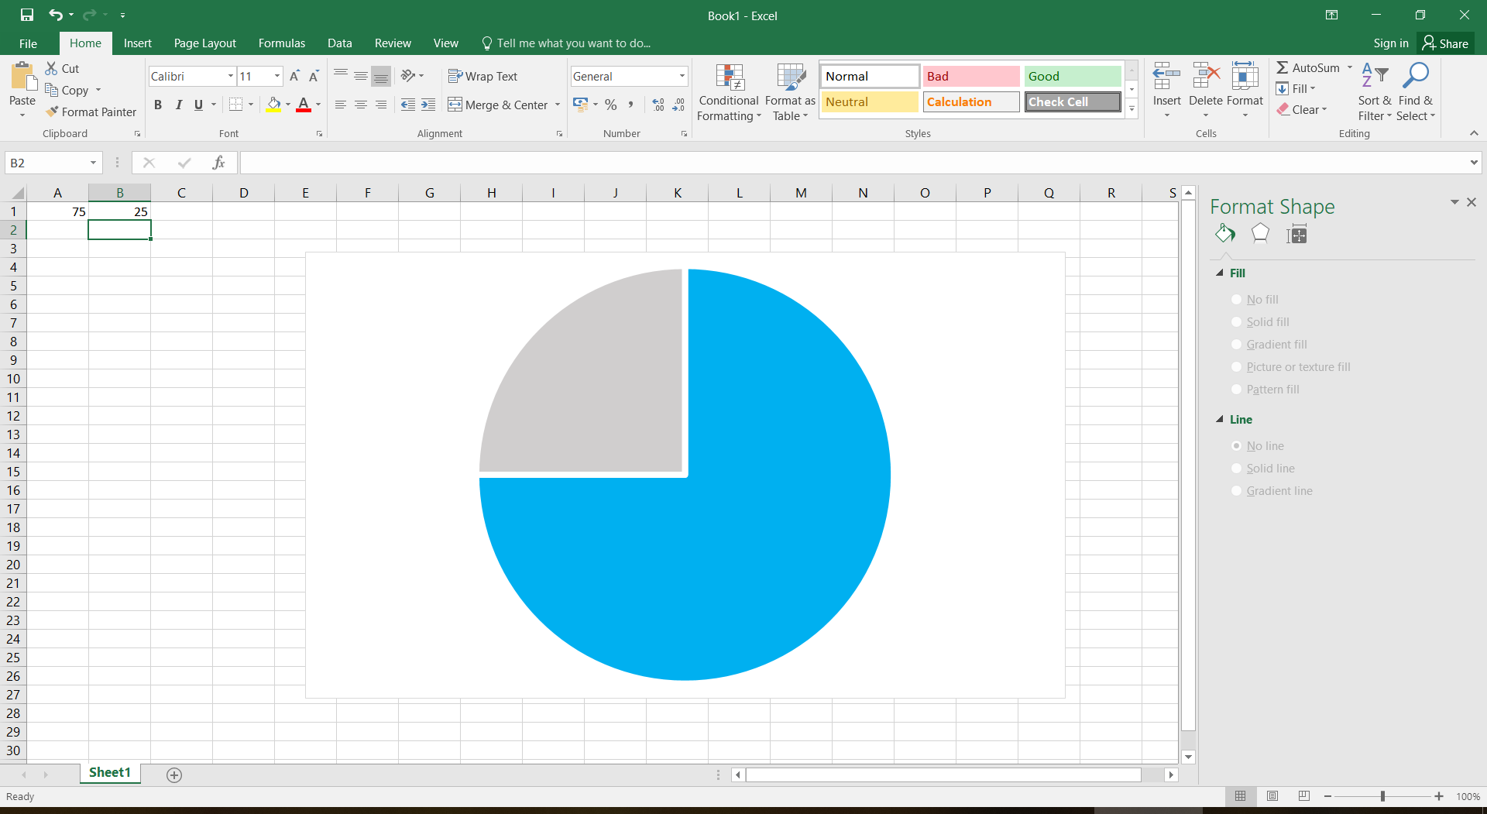

**75%**

You would continue to buy the rest of your energy from your current supplier.

**2. Would you sign up to participate in this offer if it was available to you today?**

**[SINGLE CODE]**

1. No
2. Yes

**[ASK ALL]**

**[SPLIT SAMPLE INTO 4 EACH SHOWN 1 OF THE FOLLOWING SCENARIOS]**

**[SHOW TEXT IF ALLOCATED SCENARIO 1]** – This energy offer is being operated by your local council.

**[SHOW TEXT IF ALLOCATED SCENARIO 2]** – This energy offer is being operated by a local community energy group (made up mainly of volunteers).

**[SHOW TEXT IF ALLOCATED SCENARIO 3]** – This energy offer is being operated by an energy supplier.

**[SHOW TEXT IF ALLOCATED SCENARIO 4]** – This energy offer is being operated by a well-known online social media company.

**3. Does knowing this about the offer make you more or less likely to want to participate?**

**​[SINGLE CODE][ROTATE STATEMENTS ‘A’ AND ‘B’]**

1. More likely
2. Less likely
3. No difference

**[ASK ALL]**

4. Thinking only about the *description* of the offer that you saw earlier, please indicate whether you think the following statements correspond with the description you have read.

**[ROWS][ROTATE]**

1. You could meet around three-quarters (75%) of your household’s electricity needs through the offer.
2. On the offer you would buy electricity **directly** from homes and businesses across the whole country.
3. The energy offer is being operated by your local council.

**[COLUMNS]**

1. Yes
2. No

**[ASK ALL]**

**[SPLIT SAMPLE INTO 4 EACH SHOWN 1 OF THE FOLLOWING SCENARIOS]**

**[SHOW TEXT IF ALLOCATED SCENARIO 1]** - This sort of offer is made possible by a technology that records how much electricity you buy, and who from, *in a way* *which is very difficult for someone to tamper with.*

This unchangeability is to avoid fraud and cyber attacks. However, it also means that the system cannot be easily changed at a later date (e.g. to make corrections).

**[SHOW TEXT IF ALLOCATED SCENARIO 2]*****-***This sort of offer is made possible by a technology that records how much electricity you buy, and who from, *in a way which is completely anonymous.* This anonymity protects your identity, but it does mean that you cannot see exactly who you buy electricity from.

**[SHOW TEXT IF ALLOCATED SCENARIO 3]*****-***This sort of offer is made possible by a technology that records how much electricity you buy, and who from, *in a way which is visible to all participants.* This transparency means you can easily see how much energy is being bought and sold, but your pattern and history of energy trading could be used to reveal your identity.

**[SHOW TEXT IF ALLOCATED SCENARIO 4]*-***This sort of offer is made possible by a technology that records how much electricity you buy, and who from, *without being controlled by a central authority (such as an energy supplier).* This decentralisation reduces costs and gives you more control over your data, but means it can be harder to sort out any complaints you may have.

**5. Does knowing this about the technology make you more or less likely to want to participate?**

**​[SINGLE CODE]**

1. More likely
2. Less likely
3. No difference

**[ASK ALL]**

**[SPLIT SAMPLE INTO 3 EACH SHOWN 1 OF THE FOLLOWING SCENARIOS]**

**[SHOW TEXT IF ALLOCATED SCENARIO 1]*-***The technology used to run this offer is called ‘distributed ledger technology (DLT)’.

**[SHOW TEXT IF ALLOCATED SCENARIO 2]*-***The technology used to run this offer is called ‘blockchain’.

**[SHOW TEXT IF ALLOCATED SCENARIO 3]*-*** The technology used to run this offer is called ‘blockchain’. Blockchain is the same technology used to run ‘Bitcoin’, the online currency.

**6. Does knowing this about the technology make you more or less likely to want to participate?**

**​[SINGLE CODE]**

1. More likely
2. Less likely
3. No difference

**[ASK ALL]**

**7. Which of the following companies supplies your electricity?**

**[SINGLE CODE]**

1. British Gas
2. Bulb
3. Co-operative Energy
4. Ebico
5. E.ON
6. Ecotricity
7. EDF Energy
8. First Utility
9. Flow Energy
10. Good Energy
11. Green Energy UK
12. Green Star Energy
13. LoCO2 Energy
14. M&S Energy
15. npower
16. Ovo Energy
17. Places for People Energy
18. Sainsbury’s Energy
19. Scottish Hydro
20. Scottish Power
21. Spark Energy
22. SSE
23. Utilita
24. Utility Warehouse
25. Other (Please specify)
26. Don't know

**[ASK ALL]**

8. Do you own or benefit from any of the following?

**[SINGLE CODE]**

* 1. Solar panels to generate electricity.
  2. Solar water heating
  3. Air or ground source heat pump
  4. Plug-in electric or hybrid car/van
  5. Home energy storage (e.g. batteries in garage)
  6. Smart heating controls (e.g. Hive, Nest, Tado)
  7. Smart bulbs/lamps/lighting controls (controlled from a phone/tablet)
  8. None of these
  9. Don’t know

**1 unit**

**[ASK ALL]**

**9. How concerned or unconcerned, if at all, are you about climate change, sometimes referred to as ‘global warming’?**

**[SCALE QUESTION][FLIP SCALE]**

1. Very concerned
2. Fairly concerned
3. Neither concerned nor unconcerned
4. Not very concerned
5. Not at all concerned

|  |  |
| --- | --- |
|  |  |

**1 unit**

**[ASK ALL]**

**10. When it comes to technology, what best describes you?**

**[SINGLE CODE]**

a. I am usually one of the last people I know to use new technologies.

b. I usually use new technologies when most people I know do.

c. I like new technologies and use them before most people I know.

d. I love new technologies and am among the first to experiment with and use them.

**[ASK ALL]**

**11. What is your gender?**

**[SINGLE CODE]**

1. Male
2. Female
3. Other

**[ASK ALL]**

**12. Please state your age.**

**[OPEN TEXT BOX]**

**[ASK ALL]**

**13. Where do you currently live? The map below may help you.**

**I live in...**

**[SINGLE CODE]**

1. North East
2. North West
3. Yorkshire & Humberside
4. East Midlands
5. West Midlands
6. East of England
7. London
8. South East
9. South West
10. Wales
11. Scotland
12. Northern Ireland

**[ASK ALL]**

**14. Do you live in…?**

**[SINGLE CODE]**

1. A house or bungalow
2. A self-contained flat, maisonette or apartment
3. A room or rooms (e.g. bedsit or flatlet)
4. Other

**[ASK ALL]**

**15. Is the house or flat in which you live…?**

**[SINGLE CODE]**

1. Owned outright
2. Owned with a mortgage or loan
3. Rented from the council
4. Rented from a housing association
5. Rented from someone else (e.g. a private landlord)
6. Rent-free
7. Other

**[ASK ALL]**

**16. Please select the option that you think best describes the area you live in.**

**[SINGLE CODE]**

a. Urban area - cities or towns

b. Suburban area – residential areas on the outskirts of cities and towns

c. Rural area - villages or hamlets

|  |
| --- |
|  |
|  |
|  |

**[ASK ALL]**

We would now like to ask you some questions about your household. Before you start, a household is:

• one person living alone; or

• a group of people (not necessarily related) living at the same address who share cooking facilities and share a living room or sitting room or dining area.

# 17. Counting yourself, how many people, including children, usually live in your household?

**[SINGLE CODE]**

1. 1
2. 2
3. 3
4. 4
5. 5
6. 6
7. 7
8. 8+

**[ASK ALL]**

# 18. And how many of the people living in your household are aged 15 and under?

**[SINGLE CODE]**

1. 0
2. 1
3. 2
4. 3
5. 4
6. 5
7. 6
8. 7
9. 8+

**[ASK ALL]**

**19. We would now like you to think about the main income earner in your household, that is the person with the highest income. This may be you or it might be someone else.   
  
Which of the following groups does the main income earner in your household belong to?***[If the main income earner is retired with an occupational pension, please enter their former occupation. Please only enter ‘retired’ if the main income earner is only receiving the state pension. If the main income earner has been unemployed for a period of less than 6 months, please answer based on their previous occupation.]*

**[SINGLE CODE]**

a. Higher managerial/ professional/ administrative (e.g. established doctor, solicitor, board director in large organisation (200+ employees), top level civil servant/ public service employee, head teacher etc.)

b. Intermediate managerial/ professional/ administrative (e.g. newly qualified (under 3 years) doctor, solicitor, board director of small organisation, middle manager in large organization, principal officer in civil service/ local government etc.)

c. Supervisory or clerical/ junior managerial/ professional/ administrator (e.g. office worker, student doctor, foreman with 25+ employees, sales person, student teacher etc.)

d. Skilled manual worker (e.g. skilled bricklayer, carpenter, plumber, painter, bus/ ambulance driver, HGV driver, unqualified teaching assistant, pub/ bar worker etc.)

e. Semi-skilled or unskilled manual worker (e.g. manual jobs that require no special training or qualifications, apprentices to be skilled trades, caretaker, cleaner, nursery school assistant, park keeper, non-HGV driver, shop assistant etc.)

f. Student

g. Retired and living on state pension only

h. Unemployed for over 6 months or not working due to long term sickness

**[ASK ALL]**

**20. Which of these applies to you?**

**[SINGLE CODE]**

1. Working full time (30 or more hours per week).

2. Working part time (8 - 29 hours per week).

3. Working part time (Less than 8 hours a week).

4. Full time student.

5. Retired.

6. Unemployed.

7. Other not working.

**[ASK ALL]**

**21. What is your annual pre-tax household income?   
  
By ‘household income’ we mean the total income received from all sources, including wages earnt by you, your partner and/or any other earner in the household, bonuses, pension income, benefits or rents and before tax deductions.   
  
Your data will be kept confidential and not passed on to any third parties.**

**[SINGLE CODE]**

1. Up to £10,000 a year
2. £10,001 to £20,000 a year
3. £20,001 to £30,000 a year
4. £30,001 to £40,000 a year
5. £40,001 to £50,000 a year
6. £50,001 to £60,000 a year
7. £60,001 to £70,000 a year
8. £70,001 to £80,000 a year
9. £80,001 to £100,000 a year
10. £100,001 to £120,000 a year
11. Over £120,001 a year
12. Prefer not to say

**[ASK ALL]**

**22. Do you consider yourself to have a disability or chronic illness?**

**[SINGLE CODE]**

1. Yes
2. No
3. Don’t know
4. Prefer not to say