Method and Design
This study used a single group, pre-post intervention design with one IV. The IV was time (pre-post CMT). The DVs for this study were the measures of well-being, PF, CEA, PI and negative affect before, during and after the intervention.
Participants
A total of 55 participants took part in the study (42 Female, 13 Male), with ages ranging between 23-72 (M = 51.85, SD = 12.55) across various occupations and retired individuals.
Materials
CMT Intervention
The CMT intervention was developed from The Compassionate Mind Workbook (Irons & Beaumont, 2017) and included reflection exercises, soothing-rhythm-breathing techniques and guided meditations plus additional bonus activities inspired by the workbook to aid CMT engagement. An overview of the intervention, which included psychoeducation and experiential activities, can be summarised in the following weekly structure.
Week one: defining compassion and exploring its evolutionary roots in psychology. Listening to a 60-minute interview with Professor Paul Gilbert on the nature and origins of compassion. Week two: introducing mindfulness, the physiological benefits of soothing-rhythm-breathing and psychological theory underlying meta-awareness. Relating mindfulness to compassion (noticing suffering, accepting common humanity and universality of suffering) and introducing and practising a five-minute soothing-rhythm-breathing exercise as well as noticing thoughts, feelings and emotions during this exercise. Week three: describing the concept of ‘mind loops’ as interactions between ‘old’, mammalian-reptilian parts of the brain and ‘new’, primate-human parts of the brain. Unpicking mind loops by being mindful of them and exploring how negative mind loops can affect mental well-being and our ability to be compassionate towards others and self. A continuation of soothing-rhythm-breathing exercises. Introducing mind loops diagrams as a way of sketching out difficult thoughts patterns that trigger emotions and feeling and vice versa. Week four: introducing the ‘flows of compassion’ and why the reciprocal nature of compassion often relies upon all three flows, especially with regards to the universality of suffering and our common humanity. Observation of the three flows of compassion in participants’ lives and reflecting upon thoughts and emotions surrounding observed examples of the flows of compassion. Week five: examining the motivational systems (threat system, drive system and soothing system), how they interact with one another and introducing the concept that our emotions influence, and are influenced by, these interactions. Relating to emotions as ‘emotional selves’ as well as compassion in the motivational systems together with reflections on familiar and unfamiliar emotional versions of ourselves, how they make us feel, how we feel towards them and their purpose within our motivational systems. Week six: expanding upon the multi-faceted nature of the self by exploring the identities we hold and the identity of the Compassionate Self. Describing the three qualities of the Compassionate Self (wisdom, caring-commitment and courage) and how they relate to mindfulness and the flows of compassion. Using active imagination in a guided meditation format to ‘meet’ and embody the Compassionate Self in relation to a compassionate other who is upset. Week seven: taking a closer look at the concept of self-compassion and separating it from misconceptions and other self-focussed motives/behaviours (e.g. self-kindness, self-pity and self-esteem). Also looking at how the Compassionate Self can help cultivate compassion for the self. Using active imagination in a guided meditation format to experience compassion from the Compassionate Self. Week eight: exploring fears and resistances to compassion and the reasons why compassion can be difficult for some to engage with (developmental, environmental, cultural and biological barriers). Unpicking these difficulties and how the qualities of the Compassionate Self can help overcome them. Practising compassionate letter writing towards identities and emotions that make up the self.
Measures
Warwick and Edinburgh Well Being Scale (WEWBS)
This 14-item scale assesses individuals’ well-being based on meaning and pleasure in their lives (Tennant et al., 2007), including items assessing ability to problem solve, relax, interact with others and the self with confidence and optimism as well as the quality of these relationships. For example, “I’ve been feeling useful”. Each item is measured on a five-point Likert scale (1 = ‘none of the time’ to 5 = ‘all of the time’) with respect to how individuals’ have felt over the last two weeks. This scale has Cronbach's alphas of .89 to .91 (Tennant et al., 2007), and has been used in other studies measuring well-being with regards to CMT and PF (Irons & Heriot‐Maitland, 2021; Keutler & McHugh, 2022).
Depression, Anxiety and Stress Scale (DASS-21)
The short-form version of the DASS-42, including 21-items measuring three subscales of negative affect: depression, anxiety, and stress (Lovibond & Lovibond, 1995). For example, “I found it difficult to relax”. Individuals are asked to rate items regarding how they felt over the past week on a four-point Likert scale (0 = ‘did not apply to me at all’ to 3 = ‘applied to me very much, or most of the time’). This scale has excellent internal consistency, with Cronbach’s alphas of .87 for anxiety, .94 for depression and .91 for stress and has been used across studies measuring negative affect when investigating compassion and PF (Irons & Heriot‐Maitland, 2021; Matos et al., 2022; McEwan & Gilbert, 2016; Thompson et al., 2022; Yadavaia et al., 2014).
Compassionate Engagement and Actions Scale (CEAS)
This scale comprises three subscales measuring self-compassion, compassion for others and compassion from others (Gilbert et al., 2017). Each scale is divided into two sections. Section one comprises six items measuring compassionate engagement (e.g., non-judgemental awareness, empathy, overcoming distress, and ability to care). Section two consists of four items measuring compassionate action towards alleviating/preventing suffering. For example, “I tolerate the various feelings that are part of my distress”. Section one includes two reverse-filler items. Section two includes one reverse-filler item. Across the subscales, individuals are asked to rate statements on a Likert scale from one to ten. Answers are based on how frequently statements apply when individuals become distressed (self-compassion), another is distressed (compassion for others) or when an important person in their life reacts to the individual’s distress (compassion from others) (1 = ‘never’ to 10 = ‘always’). This scale has good internal consistency with Cronbach’s alphas ranging from .77 - .90 (self-compassionate engagement and action), .90 - .94 (compassion for others engagement and action), and .89 - .91 (compassion from others engagement and action) (Gilbert et al., 2017). The scale has been used in several studies investigating CMT and well-being (Gilbert et al., 2017; Irons & Heriot‐Maitland, 2021).
Multidimensional Psychological Flexibility Inventory-Short Form (MPFI)
The MPFI is a measure of PF and PI, validated in a 24-item short-form version (Rolffs et al., 2018). The scale has two subscales measuring the six dimensions of PF and PI respectively (two items per dimension). Examples include “I was attentive and aware of my emotions” (PF) and “Negative feelings easily stalled out my plans” (PI). Individuals respond to statements on a six-point Likert scale regarding their truth over the last two weeks (1 = ‘never true’ to 6 = ‘always true’). Cronbach alphas for this scale are between .88 - .92 (Rolffs et al., 2018). The MPFI has been used across several studies investigating PF and has been independently evaluated as a reliable measure of the dimensions comprising PF and PI (Howell & Demuynck, 2021; Landi et al., 2021; Seidler et al., 2020; Thompson et al., 2022).
Procedure
Participants were recruited online via social media platforms such as Twitter and Facebook. They were asked to email the primary investigator to obtain an information sheet giving full details of the eight-week CMT intervention, how to withdraw, and how their data would be securely stored on the primary investigator’s university OneDrive. Exclusion criteria for this study were individuals undergoing psychotherapy and/or taking medication for mental-health, and those under 18.
Participants were sent an anonymous participant and consent form to complete and assigned a randomised identification number. After giving signed consent, participants were added to the enrolment list for CMT.
Participants were then sent online copies of the questionnaires via the Online Surveys platform at three time-points to track changes throughout the intervention. Time-point one (T1) took place on the weekend prior to the CMT intervention. Time-point two (T2) on the fourth weekend of the intervention. Time-point three (T3) on the weekend following the intervention. Any mention of PF was omitted from the intervention to reduce confirmation bias regarding PF.
During the intervention, participants were sent an information sheet and link to a supporting podcast on Mondays covering an aspect of compassion (maximum 30 minutes). After engaging with this, participants completed a CMT activity. These could be completed at any time during that week. Optional bonus activities were also provided to help engage with mindfulness and compassion, and to condense the eight-week programme devised by Irons and Heriot‐Maitland (2021) which required participants to engage with CMT for 2.5 hours a week. Each participant was asked to email confirmation that they had completed the week’s main activity and were encouraged to practise soothing-rhythm-breathing for at least five minutes each day. Debrief forms were supplied after the final set of questionnaires were completed, outlining the full contents of the study plus external resources and support.
Data analysis
Data analyses were conducted using the Statistical Package for Social Sciences (IBM SPSS, version, 27.0). Descriptive statistics were used for demographic data of gender and employment status. A series of repeated measures ANOVAs were conducted with post hoc analysis on data that demonstrated normality at all three time-points, to explore differences between the three time-points across each measure. Effect sizes for ANOVAs were calculated using Cohen’s F (η2p) with .10, .25, and .40 representing small, medium, and large effect sizes (Cohen, 1988). The mean scores and standard deviations (SDs) for each measure, with comparison significance, effect sizes and post hoc pairwise comparisons are shown in Table 2. Measurements that did not demonstrate normality across the three time-points were subject to non-parametric Friedman tests with subsequent post hoc Wilcoxon signed-rank tests. Wilcoxon signed-rank test significance was compared to a manual Bonferroni adjusted significance level (p < .017) to account for the comparison of multiple variables. Effect sizes for Friedman tests were calculated using Kendall’s W with .10, .30, and .50 representing small, medium, and large effect sizes (Field, 2013). The mean scores and SDs for each of these measurements, together with comparison significance, effect sizes and post hoc comparisons are shown in Table 3.
A mediation analysis was conducted with PROCESS macro for SPSS (Hayes, 2012) using a serial mediation model with present-moment-awareness as the predictor (X) and well-being as the outcome (Y). This model was constructed from correlation results at TP3 as well as theoretical accounts and previous findings that suggest PF’s mindful dimensions (acceptance, present-moment-awareness, defusion and self-as-context), together with pursuit-of-values, form the mechanisms of change leading to increased self-compassion and well-being (Levin et al., 2012; Moran and Ming, 2022; Neff & Tirch, 2013). After discovering significant correlations between these PF dimensions, self-compassion and well-being, serial mediation models were tested across these measurements. A nonparametric bootstrapping procedure was used with 5,000 resamples as recommended by A.F. Hayes (2017) due to the lack of normality across measures and this study’s small sample size. After testing several models, analysis revealed a stronger model of mediation without the inclusion of acceptance and values (bootstrapped bias-corrected confidence interval values (CI) crossed zero indicating non-significance). After their removal from the analysis, a theoretical model of serial mediation was constructed and tested, as represented in Figure 1.
Fig. 1: A theoretical serial mediation model for predicting well-being from present moment awareness after CMT.
Note: PMA = Present Moment Awareness.
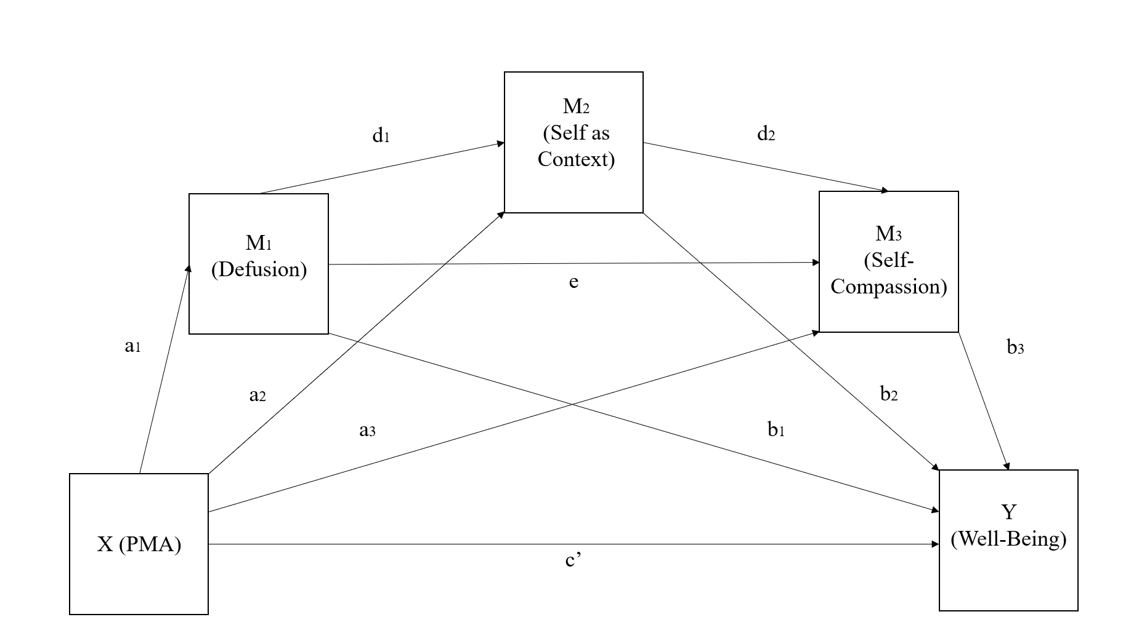

Ethical approval
Ethics approval was obtained from the university ethical committee in line with the British Psychological Society’s (2021) Code of Human Research Ethics.

