Aston Literacy Project:
Reading and Vocabulary in Primary and Secondary School

Dear parent(s) and carer(s),
Your child has been taking part in an important study about reading and vocabulary learning that has recently received new funding from the Nuffield Foundation. To continue this valuable work we need your permission to work with your child in secondary school. If you decide you DO want your child to take part, please complete the consent form, place in the envelope provided and post it to us or pass to your child’s school office by [DATE].
We also invite you to take part in two other optional activities. First, we have enclosed some short questions for parents about reading at home. Second, we would like to invite your child to do a reading diary- answering 5 short questions about what they have read outside school every day for 7 days. We will ask for your permission separately for the reading diary. You can consent to the main project without doing these extra activities.
Before you decide, we’d like to explain why the research is being done and what it will involve. Please take time to read the attached information sheet carefully and discuss it with your child. Our contact details are included below in case you’d like to ask us any questions.
Many thanks for your support.

Best wishes,

Dr. Laura Shapiro
Senior Lecturer in Psychology
School of Life and Health Sciences
Aston University, Birmingham B4 7ET
0121 204 4052
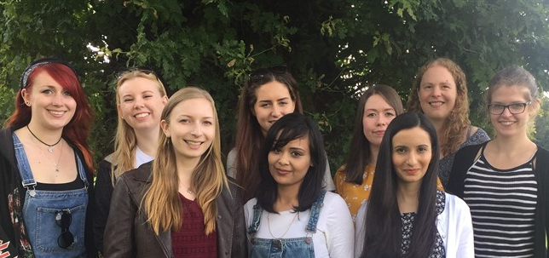
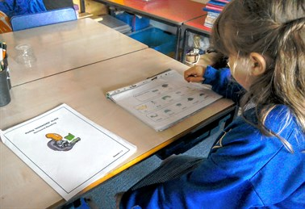
l.r.shapiro@aston.ac.uk

Our team of researchers
Project website: www.aston.ac.uk/alp A child doing our activities

Information for Parent(s) and Carer(s)

Do I have to allow my child to take part?
No. It is your choice. The work will be of value to children, teaches and parents in the future, but no one will mind if you don’t want your child to take part, and they will not be disadvantaged in any way. If you do want your child to take part, then please tell us by returning the consent form, then we will also ask your child if they want to take part. They do not have to take part if they don’t want to and they can stop at any time. You can also change your mind about your child taking part. If you decide you want us to stop working with your child, please contact Dr Laura Shapiro: L.R.Shapiro@aston.ac.uk.

Why has my child been chosen?
Your child’s primary school has been helping with our project (you might remember us writing to you before). We checked how many words children knew when they first started school and how many new words they have learnt since then. It is really important that we carry on working with the same children so that we can see how their reading and vocabulary improves in secondary school.
What does the project involve?
There are three parts to the project. You can agree to just one or more of these.
- The main part of the project is the activities we do in school-time. If you give your permission by returning the consent form, we will invite your child to do our reading and vocabulary activities. These are the same activities as before, adapted for older children. A researcher will visit your child’s school three times as agreed with the teachers (autumn term 2018, summer term 2019, autumn term 2019). Our researchers are experienced in working with children and all have a clear DBS check. The activities will take about 1 hour and your child will be asked to read out loud, match words to pictures, tell us which books they have seen before, and tell us about how many books they have at home, how much time they spend reading and what they think about reading. Some activities are on paper, and some are on a computer.
- It is also really useful to hear what you think about reading so we have attached some questions for parents. These should take about 10 minutes to answer. If you are happy to answer these, please return this sheet in the envelope provided and post it to us or pass to your child’s school office by [DATE].
- We would also like to invite your child to do a reading diary- answering 5 short questions about what they have read outside school every day for 7 days, at a time agreed with you. This should take your child about 10 minutes per day. You will need to give your permission separately for this. If you would like to receive more information about the project and the reading diary please write your contact details on the consent form.
Why are we doing this project?
Having good knowledge of word meanings (vocabulary) is really important for learning, especially at secondary school when children will come across many different words in each subject area.
We want to find out how reading helps children to learn word meanings. We will find out whether a child’s reading ability and the amount they read are important for learning new words. This will tell us how best to support vocabulary knowledge.
Is it important to support children’s basic reading skills, to help them read more accurately and fluently? And is it important to encourage children to read more often in school and at home?
Are there any disadvantages to taking part?
1. You might worry that your child will miss important lessons. We will only ask your child to do the activities when the teacher says this is OK.
2. You might worry that your child will find the activities difficult. To help your child feel more confident, we start with easier words and then get to the hard words later. We need to use hard words because we want to find out what is the hardest word your child knows. Our Researchers are experienced in working with children and are quick to notice if a child is worried or upset. They will make sure your child knows they can stop at any time and that these activities are separate from their normal school work, and we won’t tell anyone how well they did.
3. You might worry that others will find out your child’s scores. We put all your scores onto a spreadsheet on a computer. To stop other people finding out each child’s scores, we don’t put any names on this sheet. Instead, we use a number for each child. Children’s names are kept securely and only our research team have access to these. This means that your child’s identity will be protected in line with the General Data Protection Regulation.

What are the benefits of taking part?

1. If your child takes part, they will help us work out how children learn new words. We might find that being good at reading helps children learn words, even if they don’t read very much in their spare time. If so, the next step will be to work on finding the best ways to help children improve their reading. Or we might find that spending a lot of time reading helps children learn words, even if they find reading difficult. If so, the next step will be to find the best ways to encourage all children to spend lots of time reading at school and at home.

2. We will tell your child’s teachers about what we find overall and we will also show them how pupils from each school are doing on reading and vocabulary, compared to expected levels. They can use this information to support their teaching.
What happens when we have finished?

1. When we have finished working with all children from all schools we work with, we will add everyone’s new scores to a spreadsheet that has old scores from earlier years too and work out what are the most important factors that help children learn words. When we have done that, we will send your child’s teacher a report about what we found, including reports for parents and pupils.
2. We will then publish reports and give presentations about our work to researchers and teachers. We will update our website with these activities and send any published reports to your child’s school.
3. We will also share our final data on the UK data archive, so this can be used by teachers and researchers. However, we will never share any personal information (no names or dates of birth) so it will not be possible for anyone outside the research team to identify your child.
4. We may contact you again to invite your child to take part in other reading and vocabulary activities when they are in Year 9 or above. We will ask for your permission again before we invite your child to take part.

Who has reviewed the project?
The research has been reviewed and received a favourable opinion by Aston University's Ethics Committee.

Who do I contact if something goes wrong or I need further information?
If you have a question or a concern, or if you want us to remove any information we have about your child, please contact the Principal Investigator, Dr Laura Shapiro: L.R.Shapiro@aston.ac.uk, 0121 204 4052.

Who do I contact if I wish to make a complaint about the way in which the research is conducted?

Please contact the Director of Governance for the Life and Health Sciences Ethics Committee, Professor John Walter, on j.g.walter@aston.ac.uk or telephone 0121 204 4869.

Who is organising and funding the research?
This project is led by Dr. Laura Shapiro (Aston University). Please see our project website for further information and updates: www.aston.ac.uk/alp

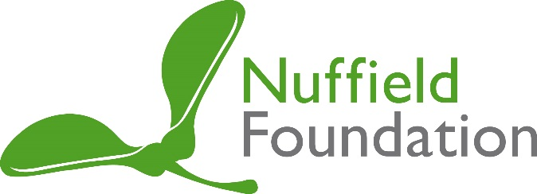
The project is funded by The Nuffield Foundation, an endowed charitable trust that aims to improve social well-being in the widest sense. It funds research and innovation in education and social policy and also works to build capacity in education, science and social science research. The Nuffield Foundation has funded this project, but the views expressed are those of the authors and not necessarily those of the Foundation. More information is available at www.nuffieldfoundation.org

