**INTERVIEW PARTICIPANT MATERIALS**

|  |  |
| --- | --- |
| **Contents** | **Page No.** |
| Recruitment Flyer (Young Participants and Familial AAs) | 2-3 |
| Young Participant Information Sheet | 4-5 |
| Participant Information Sheet (Familial AAs) | 6-7 |
| Participant Information Sheet (Professionals and Trained Volunteers) | 8-9 |
| Young Participant Consent Form | 10 |
| Participant Consent Form (Familial AAs) | 11 |
| Participant Consent Form (Professionals and Trained Volunteers) | 12 |
| Support and Rights Information Sheet | 13 |

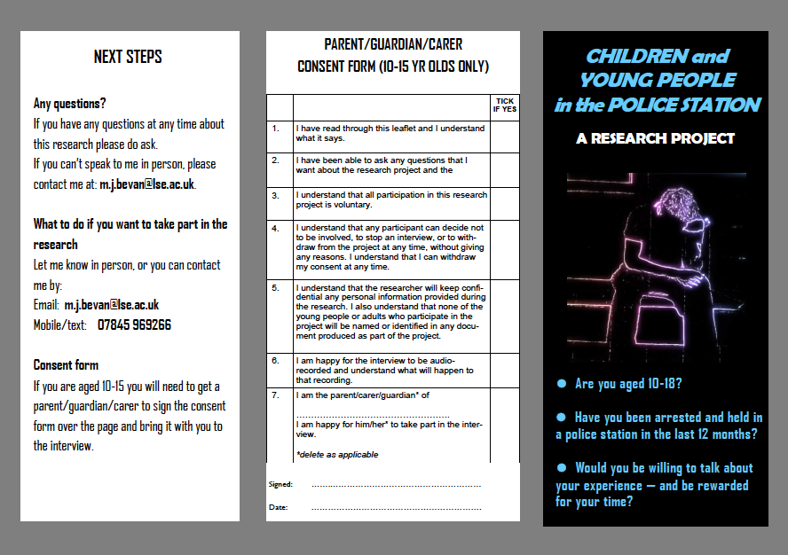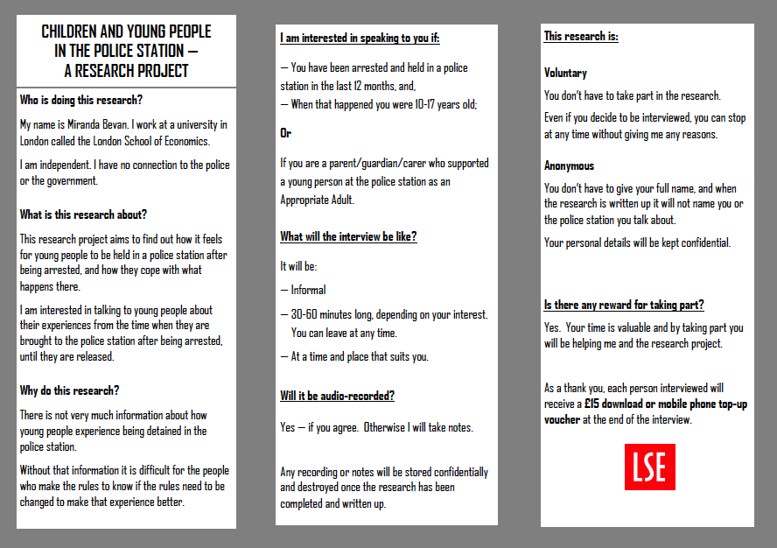

THE LONDON SCHOOL

OF ECONOMICS AND

POLITICAL SCIENCE⯀



**Research into the experience of children and young people in police custody**

**young PARTICIPANT INFORMATION SHEET**

This information sheet aims to answer questions which you may have about this research study:

**Who is doing this research?**

My name is Miranda Bevan. I work at a university in London called the London School of Economics. I am independent. I have no connection to the police or the government. If you have any questions at any time about this research you can email me at: m.j.bevan@lse.ac.uk

**What is this research about?**

This research project aims to find out how it feels for young people to be held in a police station after being arrested. So I am interested in talking to young people about their experiences from the time when they are brought to the police station after being arrested, until they are released.

**Why are you doing this research?**

There is not very much information about how young people feel about being detained in the police station. Without that information it is difficult for the people who make the rules to know if the rules need to be changed to make that experience better.

**Do I have to talk to you?**

No. It is entirely up to you whether you take part in an interview or not. That means you do not have to talk to me at all. Or, once started you can stop the interview at any time. You don’t need to say why or give me any reasons.

**How long will the interview go on for?**

Probably between 30 and 60 minutes, but that depends on how interested you are in talking about your experiences. You can end it whenever you don’t feel like talking any longer.

**Is the interview going to be recorded?**

So that I can look carefully at what you say I would like to make an audio recording of the interview. This would mean that I would have a record of your exact words. If you are not happy for the interview to be recorded I can make notes on paper instead, but I may not be able to note down everything that you say.

**What happens after the interview?**

I am talking to lots of other young people about their experiences in police custody. I am also spending time in police stations and talking to adults who work there. When all the interviews are finished, I will write about what the young people have told me and what I have found out about young people’s experiences.

**Will I be named?**

No. What I write may be published, but it will not name you, the police station or the police officers or other people that you tell me about. It will not be possible for a person reading my report to identify you from any of the details in it.

**Will my personal information be kept confidential?**

Yes. Your personal information (your name and anything you tell me which might identify you) will be treated as strictly confidential. That means the information will be stored securely and will not be made public. In particular I will not tell the police, prosecutors or your lawyers any information which might identify you or your personal experiences.

**What if I talk about something criminal that I have done?**

This is important. I am interested in what happened to you in the police station, not whether you have committed a crime. But if you do choose to talk about any offending behaviour, or accidentally talk about it, what you say remains strictly confidential. I will not tell anyone (police or prosecutors) about any offending that you might talk about, unless what you say makes me worried that someone might be in immediate danger of being physically harmed.

**Can I see what you write?**

Yes. Just let me know if you want to see what I write, or a summary of it, when it is finished.

**Is there any reward for taking part?**

Yes. Your time is valuable and by taking part you will be helping me. As a thank you, each person interviewed will receive a £15 voucher at the end of the interview.



THE LONDON SCHOOL

OF ECONOMICS AND

POLITICAL SCIENCE⯀

**Research into the experience of children and young people**

**in police custody**

**PARTICIPANT INFORMATION SHEET**

**(familial Appropriate adults)**

This information sheet aims to answer questions which you may have about this research study:

**Who is doing this research?**

My name is Miranda Bevan. I work at the London School of Economics, which is a university in Central London. I am independent. I have no connection to the police or the government. If you have any questions at any time about this research you can email me at: m.j.bevan@lse.ac.uk

**What is this research about?**

This research project aims to find out how it feels for young people to be held in a police station after being arrested. As part of the project, I am also looking at how young people are looked after and supported whilst they are detained in the police station.

So as well as talking to young people about their experiences being held in the police station, I am also keen to talk to **adults (family members, parents or carers) who acted as appropriate adults** for young people in the police station, supporting them whilst they were detained and in interview.

**Why are you doing this research?**

There is not very much information about how young people feel about being detained in the police station. Nor do we know much about what it is like as an adult to support a young person in custody and what your views are of the process. Without that information it is difficult for the people who decide how young people should be treated in the police station to know if the procedures need to be changed.

**Do I have to talk to you?**

No. It is entirely up to you whether you take part in an interview or not. That means you do not have to talk to me at all. Or, once started you can stop the interview at any time. You don’t need to say why or give me any reasons.

**How long will the interview go on for?**

Probably between 30 and 60 minutes, but that depends on how interested you are in talking about your experiences. You can end it whenever you don’t feel like talking any longer.

**Is the interview going to be recorded?**

So that I can look carefully at what you say I would like to make an audio recording of the interview. This would mean that I would have a record of your exact words. If you are not happy for the interview to be recorded I can make notes on paper instead, but I may not be able to note down everything that you say.

**What happens after the interview?**

I am talking to lots of young people about their experiences in police custody, and to other adults who supported them. I am also spending time in police stations and talking to professionals who work there. When all the interviews are finished, I will write about what I have been told and what I have found out about young people’s experiences.

**Will I be named?**

No. What I write may be published, but it will not name you, any young person or the police station, police officers or other people that you tell me about. It will not be possible for a person reading my report to identify you or any other person involved from any of the details in it.

**Will my personal information be kept confidential?**

Yes. Your personal information (your name and anything you tell me which might identify you or anyone else) will be treated as strictly confidential. That means the information will be stored securely and will not be made public. In particular I will not tell the police, prosecutors or lawyers any information which might identify you or anyone you talk about.

**What if I talk about something criminal that a young person, or anyone else, has done?**

This is important. I am interested in what happened to you, or a young person you supported, in the police station, not whether that young person, or anyone else, has committed a crime. But if you do choose to talk about any offending behaviour, or accidentally talk about it, what you say remains strictly confidential. I will not tell anyone (police or prosecutors) about any offending that you might talk about, unless what you say makes me worried that someone might be in immediate danger of being physically harmed.

**Can I see what you write?**

Yes. Just let me know if you want to see what I write, or a summary of it, when it is finished.

**Is there any reward for taking part?**

Yes. Your time is valuable and by taking part you will be helping me. As a thank you, each person interviewed will receive a £15 voucher at the end of the interview.

THE LONDON SCHOOL

OF ECONOMICS AND

POLITICAL SCIENCE⯀



**Research into the experience of children and young people in police custody**

**PARTICIPANT INFORMATION SHEET**

**(professionals and trained volunteers)**

This information sheet aims to answer questions which you may have about this research study:

**Who is doing this research?**

This is a doctoral research project supported by the Social Policy Department of the London School of Economics, in Central London. The project is independent, and not affiliated to the police or any government department. If you have any questions at any time about this research you can email the researcher, Miranda Bevan, at: m.j.bevan@lse.ac.uk

**What is this research about?**

The purpose of this research project is to explore how children (aged 10-17) experience being detained as suspects in the police custody suite. The project aims to answer the following research question: How is policy regarding the detention of children as suspects in the police custody suite implemented, and experienced by children?

The research involves semi-structured interviews with children who have recently been detained in police custody. These interviews are being supplemented by observations in police custody suites and semi-structured interviews with professionals working within police custody.

**Why are you doing this research?**

Both Her Majesty’s Inspectorate of Constabulary’s recent inspection report, *The Welfare of Vulnerable People in Custody*, and the All Party Parliamentary Group for Children’s report on children and the police, identified concerns about the effectiveness of measures to support children detained by the police and the appropriateness for young suspects of the adult custody suite environment.

No previous research has focused on how policy with regard to child suspects is implemented, looking at the police custody process as a whole from reception to release or charge. Nor has research been conducted focusing on how child suspects themselves experience that process, and the extent to which they are able to participate effectively in the process as a result.

**Voluntary participation**

Taking part in this project is entirely voluntary. Any participant is entitled to decline to be involved and to withdraw from the project at any stage, including before or during any interview. There is no requirement to give reasons for any withdrawal.

**How long will the interview last?**

It is anticipated that any interview will last between 45 minutes and 1 hour, depending on the preferences of the participant.

**Is the interview going to be recorded?**

Ideally the interview will be digitally audio-recorded so that an accurate record of the discussion can be generated for analysis. However, any participant is free to decline to be recorded, in which case the researcher will take handwritten notes of the interview.

**What will the interview be about?**

Depending on the particular role of the participant, the interview will explore how custody policy (legislation, PACE Codes of Practice, Authorised Professional Practice and other guidance) is implemented with regard to child suspects. The intention is to build an understanding of how the custody process functions in practice for young suspects. Where appropriate, the participant may be invited to reflect on their observations of how child suspects respond to the police custody process.

**What will be the output of the project?**

The research findings will be set out in a thesis, but other papers or journal articles may also be published. A summary of the findings in a format accessible to children and young people will also be produced. Please let the researcher know if you would like to receive copies of/access to any publications.

**Anonymity and confidentiality**

Interviews will be anonymised when transcribed. Any publications and other material produced will be anonymised, and will contain no information which could lead to the identification of the participating forces, custody suites or individuals.

All personal data will be treated confidentially. Original data including personal and identifying information will be stored in accordance with the principles of the Data Protection Act 1998. Hard copies of materials containing personal data will be kept in a locked cupboard, and electronic files containing personal data (eg interview soundfiles) will be stored on a secure network and transferred, where required, on removeable media which is password protected.



THE LONDON SCHOOL

OF ECONOMICS AND

POLITICAL SCIENCE⯀

**Research into the experience of children and young people in police custody**

**young PARTICIPANT consent form**

My name is: ……………………………….

I am …… years old.

|  |  |  |
| --- | --- | --- |
|  |  | Tick if Yes |
| 1. | I have been through the ‘Young participant information sheet’ with the researcher (Miranda Bevan). I understand what that sheet says. |  |
| 2. | I have been able to ask any questions that I want about the interview. |  |
| 3. | I understand that I do not have to take part in the interview. |  |
| 4. | I know that I can stop the interview at any time without giving the researcher any reasons. |  |
| 5. | I understand that the researcher will keep personal information about me confidential and that I will not be named or identified in any document she produces. |  |
| 6. | I am happy for the interview to be audio-recorded and understand what will happen to that recording. |  |
| 7. | I am happy to take part in the interview. |  |

Signed: ………………………………

Dated:…………………………

THE LONDON SCHOOL

OF ECONOMICS AND

POLITICAL SCIENCE⯀



**Research into the experience of children and young people in police custody**

**PARTICIPANT consent form**

**(familial appropriate adults)**

My name is: ……………………………….

|  |  |  |
| --- | --- | --- |
|  |  | Tick if Yes |
| 1. | I have been through the ‘Participant information sheet’ with the researcher (Miranda Bevan). I understand what that sheet says. |  |
| 2. | I have been able to ask any questions that I want about the interview. |  |
| 3. | I understand that I do not have to take part in the interview. |  |
| 4. | I know that I can stop the interview at any time without giving the researcher any reasons. |  |
| 5. | I understand that the researcher will keep personal information about me and anyone else I may talk about confidential and that we will not be named or identified in any document she produces. |  |
| 6. | I am happy for the interview to be audio-recorded and understand what will happen to that recording. |  |
| 7. | I am happy to take part in the interview. |  |

Signed: ………………………………

Dated:…………



THE LONDON SCHOOL

OF ECONOMICS AND

POLITICAL SCIENCE⯀

**Research into the experience of children and young people in police custody**

**PARTICIPANT consent form**

**(professionals and trained volunteers)**

My name is: ……………………………….

|  |  |  |
| --- | --- | --- |
|  |  | Tick if Yes |
| 1. | I have been through the ‘Participant information sheet (Professionals and Trained Volunteers)’ with the researcher (Miranda Bevan). I understand what that sheet says. |  |
| 2. | I have been able to ask any questions that I want about the interview. |  |
| 3. | I understand that I do not have to take part in the interview. |  |
| 4. | I know that I can stop the interview at any time without giving the researcher any reasons. |  |
| 5. | I understand that the researcher will treat my personal identifying information confidentially and in line with Data Protection Act 1998 principles. |  |
| 6. | I understand that all materials produced as part of this project will be anonymised, and will contain no information which could lead to the identification of the participating forces, custody suites or individuals. |  |
| 7. | I am happy for the interview to be digitally audio-recorded and understand what will happen to that recording. |  |
| 8. | I am happy to take part in the interview. |  |

Signed: ………………………………

Dated:………………………………..

