**This document details where files from the project Conversational alignment in children with an Autistic Spectrum Disorder and Their Typically Developing Peers (ES/N013115/1; “WeChat Project”) are stored/archived**

1. **DataVault**

**The below folders are archived on the University of Edinburgh institutional data repository DataVault (see** [**https://datavault.ed.ac.uk/**](https://datavault.ed.ac.uk/)**; personal details have been removed) in a vault named “Conversational alignment in children with an Autistic Spectrum condition and typically developing children” (**[**https://doi.org/10.7488/f0325f7d-d282-4d9c-bb8d-0e4e3c28cccf**](https://doi.org/10.7488/f0325f7d-d282-4d9c-bb8d-0e4e3c28cccf)**), as specified in the ReadMe files:**

* **Strand 1 (audience design) – Final Version:** Audience design (syntactic alignment); CF experiment; JCPP paper; Linguistic_communities; No_evidence_social_gains_lexical_imitation_experiment_2
* **Strand 2 (affiliation) – Final Version:** Combined Cyberball write-ups; Conversational_dynamics_(Maze_Game); Cyberball study (lexical alignment); Cyberball study (syntactic alignment); Cyberostracism_and_lexical_alignment; LexicalAlignment_TDChildren; QuestionAskingAutisticAndTDChildren
* **Extension Strand (Age effects on language use) – Final Version:** PilotStudy; Study_1; Study_2

**The below files are archived on DataVault in the vault mentioned above:**

* **ReadMe file for Strand 1:** ReadMe_Strand_1_FinalVersion.docx
* **ReadMe file for Strand 2:** ReadMe_Strand_2_FinalVersion.docx
* **ReadMe file for Extension Strand:** ReadMe_Extension_Strand_FinalVersion.docx

We note there are no links between data files corresponding to different experiments (e.g., participant IDs are not linked across files).

Full Vault Metadata below:

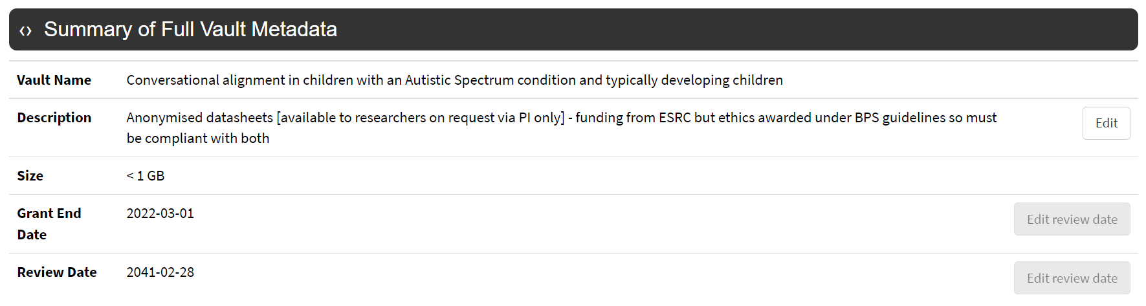

1. **ReShare**

**The below files archived on ReShare contain metadata regarding all strands of the project:**

* **ReadMe file for Strand 1:** ReadMe_Strand_1_FinalVersion.docx
* **ReadMe file for Strand 2:** ReadMe_Strand_2_FinalVersion.docx
* **ReadMe file for Extension Strand:** ReadMe_Extension_Strand_FinalVersion.docx
* **ReadMe file for all three strands:** ReadMe_EndOfProject_ReShare.docx *(present file)*