ESRC Grant ES/P005330/1
Adult aging and social attention: the role of cognitive decline and social motivation.
2017-2021. Dataset documentation.
These data sets present behavioural and eye-tracking data from five experiments looking at the effects of adult aging on gaze cueing. Experiment 1 looked at age differences in gaze cueing when varying face type (schematic, young, old) and stimulus onset asynchrony (SOA: 100ms, 300ms, 600ms, 1000ms). Experiment 2 investigated age differences in gaze cueing when varying familiarity of the face. In experiment 3 we looked at the effects of a dual task load on age differences in gaze cueing. These three experiments used a traditional gaze cueing paradigm. The final two studies looked at gaze cueing in realistic scenes. Experiment 4 evaluated age differences in using gaze cues in a real scene during a search task, while Experiment 5 looked at naturalistic gaze behaviour while free-viewing complex social scenes.

Experiment 1: Age differences in gaze cueing when varying face type (schematic, young, old) and stimulus onset asynchrony (SOA: 100ms, 300ms, 600ms, 1000ms).
Methods:
Participants.
Two groups of participants were recruited: 47 younger participants (aged 18 to 30) and 41 older participants (aged 60 to 85). The data of 14 younger participants and 10 older participants was removed from the analysis either because they did not complete all blocks of trials, or there was difficulty in aspects of eye-tracking. Therefore the final sample consisted of 33 younger adults, and 31 older adults.

Stimuli and procedure
Coloured photographs of the faces of 4 young adults (2 female) and 4 older adults (2 female) displaying neutral expressions were taken from the FACES database (https://faces.mpdl.mpg.de/imeji/). An image of a neutral schematic face was also used. The gaze direction of these images was manipulated using Adobe Photoshop, to produce images with eye-gaze averted to the left or the right.
Each trial began with a fixation dot in the centre of the screen. After 300ms a face with direct gaze was then presented in the centre of the screen for 1000ms, the eyes then moved to either the left or right of the screen. After a cue-target SOA of 100ms, 300ms, 600ms or 1000ms a target (an asterisk of approximately 1cm x 1cm) appeared to the left or right of the screen (approximately 8 degrees from the centre). There was a 1000ms inter-trial interval before the next trial began.
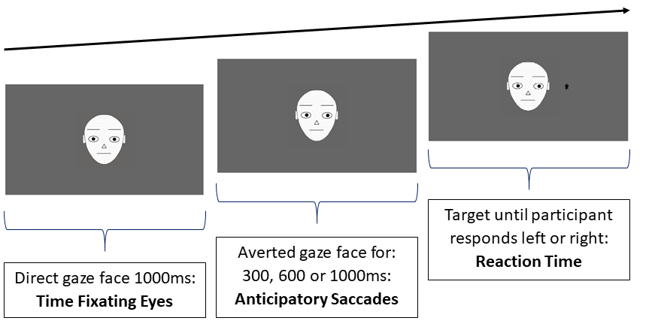
Averted gaze cue for 100, 300, 600, 1000ms. First saccade in same or different direction to cue

Illustration of stimulus sequence for gaze cueing task. Participants first fixated a central dot, then saw a direct gaze face for 1000ms, followed by an averted-gaze face for a variable SOA, after which the target appeared. Participants had to respond left or right to target location. In the trial illustrated, the target (the asterisk) appears on the congruent side. The figure is not drawn to
scale, and the targets were smaller in the actual experiment.

Participants were asked to look at the central dot at the beginning of each trial. They were told that this dot would be replaced by a photograph of a face and the eyes would then move to either the left or right of the screen and then a target would appear. Participants were explicitly informed that the movement of the eyes would not be informative of target location. They were asked to respond as quickly and accurately as possible to the target location through a keyboard press. No instructions were given about how participants should move their eyes.
The gaze cueing task was split into 12 blocks of 64 trials. To avoid fatigue, participants completed these over 2 sessions, carried out on different days. Participants completed 6 blocks of trials in each session (2 blocks with younger face cues, 2 blocks with older face cues and 2 blocks with schematic face cues). In each block in 50% of trials gaze direction was congruent with target location. For each type of cueing stimulus there was 256 trials (128 congruent).

While completing the gaze cueing task, participant’s eye movements were tracked using an Eyelink 1000 Plus eye tracker running at 1000Hz monocular sampling rate. A chinrest with forehead mount was used to stabilise participant head position at 72cm from the monitor. The refresh rate of the monitor was set at 120Hz and used to control stimulus timing and SOAs. Viewing was binocular but only the participant’s dominant eye was tracked, as determined by the USAEyes Dominant Eye Test Card (https://www.usaeyes.org/lasik/library/Dominant-Eye-Test.pdf). Prior to each experimental block, each participant underwent a randomised nine-point calibration and validation procedure. Every 10 trials a single-point calibration check was applied as the participant fixated a dot in the centre of the screen.

Datasets.
DATAFILE: Expt1SOABehavTrials.xlsx
This file is the trial by trial data for Expt 1. It has the raw behavioural data (manual reaction time responses to targets from the gaze cueing tasks) for each trial completed by each of the 64 participants in Experiment 1.

The variables are coded in the dataset as follows:
Variable Name | Description | Notes & Values
SOA | Stimulus onset asynchrony from cue to target | Values 0.1 = 100ms, 0.3 = 300ms, 0.6 = 600ms, 1 = 1000ms
CueStimulus | Name of stimulus used to show gaze averted face
DirectStimulus | Name of stimulus used to show direct gaze face
Correct | Correct answer
CongruentOrIncongruent | Target congruent or incongruent with direction of gaze cue | 0 = incongruent, 1= congruent
Response.keys | Actual keypress response made
Response.rt | Time from onset of target to keypress response
session | Block from 1 to 12
facetype | Stimulus type | 1 = schematic, 2 = young face, 3 = old face
part | participant ID
group | Participant age | y = young, o = old

DATAFILE: Expt1SOAGazeCueMeans.xlsx
All RTs from the Expt1SOABehavTrials.xlsx dataset were z-scored to account for age related differences in general slowing of RTs. The following datapoints were removed to produce this database:
- Trials where no response or two responses were recorded, as well as trials with an incorrect response (0.67%)
- Latencies below 200 ms or above 2000 ms (0.17%).
- Z-scored response times above 2.5 SD from the mean
We computed the difference between the mean (z-scored) latencies in the incongruent trials and the congruent trials to create information averaged across trials for each participant, for each SOA and face type. The key measure here is in the column ‘gazeratio’. A positive value of this measure indicates a gaze cueing effect, that is, that participants took longer to answer incongruent compared to congruent trials.
Variable Name | Description | Notes & Values
congruent | Mean Z scored RT for congruent trials
incongruent | Mean Z scored RT for incongruent trials
gazeratio | incongruent - congruent
part | participant ID | includes o for older and y for younger participant
group | participant age group
facetype | stimulus type | schematic, young or old faces
SOA | Stimulus onset asynchrony from cue to target | Values 0.1 = 100ms, 0.3 = 300ms, 0.6 = 600ms, 1 = 1000ms

DATAFILE: Expt1SOAFirstSaccade.xlsx
This file describes eye-movement data: the first saccade made after seeing the gaze cue in each trial of the study by each participant. The last column Dir1Sacc codes whether the first saccade made during the SOA was in the same direction as the averted gaze cue, in the opposite direction, or there was not an eye movement. Each row is a trial.
Variable Name | Description | Notes & Values
partID_session | ParticipantID_Age_Session
trial | Trial no within session
soa | Stimulus onset asynchrony from cue to target | Values 0.1 = 100ms, 0.3 = 300ms, 0.6 = 600ms, 1 = 1000ms
CueStimulus | Name of stimulus file
partID | ParicipantID+AgeGroup
group | Age group
session.1 | Session | From 1-12 sessions of eye-tracking
targetloc | Target location | Left or right
gazeCue | Gaze cue direction | Left or right
facetype | Face stimulus type | 1 = schematic, 2 = young face, 3 = old face
congruency | Target congruent or incongruent with direction of gaze cue | 0 = incongruent, 1= congruent
duration | Duration of first saccade
Dir1Sacc | Direction of first saccade | Same direction as gaze cue, different direction or no saccade

DATAFILE: Expt1SOAEyesMouth.xlsx
This file describes eye-tracking data using a region of interest analysis. This represents where each participant was looking on the screen during each part of the trial where a direct gaze face was shown (total time = 1000ms). Each row is a trial. The columns TimeFixEyes and TimeFixMouth indicate the time spent looking at the Eyes and Mouth (respectively) during the 1 second presentation of the direct gaze face. TimeFixFace is time fixating any other area on face except eyes and mouth. TimeFixws is time fixating any other area of the screen apart from the face. Other variables present the number of fixations in each of these regions.

Variable Name | Description | Notes & Values
PartID_Session | ParticipantID_Age_Session
SOA | Stimulus onset asynchrony from cue to target | Values 0.1 = 100ms, 0.3 = 300ms, 0.6 = 600ms, 1 = 1000ms
CueStimulus | Name of stimulus file for gaze cue
Congruency | Target congruent or incongruent with direction of gaze cue | 0 = incongruent, 1= congruent
FaceType | Face stimulus type | 1 = schematic, 2 = young face, 3 = old face
PartID_Session | Participant ID code
group | Age group | y = young, o = old
session.1 | Session | From 1-12 sessions of eye-tracking
directface | Name of direct gaze face stimulus file
totalNrFix | Total number of fixations during presentation of direct face
NrFixFace | Number of fixations on the face
NrFixEyes | Number of fixations on the eyes
NrFixMouth | Number of fixations on the mouth
NrFixWS | Number of fixations on other parts of screen
totalTimeFix | Total time fixating in ms
TimeFixFace | Time fixating face
TimeFixEyes | Time fixating eyes
TimeFixMouth | Time fixating mouth
TimeFixws | Time fixating other parts of screen
firstFixLoc | Location of first fixation once direct gaze face appeared
timeFirstFix | Time to first fixation

Experiment 2: Age differences in gaze cueing when varying familiarity of the face.
Methods:

Participants

We recruited pairs of older adults and pairs of younger adults. Each pair comprised two participants from the same age range that knew each other. The experiment comprised two sessions, held on two different days. In the first session, we first photographed each of the two participants, and then each participant completed a range of background measures. In the second session, participants completed the eye-tracking gaze cueing task. Our final data set comprises thirty-one older adults ranging in age from 60 to 83 and forty younger adults ranging in age from 18 to 24.

Stimuli and procedure

We took coloured photos using a Canon EOS 4000D standing on a tripod 2m from a chair where the participant sat. We photographed each participant’s face looking directly at the camera and then to the left and right by asking them to look, without moving their head, at marks placed on panels at both sides of the camera. For each pair of participants, the photograph from the other was used in the gaze cueing task as the familiar face, and three photographs from unfamiliar faces (from other participants in the experiment), matched for age, gender, and ethnicity of the familiar face, were used as unfamiliar faces. The photos were embedded on a grey background that fitted the 1920 x 1080 screen.

For each participant, an experimental block contained 64 trials, with the familiar face appearing 16 times and each of the three unfamiliar faces appearing 16 times, with a randomized order of presentation. On each trial, participants were presented with a face with averted gaze (left or right) for 300ms before a target was presented at the left or right of the face. On 32 of the trials the target location was congruent with the gaze direction, and on the other 32 trials it was incongruent with the gaze direction. Our design thus crossed two within-participants factors: Familiarity (Familiar vs. Unfamiliar face; within-participants) and Congruence (Congruent vs. Incongruent trial). Age group (Older vs. Younger) was a between-participants predictor. Each participant was administered four equal blocks of trials, having a short break between blocks. We thus collected data from 256 trials for each participant.

The experiment was generated in SR Research Experiment Builder 1.10.165 (2011), and conducted on a Asus TX650 computer running OS Windows7 Pro. Stimuli were presented on a BenQ XL2420Z 24-inch monitor with 1920 x 1080 pixels image resolution, and a refresh rate of 120 Hz. Eye movements were recorded using an EyeLink 1000 desk-mounted eye-tracker at a sampling rate of 1000 Hz. Participants sat 72 cm away from the display, and a forehead and chin rest was used for head stabilization. Viewing was binocular but only the participant’s dominant eye was tracked, as determined by the USAEyes Dominant Eye Test Card (https://www.usaeyes.org/lasik/library/Dominant-Eye-Test.pdf).

Each block of 64 trials began with a 9-point calibration and validation procedure. After the initial calibration procedure, participants were presented written instructions for the task, saying they should respond if the target appeared left or right using the left-hand key (A) or the right-hand key (L), respectively. They were told that the photographed person would look left or right but that this was not predictive of the subsequent target location.

On each trial, a fixation point was first presented which served as calibration check to the experimenter. When the experimenter accepted the fixation at this point, the face with left- or right-averted gaze was seen for 300ms before the target (an asterisk approximately 1cm x 1cm appeared, at the left or right of the face (Figure 1). The participant then had to respond to the target location as quickly and accurately as possible, triggering the presentation of the next trial.

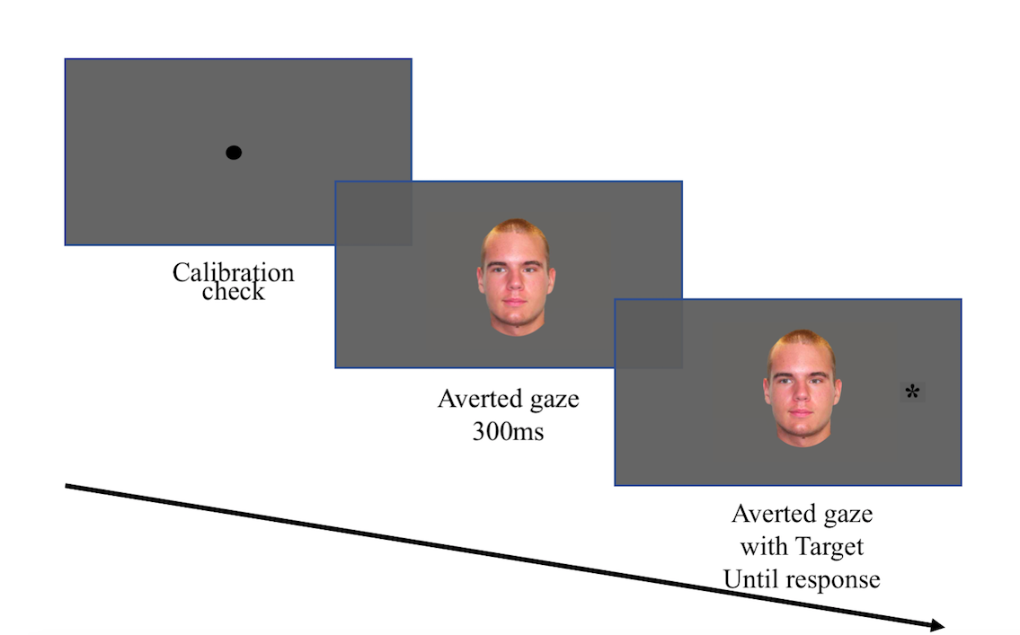
Illustration of stimulus sequence for gaze cueing task. Participants first fixated a central dot, then saw an averted-gaze face for 300ms, after which the target appeared. Participants had to respond left or right to target location. In the trial illustrated, the target (the asterisk) appears on the incongruent side. The figure is not drawn to scale, and the targets were smaller than illustrated.
DATAFILE: Expt2FamiliarityTrials.xlsx
This is the raw data of behavioural performance (manual response RT on each trial for each participant) and eye-tracking variables for Experiment 2.

Variable Name | Description | Notes & Values
PartID | Participant ID code | 2nd letter Y = young, O = old
Target_Location | Location of target
Congruence | Target congruent or incongruent with direction of gaze cue
Familiarity | Stimulus face familiar or unfamiliar
unfamiliar_item | Which unfamiliar face used
stimulus_name | Name of stimulus face
correctanswer | Correct keypress | a or l
Actual_Response | Actual keypress
mean_cal_error | Mean callibration error in degrees for trial
max_cal_error | Maximum callibration error
Horizontal_left_error | Callibration error left
Horizontal_middle_error | Callibration error middle
Horizontal_right_error | Callibration error right
RT | Keypress reaction time in ms to target
first_saccade_latency_wrt_cue | Time in ms to first saccade after presenting gaze cue
first_saccade_latency_wrt_target | Time in ms to first saccade after presenting target
saccade_present | Saccade present during trial | 0 = no, 1= yes
first_saccade_LR | First saccade to gaze cue to left or right of horizontal plane | NA = no saccade
usable_eye_data | Data from trial meets all criteria (see text)
session | Eye tracking session (from 1-4)
group | Age group
item | face used
accuracy | target correctly located or not
zscoredRT | z scored keypress reaction time to target

DATAFILE: Expt2FamiliarityGazeCue.csv

The following trials were removed from Expt2FamiliarityTrials.xlsx to produce this database:
- Trials where no response or two responses were recorded, as well as trials with an incorrect response (0.08%)
- Latencies below 200 ms or above 2000 ms (0.80%).
- Z-scored response times above 2.5 SD from the mean (5.14%)
We computed the difference between the mean (z-scored) latencies in the incongruent trials and the mean (z-scored) latencies in the congruent trials to create a data file containing information averaged across trials for each participant, for each SOA and face familiarity condition. The key measure here is in the column ‘gazeratio’. A positive value of this measure indicates a gaze cueing effect, that is, that participants took longer to answer incongruent compared to congruent trials.

Variable Name | Description | Notes & Values
Congruent | Mean Z scored RT for congruent trials
Incongruent | Mean Z scored RT for incongruent trials
Familiarity | Familiar or unfamiliar face
gazeratio | incongruent - congruent
part | participant ID | includes o for older and y for younger participant
group | participant age group

DATAFILE: Expt2FamiliaritySaccades.xlsx

Here we recorded the presence of anticipatory eye movements for each trial, that is, the likelihood of making an eye movement after the presentation of the averted gaze face (plus 100ms to account for eye movement programming) and before the target appearance (plus 100ms to account for eye movement programming), in any direction (coded 1) versus not making any eye movement (coded 0). Where saccades were present they were further coded as in the same or different direction as the gaze cue (variable antSaccadeGazeDirect). We discarded trials with calibration errors > 1º in the three horizontal calibration points (left, middle and right, 9.73%), and those where the first saccade amplitude was smaller than 0.5º, and where the first saccade started in a point distancing horizontally or vertically more than 2º (~95pixels) from the screen centre (12.27%).

Variable Name | Description | Notes & Values
PartID | Participant ID code | 2nd letter Y = young, O = old
Target_Location | Location of target
Congruence | Target congruent or incongruent with direction of gaze cue
Familiarity | Stimulus face familiar or unfamiliar
unfamiliar_item | Which unfamiliar face used
stimulus_name | Name of stimulus face
correctanswer | Correct keypress | a or l
Actual_Response | Actual keypress
mean_cal_error | Mean callibration error in degrees for trial
max_cal_error | Maximum callibration error
Horizontal_left_error | Callibration error left
Horizontal_middle_error | Callibration error middle
Horizontal_right_error | Callibration error right
RT | Keypress reaction time in ms to target
first_saccade_latency_wrt_cue | Time in ms to first saccade after presenting gaze cue
first_saccade_latency_wrt_target | Time in ms to first saccade after presenting target
saccade_present | Saccade present during trial | 0 = no, 1= yes
first_saccade_LR | First saccade to gaze cue to left or right of horizontal plane | NA = no saccade
usable_eye_data | Data meets all criteria (see text)
session | Eye tracking session (from 1-4)
group | Age group
item | face used
anticipatorySaccade | Was an anticipatory saccade present in the trial? | 0=no 1=yes
antSaccadeGazeDirect | no saccade, in direction of gaze cue, or in opposite direction | no saccade, same direction, dif direction

Experiment 3: Age differences in gaze cueing during a dual task.

Methods:
Participants
We collected complete datasets from 26 older and 25 younger participants. Data collection was curtailed at this point due to the COVID pandemic.

Stimuli and procedure
Participants completed a traditional gaze cueing paradigm (using similar methods and stimuli to Experiment 1 above) while concurrently doing a working memory task, that could be more or less demanding (low vs. high cognitive load). The stimuli were photographed faces of 4 younger (2 male 2 female) and 4 older (2 male, 2 female) people from the FACES database. For each face, the photographed person could be looking straight ahead or have the gaze averted left or right. Thus, we used 24 photographs, sized 640 x 480 pixels. For the secondary task, we used a low or high memory load condition. For the low cognitive load condition the 4-digit number was always ‘1234’. 4-digit numbers made up of the numbers 1 to 9 were randomly generated to be used in the high cognitive load condition (e.g., 4371). There were no repeats of individual digits in the number but some of the of the 4-digit numbers appear more than once.
After an initial drift check, a 4-digit number was presented, one digit at a time, to be remembered. A fixation point followed, before the face with direct gaze was presented for 1000ms. Then the face appeared with the gaze averted left or right, for either 300 or 1000ms, after which a target at the left or right of the face appeared. Participants had to respond to the target location using the left or right buttons of the keypad. After answering, they were prompted to say out loud the digits they were to remember, either in the same order of presentation (low cognitive load condition) or in reverse order of presentation (high cognitive load condition).
Each participant saw 128 trials in each cognitive load condition, split into 2 blocks (64 trials with young faces as the face cue and 64 trials with old faces as the face cue). On each block, in 50% of the trials the target appeared at a location congruent with the averted gaze, and in 50% of the trials the target location was incongruent with the averted gaze. We thus collected 256 trials from each participant. The order of load condition and cue face type (old, young) was counterbalanced across participants.

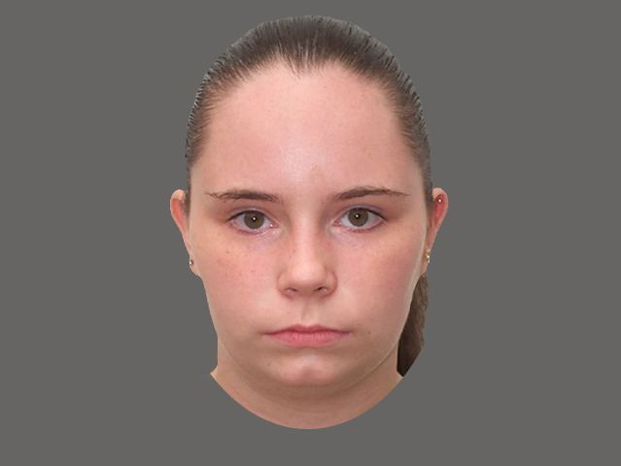
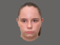
.
5342
.
*
Drift correct at the start of every trial
4-digit number to be remembered: 1500ms
Fixation point
Direct gaze face: 1000ms
Averted gaze face 300ms or 1000ms
Target appears until response.
Prompt to key in digits in same order (low load) or reverse order (high load).

Illustration of stimulus sequence for the dual task. Participants first fixated a central dot, then saw a 4 digit number to be remembered (either 1234, low load or random digits, high load). After another fixation point a direct gaze face appeared for 1000ms, followed by an averted-gaze face (for 300 or 1000ms), after which the target appeared. Participants had to respond left or right to target location. After this they were prompted to key in the digits which they saw at the beginning of the trial in the same or reverse order. The figure is not drawn to scale.

Datasets

DATAFILE: Expt3DualTaskTrials.xlsx
This is the raw data for each trial carried out for each participant (manual response RT plus eye movement data).
Variable Name | Description | Notes & Values
ParticipantFile | ParticipantAge(YorO) AgeFace(YorO) DualTaskCondition(0or1) | Dual task 0 = easy level, 1 = hard level
direct_face | Name of direct gaze stimulus file
mean_cal_error | Mean callibration error in degrees for trial
max_cal_error | Maximum callibration error
Target_Location
Congruence | Target congruent or incongruent with direction of gaze cue
CognitiveLoad | Secondary task condition | Dual task 0 = easy level, 1 = hard level
soa | Stimulus Onset Asynchrony | 300 or 1000 ms
type_face | Young or Old
averted_face | Name of gaze cue stimulus file
numbers | Actual numbers in secondary task
RT | Keypress reaction time in ms to target
trialno | Trial number in sequence
first_saccade_latency_wrt_cue | Time in ms to first saccade after presenting gaze cue
first_saccade_latency_wrt_target | Time in ms to first saccade after presenting target
saccade_present | Saccade present during trial | 0 = no, 1= yes
first_saccade_LR | First saccade to gaze cue to left or right of horizontal plane | NA = no saccade
tft_eyes | Total fixation time on eyes | NaN = no fixations
durfirfixeyes | Duration of first fixation on eyes | NaN = no fixations
NbFixEyes | Number of fixations on eyes | NaN = no fixations
tft_mouth | Total fixation time on mouth | NaN = no fixations
durfirfixmouth | Duration of first fixation on mouth | NaN = no fixations
NbFixmouth | Number of fixations on mouth | NaN = no fixations

DATAFILE: Expt3DualGazeCueMeans.csv

We removed trials with incorrect answer to target location; responses <200ms or >2000ms; for each participant, responses distancing more than 2.5SD from mean z score. Then we computed the gaze cueing effect on z-scored RTs: For each participant and condition, it is the mean RT on Incongruent trials - mean on congruent trials

Variable Name | Description | Notes & Values
gazeEffect | Mean z(RTincongruent)- Mean z(RTcongruent)
PartID | participant ID | O = old, Y = young
soa | Stimulus onset asynchrony from cue to target | 300 or 1000ms
cognitive_load | secondary task load | 0 = low, 1 = high
group | Age group

DATAFILE: Expt3DualFixSacc.csv

For eye movements we removed trials with mean calibration error >.5 and maximum calibration error >1º. We drew areas around the eyes and mouth on each of the eight faces used as stimuli. From the sequence of fixations on each trial we extracted the ones that started after the onset of the direct gaze and that finished before the onset of the averted gaze face. Then we selected from these fixations the ones that distanced no more than 1.5º from the ROIs face and mouth and computed, on each case, the total duration of the time spent fixating on eyes (tft_eyes) and on mouth (tft_mouth) for each participant on each trial.

We coded whether a (first) anticipatory saccade was or not performed during the cue window (300ms or 1000ms, always starting at +100ms from cue onset). The variable ‘anticipatorySaccade’ is 1 for when a saccade was made and 0 when no eye movement was made. We also coded if the (first) anticipatory saccade was in the direction of the averted gaze, in the opposite direction, or if there was not a saccade (variable ‘antSaccadeGazeDirect’).

Variable Name | Description | Notes & Values
Participant | Participant ID
direct_face | Name of direct gaze stimulus file
mean_cal_error | Mean callibration error in degrees for trial
max_cal_error | Maximum callibration error
Target_Location
Congruence | Target congruent or incongruent with direction of gaze cue
CognitiveLoad | Secondary task condition | Dual task 0 = easy level, 1 = hard level
soa | Stimulus Onset Asynchrony | 300 or 1000 ms
type_face | Young or Old
averted_face | Name of gaze cue stimulus file
numbers | Actual numbers in secondary task
RT | Keypress reaction time in ms to target
trialno | Trial number in sequence
first_saccade_latency_wrt_cue | Time in ms to first saccade after presenting gaze cue
first_saccade_latency_wrt_target | Time in ms to first saccade after presenting target
saccade_present | Saccade present during trial | 0 = no, 1= yes
first_saccade_LR | First saccade to gaze cue to left or right of horizontal plane | NA = no saccade
tft_eyes | Total fixation time on eyes | NA= no fixations
durfirfixeyes | Duration of first fixation on eyes | NA= no fixations
NbFixEyes | Number of fixations on eyes | NA= no fixations
tft_mouth | Total fixation time on mouth | NA= no fixations
durfirfixmouth | Duration of first fixation on mouth | NA= no fixations
NbFixmouth | Number of fixations on mouth | NA= no fixations
session | condition old(O)/young(Y) faces and easy(0)/hard(1)
group | Age group of participant
gazeDirection | L or R
anticipatorySaccade | Was an anticipatory saccade present in the trial? | 0=no 1=yes
antSaccadeGazeDirect | no saccade, in direction of gaze cue, or in opposite direction | no saccade, same direction, dif direction

Experiment 4: Age differences in using gaze cues in a real scene during a search task.

Note that this study has been published:
Fernandes, E.G., Phillips, L.H., Slessor, G. & Tatler, B.W. (2021). The interplay between gaze and consistency in scene viewing: Evidence from visual search by young and older adults. Attention, Perception & Psychophysics, 83, 1954–1970. https://doi.org/10.3758/s13414-021-02242-z.
The publication includes supplementary databases of the data used in the study (also described below), and also all of the images used in the study: https://link.springer.com/article/10.3758/s13414-021-02242-z#Sec18.

Methods

Here we looked at age differences in attending to gaze cues in complex naturalistic scenes. Participants completed a scene viewing search task. In each trial they saw a photograph of a complex scene including a person looking towards an object, along with distractor objects. They had to search for a named target object and fixate on the target and make a key response to indicate whether the object was or not present in the scene.

Participants

64 participants completed the study and had acceptable datasets: 30 older (11 males; aged M=70.8, SD=5.7) and 34 younger (3 males; aged M=23.0, SD=2.9) participants.

Design and materials

The experimental items for each participant were 32 real-world scenes (i.e., photographs) where participants had to look for a pre-specified (named) target object, while their eye movements were recorded. In each scene (e.g., living room), an actor was looking at the to-be-searched target object (e.g., throw) or looking at a distractor object on the opposite side of the scene, and the target object could be consistent (e.g., throw) or inconsistent (e.g., kettle) with the semantic context of the scene (e.g., living room). Sixty-four additional photographs were filler items, obtained from websites, that appeared between each two experimental items. For each trial the target item was cued by a word appearing on the screen before the presentation of the image, then participants had to identify whether the target object was present in the scene. In half of the 96 trials the correct answer to this question was Yes, and it was No for the other half of presented items.

To create our 32 experimental items, we took coloured photos with a Canon EOS 4000D. We photographed 32 different scenes (16 outdoor, e.g., garden, and 16 indoor, e.g., living room). For each of the (16) indoor scenes, four young (1 male) and four older (2 males) actors were photographed, and for each of the (16) outdoor scenes another four young (2 males) and four older (3 males) actors were photographed. For each scene (e.g., living room), and for each actor, we first placed the consistent object (e.g., throw) in the physical scene, and the distractor object (which was always consistent with the scene) at the opposite side, relative to the actor. We photographed the actor looking at the target object, first, and then looking at the distractor. This procedure was then repeated, after replacing the consistent by the inconsistent (e.g., kettle) target object. Photographs were taken with a tripod that was kept at the same location and with the same extension for all photographs of each scene. Each photo was saved as a JPG file with 5184x3456 pixels dimension, and 72 dpi horizontal and vertical resolution, and was then resized to 1620x1080 to fit the presentation screen while keeping the same aspect ratio.

Apparatus and recording

The experiment was generated in SR Research Experiment Builder 1.10.165 (2011), and conducted on a Asus TX650 computer running OS Windows7 Pro. Scenes were presented on a BenQ XL2420Z 24-inch monitor with 1920 x 1080 pixels image resolution, and a refresh rate of 120 Hz. Eye movements were recorded using an EyeLink 1000 desk-mounted eye-tracker at a sampling rate of 1000 Hz. Participants sat 72 cm away from the display, and a forehead and chin rest was used for head stabilization. Viewing was binocular but only the participant’s dominant eye was tracked, as determined by the USAEyes Dominant Eye Test Card (https://www.usaeyes.org/lasik/library/Dominant-Eye-Test.pdf). The experiment began with a 9-point calibration and validation procedure. Calibration was accepted if the average and worst calibration errors were below 0.5 and 1 degrees of visual angle, respectively. A new calibration was repeated whenever the experimenter found it necessary, namely, when the pre-trial calibration check shown at each trial onset indicated an error above 1º for three or more successive trials.

Example trial of the visual search experiment. Participants would first fixate a central dot for pre-trial calibration check, and then see a written word indicating which object to search for, followed by a blank screen and the search scene containing (or not) the target object. Participants were instructed to look at the target object if it was present, and to press the key on the keyboard to log their yes/no response, and, after a blank screen, the next trial would start.

Analysis

The region of interest (ROI) for the eye movement analysis was the target object. We defined ROIs using MATLAB’s (version R2019a) function drawpolygon to draw, in each scene, the contour of the target object. For each scene, each actor was photographed looking at or away from two different target objects (consistent and inconsistent). Raw gaze data were pre-processed using MATLAB. For each participant and trial, we first extracted the timestamps indicating the trial start and end, the scene onset, the manual response, and the fixations (start, end, x coordinate and y coordinate) starting between the scene onset and the final blank screen. We then mapped each fixation onto the target ROI. We assigned a fixation to the ROI if its distance to the nearest ROI pixel was smaller than the distance corresponding to 1º of visual angle (47.3 px). From the 2048 trials (32 experimental trials for each of the 64 participants), we removed 17 trials for which the average and worst calibration errors were below 0.5 or 1 degrees of visual angle, respectively. We further discarded from analyses 128 trials where participants answered incorrectly that the object to be searched for was not present. We also removed from the analysis the trials where the target was not fixated at all (36) or where, at the scene onset, the target region was already being fixated (16). These procedures led to elimination of 197 out of 2048 trials (9.6%).

We focused on measures that are commonly reported in studies on scene viewing and visual search: a) the time to first fixate the target (i.e., the start time of the first fixation at the target minus the scene onset time, in ms); b) the probability of having fixated the target at each fixation ordinal number (i.e., whether, at each fixation ordinal number, the target was or was not fixated; a binomial coded 1 and 0, respectively); c) the total fixation time at the target (i.e., the sum of the durations of all fixations at the target starting between the scene onset and the final blank screen, in ms); and d) the answer response time (i.e., the difference between the manual response time and the scene onset, in ms). In order to obtain closer to normal distributions of the time measures we log-transformed these outcomes. We further removed latencies that distanced more than three standard deviations (SDs) from the mean, for each participant. This corresponded to 6 (0.3%) and 13 (0.7%) trials, for time to first fixate and total fixation time, respectively. For the answer response time (RT), we first excluded 17 outlier observations longer than 5000ms (0.9%) and then, for the log-transformed RTs, another 3 observations (0.1%) more than 3SD away from the mean.

DATAFILE: Expt4SearchSceneTrials.xlsx

This dataset shows the trial by trial information (one trial per row) for each participant. Note data exclusion info above.

Variable Name | Description | Notes & Values
ParticipantFile | participant ID
RandVersion | randomisation version
trial | trial number
image | name of image
scenario | image setting
age_of_person_in_image | age group of person in scene
name_of_person_in_image | identifier of person in scene
salience | low/high salience of target | All targets in this study were low salience
consistency | is target consistent with scene | Semantic consistency
gaze | is person in photo looking at target | gazed or nongazed
object_location | left or right
correctanswer | y = yes, target present, N = not present | Only target present trials are analysed: target absent trials were fillers
response_key_pressed | answer given l = yes
mean_cal_error | Mean callibration error in degrees for trial
max_cal_error | Maximum callibration error
RT | RT of keypress response to target presence
first_saccade_latency | Time in ms to first saccade after presenting scene
tth_target | time in ms to first fixation on target
tth_distractor | time in ms to first fixation on distractor
tth_face | time in ms to first fixation on face
tft_target | total time fixating on target
tft_distractor | total time fixating on distractor
tft_face | total time fixating on face
NbFixTarget | number of fixations on target
NbFixDis | number of fixations on distractor
group | age group of participant
CPrTfix1 (to 10) | cumulative probability of fixating target at fixation 1 (to 10)
PrFTfix1 (to 10) | was the target fixated at fixation 1 (to 10)?
PrFDfix1 (to 10) | was the distractor fixated at fixation 1 (to 10)?

Experiment 5: Age differences in using gaze cues in a real scene during a freeviewing task.

In this study younger and older participants were shown photographs which contained at least one person looking at an object. There was no task to carry out and so we were interested in age differences in visual inspection behaviour when viewing freely varied scenes including people. We were interested in whether there were any age differences in looking at the eye region or following gaze direction.

Methods
Participants
30 younger participants (aged M=23.4, SD=3.3) and 24 older participants (aged M=71.6, SD=5.3) completed the experiment fully.
Stimuli and procedure
These images were chosen from other available image databases (e.g. http://gazefollow.csail.mit.edu/; http://flickr.com/ ) to meet the criteria that (a) there was one person clearly shown in the picture, (b) the direction of their gaze could be clearly seen, (c) the gaze direction was not looking directly at the camera but instead at an object within the scene, (d) there was a size ratio of 1: 1.5. We tried to select images which included a range of ages, but there were few pictures including older adults which met the criteria.
Participants were shown the 120 images, one at a time, in a randomised order. Participants were asked to look freely at each of 120 images for the 5s for which it remained on the screen. No responses were made.
The experiment was generated in SR Research Experiment Builder 1.10.165 (2011), and conducted on a Asus TX650 computer running OS Windows7 Pro. Scenes were presented on a BenQ XL2420Z 24-inch monitor with 1920 x 1080 pixels image resolution, and a refresh rate of 120 Hz. Eye movements were recorded using an EyeLink 1000 desk-mounted eye-tracker at a sampling rate of 1000 Hz. Participants sat 72 cm away from the display, and a forehead and chin rest was used for head stabilization. Viewing was binocular but only the participant’s dominant eye was tracked, as determined by the USAEyes Dominant Eye Test Card (https://www.usaeyes.org/lasik/library/Dominant-Eye-Test.pdf). The experiment began with a 9-point calibration and validation procedure. Calibration was accepted if the average and worst calibration errors were below 0.5 and 1 degrees of visual angle, respectively. A new calibration was repeated whenever the experimenter found it necessary, namely, when the pre-trial calibration check shown at each trial onset indicated an error above 1º for three or more successive trials.

Analysis
Two regions of interest (ROIs) were drawn as illustrated in Figure 1. The first ROI comprised the face of the person in the image, and the second one was the location at which the person was looking at (based to the ground truth annotations of 20 participants; for each image, we draw an ellipse that contained 80% of the 20 annotation points).

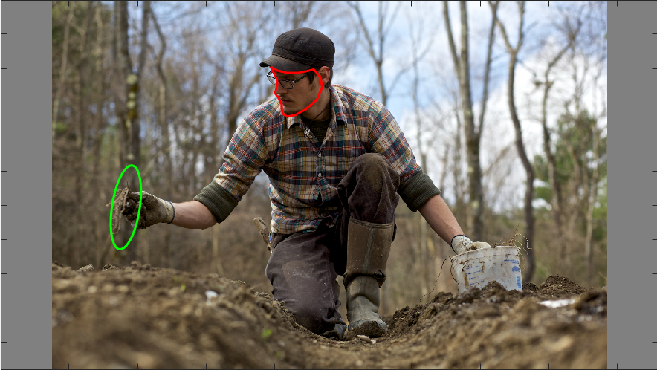

Example image in the Free Viewing task, with the analysed ROIs (the Face, in red, and the Gazed-at Location, in green).
We had 6469 trials (54 participants x 120 images=6480, but 11 had only 1 fixation), and we eliminated 79 trials (1.22%) with mean calibration error above 0.5º or maximum calibration error above 1º. We also discarded an image for which 16 of the ground truth annotations indicated that the region where the person was looking at was outside of the screen. Our final database has 6336 trials.
For each trial, we considered fixations that started after the scene onset, until the first fixation that finished after the scene offset. We mapped each fixation onto one of the two ROIs or ‘other’ location on the screen (we considered fixations distancing less than 1.5º of visual angle from a ROI to be at that ROI).
We first considered the probability of fixating or not each of ROIs, face and gazed-at location and, for the subset of data where the ROI was fixated, the mean number of fixations on it by trial.
We then computed the probability of fixating each ROI at each ordinal fixation (e.g., for the second fixation, the probability of fixations to Face is the proportion of trials when the second fixation was at the Face, relative to the total number of trials; we computed this measure for each participant).
Finally, we computed the latency to First Fixate (tth_) and the Total Time fixating (tft_) each ROI. The tth is the difference between the starting time of the first fixation at a ROI (e.g., face) and the scene onset time. The tft corresponds to the sum of the durations of all fixations at a ROI during the analysed time window.

Datasets

DATAFILE: Expt5FreeviewTrials.xlsx

This includes data is from 30 younger participants and 24 older participants (we recruited 86 participants but 31 had calibration errors >.5 (average) and >1 (maximum), and another one was discarded because of her age).

Variable Name | Description | Notes & Values
ParticipantFile | participant ID
item | number of item
image | name of image file
age_of_person_in_image | age person in image | estimated age group C = child, Y = young, M = middle-aged, O = old
mean_cal_error | Mean callibration error in degrees for trial
max_cal_error | Maximum callibration error
first_saccade_latency | Time in ms to first saccade after presenting scene
tth_GL | time in ms to first fixate on gazed-at-location
tth_face | time in ms to first fixate on face
tft_GL | total fixation time for gazed-at-location
tft_face | total fixation time for face
NbFix_GL | number of fixations for gazed-at-location
NbFix_face | number of fixations for face
NbFix | total number of fixations
durfirfixGL | duration of first fixation to gazed location
durfirfixFace | duration of first fixation to face
NbFixother | number of fixations in other regions
group | age group of participant

