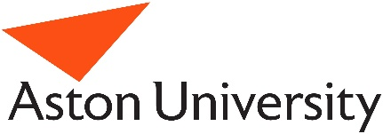
THIS FORM WILL BE TRANSLATED INTO SWAHILI (KENYA) BY PAMELA WADENDE AND TONGA (ZAMBIA) BY BARNABAS SIMATENDE. IT IS ONLY PRESENTED IN ENGLISH FOR THE PURPOSES OF ETHICAL REVIEW
Exploring mealtime language use, at home and school, with children in Kenya and Zambia
Consent Form
Name of Chief Investigator: Professor Claire Farrow: parents and caregivers
Please initial boxes
I confirm that I have read and understand the Participant Information Sheet (Version Number 6, 19/10/2020) for the above study. I have had the opportunity to think about the information and ask questions.

I understand that it is my choice whether to take part and that I can stop taking part at any time without giving any reason and without my legal rights being affected.

I agree to my personal data and data relating to me collected during the study being processed as described in the Participant Information Sheet.

I agree to my interview being audio recorded and to anonymised direct quotes from me being used in publications that may come from this study.

I agree to study visits being video recorded by a research assistant or myself.

I agree to have my child take part in phone interviews and that the interviews with my child be recorded.

I agree to take part in this study.

_________________________ ________________ ___________________
Name of participant / caregiver Date Signature

_________________________ ________________ ___________________
Name of Person receiving Date Signature
consent.

