***Anonymous ID (to be completed by the researcher):***

**Demographic Information**

What is your age (in years)? _____________

What sex were you assigned at birth on your original birth certificate?

🞎 Male

🞎 Female

🞎 Prefer not to say

What is your current gender identity?

🞎 Male

🞎 Female

🞎 Transgender male/Trans man/Female-to-Male (FTM)

🞎 Transgender female/Trans woman/Male-to-Female (MTF)

🞎 Genderqueer, neither exclusively male nor female

🞎 Additional Gender Category, or Other, please specify: ______________

🞎 Don’t know

🞎 Prefer not to say

How would you describe your ethnic origin?

🞎 White

🞎 Mixed/Multiple Ethnicities

🞎 Asian/Asian Scottish or Asian British

🞎 Black/African/Caribbean/Black Scottish or Black British

🞎 Any Other ethnic group (please describe): ______________

🞎 Unknown

🞎 Prefer not to say

What are the first three digits of your postcode? _____________

*This will not allow us to identify where you live, but will allow us to compare how people living in different areas of the country think and feel.*

**Pre-Study VAS**

How are you feeling?

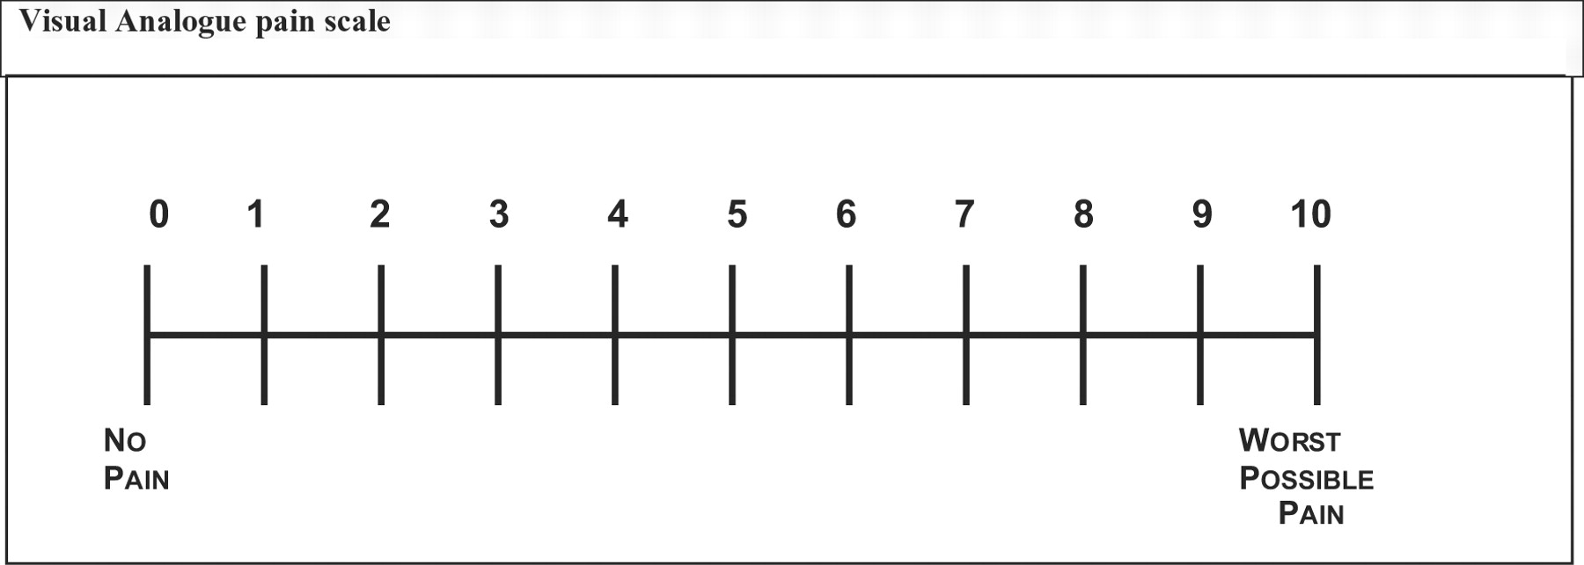

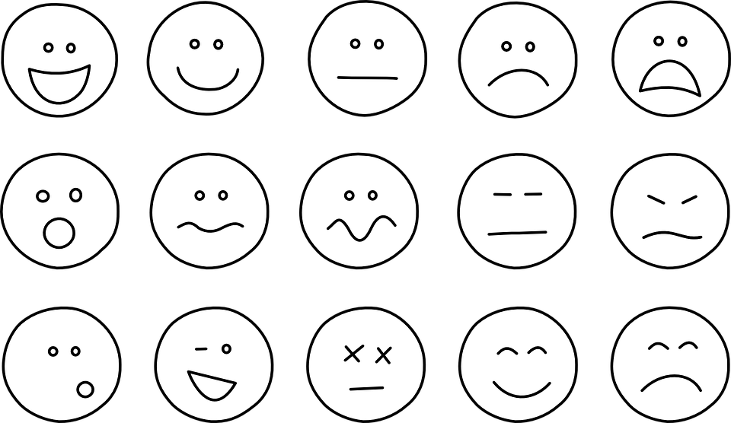

**Post-Study VAS**

How are you feeling?



