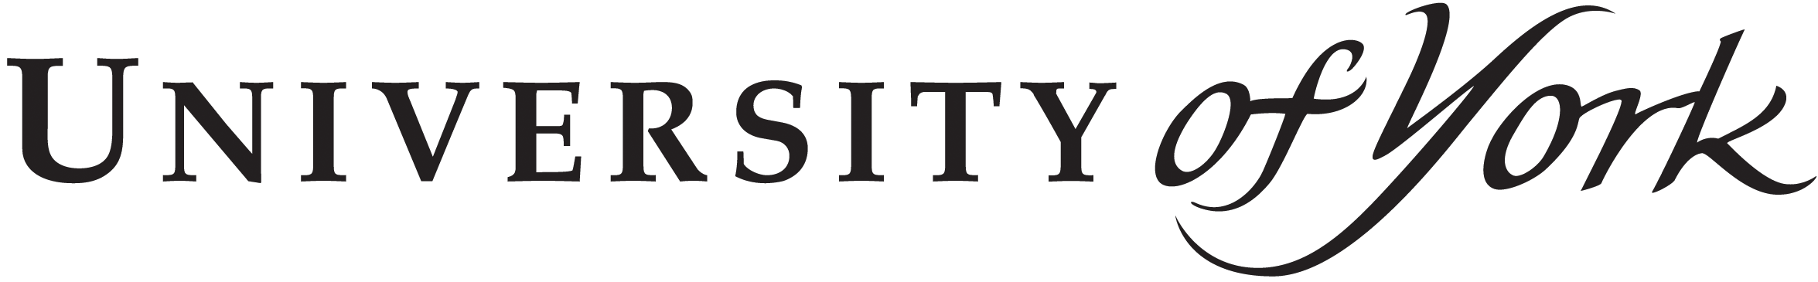
Department of
Language and
Linguistic Science
Heslington, York, YO10 5DD, UK
Phone number: 01904 32 2653
Email: dunstan.brown@york.ac.uk
INFORMATION SHEET
PLEASE KEEP THIS INFORMATION SHEET AND A SIGNED COPY OF THE CONSENT FORM FOR YOUR RECORDS
You are invited to take part in a research study. Before you decide whether to participate it is important for you to understand why the research is being done and what it will involve. Please take the time to read the following information carefully. If there is anything you do not understand, or if you want more information, please ask the researcher.
Title of study:
Matches & mismatches in nominal morphology and agreement: Learning from the acquisition of Eegimaa
Researcher:
Dunstan Brown
Marilyn Vihman
Serge Sagna

What is the research about?
The aim of this project is to study acquisition of linguistic structures in children aged 1 year 10 months to 4 years. Through this project our goal is to contribute to advances in scientific research on child language development.

Who is carrying out the research?
This research will be carried out by Dunstan Brown, Marilyn Vihman and Serge Sagna of the University of York (United Kingdom).
Why has your child been chosen to participate?
We are working with children aged 1 year 10 months to 4 years. Thus your child has been chosen because his or her age fits with the age group that interests us.
What does the study involve?
Our study is based on audio and video recordings of children in their natural environment. We are interested in children’s vocalisations when they begin speaking. The words and phrases that they produce will be recorded, transcribed and analysed scientifically in order to establish the cognitive processes underlying child language learning. The recordings will be carried out by Serge Sagna with the help of assistants, including David Sagna, Robertine Bassène et Honoré Bassène.

Doe my child have to participate?
You do not have to take part in the study. If you do decide to take part you will be given this information sheet to keep and will be asked to sign two copies of the consent form (one copy is for you to keep). If you decide to take part you will still be free to withdraw without giving a reason, even during the session itself. If you withdraw from the study, we will destroy your data and will not use it in any way.
What are the possible risks for my child of taking part?
This student includes no dangerous activities. Thus your child is running no risk whatsoever of participating in this research.
Are there any benefits to participating?
The results of our research will be used to produce pedagogical material for basic reading and arithmetic to help child Eegimaa speakers to adapt to the school programmes taught in languages they don’t know.
What will happen to the data I provide? The data you provide will be used alongside the data of other participants too. Your data will be stored securely in the University of York, Department of Language and Linguistic Science. Selected recordings and transcripts will be accessible to the wider public over the internet. We will seek your permission when we do this.
The recordings of your child might be retained after the end of this project for future scientific research on the language. The contents of these recordings are confidential and will be treated as such by this research team. Your child’s name, as well as any information about the child, will not be revealed in any publications. All this information will be stored in the archive of the University of York, in the Department of Language and Linguistic Science.
What about confidentiality?
The identity of your child will not be revealed. We will use pseudonyms in our publications and in the archiving of the findings to protect his or her identity.
Will I know the results?

Given that we are studying a group of children our conclusions will reveal only general tendencies in the group. We will therefore not be in a position to provide you with individual results about your child.

This study has been reviewed and approved by the Departmental Ethics Committee of the Department of Language and Linguistic Science at the University of York. If you have any questions regarding this, you can contact the chair of the L&LS Ethics Committee, Márton Sóskuthy, (email: marton.soskuthy@york.ac.uk; Tel: (01904) 324171).

If you have further questions regarding this study, please feel free to contact:
Researcher name
Serge Sagna
Department of Language and Linguistic Science
University of York, Heslington, York, YO10 5DD
tel: (0)1904 322475
email: serge.sagna@york.ac.uk

Supervisors name and details (if applicable)

