  

# Online ultrasound tongue imaging resources for phonetics, linguistics, speech therapy teaching and drama coaching

Information sheet for accent database participants

# About the project

The aim of our project is to create learning resources for students of phonetics, English language, speech therapy and drama studies. As part of the resources we will provide students and teachers with free online access to video and diagrams showing the movement of the tongue and the lips during speech, sampled from different varieties of English. Researchers and students may measure aspects of your speech and may include the results of analysis in specialist and general publications, and in lectures and talks to academic meetings or conferences. Examples (short movies or still images) drawn from the data as well as the results might be used in the preparation of grant applications to fund future research.

# Ultrasound

The project uses a standard medical ultrasound machine and two micro video cameras in tandem with a computer to record acoustics (speech) and articulation (tongue and lip movements) simultaneously. The ultrasound technique (used here to record the tongue movement) is not physically invasive. Ultrasound has been subject to rigorous safety assessments. At all levels of intensity used for diagnostic imaging, there are no known risks associated with ultrasound, and there are no specific dangers or safety requirements. We scan the throat and mouth using the same equipment as that used to scan pregnant women.

# The recording scenario

You will be asked to sit in a soundproofed studio in the Clinical Audiology, Speech and Language (CASL) Research Centre at Queen Margaret University, Edinburgh. You will need to wear a stabilising headset, which will ensure that the ultrasound probe does not move too much once it is correctly positioned (Figure 1 overleaf). The probe needs to rest firmly against the underside of the chin. The end of the ultrasound probe will be covered in sterile, water-based gel to avoid any gaps between the probe and the skin. You will be asked to swallow some water at the beginning of the recording so that we can obtain video of the outline of your palate. Two micro video cameras will be positioned to capture the front-view and profile images of your mouth while you speak. Your task will be to read words and sentences, or name pictures displayed on a computer screen. With your consent, we may also record your spontaneous speech, e.g. while you are having a conversation with the researcher.

The whole procedure should take under 50 minutes, about 30 minutes for the actual recording. You will be asked to fill out a consent form and provide demographic information such as your age and where you come from before the recording session begins.

# Anonymity

Your speaking voice, videos of your tongue movement, and, with your consent, zoomed-in videos of **lower portion of your face, focusing on the lips and mouth** (see Figure 2) will be made available online on our project website as a learning resource. Your name will not be available to users of the website; however, there is a possibility that someone who knows you might recognise your voice or mouth. **If you do not want your lip movement to be videoed, please let the researchers know and they will record only audio and tongue movement.** We may include on the website, general demographic information such as your age, your gender and the region you come from, e.g. eastern Scottish Central Belt. Where we have your permission, we will select short sections of your conversational speech to put on our website. We will select neutral phrases that do not contain incriminating or defamatory statements, or personal information that may be used to identify you. Your name and contact details and our copy of the consent form will be kept securely along with a record of an anonymous subject code which will be used to identify your data.

We may also measure aspects of your speech and include anonymised measurements, combined with data from other anonymised participants, in specialist and general publications and in lectures and talks to academic meetings or conferences.

# Withdrawing consent

You are free to withdraw from the study at any time. You can withdraw consent for the further storage, analysis or measurement of the raw data we have collected from your recordings at any stage, without giving a reason, and we will destroy all audio and video recordings of your speech and raw ultrasound data, so that no new analyses will be made from raw data. We will also delete any examples of raw audio and visual data from our websites, and cease their use in teaching if you ask, but we would not be able to guarantee that the video or audio had not been copied elsewhere. Please also note that any *published* analyses based on recordings made of your voice and tongue and lip movements cannot be withdrawn. Once the analyses are published, anonymised measurements which have been previously made, and combined with data from other anonymised participants, cannot be deleted from our data: scientific replicability means that such data (numerical and anonymous) will be retained.

If you would like to consult an independent person, who knows about this project but is not involved in it, you are welcome to contact Dr Rachel Smith, [Rachel.Smith@glasgow.ac.uk](mailto:Rachel.Smith@glasgow.ac.uk), Tel: 0141 330 5533 at English Language, 12 University Gardens, University of Glasgow, Glasgow, G12 8QQ.

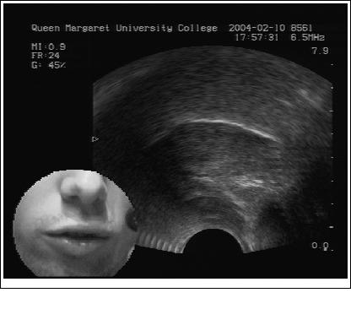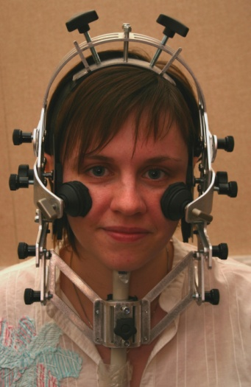

Figure 2: Sample ultrasound video frame showing tongue contour in white with an insert showing the lips.

Figure 1: Participant with the headset holding the ultrasound probe in place under the chin to ensure that the probe is stable.