**Study 5: Cue adolescents and adults to think about the future prior to delay discounting**

In this study we investigated whether adult and adolescent discounting of delayed rewards is affected by cueing them to think about the future. Participants were assigned to one of four conditions: episodic future thinking (EFT), episodic memory (EM), future thinking other (FT-other) and control. Participants completed a series of tasks administered online. In the interview task participants in the EFT, EM and FT-other produced cues that referred to events that were either likely to happen to them in the future (EFT), had happened to them in the past (EM) or were likely to happen to someone else in the future (FT-other). All participants then completed a delay discounting task, a task of future self-connectedness and a measure of future time perception. All tasks were cued for those not in the control condition.

**Participants*.*** The sample consisted of 248 participants in total; 126 adolescents (73males; Mage = 14 years, 1month; range = 12 years 1 month – 14 years 11 months) and 122 adults (*n* males; Mage = 34 years; range = 19 years – 69 years).

**Materials**

All tasks were created and administered using the Qualtrics software package.

***Interview task.*** Adolescent and adult participants were randomly assigned to one of four groups; an episodic future thinking group who generated information about personal events in the future (EFT-Self; *N* = 62; 31 adults); an episodic future thinking group who generated information about future events that would happen to someone other than themselves (FT-other; *N* = 58; 30 adults); an episodic memory group who generated information about past events (EM; *N* = 62; 30 adults); and a control group who did not engage in the interview task (Control; *N* = 66; 31 adults). Participants who took part in the task were asked to describe one particular event, in reference to a cued temporal period, and to summarise the event in a single cue sentence***[1]***. Five temporal windows were used in the study: *yesterday*/*tomorrow, a week ago/in one week, one month ago/in one month, six months ago/in six months, a year ago/a year from now*. Participants in the cued conditions generated event descriptions and cues in chronological order from nearest to present (*yesterday*/*tomorrow*) to furthest from present (*a year ago/a year from now*).

Participants were instructed to consider a number of rules when choosing an event to describe in the interview task; 1) The event should be one in which the participant would be/was there in person (EFT & EM) / The event should be one in which something will happen to someone other than the participant (FT-other); 2) The event should happen/have happened approximately around the given time period; 3) The event should happen/have happened at a specific time and in a specific placeand should take place/should have taken place over a period of time no longer than about half a day; 4) The event should have a positive valence.

Participants were instructed to spend a couple of minutes typing details of their chosen event in a large text box. They were then instructed to summarise their chosen event in a single sentence and type it into a smaller text box, which would be subsequently used as a cue during the remaining tasks. After describing each event, participants rated the ease with which the event came to mind (using the scale in Figure 1), the clarity of the event as they remembered / imagined it (using the scale in Figure 2) and the emotional valence of the event (using the scale in Figure 3). Interviews were coded for internal and external event details using the Autobiographical Interview Scoring Manual (Levine et al., 2002).

***Delay discounting task.*** A computerised temporal discounting task (e.g. Kwan et al., 2015) involved the presentation of a choice of an immediate monetary reward (which varied in value from £1 to £31), or a delayed reward, which was fixed at £32. The delayed reward was offered at five different delays, the same delays used in the interview task (tomorrow, one week, one month, six months and one year). Participants made their choice by selecting one of the two rewards on the screen. There were two practice trials for all participants. For participants in the three intervention conditions, there was a further practice trial, which demonstrated how for each trial in the main task, the relevant cue for a particular delay would appear on the screen before the immediate and delayed choices appeared on the screen, and that participants would be asked to think about this cue before making their decision. Participants in the control condition completed the task uncued.

The main task involved five experimental trials and one filler trial per each delay, giving a total of 30 trials per each participant. The trials were presented in the same pseudorandom order for all participants. On each trial in at a particular delay the value of the immediate reward was set as the mean value of two parameters H and L, i.e. immediate reward = (H + L) / 2. On the first trial H was set to £32 and L is set to 0 such the immediate reward was £16. If the participant chose the immediate reward then H was adjusted down to take the value of the immediate. If the participant chose the delayed reward then L was adjusted upwards to take the value of the immediate reward. After 5 trials the values of H and L converge such that the difference between them is £1. The midpoint between the final values of H and L is the participant’s indifference point for that delay. Unsystematic discounters were identified using a rule recommended by Johnson and Bickel (2008). For the remaining participants, their delay discounting data was analyzed in a two-step process. First, a number of discount functions were fitted to each participant’s data. These discount functions were selected based on their normative (exponential discount function) or putative descriptive status (hyperbolic and quasi-hyperbolic discount functions). A fourth ‘noise’ model, a y-intercept model based on the mean indifference point that captures insensitivity to variations in delay was also fitted. The best fitting model for each participant was determined on the basis of Bayesian Information Criterion scores (BIC; Schwarz, 1978). In step two we derived model-based Area Under the Curve (model AUC), by applying integral calculus to the fitted function (Gilroy & Hantula, 2018). Model AUC scores are scaled to the interval 0-1 by dividing them through by the total area of the graph.

***Future self-connectedness task.***This was based on the task used by McCue, McCormack, McElnay, Alto & Feeney (2019). In this task, participants were asked to compare the person they are in the present, to the person they will be 1 year in the future, and to rate (on a scale of 0–100) how similar they feel their present self and future self to be. In the two EFT and the EM conditions, participants were provided with the cue they generated for 1 year in the interview task. Participants were asked to think about this cue before they rated the similarity between their present and future self. The cue appeared on the screen for 10 seconds before the scale appeared. Participants in the control condition completed the task uncued. The scale was verbally and pictorially anchored at either end. The leftmost side of the scale depicted two non-overlapping circles and a ‘completely different’ label, whilst the rightmost side of the scale depicted two overlapping circles and an ‘exactly the same’ label. Participants who did not generate an appropriate cue for the 1 year delay had their data subsequently removed from this task; this led to the removal of 6% of the adolescent sample (*n* = 8) and 1% of the adult sample (*n* = 1).

***Subjective Temporal Distance Judgement task.*** This task (e.g. Kim & Zauberman; 2009, 2013) involved participants making judgements regarding the subjective distance of various time points in the future. Participants made estimates of the subjective distance of twelve different time-points in the same order (1 month, 10 months, 6 months, 3 months, 9 months, 8 months, 5 months, 11 months, 2 months, 4 months, 7 months and 1 year). Participants were instructed via a video demonstration that they were to think about how far away different times felt to them in the future. To do so, they had to position the cursor over a square on the screen, and then press, hold, and then release the mouse button, to indicate how far in the future each time felt. In the demonstration video, the experimenter instructed the participants on how to complete the task, using two practice trials (“I’m thinking about a short time from now, so I press and hold the left mouse button for a short bit.... Now I’m thinking about a long time from now, so I’ll press and hold the left mouse button for a long time”).

In the three intervention conditions, participants were given cues from the interview task which corresponded to three the five delays used in this task. For the 1 month, 2 month and 3 month trials, participants were shown the cue they had generated for the 1 month event in the interview task; for the 4, 5, 6, 7 and 8 month trials, participants were provided with the cue for the 6 month event from the interview task; finally, for the 9 month, 10 month, 11 month and 1 year trials, participants were shown their cue for the 1 year event from the interview task. Before participants made each subjective time estimate, they were asked to think about the cue that was presented to them on each particular trial. Participants in the control condition completed the task without the cues. For each trial, the duration of the mouse press for each subjective judgement (measured in milliseconds) was recorded.

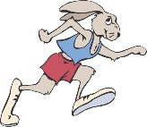

Figure 1. Scale used for speed judgements in the interview task.

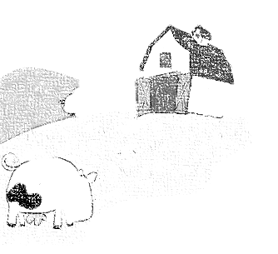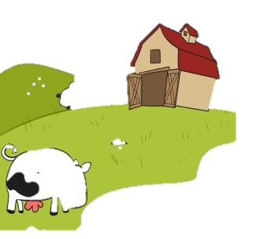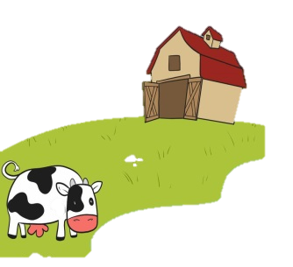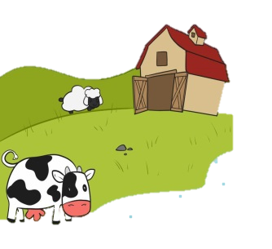

Figure 2. Scale used to elicit clarity judgements in the interview task.



Figure 3. Scale used to elicit emotion valence judgements in the interview task.

1. 140 adolescents originally completed the study, although 10% of the adolescent sample (*n* = 14) did not produce a minimum of four appropriate cues, and so their data was subsequently removed from the study