**Study 1: Delay of gratification and future thinking in 4-to-5-year-olds**

This study examined the relationship between delay of gratification and episodic future thinking skills in children aged 4-to-5-years. Children were administered a delay of gratification task, 3 tasks that measure aspects of their episodic future abilities and tests of their verbal and visuo-spatial IQ.

**Participants**

109 children aged 4-to-5-years participated in this study.

**Measures**

**Delay of Gratification**. The task began with a training session, the aim of which was to allow children to experience the length of the delay period in real time (this precaution was used because of the difficulty that young children have understanding temporal adverbs such as ‘tomorrow’). Children were introduced to a pictorial timeline representing a typical 24-hour cycle in their life (Figure 1). They were told that the pictures showed them lots of things that might happen to them later. Each picture on the timeline was described in turn (e.g., “Here you are in class now. After class it will be time to go home. This is you going home from school…”). Two boxes were placed at each end of the 24 hr timeline, one at the left end labelled ‘now’ and one at the right end labelled ‘next day’. Children were introduced to two puppets and were told that they were going to play a game in which they would get to choose some treats. They were told that sometimes the puppets could get the treats that they chose straight away (experimenter pointed to the ‘now’ box at the left end of the timeline) and sometimes they would have to wait a while to get their treat (pointed to the ‘next day’ box at the right end of the timeline). The experimenter then told children that each puppet was going to be given a choice between one marble right now (pointed to the ‘now’ box) or two marbles when he came back in a day’s time (pointed to the ‘next day’ box). The first puppet selected the immediate reward and the second puppet selected the delayed reward.

Data collection was conducted in a second session on the day following the demonstration. The experimenter and participant sat facing one another across a desk. The 24 hr timeline was positioned in front of the child and the two boxes for the delay of gratification task were positioned at either end of the timeline. The experimenter reintroduced the two puppets from the previous day’s demonstration. Children were reminded of each puppet’s choice and observed the puppet who had chosen to delay receiving two marbles. Each participant underwent four DoG trials: sweets (1 versus 5), stickers (1 versus 5), 2-minute long cartoon clips (1 versus 3) and stationery sets (plain versus princess or superhero). Trial order was counterbalanced across participants. Each trial began with the experimenter introducing the rewards, and then saying “I’m going to give you a choice, you can either get [low value reward] right now (placed low value reward in ‘now box’) or you can wait and get [high value reward] when I come back again in a day’s time (placed high value reward in ‘next day’ box). If you take this [low value reward] you get it right now but you won’t get the [high value reward]. If you want to wait for the [high value reward] you don’t get anything right now but you will get the [high value reward] when I come back again in a day’s time.” Two check questions were then presented: the experimenter pointed to each box in turn and asked children to indicate when they would get the reward in that box should they select it. If they responded incorrectly the experimenter corrected them and then repeated the DoG instructions and check questions. When children answered the check questions correctly they were asked the test question: “What would you like to do? Point to the box which shows me which you would like.” This procedure was repeated for each trial. On each trial children were given a score of 1 for selecting the delayed reward and 0 for selecting the immediate reward.

**Tool saving task.**The tool saving task was a modified version of that used by Russell et al. (2010). It employed a specially constructed table-like apparatus, on top of which three different games could be played (yielding three trials). The table top was made of wood and its dimensions were 740 mm x 540 mm; it was 600 mm in height. On each of three trials participants played a game on one side of the table with an apparatus that required the use of a specific tool. During the course of each game, participants were brought to the other side of the table and shown a slightly different version of the game for which the tool they were currently using was demonstrated to be ineffectual. The experimenter then demonstrated that a different tool was required to play the game on this side of the table. After completing the original game participants were then led away from the table such that it was out of view and told that in a day’s time they would play the type of game they had just played again but on the other side of the table. They were then presented with three tools: the one demonstrated to work for tomorrow’s version of the game, the tool they had used in today’s game, and a novel distractor tool. They were asked to place one tool in a bag for use the next day.

For the first game (doors), two doors were positioned side by side across the centre of the table. The doors were locked and faced opposite directions. There were three colored keys of different shapes: one which opened door 1, one which opened door 2, and a distractor key. A ramp ran from the foot of each door to the table end and a series of small rectangular tiles could be placed on the ramp to make a path. Children built a path up a ramp to allow a character to open door 1 with the appropriate key.

The second game (fishing) was played on four small circular ‘ponds’ two at each end of the table. Two of the ponds at one end of the table contained small metal fish and two at the other end of the table contained small Velcro fish. There were three fishing rods, one with a magnet ‘bait’ for catching metal fish, one with a Velcro ‘bait’ for catching the Velcro fish and a third distractor fishing rod with a red plastic ‘bait’. Children fished for metal fish using the magnet bait rod.

The third game (slide) was played using a trough placed in the centre of the table top and two slides, one wide and one narrow, positioned back to back on the trough. At the base of the wide slide were a number of large wooden balls while at the base of the narrow slide there were a number of small wooden balls. A large rake with a wide grooved head could be used to push the large wooden balls up the wide slide and deposit them in the trough; this head did not fit in the narrow slide. A small rake could be used to push the small wooden balls up the narrow slide. A third rake with a non-functional head acted as a distractor item. Children used the large rake to push the large wooden balls up the wide slide.

The three games were played in the same order (doors, fishing and slide) for all participants. Given the 1 in 3 odds of selecting the target item by chance on any given trial a conservative criterion for passing the task was imposed: children selecting the target item on all three trials were scored 1, failure to select the target item on 1, 2 or 3 of the trials was scored 0.

**EFT interview*.*** This task was similar to that used by Quon and Atance (2010). Children were asked to think in turn about three events: the next time they would be “going to a play park”, “visiting a friend’s house”, and “going to a birthday party”. The experimenter said: “I want you to think about the next time you will be [event]. You might be [event] very soon. Can you tell me about the next time you will be [event]?” If participants gave no response they were provided a prompt: “let’s think really hard about the next time you will be [event]. What can you tell me about the next time you will be [event]?” Once children gave a response they were provided with an open-ended follow-up prompt, “can you tell me any more about [event]?” Participants were then asked five specific follow-up questions: “Can you tell me more about what will happen?”; “Can you tell me more about who will be there?”; “Can you tell me more about where this will be?”; “Can you tell me more about when this will be?” and “Can you tell me more about how you will feel?” Children then rated the clarity of the event they were thinking about using a 5-point clarity scale (Figure 2). The scale depicted five pictures of the same mountain in decreasing pixilation from ‘not clear at all’ (scored 1) through to ‘very clear’ (scored 5) with ‘not very clear’, ‘a little bit clear’ and ‘fairly clear’ as the intermediate descriptions.

The experimenter introduced the clarity scale and described each point on the scale. Participants were told, “When we think about things that will happen we often have a picture of it in our head. When you thought about [event], how clear did the picture of it in your head look? Point to the picture that shows how clear [event] looked to you in your head.” Interviews were recorded on digital recorders and transcribed for the purpose of analysis. As many children produced little detail to the open questions, analysis was based on participant’s responses to both the open and follow-up questions. These responses were scored for episodicity using a scale described by Coughlin et al. (2014). Scores ranged from 0-4, where 4 indicated a description of a specific event isolated in space and time and accompanied by contextual detail, such as imagery or emotions. Transcribed responses were scored blind to the participant’s age or gender. Clarity ratings were scored on a scale from 1-5 with 5 indicating very clear. The mean episodicity and clarity scores across the three events were calculated.

**Picture Book task.**On each of three trials participants were presented with a photograph of a scene (farm, seaside, and mountain in that order) on a laptop and were asked to identify the scene. Participants were then told, “Let’s pretend you are going to the farm / seaside / mountain. It’s time to get ready to go. Which of these do you need to bring with you?” The experimenter presented photographs of three further items to participants, labelling them in turn. A toothbrush (distractor), pair of boots (target) and picture of a pig (semantic associate) for the farm scene; a bunch of flowers (distractor), starfish (semantic associate) and towel (target) for the seaside scene; a coat (target), a rock (semantic associate) and a balloon (distractor) for the mountain scene (see figure 3a-3c). After children made their choice they were asked why the chose the object they did. Responses were transcribed and coded as either as containing no future oriented talk (score of 0), as containing future oriented talk but no reference to a future state / need (score of 1) or as containing future oriented talk that referred to a future state / need (score of 2).

**Time Estimation task*.*** The time estimation task employed a 10-point scale depicting a long straight path with a cartoon character standing at the beginning, looking along the path (Figure 4). There were 10 red markings evenly spaced along the length of the path. The experimenter introduced the 10-point time estimation scale and told children that they would use this picture to show how far away some things are that will happen to them in the future. Participants were given the following instructions: “things that will happen soon are near to us (pointed to the start of the scale), things that will happen a long time from now are far from us (pointed to end of scale) and things that will happen in an in-between amount of time are not near and not far from us (pointed to middle of scale). You are going to use this picture to show me how far away some things are that are going to happen. I want you to think about when I come back again in a day’s time (pointed to end of 24-hour timeline). We will play some more games when I come back again in a day’s time. How far away does that feel? Use your pencil to circle the red bit on the picture that shows how far away it feels.”

**IQ*.*** The Block Design and Vocabulary subtests of the Wechsler Preschool and Primary Scale of Intelligence, Fourth Edition (WPPSI-IV; Wechsler, 2012) were administered.

Figure 1. Pictorial 24-hour timeline.

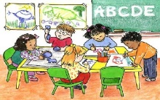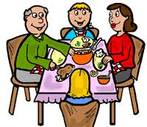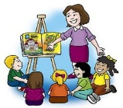

Figure 2. Pictorial scale used for clarity ratings



Figure 3a. Picture book task ‘farm trial’ stimuli.

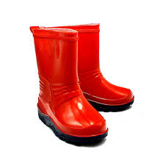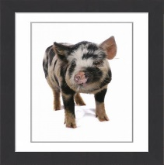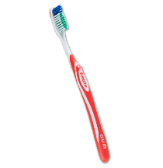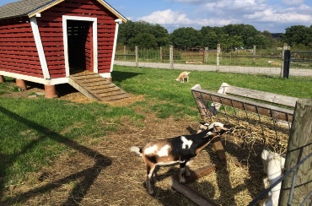

Figure 3b. Picture book task ‘seaside trial’ stimuli.

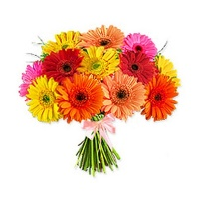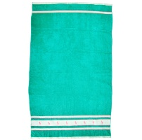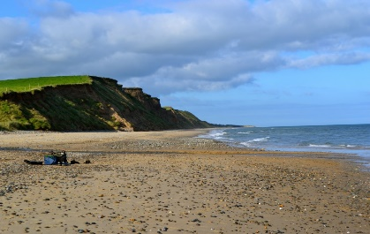

Figure 3c. Picture book task ‘mountain trial’ stimuli.

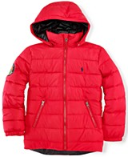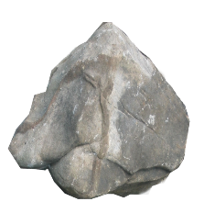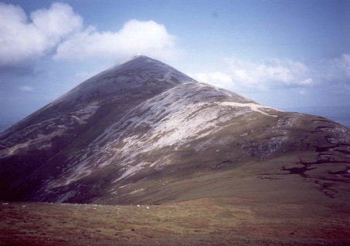

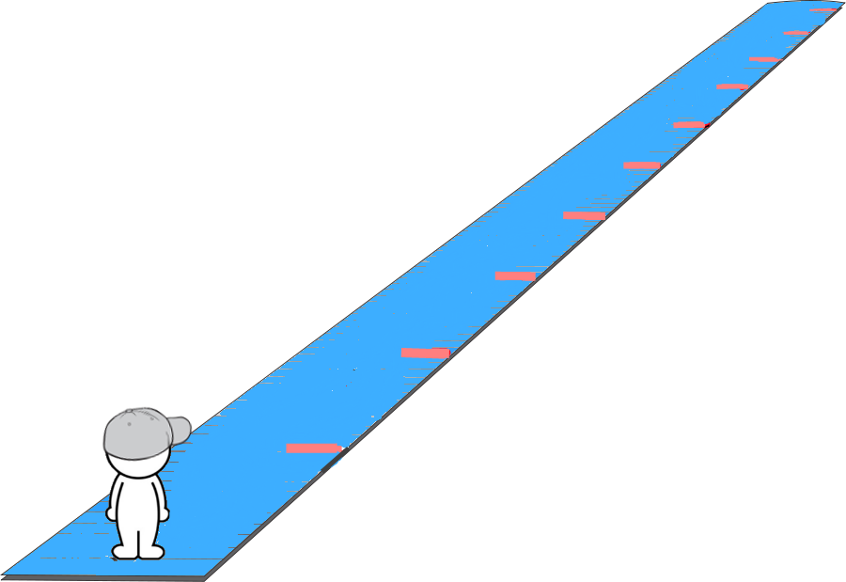

Figure 4. Time estimation task scale.