SURVEY INSTRUMENT DESIGN

Introduction
After the target firms are determined in the sampling process, the survey instrument should be designed and polished for the purpose of (a) depicting the general characteristics of private firms in the Guangdong Province, (b) calibrating the growth of these firms, and (c) exploring the causality between multiple attributes and firm growth. In such a manner, an administered questionnaire is adopted and consists of eight sections:
- background
- firm operation
- human resource management
- finance
- technology and innovation
- enterprise culture
- competition
- macro environment

These sections provide the primary data from private firms in the region (section 1 and 2), and factors that may foster the firm growth (Section 1-8), such as entrepreneurship, resources, environment and other contingency factors, and so forth.
Besides, six show cards are incorporated to demonstrate six different types of cost structures in response to question 2.5 in the firm operation section. Brief explanation under each diagram on the show card is given out and interviewers are depended on for further clarification, where appropriate.
The administered questionnaire contains 106 numbered questions in qualitative and quantitative forms. Whilst the former type enables respondents to provide the qualitative information in his/her particular situation, the latter supplies the numerical data in a relatively more objective way. It is hoped that maximum information can be gathered by employing the evidence in both qualitative and quantitative nature. Besides, questions are organized in a variety of formats, such as blank-filling, multiple-choices (which allows either a single answer or multiple answers), and true or false.
Targeting Chinese privately owned firms, the original questionnaire adopted a version in simplified Chinese. As all interviewees are native Chinese and not necessarily English speaking, questionnaires in a Chinese version are believed to be indispensable. Responses to questions are also written down in Chinese, which ensures that nothing would be missed out during the interview, at least in terms of language.

General Information

Basic Information
The objective of this section of the survey instrument is to characterize Chinese private firms in the sample and in their market environment in general. It involves discovering firm age, industry, major business and products, market extent and market share, considered seriatim.
Basic registry information on the business license issued by the State Administration for Industry and Commerce (SAIC) is selectively acquired, such as start-up capital (question 1.1), registered firm ownership (question 1.3) and major business extent (question 1.4). Start-up capital is the initial capital in cash that must be deposited in a bank account for the registry with the SAIC, which is commonly viewed as a proof of financial capability. Firm ownership is rather sophisticated regarding the mixed central-planned and market-driven economy in China (question 1.3). The extent of major business describes the specific business a firm is allowed to operate, which helps to identify the CNSIC code. Major products are also listed by owner-managers to highlight the principal market in which these firms function (question 1.4.1).
Firm market environment is primarily explored by the geographical extent of major markets (question 1.4.2) and the market share in owner-managers’ knowledge (question 1.4.3), as shown in Table 4.6 below. The former is divided up to five levels: worldwide, Asia, mainland China, Guangdong Province and the capital city Guangzhou (or local). The latter adopted a percent range to probe the market shares perceived by owner-managers.

Table 4.6 Survey Instrument – Questions 1.4.2-1.4.3
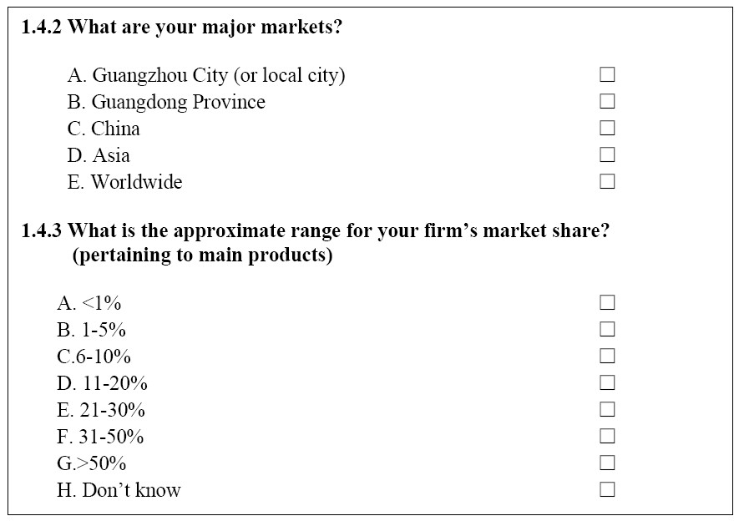

Firm Operation
The function of this subsection was to examine more aspects of firm operation, such as planning, pricing, costs, sales and marketing, and customer services, etc.
A wide range of planning options are available in question 2.12 for respondents to choose in terms of sales, new product, organizational structure, cost, finance, and strategic development, and so on. If additional plans are not included in this list, respondents are encouraged to supplement in the open-ended question 2.12.1. Moreover, the most difficult plan among all is required to report in question 2.12.2.
Interviewees are asked to choose their pricing methods among options (question 2.1), such as “the cost of each product plus a fixed percentage of profit”, “the cost of each product plus a flexible percentage of profit”, “the highest price the market can bear”, “mainly depend on big clients to quote”, “set by government agencies”, “regulated by law”, or “others”. Furthermore, it is concerned why firms alter their product prices in question 2.3 with possible reasons like “the start of new production cycle”, “the beginning of new tax year”, “the change of cost structure”, “the shift of market demand”, “new government regulations”, “competitors’ price change”, etc. Concerning the price elasticity of demand, the questions 2.7.1/2.7.2 investigate the impact of decrease/increase in price on firm’s sales and the question 2.8 further asks whether there is an elbow room in which firm’s price change will exert no influence on sales and in what percent if the answer is affirmative.
While there is no consensus on the form of a standard cost curve in theory, interviewees are offered six show cards from A to F (see table 4.7 as an example below), on which six types of possible cost structures are drawn to approximate the real situation of firms. A brief note is provided under each diagram and further demotic explanation is available from interviewers (the author and his trained co-fieldworkers), where appropriate. In terms of firm growth, it is interesting to know whether extra cost brought about by expansion should be also taken into account by firm owner/managers (question 2.6).
In the modern management literature, marketing is of crucial significance. Market surveys and advertisements are addressed in the questionnaire (question 2.6, 2.6.1, 2.10). The respondents are asked whether their firms take any form of market survey and to what purpose (e.g. “to know the customers’ sensitivity to price change”, “to know how customers think of the new products”, “to know better about the competitors”, “to know the market trend”, etc). The interviewees are also surveyed about the medium of advertisement their firms employed in the past, such as television, newspaper, radio station, magazines/journals, Internet, outdoor ads, and so on.

Table 4.7 Cost Structure on Show Card 2.5 (D)
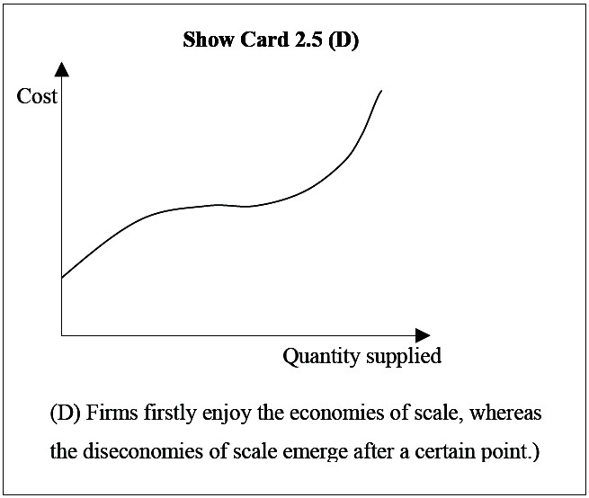
With the growing customer-oriented business culture (Reid, 1993, 2007), after-sales service can be the pivotal strategy to win over new clients as well as to keep old ones. Considering customer service (question 2.11), firms are divided into those with such a specific department, those that plan to build up one, those that depend on different departments to deal with different clients’ problems, or those that believe no need in their particular industry.

Entrepreneurship
Owner-managers are provided the options above for selecting their own definition of the entrepreneur and an open-ended blank to supplement if needed (question 6.1-6.1.1), as shown in Table 4.8 as follows.

Table 4.8 Entrepreneur
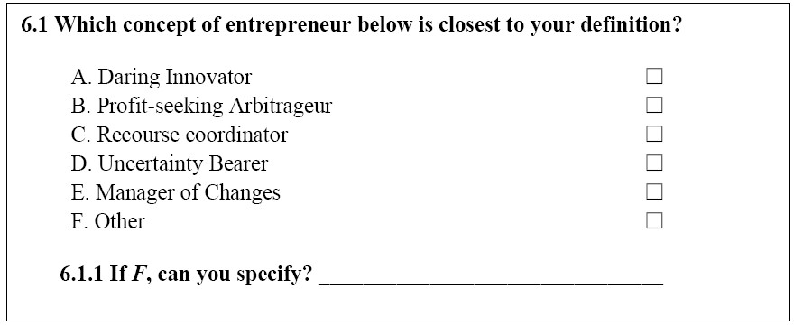

Innovativeness
R&D emphasis is embodied in question 5.1 by asking whether this particular firm has its own R&D department already, or is planning to establish one, or feels no use according to the industry in which the firm operated. Question 5.2 further gives out six possible range of R&D expenditure in 2003, whereas question 5.9.2 offers the percent range of total profit that would be used for R&D in the future. New products are investigated for the year of 2003 in question 5.5, which offers six options including none, 1-3, 4-6, 7-10, 10-20, and above 20. It is believed that the more spending on R&D activities, the higher ratio of R&D expenditure to profit, the more new products, the higher degree of innovativeness a firm will present.

Risk-taking
The degree of risk-taking is measured either by financial risks or by business risks. While the former usually refers to financial gearing/leverage (debt/equity ratio) and dividend-earnings ratio, the latter relates to the standard deviation of returns over years. Due to the Chinese owner-managers’ desire for secrecy about sensitive earnings/returns figure, this survey instrument employs the financial gearing/leverage (question 4.5) as the proxy of risk-taking.

Proactiveness and Competitive Aggressiveness
Proactiveness is (a) a strong tendency to be successfully ahead of competitors in product novelty and innovation speed, (b) a precise growth, innovation and development orientation, and (c) a rather rigid “undo-the-competitors” posture. The item of competitive aggressiveness is added as (d) an aggressive attitude and the readiness to compete intensely.
The factor (a) is reflected in question 5.4, which demonstrates the technological level of the firm in question (highly advanced, moderately advanced, moderate, less advanced, laggard). The factor (b) can be answered by whether a firm has developed its concrete strategic development plan (question 2.12) or by whether this firm has a growth ambition of being listed on the stock exchange (Shenzhen Second Board for SMEs, question 4.8). The factor (c) can be illustrated in question 7.7 by asking whether a firm would defend if attacked. Along with question 7.7.1, the same question (7.7) also reveals the number of defensive strategies to “undo the competitors” and thus shows the extent of competitive aggressiveness.

Autonomy
In Chinese language, autonomy means “self-control” without interference from outside. The AQ2004 examines the firm’s authority styles and top management election methods. Question 3.3 tests whether an entrepreneur is willing to decentralize his/her authority to subordinates who are capable and trustworthy, whereas question 3.6 probes whether the director of the board and CEO are the same person and if not, how the CEO is elected (question 3.6.1). Thereby, the tight control of firms by management itself can be viewed as displaying a relatively high degree of autonomy.

Resources: Tangible and Intangible
The success of firms largely relied on the resources a firm owned and controlled. In AQ2004, resources are addressed in tangible and intangible types. While the tangible relates to tangible assets, the intangible refers to human capital, corporate culture, intellectual property, reputation, knowledge (technological), network, and the relevant capabilities to achieve and maintain these resources.

Tangible Assets
The following proxies are used of tangible assets: (a) register start-up capital (question 1.1); (b) the sources of start-up capital (question 4.4); (c) the number of the extra investments after establishment (question 4.7-4.7.1).

Human Capital
Human capital is operationalized in question 3.2 as the percent of employees with college diplomas or higher academic degrees. Compensation level compared with the average industry level in question 3.1 is also believed to be able to reflect the quality of human capital, presuming that higher salaries would attract more qualified employees. The quality of human resource is hoped to be enhanced by regular or irregular training programmes (question 3.4). And the employees of high calibre can be maintained by a wide range of incentive schemes, such as end-of-year bonus, better welfare plans, training opportunities, promotion, paid holidays/sick leave, and stock options, and so on (question 3.8). This survey questions whether the directors of the board attend any training programmes and seminars, and how often, if the answer is positive (question 6.6).

Corporate Culture
Enterprise culture in this particular sample is embodied as (a) the development of specific company codes and regulations in question 6.4 (too perfectly developed to change, or update regularly, or only change when problems arise), (b) company tenet/slogan in question 6.5 and 6.5.1 (see table 4.3.4 below), (c) the frequency of company social activities in question 6.7 (once a year, several times a year, once in a few years, never), (d) working place conditions in question 6.3 (cleanness, comfort, convenience and safety, etc), (e) the source of enterprise culture in question 6.2 (entrepreneur’s personal charisma, personality and virtues), and so forth.

Table 4.9 Company Tenet/Slogan
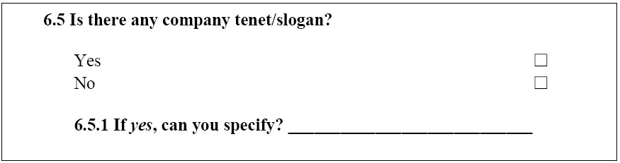

Intellectual Property
The interviewees are asked whether their companies have any patent in product or technology and how many if the answer is affirmative (question 5.9 and 5.9.1).

Reputation
Bearing in mind the smallness of most firms in this sample, reputation here is examined by the comparative market positioning in question 7.5 and 7.5.1 (respondents’ own products would be inferior, or equivalent, or superior compared with competitors’). Besides, with the emergence of internet, the fact is that having a company website is certainly reputable for Chinese owner-managers (question 5.6).

Technology
In this survey instrument, the technology concept is conveyed by both self-perceived and legitimately certified technological level, R&D and the application of information technology. The self-perceived technological level compared with the average industry (question 5.4) can be a reasonable indicator of technology as owner-managers know their technical know-how the best. Interviewees are also asked if their firms have passed ISO9000 or any other international standard set by International Organization for Standardization (ISO). The options available to choose (e.g. we already have, we are in the process of application, we have no such plan) can not only answer the primary enquiry, but can also reflect the general attitude of owner-managers towards technology.
In terms of R&D, Grant’s ratio of R&D staff to total employment can be calculated from the number of R&D staff (question 5.1.1) divided by the current employment (question 1.2), provided there is an established R&D department. Besides, the number of R&D staff who have a master’s degree or above (question 5.1.1.1) shows the quality and potential of innovation. Furthermore, nowadays a marked feature of technology can be the application of information technology, such as the use of email and internet meetings for communication (question 5.8 and 5.8.1), the use of internet for “e-commerce” (question 5.7), the type and number of computer software installed (question 5.11 and 5.11.1), the application of management information system (MIS) as well as the major difficulty in use (question 5.12 and 5.12.1).

Network
It is commonly felt that “guan xi” in China exerts vital influence on firms’ superior performance operationalized this network concept as the number of technological relations and the amount of technology transfer.
In the AQ2004, the major contacts for advice when entrepreneurs start their firms can reflect the range of connections to certain extent (question 4.1), whereas the major sources of innovation reveal the size of technological relations (question 5.3). Moreover, other external relations can be embodied by the type and number of suppliers (question 7.1 and 7.2) and the financial connections with family/friends, banks, venture capital, other firms, and stock market, and so on (question 4.4).

Contingency Factors

Structure
The development of firms’ codes and regulations is examined in question 6.4 and the specific question (3.7) about recruitment also indirectly reveals the design of firm functions. The type of control is scrutinised by questioning the willingness of entrepreneurs to delegate their authority (question 3.3). The variety of communication methods can also be conducive to judge whether the structure is rigid or flexible (question 5.8).

Environment
Government support can be financial sponsorship (question 8.1), such as
“Township Enterprise Development Fund”, “SME credit guarantee scheme”, “High-tech SME Innovation Fund”, etc. It also can be nurturing policies (question 8.2), like high-tech companies income tax reduction policy, technology innovation subsidy policy, subsidy for the acquisition of equipments made-in-China, township enterprise income tax reduction, income tax reduction by creating jobs for urban laid-offs, export drawback, income tax reduction for university factories and welfare factories, small firm income tax reduction, and income tax reduction for firms in minority regions, and so on. It is felt that the more diverse the support received from government, the more benevolent the business environment is.
With regard to serious social problems “San Luan” in China since 1990s, interviewees evaluate the current business environment after the renovation action in 1999 (question 8.3). The “San Luan” problem may be perceived to be eradicated, or alleviated, or unchanged, or even worse. Further, owner-managers express the expectation of assistance from government SME support centre, local SME credit guarantee agencies, industry associations, professional consulting companies, venture capital, and so forth (question 8.4). The establishment and development of any organization that entrepreneurs want the most would be supposed to improve the business environment the greatest.
The last-named dimension of environment is location, which is operationalized as “population level and GDP growth per capital”, “employment growth”, and “accessibility”. This survey instrument does not cover such data but the year book of Guangdong Province can supply the reference.
Not fully, but however partially, the percent range of market share (question 1.4.2) and the market extent (question 1.4.3) can hint at the degree of the market concentration. However, the core of the question is to examine the competitive environment by owner-managers’ self-perception in the industry (question 7.3). The industry can be at the emerging stage, or just about to mature, or may have already been saturated, or about to shrink as an sunset industry, or rather may have encountered the reconstruction and even insolvency. The ease of entry into the industry can be very hard, slightly hard, slightly easy, or very easy (question 7.3.1), and the ease of the exit from the industry can also be calibrated on a four-point scale (question 7.3.2). Moreover, owner-managers can illustrate the self-perceived obstacles that will prevent potential competitors from entering the market (question 7.4), such as narrow product range, high average total cost, high start-up capital needs, the lack of raw material suppliers, government restriction, existing fierce competition, the shortage of experienced employees, and so forth. The number and nature of these barriers would have a marked bearing on the market concentration, and would eventually influence the firm growth.

Strategy
A firm would cooperate or even acquire competitors in the case of excess demand (question 2.2). A price hike/cut would occur according to rivals’ pricing (question 2.3). It may be equally likely for a firm to compete as well as collaborate in terms of innovation (question 5.3). Apart from other entry barriers, potential rivals would be also kept out if existing firms have already competed intensely (question 7.4). The superiority over substitutes can guarantee an advantageous position in the market (question 7.5.1). And the precise definition of buyers (question 7.1) not only shows the firm’s customer orientation, but also forebodes the likelihood of winning over new buyers while maintaining the old ones. Lastly, the bargaining power between the firm and its suppliers can directly affect growth and performance (question 7.2.1). In order to strengthen the core competence, firms can choose cost leadership, or product differentiation, or both (question 7.6).
In spite of the competitive strategy, firms are supposed to defend when attacked. For example, the firms may defend by increasing the entry barriers, or by declarations to retaliate, or by keeping low key to avoid possible attack, or rather by taking no defensive actions (question 7.7).

Simplified Chinese is widely used in Mainland China now, while traditional Chinese is used mainly in Hong Kong, Macau and Taiwan.
“San Luan” means three unjustified arbitrary government behaviours: fine, levy and raise money.

