**Bagda/Shrimp (*Penaeus Monodon*):**

**Disease name with Symptoms:**

1. **No problems**
2. **White spot disease (WSSV):**
3. White spot mainly on carapace and sometimes a little bit on whole body surface
4. Aggregation at the gher edge
5. Sluggish movement
6. Less appetite
7. Reduced preening activities erratic or spinning swimming near to gher surface
8. Reddish discoloration on whole body surface 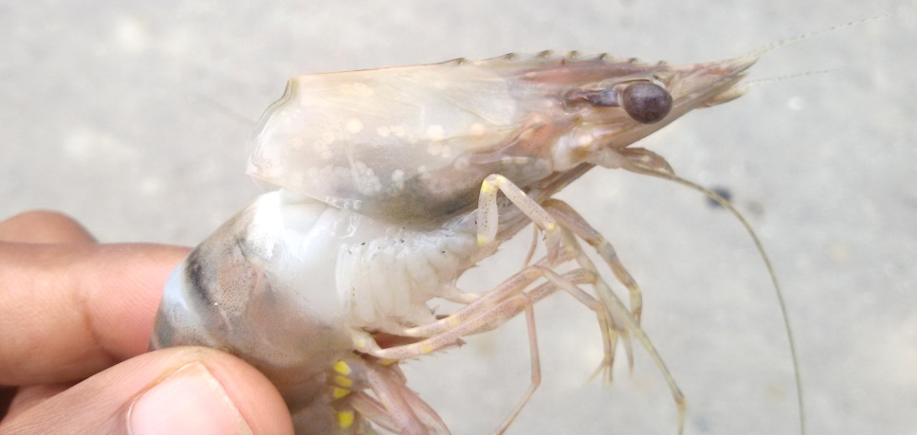

Photo credit: Siddhwartha Kumar Basak

1. **Yellow head disease:**
2. Yellowish discoloration under carapace or hepatopancrease
3. Aggregation at the gher edge
4. Erratic swimming near the surface
5. Sluggish movement

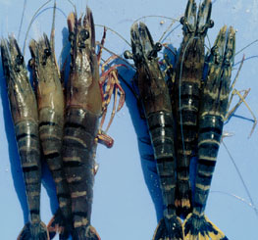

Picture Source: www.google.com

1. **Spongy disease:**
2. Spongy body
3. Sluggish movement
4. Opaque and whitish muscle.
5. **Cotton shrimp:**
6. Muscle of affected shrimps appears cooked.
7. Sluggish movement

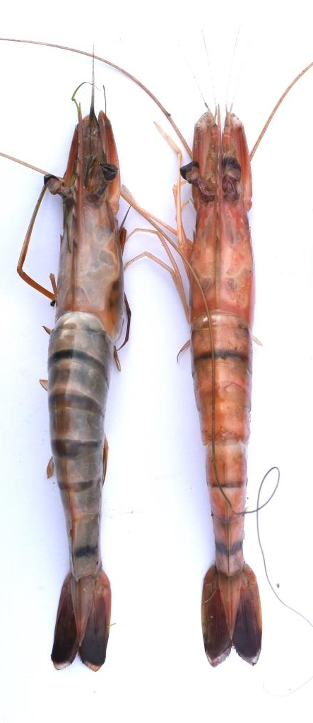

Photo credit: Siddhwartha Kumar Basak

1. **Fungus disease:**
2. Blue or greenish discoloration on body surface
3. Lethargic
4. Less appetite
5. Aggregation near the gher bottom
6. **Black spot (vibriosis):**
7. Black or brown cuticular lesions, opacity of musculature, tough and black branching filaments (up to 2 mm wide) in connective tissue of tail segments,
8. Black lymphoid (Oka) organ, melanization of appendage tips.

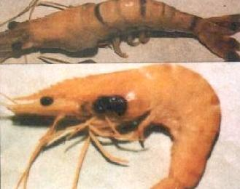

Picture Source: www.google.com

1. **Acute Hepatopancreatic Necrosis Syndrome (AHPNS):**
2. Hepatopancreas pale to white
3. Guts with no or irregular contents
4. Stomach empty
5. Lethargy, low speed in growth rate, spiral swimming
6. Moribund shrimp sink to the bottom 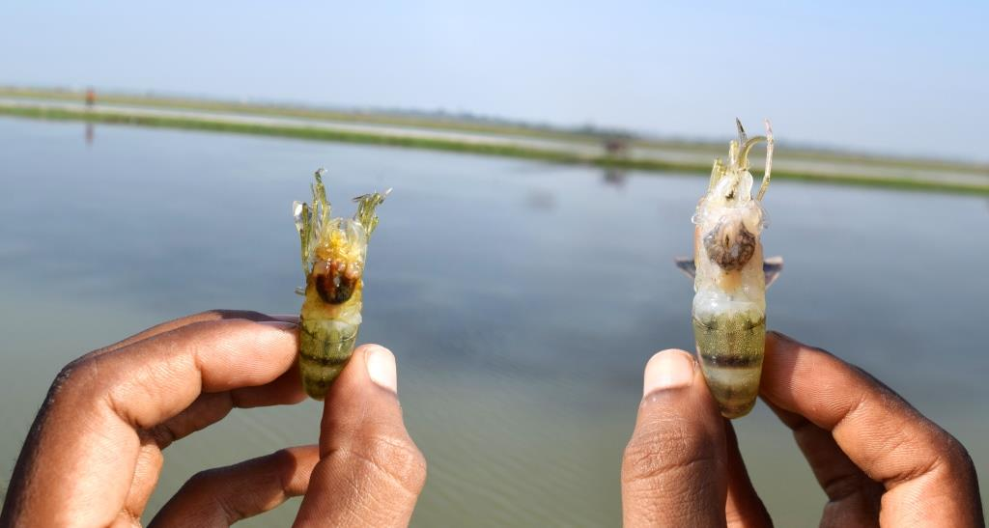

Photo credit: Siddhwartha Kumar Basak

1. **Soft shell disease:**
2. Shell is thin and soft for several weeks,
3. Shell surface is often dark, rough and wrinkled, and affected shrimps are weak.
4. The disease must not be confused with the condition of newly molted shrimps, which have clean, smooth, and soft shells that harden within 1-2 days
5. Lethargic
6. Slow growth rate

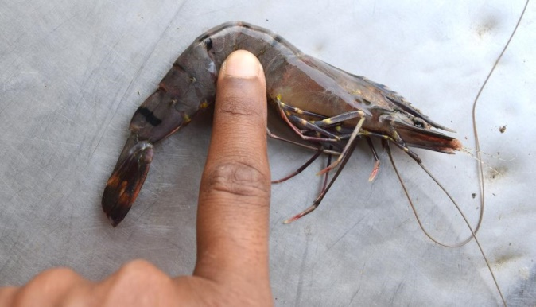

Photo credit: Siddhwartha Kumar Basak

1. **Sudden Die off:**
2. Sudden died of shrimp under water or bottom
3. Less appetite
4. Aggregation near the gher bottom
5. Affected shrimp appears reddish discoloration on whole body surface

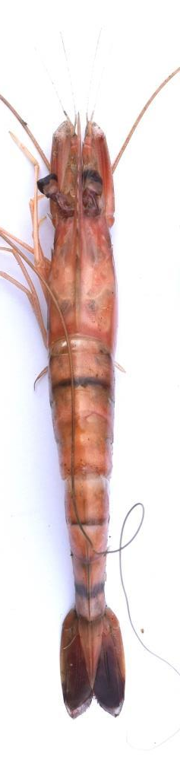

Photo credit: Siddhwartha Kumar Basak

1. **Others Disease:**

**Golda/Prawn (Macrobrachium rosenbergii):**

**Disease name with Symptoms:**

1. **No problems**
2. **Black gill syndrome:**
3. Black spot on gill under carapace
4. Bacterial erosion on carapace and gill
5. Sluggish movement
6. Less appetite
7. Damage gill

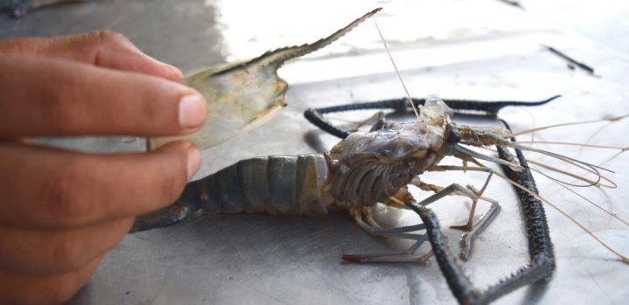

Photo credit: Siddhwartha Kumar Basak

1. **Accumulation of fluid in head:**
2. Water accumulation under carapace
3. Discoloration of hepatopancrease and stomach
4. Sluggish movement
5. Erratic swimming at gher edge
6. Less appetite

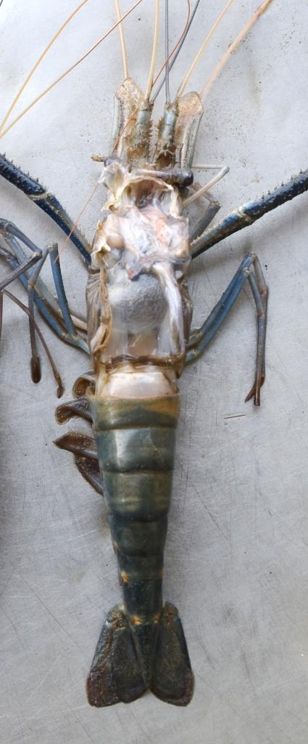

Photo credit: Siddhwartha Kumar Basak

1. **Broken antenna/antennae & rostrum:**
2. Antenna and rostrum broken and erosion
3. Whole body surface is rough and wrinkled and affected shrimps are weak.
4. Lethargic
5. Less appetite
6. Aggregation at the gher edge.

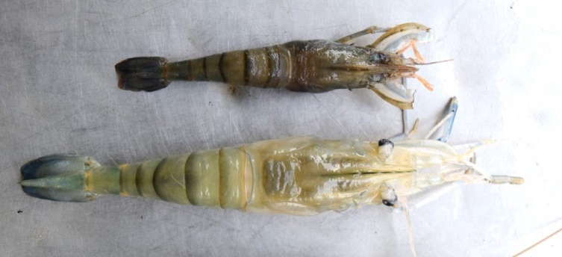

Photo credit: Siddhwartha Kumar Basak

1. **Soft shell disease:**
2. Shell is thin and persistently soft
3. Shell is rough and wrinkled
4. Lethargic
5. Slow growth rate
6. **Others Disease:**