HEADLINES Shared identity manipulation was successful (IG>OG), but there was a significant difference between outgroup conditions. There were no other significant main effects. Shared identity did not predict the urge to yawn, self-reported yawns during video, self-reported yawns after video. If outliers are removed, controlling for EmoCon, shared identity significantly predicted self-reported yawns during the video, *B* = 0.14, *SE* = 0.07, *t* = 2.01, *p* = .046. If outliers removed, there was a significant moderated mediation with urge to yawn (Condition – [ID] – Shared ID – self-reported yawns during video).

Procedure

This was an online study that aimed to replicate a previous study (archived as ‘The role of social identity on the contagious transmission of yawning: study 2’) but without videoing participant responses so that they would not be affected by the fact that they were under observation. Participants were recruited though Prolific and invited to take part in a study on how people experience and express emotions. This experiment was a 2x2 design (participant gender: male vs female; actor gender: male vs female) in which male and female participants began by answering questions in part 1 of a 2-part questionnaire, hosted on Qualtrics, which was designed to make the participant’s gender salient. They then watched a 2 min 7 s video of either a male or female actor yawning. They were then redirected to complete the second part of the questionnaire which included questions about the degree to which they identified with the actor in the video, the behaviour and emotions of the actor, their tendency to experience emotional contagion measured using the Emotional Contagion Scale (Doherty, 1997) and self-reported urges to yawn.

*Main Effects*

* There was a significant main effect of IG/OG on Shared Identity, *F*(1, 211) = 20.04, *p* < .001, partial eta-sq = .09
* There wereno other significant effects of IG/OG on strength of identification, urge to yawn, self-reported yawning during and after video

*Shared identity as predictor of DVs*

* Shared identity does not predict urge to yawn, yawns during video (SR), yawns after video (SR).
* If outliers removed, controlling for EmoCon, shared identity significantly predicted self-reported yawns during the video, *B* = 0.14, *SE* = 0.07, *t* = 2.01, *p* = .046.

*Indirect effects*

There was a non-significant moderated serial mediation (PROCESS model 83) of Self-report yawns DURING Video (similarly ns for yawning AFTER the video):

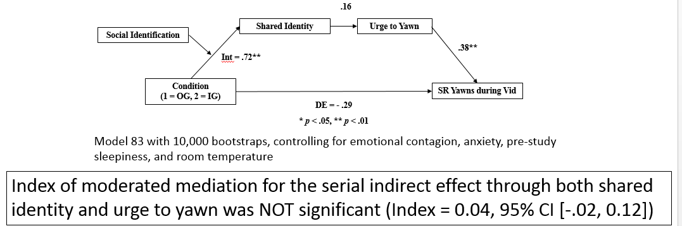 *NOTE: Index of mod-med is actually greater than in the webcam study which wasn’t significant either for self-reported yawns.*

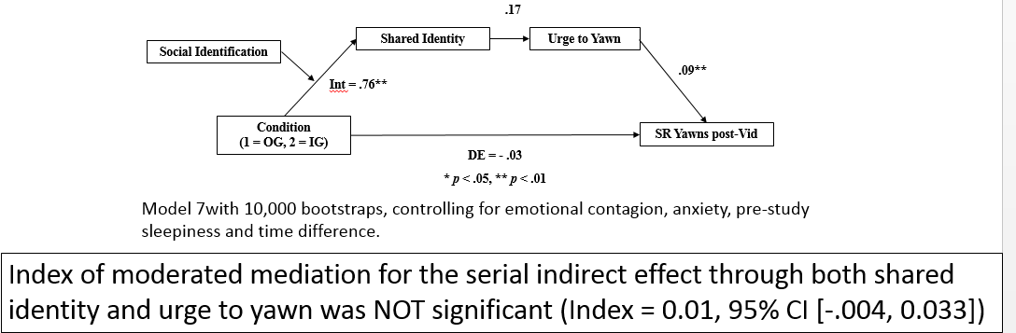

If outliers removed, significant moderated mediation without urge to yawn (Condition – [ID] – Shared ID – Yawns during video (SR)) (Model 7):

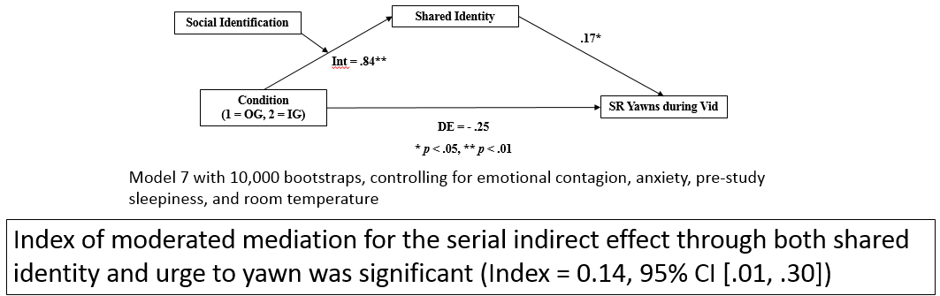

This is not significant for self-reported yawns *after* the video:

Doherty, R. W. (1997). The Emotional contagion scale: A measure of individual differences. Journal of Nonverbal Behavior, 21, pp. 131-154.