Scratch 1
Design
Sussex students at various locations on campus were recruited and were asked to read an information sheet (Info_consent_ethics_scratch1, Appendices A-C), sign a consent form (Info_consent_ethics_scratch1, Appendix D) and complete a questionnaire tailored to each condition (Ingroup, Outgroup and Control. See Questionnaires_scratch1, Appendices A-C). For ingroup participants, they were told that the study was designed to investigate the extent to which scratching behaviour was contagious and how it differed between students and non-students, firstly by looking at students. In the outgroup condition, participants were told that the study focussed on the difference between Sussex students and Brighton students, firstly by looking at Sussex students. To remain consistent, participants in the control condition were also told that the subjects in the video were Brighton students, but that the study was interested in the effects of itch contagion alone. Therefore, participants remained as naïve as possible to the true purpose of the study, with no knowledge of the social identity manipulation. The identity of participants in the ingroup (as a student) and outgroup (as a Sussex student) conditions were made salient in part 1 of the questionnaire while participants in the control condition, for whom identity was not made relevant, were not given part 1 of the questionnaire.
Next, participants were shown a 1min 40s video of two ‘Brighton students’ scratching, one male and one female. The participants were filmed whilst watching the video using Photo Booth, which they had consented to. The video was identical across conditions and consisted of a headless man or woman continuously scratching, from Holle et al. (2012), in 10 blocks of 10 seconds, 5 of each gender. In each block a different body part was scratched. Videos were 1 minute 40 seconds long. Webcam recording stopped at end of video.

Example stills from the video
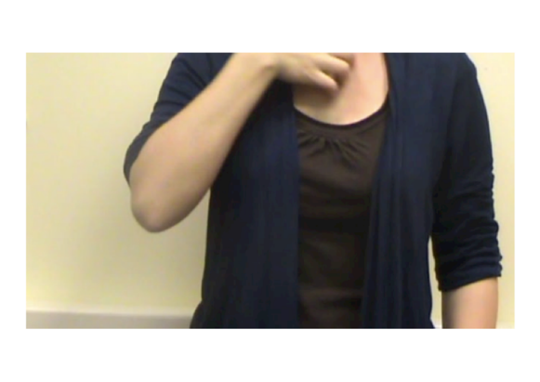 | 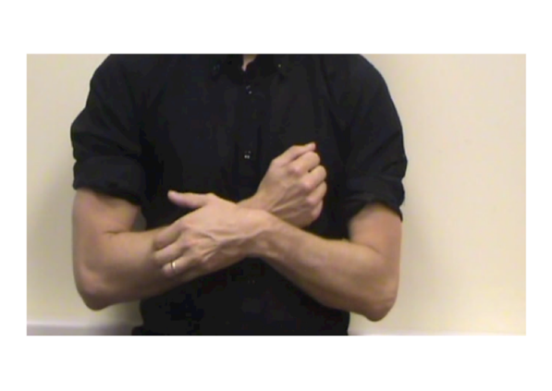

- 1x3 (Ingroup/Outgroup/undefined) [participant identity salience = student/Sussex/no information].
- N=37 (following removal of 5 participants who failed the comprehension check)
- Participants told in advance study was on ‘contagious itching’.
- Videos were coded to measure scratches performed on different parts of the body.
Main effects of condition
- Self-relevance (IG>OG and Control) [non-parametric] (Manipulation check)
- Self-reported itchiness (IG>OG and Control)
- Number of scratches (no significant difference, but IG>OG) [non-parametric] (looks underpowered)
- Time to first scratch, no significant difference
- Total itch duration - no significant difference
- Scratch duration per scratch - no significant difference
Self-relevance and scratching DVs
Self-relevance significantly predicted self-report itchiness (p<.05), although the duration of scratching and number of scratches was only marginally significant (p=.09).
Indirect effects
- Mediation (dichotomised condition into IG/OG)
  - Condition (IG/OG) – Self-relevance (med) – Self-reported itchiness
    - Non-sig
  - Condition (IG/OG) – Self-relevance (med) – Observed scratches
    - Non-sig

- Moderation (dichotomised condition into IG/OG)
  - Condition (IG/OG) – Strength of ID (mod) – Self-reported itchiness
    - Non-sig
  - Condition (IG/OG) – Strength of ID (mod) – Observed scratches
    - Non-sig

Holle, H., Warne, K., Seth, A. K., Critchley, H. D., & Ward, J. (2012). Neural basis of contagious itch and why some people are more prone to it. Proceedings of the National Academy of Sciences, 109(48), 19816-19821. Doi: 10.1073/pnas.1216160109

