# Appendix 1: Experimental Materials

## Recruitment and Experimental Materials

### Recruitment Emails

Feele lab - Experiment BX

Dear #first name# #last name#,

We would like to invite you to participate in an experiment at the Feele lab SC0.29 in the University of Exeter Business School.

As part of the research, we are interested in emotions associated with people’s reactions.  In order to capture emotions, we would like to collect heart rate and skin conductance data (by placing sensors on two of your fingers and your ear lobe) and facial expressions using a web camera.  The sensors are not painful in any way and the facial recognition software will not record any images of your face.

Participation in our experiments is entirely voluntary.

***

IMPORTANT:

Please check your availability BEFORE you book because

YOU ARE NOT ALLOWED TO CANCEL A BOOKING!

We ask that you bring your UniCard AND A PEN to the session.

***

The sessions are scheduled for the following times:

#sessionlist#

If you want to participate, you can book a session by clicking on the

following link:

#link#

(If you cannot click on the link, copy it to the clipboard by selecting it, right-clicking and choosing Copy, and then paste it into the address line in your browser by right-clicking there and choosing Paste.)

### Instruction Sets

##### Screen 1: Overview Instructions

Welcome to today's experiment.

This is an experiment on economic decision making, there are no right or wrong choices.

You will be paid £3 for showing up today and may have the opportunity to earn more money through your choices in the experiment. You will see a pile of three one pound coins in the bottom left hand corner of your desk. This money represents your show up fee, it is now yours. Please remember to take it with you at the end of the experiment. It is important that your actions in this experiment are anonymous to the experimental team. As the university finance department require that payments are recorded you will still be required to sign for your payment, but this record will only be passed to the finance department and the experimentalists will have no access to these records. Please bear in mind that the experiment is designed to be anonymous and do not use information that would indicate your identity, such as your name or student id, in any of your responses or the materials in the laboratory other than the PARTICIPANT PAYMENT RECEIPT form.

The experiment will be 5 parts, we will introduce the other parts later in the session. There are six tasks to complete in this first section. Any decisions made in this first part of the experiment are hypothetical. The instructions for each of the tasks will be given as part of the task. You will be given eight minutes to complete the first part of the experiment. **The task you are on will automatically submit itself if you run out of time.**

If you have any questions, please raise your hand and the experimenter will come to you to address them.

Once the recording of the instructions has finished playing, please click the Next button below.

##### Screen 2: Instructions Part 2, Part 3, Part 4 and Part 5

Thank you for completing **Part 1** of the experiment. We will now cover the instructions for the remainder of the experiment.

In **Part 2** of the experiment, you will be asked a series of questions about yourself. Please answer these based on how you really are, rather than how you would like to be. You will be given four minutes to complete the questionnaire. **The questionnaire will automatically submit itself if you run out of time**. The experiment will be paused at the end of **Part 2** until everyone has completed the questions.

Section Specific to Video Treatments:

In **Part 3** of the experiment you will be asked to watch a video on the computer.

Section Specific to PASAT Treatments:

In **Part 3** of the experiment you will be asked to undertake another computer based task. This task will offer you an opportunity to increase your payment for the experiment. Any payment arising from this part of the experiment will be processed separately. Further details will be given in the instructions for this part of the experiment.

Once everyone has completed **Part 3** of the experiment, we will progress to the final section, **Part 4**.

In **Part 4** of the experiment, you will be asked to complete a survey. The experiment will again be paused until everyone has completed the questionnaire in **Part 4** of the experiment.

Once everyone has completed **Part 4** of the experiment, we will progress to the final section, **Part 5**.

In the final part of the experiment you will have the opportunity to increase your payment for today's experiment in a task requiring you to check a passage of text for spelling mistakes. You will be presented with a piece of text on the computer containing twenty spelling mistakes. Your task is to highlight as many as possible.

The computer will allow 90 seconds for you to try and highlight 20 items.

You will earn 50 pence for each of the items you identify.

Once the task is over you should count how many items you have identified and work out your payment for this part of the experiment. You have been provided on the desk with a small white envelope containing 20 fifty pence pieces. You should remove the appropriate number of fifty pence pieces from the envelope for your payment. You should then seal any remaining coins in the small white envelope.

You should then write the value of your payment PLUS the £3 for your show up fee on your PARTICIPANT PAYMENT RECEIPT form. For example, if you identify 11 items, you should remove 11 fifty pence pieces corresponding to £5.50 to add to your £3 show up fee. You should then complete the PARTICIPANT PAYMENT RECEIPT form for the total of £8.50. Could you then please carefully remove the shimmer sensor equipment, and place it on your desk. You may then leave, placing the white envelope containing any remaining coins in the white box and the PARTICIPANT PAYMENT RECEIPT form face down in the brown box provided by the door to the laboratory as you exit

Once the recording of the instructions has finished playing, please click the Next button below.

##### Screen 3: Part 3 Instructions

Part 3 of the experiment is a serial addition test.

In this task you will see a series of single digit numbers presented once every three seconds. You should observe the first two numbers, add them up and indicate your answer. When you see the next number, add it to the one presented right before it. Continue to add the next number you see to each previous one.

Remember, you are not being asked to keep a running total, but rather the sum of the last two numbers that were presented.

You will receive a point for each correct response given and your goal is to gain as many points as you can.

For example, if the first two numbers were 5 and 7, you would respond 12. If the next number were 3, you would respond 10. Then if the next number were 2, you would respond 5.

On each trial you will see a set of buttons with numbers on them. Respond by clicking on the button with the mouse that corresponds to the sum.

Note: do not respond to the first trial because there is no preceding number to add to it.

There will be two rounds, the first will serve as a practice. In the practice round you will receive a point for each correct response given and your goal is to gain as many points as you can. In the second round, you will have the opportunity to earn an extra bonus payment for today's experiment.

This is a challenging task. If you lose your place just jump right back it, observe two numbers in a row and add them up and keep going.

Please watch the video below for a demonstration of the task and then click Next to begin.

##### Screen 4: Part 3 - Serial Addition Test Practice Complete

Thank you for completing the practice.

In the next round you have the opportunity to earn a bonus payment for today's experiment.

You will start with **£2.00** and may earn **10** pence for each question you answer correctly. Incorrect answers or answers not submitted before the value is updated will, however, reduce your payment by **20** pence. If your total falls to zero, you cannot loose any more money, but can still aim to increase your payment with further correct answers.

Please note that any payment for this part of the experiment will be processed separately. The experimenters will bring any payments due for this part of the experiment to your desk after the task.

The task will last for 120 seconds. You should note that the length of time the current value is displayed for will decrease as the experiment progresses.

You should not refresh the page once it has loaded.

Remember, if you **lose** your place just jump right back it, observe two numbers in a row and add them up and keep going.

Once the recording of the instructions has finished playing, please click the Next button below.

##### Screen 5: Part 4 Instructions

In Part 4 you will be asked to complete a short survey. You will be asked to indicate how you feel in relation to a series of emotions on a scale that runs from "Not at all" to "Very much".

Once the recording of the instructions has finished playing, please click the Next button below.

##### Screen 6: Part 5 - Spelling Error Task

In the final part of the experiment, you will be presented with a piece of text on the computer containing twenty spelling mistakes. Your task is to highlight as many items as possible in ninety seconds. You will earn 50 pence for each of the items you identify.

You should use the mouse and the left mouse button to highlight words in the text. Sections selected will be indicated with a yellow back-ground. You can de-select text by double clicking on it. The clear button will clear all highlighted text.

You should not refresh the page once it has loaded. If you refresh the page the experiment will be terminated and any bonus payment will be lost.

Once the task has finished, you should count how many items you have identified and work out your payment for this part of the experiment. You should remove the appropriate number of fifty pence pieces from the white envelope on the desk for your payment. Once you have removed your coins, you should tear off the strip on the envelope and seal in any remaining coins. You should then complete the PARTICIPANT PAYMENT RECEIPT form for the correct amount, including your £3 show-up fee. You should then then remove your headphones and carefully remove the shimmer equipment and place it on the desk. You may then leave, and as you do, please take the white envelope and the PARTICIPANT PAYMENT RECEIPT form with you. Then as you exit the laboratory, please place the white envelope containing any remaining coins in the white box by the door and the PARTICIPANT PAYMENT RECEIPT face down in the brown box as you exit.

You can test the highlight functionality that will be used in the task by highlighting words or parts of words in this sentence.

Once the recording of the instructions has finished and you are ready to begin the task, please click on the Next button below to start.

## Experimental Setup

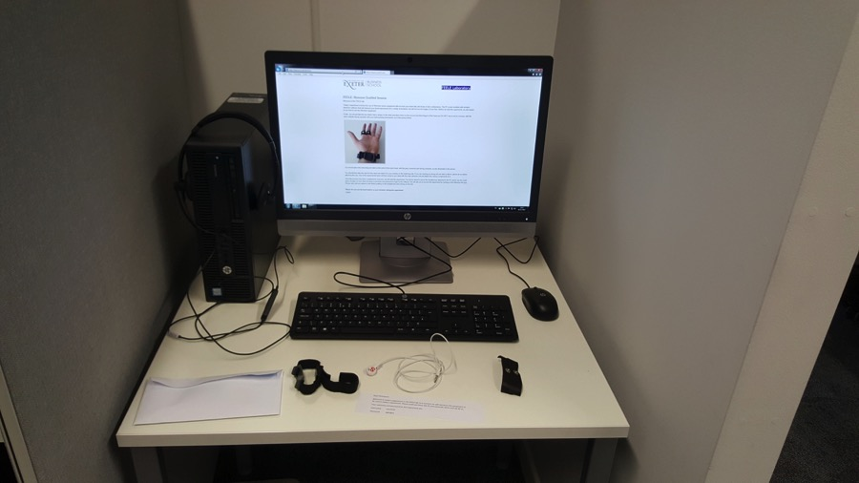

Figure A1: Initial booth setup for Opportunity treatment

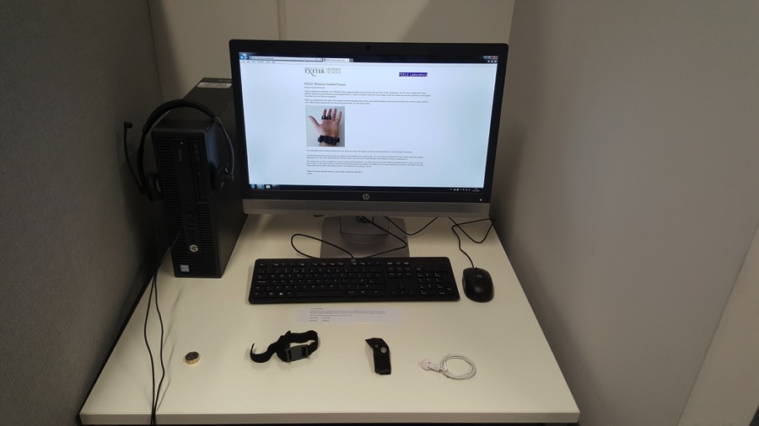

Figure A2: Initial booth setup for Mark treatment

## Screenshots

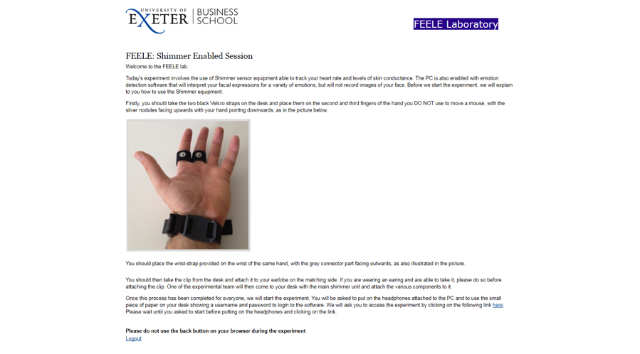

Figure A3: Initial screen explaining the way to set up Shimmer equipment.

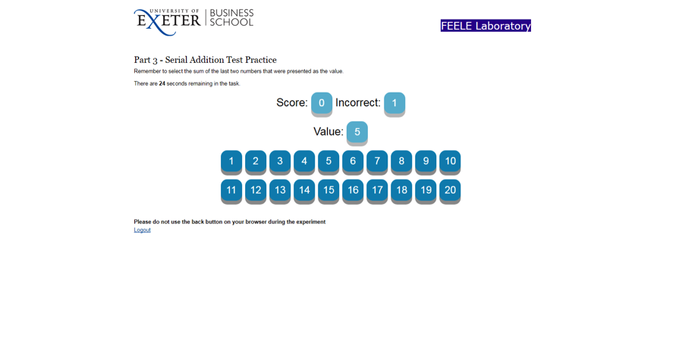

Figure A4: PASAT Practice task

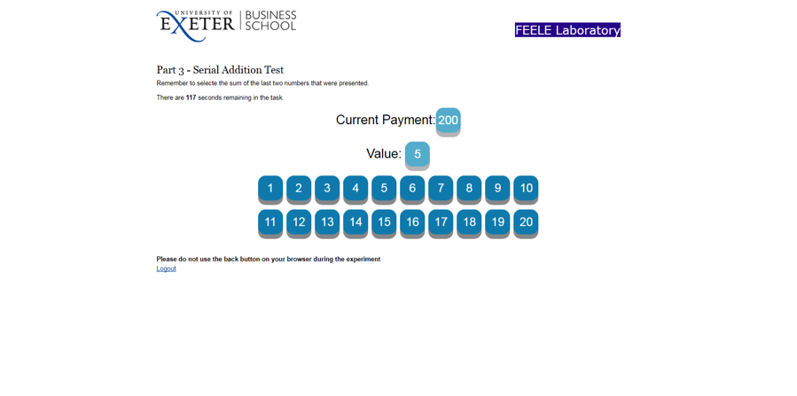

Figure A5: PASAT Main task

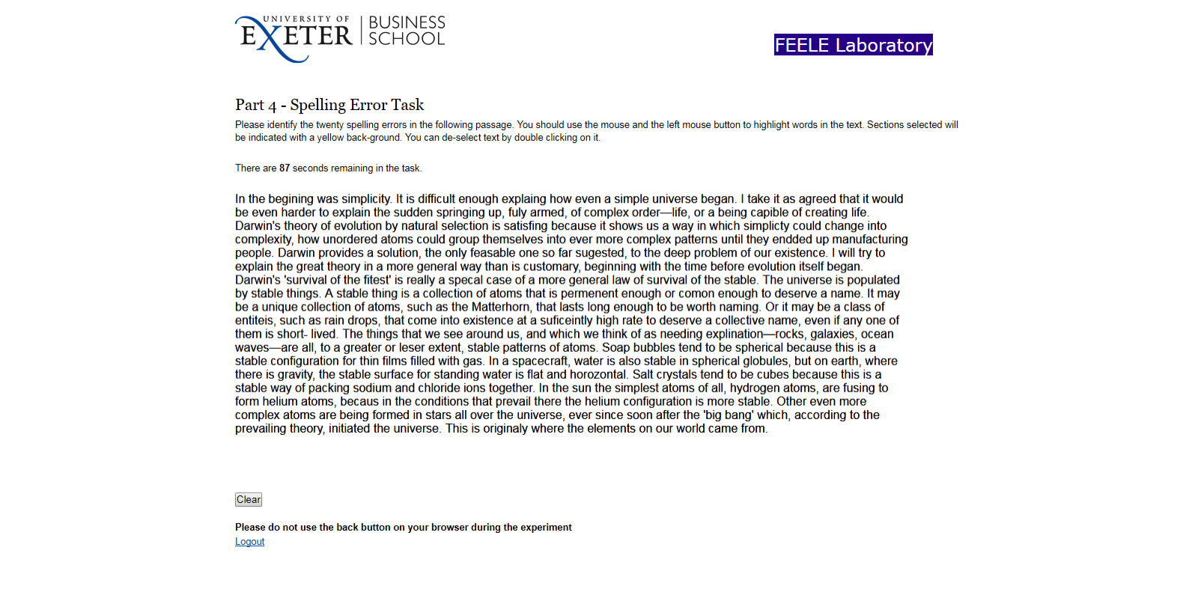

Figure A6: Main task