Testing protocol

Participants are to complete all tasks in their native language
- UK nationals – English
- Chinese short-term – Mandarin/Cantonese (simplified/traditional characters)
- Chinese long-term – Mandarin/Cantonese (simplified/traditional characters)
- Chinese nationals – Mandarin/Cantonese (simplified/traditional characters)
- UK short-term – English
- UK long-term – English

NB – for migrants, trips are allowed as long as they are within the ‘Eastern’ (short-/long-term UK) or ‘Western’ (short-/long-term China) world. Count overall time, must be below 2 month/above 2 year total.

Order of testing
- Read information sheet and sign consent form
- Demographic information
  - Two demographic information sheets – one to be completed by participant, the other to be completed by the tester
- Cognitive bias tasks
- WASI (In the UK we have been using the WASI, not the WASI-II)
- Questionnaires
- Payment and receipt

Cognitive bias tasks

Tasks will be completed in one of two fixed pseudo-random orders (either column 1 or column 2, alternate across Ps within each group):

4 – Pictoral probe | 2 – Word probe
6 – SRT | 1 – Word Stroop
3 – Pictoral Stroop | 5 – SST
5 – SST | 3 – Picture Stroop
1 – Word Stroop | 6 – SRT
2 – Word probe | 4 – Picture probe

Order will be counterbalanced within each group (UK, short-term Chinese, long-term Chinese; Chinese, short-term UK, long-term UK)

Probe tasks (pictorial and word):

- Participants use the computer and Serial Response (SR) box to complete the task
- Participants instructed to sit up to the table with their chair tucked in as far as possible so that their stomach is touching the table. Participants should sit up straight and not slump (it is best to make sure that participants can tuck in their chair without the disturbance of table legs).
- The viewing distance from the computer should be 85cm, assuming that the on screen distance between fixation cross and letter target is 9 cm. If on screen display gives a different distance (which may happen with different machines) then the viewing distance should be recalculated using formula:
Tan [visual angle] = [distance between fixation cross and letter target, in cm]/[distance from eyes to screen, in cm]
The visual angle should be 6° across participants for all testing.
  - Before the participant arrives, measure 85 cm on the table in front of where the participant will be sat. When completing pictorial and word probe tasks, line the back of the computer up with the mark on the table and ensure that the participant has their stomach against the table.
- Participants should put their index fingers on the SR box, over the 1 and the 5
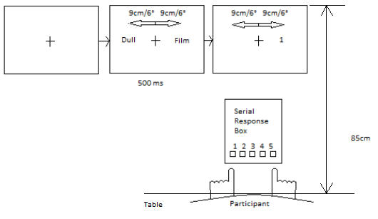

- Participants should read and follow the instructions on screen
- If the tester can see that the participant is consistently making mistakes in the practice trials then they should explain the task to them again (do not re-start the programme).

SRT

- Participants use the computer to complete the task
- In the UK we are using two separate computers, each with either simplified or traditional characters stuck on to the keys as shown in the picture below.
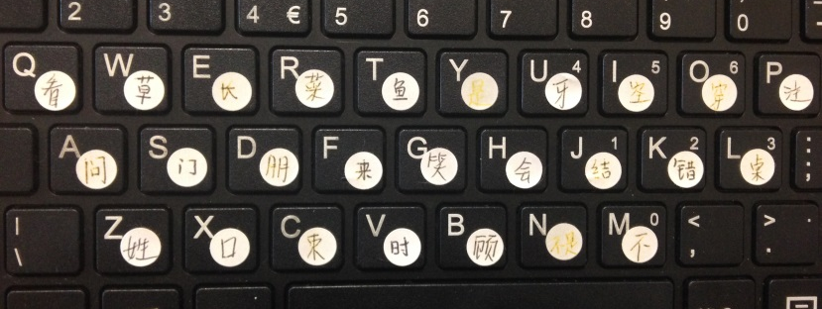
- When completing the task in Chinese, the participant must read out loud all the characters to ensure encoding of the characters which are available to fill the gaps and their location on the keyboard.
- Participants should read and follow the instructions on screen
- If the participant is confused, then explain the task to them (do not re-start the programme).

Stroop (pictorial and word)

- Participants use the computer to complete the task. Testers will also need a pen, Stroop recording sheets (NB – pictorial and word Stroop recording sheets are different as pictorial Stroop has 20 trials, word Stroop has 16 trials) and stopwatch.
- Participants should read and follow the instructions on screen
- Testers should be in charge of pressing the spacebar to move the task on to the subsequent trials.
- Participants will vocalise the colour of the picture/word in their native language (English, Mandarin, Cantonese)
- Testers should start the stopwatch at the first vocalisation and stop the stopwatch at the last vocalisation.
- Testers should then record the time in the appropriate place on the Stroop recording sheets and whether the participant made any errors (Y/N)

- After the session, it will be necessary to input the data. In the UK we have been adding this data to the Participant Tracker file under a separate tab
- As the order of presentation of the different emotion types (word – social threat, physical threat, positive, neutral; pictorial – happy, sad, angry, fear, neutral) is randomised, it is necessary to make a note of the trial type before inputting the data.
- Open the E-Data Aid file for each individual participant and scroll across to the column named 'pictype'. There it has the order of the trials. Record these down on the recording sheet.

- You can then enter the data under the appropriate column in the Participant Tracker file

SST

- Participants use pen and paper to complete this task. Testers will also need a stopwatch, the 6-digit number and instructions for learning the number.
- In the UK, all participants are being explained the task and completing the practice items in English. This is due to experimenter limitation.
- Follow the researcher instructions for the task. Read the explanation of the task out to the participant and then ask them to complete the practice items.
- Go through their answers with them, giving the alternate disambiguation, or the corrected version if they unscramble the sentence incorrectly (e.g. forming a question rather than a statement/their answer is grammatically incorrect/they only use 4 words rather than 5/they use all the words etc)
- Follow the researcher instructions for the task to help the participant learn the 6-digit number (hold the digit up for 5 seconds, hide for 10, then ask the number). They must repeat the number correctly twice consecutively in order to begin the sentences.
  - The number should be learnt in the language of testing (i.e. in the UK, even though we are explaining how to learn the number in English, Chinese participants will repeat the number back to us in Mandarin/Cantonese)
  - The order of the number should be counterbalanced within groups (UK, short-term Chinese, long-term Chinese, Chinese, short-term UK, long-term UK). Follow the counterbalancing on the Participant Tracker file under the SST tab
- When the participant has successfully repeated the number back twice consecutively begin the sentences
- Use the stopwatch to time the length of time taken by the participant to complete the sentences. The time limit is 3 min; if a participant reaches 3 minutes then stop them.
- Ask the participant to fill in the 6 digit number at the bottom of the page.
- Record the time taken to complete the sentences
- As we will need to calculate the inter-rater reliability, one person at each site will have to mark all the SSTs. That person will then mark all the SSTs from the other site as well.
- Disambiguated sentences can be either positive (and unexpected positive), negative (and unexpected negative), wrong, or not attempted.
  - We have pre-determined positive and negative disambiguations in all languages. All other positive/negative disambiguations will be unexpected positive or unexpected negative
  - Instructions for marking are in the researcher instructions for the task
- After they have been marked, the results for each item, total positive, total negative and total attempted should be input into the Participant Tracker file under the SST tab.

WASI

- Carry out the matrix reasoning and block design sub-tests of the WASI
- Instructions are in the manual, as are the scoring instructions.
- Make a note of the raw scores, T-scores and PIQ on the extra demographic information sheet (completed by tester) and input under the relevant columns in the Participant tracker file (T-scores and PIQ only).

Questionnaires

Questionnaires will be completed in one of two fixed pseudo-random orders:

7 – STAI | 2 – EPQ-N
6 – Rosenberg SES | 5 – Hepper SESPS
4 – SCS | 1 – BDI-II
3 – PANAS | 3 – PANAS
1 – BDI-II | 4 – SCS
5 – Hepper SESPS | 6 – Rosenberg SES
2 – EPQ-N | 7 – STAI

Order will be counterbalanced within each group (UK, short-term Chinese, long-term Chinese; Chinese, short-term UK, long-term UK)

NB – order of task presentation and questionnaire presentation will also be counterbalanced within each group (e.g. Participant 1 gets task order 1, questionnaire order 1; Participant 2 gets task order 1, questionnaire order 2; Participant 3 gets task order 2, questionnaire order 1; Participant 4 gets task order 2, questionnaire order 2 etc). Counterbalancing order has already been worked out in the Participant Tracker file, so follow this order.

Questionnaires should be carried out in the participant’s native language.

- In the UK, we are using a programme called Qualtrics to administer all the questionnaires.

