Pathways to socio-economic and civic-political inclusion of ethnic minorities in Britain and Canada: The influence of family capital (ES/N011635/1)

Depositor: Laurence Lessard-Phillips

**Notes on datasets**

This document details the elements of the existing surveys that were used to create the family capital scores and other relevant variables in the UK datasets. Note that users interested in recreating this ‘new’ data will need to request access to the original datasets from the data owners. Data for Canada is only available in Statistics Canada Research Data Centres, which requires special on-site access. More information about the process for data access can be found here: <https://www.statcan.gc.ca/eng/rdc/index>. Given this, the code to generate the scores is not provided here.

The surveys are:

1. Millennium Cohort Study (UK)

General information:

<https://discover.ukdataservice.ac.uk/series/?sn=2000031>

<http://www.cls.ioe.ac.uk/page.aspx?&sitesectionid=851&sitesectiontitle=Welcome+to+the+Millennium+Cohort+Study>

Survey 1 (SN4683): <https://discover.ukdataservice.ac.uk/catalogue/?sn=4683&type=Data%20catalogue>

Survey 2 (SN 5350): <https://discover.ukdataservice.ac.uk/catalogue/?sn=5350&type=Data%20catalogue>

Survey 3 (SN 5795): <https://discover.ukdataservice.ac.uk/catalogue/?sn=5795&type=Data%20catalogue>

Survey 4 (SN 6411): <https://discover.ukdataservice.ac.uk/catalogue/?sn=6411&type=Data%20catalogue>

Survey 5 (SN 7464): <https://discover.ukdataservice.ac.uk/catalogue/?sn=7464&type=Data%20catalogue>

1. Understanding Society (UK)

General information:

<https://discover.ukdataservice.ac.uk/series/?sn=2000053>

<https://www.understandingsociety.ac.uk/>

Wave-specific information (from SN 6614):

<https://discover.ukdataservice.ac.uk/catalogue/?sn=6614&type=Data%20catalogue>

**Data structure**

1. Millennium Cohort Study (MCS)

Some of our UK analyses (based on original construction of family capital and the comparative work) is based on the MCS, which is a longitudinal study of UK children born in 2000-2001 and legally residing in the UK at 9 months.[1] Most of the analytical work has been done on the first 3 surveys (or ‘sweeps’) of the data, from when the children were 9 months old to age 5, for the comparative work. Given the age of the children and the information collected, most information is taken from the interview with the main carer, usually the child’s mother/parent. Our analytical sample is restricted to children who are: (1) present at all time points; (2) have valid values for identifying migration status of family and ethnicity of the child; (3) have valid indicators allowing the construction of family capital; and (4) have non-missing cognitive scores in at the third survey.

1. Understanding Society (USoc)

The analysis of civic-political inclusion outcomes among young people is based on USoc data, an annual longitudinal study at the individual and household levels that surveys household members aged 16 and over, but also includes a youth questionnaire for household members aged 10-15.[2] The sample focuses on young people who were aged between 10 and 20 and living with at least one parent in 2010/11 (Wave 2). We follow these young people up until 2013/14 (Wave 5), when they are aged 13 to 23, as shown in Table 1. Our sample consists of young people present at the four waves, without missing values for ethnicity, and with valid values for family capital indicators.

Table USoc sample composition

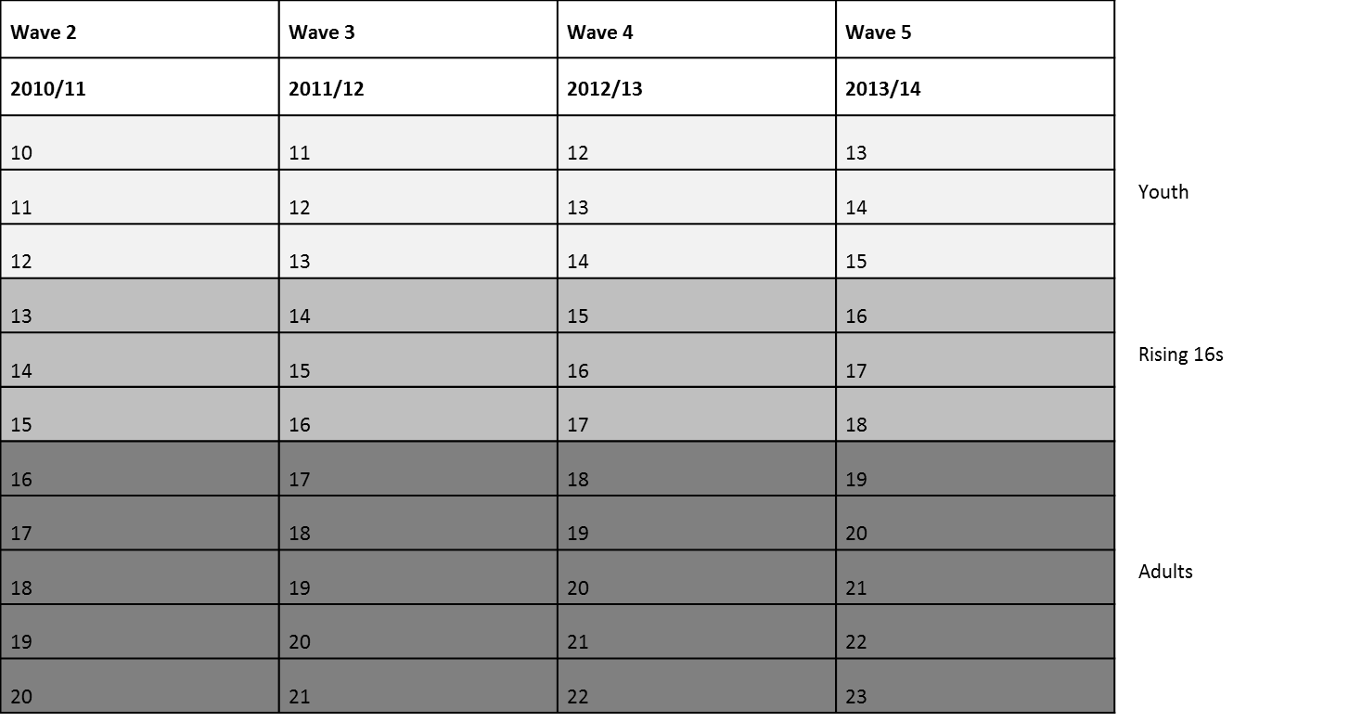

1. More information available at http://www.cls.ioe.ac.uk/page.aspx?&sitesectionid=851&sitesectiontitle=Welcome+to+the+Millennium+Cohort+Study
2. More information available at https://discover.ukdataservice.ac.uk/catalogue/?sn=6614&type=Data%20catalogue