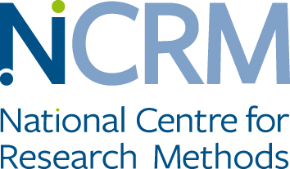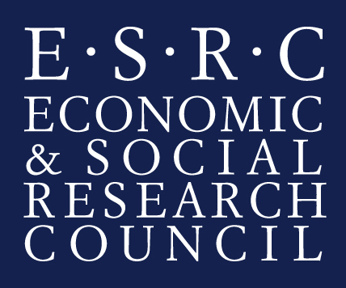

Walking Stories and Participatory Theatre: Mobile Methods Performing
Migrants’ citizenship
You are being invited to take part in a research study. Before you decide whether or not to take part, it is important for you to understand why the research is being done and what it will involve.
What is the purpose of the study?
This research is about your experiences of living as a young person from a migrant background in London. We are going to do drama exercises and walking together to explore everyday images of London, belonging, friendships and family life.
Your thoughts and feelings on particular issues as well as day to day experiences of living in the UK are important to us and we would like to hear about them.
You can decide whether to take part in this study or not. If there are any questions you do not like to answer or any part of the study that you do not want to take part in, please just say ‘I don’t want to answer this question.’, or ‘I don’t want to take part in this theatre activity’ ‘or I don’t want to continue with this walk’ ‘or I want my photos back and not included in the film’. You don’t need to give any reason. You can withdraw from the study anytime before the last meeting.
During the walk we will stop to discuss and photograph places that are important to you for whatever reason. We would like to display some of the photographs on the web site and in publications with your permission.

Audio, photographs and films will be stored securely on a pass-word protected computer. We would like to use the images and sound files on the web resource, in written publications and in the book. We will also send you the images and sound files if you would like a copy and we will discuss with you whatever you would like or would not like to be part of publication or website.
The audio tapes / videos / photographs will be kept securely in accordance with the Data Protection Act 1998, and participants will be able to request a copy at any time.

Your will be asked to attend 12 sessions and one interview (12 weeks) from April to July 2016. The sessions will include walks and theatre workshops for two to three hours. In addition we would like you to take part in an interview. The interviews will take between one and two hours. The research team will ask you some questions about how you felt being part of the walking maps and theatre workshops, and about your experiences of living in London as a young person.
Everything you say in the interview will be confidential and anonymised. The interviews will be written up word for word and we would be happy to share a copy of this document with you. When we write about the results of this study we may use quotes from interviews or parts of your story but this will not have any reference to your name or any other information that can identify you.
We are asking you to give your consent for the walking maps and participatory theatre sessions to be filmed and be shown on the project website. If you do not want to be filmed during the theatre workshops you can still participate in the theatre workshops and we can edit out the scenes in which you appear from the video clips. No images and audio from the workshops will be used for the toolkit and website unless you give your consent.
The study will include a written guide for social researchers of how to use drama workshops to understand the experiences of migrant families in the UK. It will include a video with extracts of the workshops as part of the guide and will be part of the research website. The website is open to the general public and anyone can access it.
If you feel that you would like support with any issues raised during the research you can approach the research team, your school or the Childline helpline 0800 1111, or Samaritans helpline 116 123.

If you have any further questions, please feel free to ask before we start. This study is funded by the Economic and Social Research Council and is part of the National Centre for Research Methods, led by Dr. Umut Erel from the Centre for Citizenship, Identities and Governance and Sociology Department of the Open University. It is undertaken by Dr. Umut Erel, Professor Maggie O’Neill, University of York; Professor Tracey Reynolds, University of Greenwich and the workshops led by Erene Kaptani, Open University and filmed by Counterpoints Arts. You can contact Dr. Umut Erel or talk to us before or at the end of any of the workshops if you have any further questions.

Agreement to Participate

I,______________________________________

agree to take part in this research project.
I have had the purposes of the research project explained to me.
I have been informed that I may withdraw from the research anytime before the last session.
I have been assured that my confidentiality will be protected as specified in
the leaflet. I agree that the information that I provide can be used for artistic, educational or research purposes, including the website, media and publications.
I understand that if I have any concerns or difficulties I can contact:
Dr. Umut Erel email: u.erel@open.ac.uk

Sociology Department
Centre for Citizenship, Identities and Governance
Faculty of Social Sciences
The Open University
Walton Hall
Milton Keynes
MK7 6AA
United Kingdom
Tel: +44 (0)1908 654461

If I want to talk to someone else about this project, I can contact the Director Centre for Citizenship, Identities and Governance
Prof. Elizabeth Silva
Faculty of Social Sciences
The Open University
Walton Hall
Milton Keynes
MK7 6AA
United Kingdom
elizabeth.silva@open.ac.uk
Tel: +44(0)1908 654704

Signed: _______________________________________ Date________________________

I agree that research data for this project may be stored outside the EU ☐

