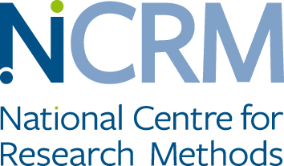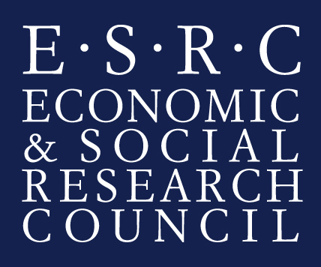

Walking Stories and Participatory Theatre: Mobile Methods Performing Migrants’ citizenship
Your child is being invited to take part in a research study. Before you decide whether to give permission for your child to take part, it is important for you to understand why the research is being done and what it will involve.
What is the purpose of the study?
This research is about the experiences of young people and families from different backgrounds in London. We are going to use drama exercises and walking together in the area to explore everyday images of London, young peoples belonging, friendships and family life.
The study aims to use walks and interactive theatre workshops as ways for understanding the experiences of migrant families in the UK and inform policy. It will also include interviews to reflect on your child’s experience in taking part in these workshops.
Your child can decide whether he or she would like to take part in the study or not. If they or you would like to withdraw from the study, you can do so anytime before the final session. During the walk we will stop to discuss and photograph spaces and places that are important to your child for whatever reason. We would like to display some of the photographs on the web site and in publications with your child’s permission.

Audio, photographs and films will be stored securely on a pass word protected computer. We would like to use the images and sound files on the web resource, in written publications and in the book. We will also send you the images and sound files if you would like a copy and we will discuss with you whatever you would like or would not like to be part of publication or website.The audio tapes / videos / photographs will be kept securely in accordance with the Data Protection Act 1998, and participants will be able to request a copy at any time.

Your child will be asked to attend 12 sessions and one interview (12 weeks) from April to July 2016. The sessions will include walking methods and theatre workshops for two to three hours. In addition we would like your child to take part in an interview at the end of the walking maps and theatre project. The interviews will take between one and two hours. The research team will ask your child some questions about how your child felt being part of the workshops and their experiences of living in London as a young person.
Everything your child says in the interview will be confidential and anonymised. When we write about the results of this study we may use quotes from interviews or parts of your child’s story but this will not contain any reference to your child’s name or any other information that can identify your child.
The study will include a written guide for social researchers of how to use drama methods to understand the experiences of migrant parents living in the UK. It will include a video with extracts of the workshops as part of the guide and will be part of the research website. The website is open to the general public and anyone can access it.
We are asking you to give your consent for the walking maps and participatory theatre sessions to be filmed and be shown on the project website. If you do not want your child to be filmed during the theatre workshops your child can still participate in the theatre workshops and we can edit out the scenes in which your child appears from the video clips. No images and audio from the workshops will be used for the toolkit and website unless you give your consent.
If you have any further questions, please feel free to ask before we start. This study is funded by the Economic and Social Research Council and is part of the National Centre for Research Methods, led by Dr, Umut Erel from the Centre for Citizenship, Identities and Governance and Sociology Department of the Open University. It is undertaken by Dr. Umut Erel, Professor Maggie O’Neill, University of York; Professor Tracey Reynolds, University of Greenwich and the workshops led by Erene Kaptani, Open University and filmed by Counterpoints Arts. You can contact Dr. Umut Erel or talk to us before or at the end of any of the workshops if you have any further questions.

Agreement to Participate

I am happy for my son/ daughter/ ward, _____________________________________
to take part in this research project.
I have had the purposes of the research project explained to me.
I have been informed that they may withdraw from the research anytime before the analysis stage.
I have been assured that my child’s confidentiality will be protected as specified in the letter/leaflet. I agree that the information can be used for educational or research purposes, including the website, media and publications.
I understand that if I have any concerns or difficulties I can contact:
Dr. Umut Erel email: u.erel@open.ac.uk

Sociology Department, Centre for Citizenship, Identities and Governance, Faculty of Social Sciences, The Open University, Walton Hall, Milton Keynes, MK7 6AA, United Kingdom
Tel: +44 (0)1908 654461

If I want to talk to someone else about this project, I can contact the Director Centre for Citizenship, Identities and Governance
Prof. Elizabeth Silva
Faculty of Social Sciences, The Open University, Walton Hall, Milton Keynes, MK7 6AA, United Kingdom elizabeth.silva@open.ac.uk Tel: +44(0)1908 654704

Signed: _______________________________________ Date________________________

I agree that research data for this project may be stored outside the EU ☐

