**Information feedback and contest structure in rent-seeking games**

Francesco Fallucchi[1], Elke Renner[2] and Martin Sefton[3]

1 August 2013

**Abstract**

We investigate the effects of information feedback in rent-seeking games with two different contest structures. In the share contest a contestant receives a share of the rent equal to her share of rent-seeking expenditures, while in the lottery contest a contestant wins the entire rent with probability equal to her share of rent-seeking expenditures. In share contests average expenditures converge to equilibrium levels when subjects only get feedback about own earnings, and additional feedback about rivals’ choices and earnings raises average expenditures. In lottery contests information feedback has an opposite, and even stronger, effect: when subjects only get feedback on own earnings we observe high levels of rent dissipation, usually exceeding the value of the rent, and additional feedback about rivals’ choices and earnings has a significant moderating influence on expenditures. In a follow-up treatment we make information feedback endogenous by allowing contestants in a lottery contest to make public or private expenditures. Subjects make the vast majority of expenditures privately and overall excess expenditures are similar to the lottery contest with own feedback.

**Keywords**: contests, rent-seeking, information feedback, learning, experiments

**JEL classification**: C72; C92; D72

**1. Introduction**

Tullock’s (1980) seminal model of rent-seeking is widely used to model a variety of contests in economics and political science. For example, in a recent review Konrad (2009) discusses applications ranging from lobbying and patent races to litigation lawsuits and sporting contests. In this paper we examine, using laboratory methods, how feedback on contest choices and outcomes can affect contestants’ behavior in a repeated setting.

This is an important issue because in practice many contests are repeated, and information about rivals’ choices and outcomes can vary. In some settings the amount of resources spent in a contest can relatively easily be observed. For example, in advertising competition the amounts spent on adverts is, due to the nature of the expenditure, usually visible to all competitors and information on outcomes in terms of market shares is commonly available. In other settings, information on rent-seeking expenditures is less evident. For example, contestants competing for research grants typically do not observe the amount of costly effort put in by rivals and often only learn whether their own bid was successful.

In some cases the availability of information about competitors’ expenditures and payoffs is regulated by legal or institutional rules. In the US, for example, the financing of electoral campaigns is regulated by law which requires disclosure of the funds candidates or parties raise and spend and this information is made publicly available. Similarly, lobbying activities in the US are subject to legal disclosure rules. Such disclosure obligations are absent in many other countries where lobbying activities are not governed by formal regulations. Understanding how different information conditions affect contest outcomes is therefore important for regulators or policy makers in considering the appropriate degree of information transparency.

Information feedback can matter for a variety of reasons. Stigler (1964) argued that information about competitors’ choices can facilitate collusion in oligopolistic markets; on the other hand, competitors may react to one another’s choices in ways that lead to more competitive outcomes. For example, in quantity-setting homogeneous goods markets if competitors myopically best respond to their rivals’ previous outputs this process converges (under suitable assumptions) to a Cournot-Nash equilibrium (Theocharis, 1960, Fisher, 1961), while if competitors imitate the most profitable rival the dynamic processes converges to the Walrasian outcome (Vega-Redondo, 1997). These arguments can be extended to contest settings. In general, different forms of information feedback facilitate different kinds of learning and different learning rules can have sharp implications for contest outcomes. Moreover, the way in which learning can affect outcomes depends on contest structure.

For these reasons the design of our experiment varies both information feedback and contest structure. We consider two different contest structures: a *share* and a *lottery* contest. In the *share* contest contestants compete for a rent and each receives a share of the rent equal to the share of rent-seeking expenditures, while in the *lottery* contest one contestant wins the entire rent, and each contestant’s probability of winning is her expenditure divided by aggregate expenditures. For each type of contest we study two information feedback conditions. In our *own* feedback condition subjects are only informed of their own choice and earnings at the end of a contest. In our *full* feedback condition subjects are additionally informed of the choices and earnings of their rivals. In order to study the effect of information feedback in environments where learning dynamics may take time to converge (if at all), in all treatments we have participants play a sequence of 60 contests.

In share contests we find that information feedback increases expenditures in later periods. With own information feedback average expenditures in later periods are close to equilibrium levels, while with full feedback average expenditures converge to a significantly higher level – about 20% above equilibrium. We find no evidence of collusive behavior in either treatment and from analysis of individual level data we find support for imitative learning to explain the difference between treatments.

In lottery contests the effect of information feedback is even more marked, and is *reversed*. With full feedback expenditures stabilize in later periods around 13% above equilibrium levels. In lottery contests with own feedback expenditures begin high and remain high; even in later periods group expenditures exceed the rent in the majority of games and on average are 67% above equilibrium levels. It is striking that in this low information environment subjects do not reduce their expenditures despite the persistent losses that they experience.

One key finding from these treatments is that when subjects can observe or infer the actions of others, they have a tendency to best respond, and this has a significant moderating impact on rent-seeking. In lottery contests, in the absence of information that allows them to best respond, subjects’ rent-seeking expenditures remain stubbornly high, even after considerable experience.

Given the pronounced impact of information feedback on expenditures in lottery contests, we were interested in whether the low information feedback environment could emerge endogenously. In many naturally-occurring contest settings contestants are able to choose whether and to what extent they reveal to other contestants how much they invested into a contest. To investigate if subjects take advantage of an option to reveal their contest expenditures we ran a follow-up lottery contest treatment where contestants can choose to make contest expenditures either in public or in private. Interestingly, we find that the vast majority of expenditures are made privately. Thus, subjects in the follow-up treatment learn little about the expenditures of rivals, and this reduces the possibility of learning from feedback about others’ choices. It turns out that expenditures in this treatment closely resemble excessive rent-seeking levels observed in the lottery contest with own feedback.

The remainder of the paper is organized as follows. In Section 2 we summarize related rent-seeking experiments. Section 3 discusses how different learning rules affect contest outcomes. Section 4 describes the design of our main experiment, and Section 5 presents the results. In Section 6 we present our follow-up treatment. In Section 7 we discuss our findings and offer concluding comments.

**2. Related Rent-Seeking Experiments**

Numerous experiments have been conducted using the framework of Tullock’s (1980) rent-seeking model (for an extensive survey of these and related contest experiments see Dechenaux et al., 2012). These experiments usually consist of multiple periods where each period has the following structure. There are $N$ contestants, each with endowment *e*, who compete for a rent of size $V$ by simultaneously choosing rent-seeking expenditures. Let $x_{i}∈\left[0,e\right]$ denote contestant *i*’s expenditure and $X=\sum_{j=1}^{N}{x_{j}}$ denote aggregate expenditures. In a *lottery contest* one contestant wins the entire rent, and the probability that contestant $i$ wins is given by her expenditure relative to aggregate expenditure, so that $i$’s payoff is:

$$π_{i}=\left\{\begin{aligned}e-x_{i}+V with probability \frac{x_{i}}{X} \\ \\ e-x_{i} with probability 1-\frac{x_{i}}{X} \end{aligned} \right.$$

Assuming risk-neutrality, and that the endowment is non-binding, contestant $i$ invests $x_{i}=V{(N-1)}/{N^{2}}$ in the unique equilibrium.

Substantial departures from this equilibrium prediction are often observed. For example, Potters et al. (1998) found that in two-person contests average expenditures were 68% greater than the equilibrium prediction over thirty periods. Even focusing on the last ten periods expenditures were more than 50% above equilibrium. In fact, most studies find excessive expenditure relative to the risk-neutral equilibrium, sometimes more than double the equilibrium predictions.[4] Although excessive rent-seeking is most commonly observed, expenditure as a percentage of equilibrium expenditure varies widely across studies even after controlling for differences in the number of contestants, the size of the rent, and other factors that affect equilibrium expenditures. Table 1 compares the results from all experiments we are aware of that use the Tullock contest as described above.[5]

[Table 1 about here]

Note that the studies listed in Table 1 use a variety of forms of information feedback. We categorize feedback as “full” if participants are told, or can infer, the choices and earnings of all other group members at the end of the period. Even within this category studies vary in the way feedback was given. For example, in some of the N=2 cases participants are given the effort of the rival and own earnings, from which they can infer the rival’s earnings, whereas in other cases they are informed about earnings directly. At the other extreme we categorize feedback as “own” if participants are informed only of their own choices and earnings. Most studies fall between these two extremes, giving different sorts of partial information; in many cases the experimenter reveals aggregate expenditure (e.g. Sheremeta, 2010) while in others information was not conveyed in numerical terms (e.g. Abbink et al., 2010).

It should also be noted that the studies in Table 1 vary considerably in numerous dimensions, making it difficult to disentangle the effect of information feedback from other factors that differ across studies. This is why we introduce a new design that varies information feedback conditions while holding other factors constant.[6]

In all of the above studies the contest winner earns the entire rent. An alternative version of a Tullock contest can be employed in which each contestant receives a share of the rent equal to her share of rent-seeking expenditures. We refer to this as a *share contest* structure. In the share contest $i$’s payoff is given by

$$π_{i}=e-x_{i}+{Vx_{i}}/X.$$

This can be interpreted as a lottery contest in which contestants are paid their expected earnings.[7] Since lottery and share contests have the same expected payoff function equilibrium predictions (assuming risk-neutrality) are the same in both contests.

A small number of recent studies have examined share contests. Schmidt et al. (2006) conduct one-shot contests and find no significant differences between lottery and share versions (although, somewhat unusually relative to other studies, expenditures are below equilibrium predictions). Chowdhury et al. (2012) also compare lottery and share contests where participants play over 30 periods against randomly changing opponents and are informed of own earnings and aggregate group expenditure at the end of each period. They also find no significant difference between the two treatments.[8] Cason et al. (2010) implement a share contest using a real effort task, although they do not study a comparable lottery contest and it is difficult to compare efforts with equilibrium predictions without making restrictive assumptions about the effort cost function. Sheremeta et al. (2012) compare 20-period lottery and share contests (albeit with a somewhat different contest structure than that defined above), giving feedback on own earnings and aggregate choices at the end of each period. In both contests they find excess expenditures relative to equilibrium, with expenditures significantly lower, and hence closer to equilibrium, in the share contest.

None of these studies using share contests have examined the effects of alternative information feedback. Information feedback determines the extent to which individuals can employ different learning rules and, in the next section, we show that whether information feedback on others’ choices and earnings is provided has important implications for learning in both contest structures.

**3. Learning in Contests**

Under the assumption of risk-neutrality the equilibrium predictions for both contest structures are the same, and regardless of risk attitudes the equilibrium prediction for a given contest structure is independent of contest feedback. Thus, from the perspective of equilibrium theory, feedback at the end of the contest should not influence expenditures.

However, behaviorally feedback might be important: It is very unlikely that subjects in an experiment will calculate the equilibrium of a game and use the equilibrium strategy from the outset. Instead, subjects are more likely to follow boundedly rational decision processes that draw on the information they receive about past choices and associated payoffs. Moreover, different sorts of information feedback may facilitate different sorts of learning.

Consider our full feedback condition in which subjects are informed of rivals’ previous choices and earnings. Then one learning rule that could be employed, in both lottery and share contests, is the rule of myopically best responding to the actions chosen by rivals in the previous period. We refer to this as the *best response* learning rule. In fact, even if subjects are only informed of own earnings, this learning rule can be employed in share contests as subjects can, in principle, infer the sum of rivals’ expenditures from their own choice and own earnings, and the best response can be calculated from this sum. In three-player contests, as will be used in our experiment, expenditures under the best response rule converge to the equilibrium and so equilibrium expenditures would emerge in these three treatments if our subjects were to use this rule. The best response rule cannot be applied in the lottery contest when subjects only get feedback on own earnings.

When information about others’ choices and payoffs is available, subjects may use other learning rules that imitate the most successful contestant. (Note, however, that this *imitate the best* rule cannot be applied in either type of contest with own feedback.) Evidence of such imitative behavior is found in a number of studies based on Cournot oligopoly settings (Offerman et al. 1997, Huck et al. 1999, Huck et al. 2000, Apesteguia et al. 2007, Apesteguia et al. 2010). The implications of imitative learning are sensitive to contest structure.

In a share contest the payoff function can be rewritten as

$π_{i}= e+\frac{x_{i}}{X}\left(V-X\right)$,

and so if the rent is less than fully dissipated ($V-X>0$) the contestant who invests the most has the highest payoff, while if the rent is over-dissipated ($V-X<0$) the contestant who invests the least has the highest payoff. Thus, if all players imitate the action chosen by the most successful contestant in the previous period, they will all copy the choice of the highest (lowest) spender if the rent is under- (over-) dissipated, and expenditures will then lock–in on this level. If the imitation dynamic includes a small perturbation, then this converges to full dissipation. Imitation dynamics in a lottery contest are very different. If contestants imitate the choice that led to the highest payoff in the previous period, then expenditures lock-in on the expenditure of the initial winner, and this implies that in expectation expenditures lock-in at a higher level than the initial average.[9] If the imitation dynamic includes a small perturbation the dynamic process resembles a random walk with upward drift.

Figure 1 illustrates the alternative learning processes. We set *V = e* = 1000 and simulated ten three-player groups over sixty periods. Initial expenditures are equi-probably distributed on the integers {0, 1, … 1000}. In subsequent periods players either imitate the most successful choice in the previous period or play a best response to the choices in the previous period. We perturb the process by adding a number equi-probably distributed on {-5, -4, …, +4, +5} and truncating if necessary to ensure that choices are non-negative and do not exceed 1000.

[Figure 1 about here]

The figure shows the different outcomes emerging from the different learning rules. The best response dynamic converges to the equilibrium in either contest structure, while imitation dynamics converge to full dissipation of the rent in the share contest (an average of 333 for each player), and to over-dissipation of the rent in the lottery contest.

In summary, with full feedback either best response or imitative learning rules could be applied. The best response rule converges to equilibrium in either type of contest, but the implications of imitative learning are sensitive to the contest structure. In a share contest with own feedback the best response rule could be applied, and would converge to equilibrium, but imitative learning rules cannot be applied. Neither best response nor imitative learning rules can be applied in a lottery contest with own feedback.

**4. Experimental Design and Procedures**

The experiment consisted of eight sessions with either 15 or 18 subjects each. Sessions were conducted at the University of Nottingham in December 2011 using the software z-tree (Fischbacher, 2007). We recruited 123 students from a wide range of disciplines through the online recruiting system ORSEE (Greiner 2004) and no participant took part in more than one session. None of the participants had taken part in previous contest experiments.

At the beginning of each session participants were randomly matched into groups of three that remained the same for the whole experiment. Participants did not know the identities of the other subjects in the room with whom they were grouped. They were given instructions for the experiment (reproduced in Appendix A) and these were read aloud by the experimenter. Any questions were answered by the experimenter in private, and no communication between participants was allowed. No information passed across groups during the entire session.

We used a 2x2 design where our four treatments differed by the contest structure (SHARE or LOTTERY) and the information provided to subjects at the end of each period (OWN or FULL). We conducted two sessions with each treatment, resulting in observations on eleven independent groups in the SHARE-FULL treatment and ten independent groups in each of the other treatments.

In all sessions the decision-making part of the experiment consisted of 60 periods.[10] In each period subjects were endowed with 1000 points and competed for a prize of 1000 points. Subjects simultaneously chose how many contest tokens to purchase, at a price of one point per contest token, and any points not used to purchase tokens were added to their total balance. At the end of the period each subject also received contest earnings which were added to their total balance. In the share contest each subject received a share of the prize in accordance with their relative token expenditures, while in the lottery contest one subject per group won the entire prize.[11] With these parameters and assuming risk-neutrality equilibrium group (individual) expenditure is approximately 667 (222) points in both contests.

At the end of each period subjects in the OWN information treatments were reminded of their own choice and informed of their own earnings for the period and their accumulated earnings so far. In the FULL information treatments subjects were additionally informed about the choices and period earnings of the other two members of the group to which they belong. Those were listed according to contest tokens purchased in descending order. Subjects could recognize their choices in the screen by the label “OWN”, while information about the other participants were labeled as “OTHER”. This was done to prevent the possibility of tracking the choice of a particular member of the group.[12]

Subjects accumulated points across the 60 periods and at the end of each session were paid 0.015 pence per point. Earnings averaged £9.40 for a session lasting about 60 minutes.

**5. Results**

We present our results in three sub-sections. In sections 5.1 and 5.2 we look at the effect of feedback in SHARE and LOTTERY treatments respectively, and in section 5.3 look at the overall implications for rent dissipation. Unless otherwise noted within-group comparisons are based on two-sided Wilcoxon matched-pairs signed-rank tests and between-group comparisons are based on two-sided Wilcoxon rank-sum tests, in both cases treating each group as a single independent observation.

**5.1 Share Contests**

Figure 2 shows the average group expenditures across periods. In both treatments expenditures decrease from initially high levels in the first half of the session and are then more stable in the second half. The decrease is more pronounced in OWN than in FULL, and comparing expenditures in periods 1-30 with 31-60 we see a significant decrease in the OWN (p=0.009) but not in the FULL (p=0.286) information treatment. Comparing periods 31-45 with 46-60 we fail to find significant differences in either treatment (FULL: p=0.328, OWN: p=0.575), supporting the observation that expenditures are stable within the second half of the experiment.

[Figure 2 about here]

Table 2 summarizes average group expenditures. Group expenditures are lower with OWN than with FULL information, and the difference is significant in the last 30 periods (p=0.024). In the last 30 periods the average group expenditure is 20% higher than the equilibrium prediction in FULL, while the average group expenditure in OWN is remarkably close to the equilibrium level.[13]

[Table 2 about here]

A closer look at the distribution of the choices reveals more information about changes in behavior over time and across treatments. In Figure 3, for each treatment, we compare the distribution of choices in the first and second half of the experiment. In the first half of the experiment choices in the OWN information treatment are widely dispersed with a mode at the lowest expenditure interval (panel a). In the second half the distribution shifts with a mode at the equilibrium interval (panel b). In the FULL information treatment the distributions in the two halves are more similar. Note the differences between panels b and d: in the second half of the experiment choices in FULL are mainly above equilibrium while in OWN choices are more symmetrically distributed about the mode at the equilibrium. The difference between panels b and d is qualitatively consistent with the hypothesis of imitative learning.

[Figure 3 about here]

To further examine how different learning rules drive behavior changes we follow Huck et al. (1999) by estimating how adjustments in individual behavior depend on the adjustments that would be required to i) best respond, ii) imitate the best and iii) imitate the average. The most general adjustment model is as follows:

$$x_{i t}-x_{i t-1}=α+β\left(x_{i t}^{BR}-x_{i t-1}\right)+λ\left(x_{i t}^{IB}-x_{i t-1}\right)+γ\left(x_{i t}^{IA}-x_{i t-1}\right)+ε_{i t}$$

where $x_{i t-1}$ and $x_{i t}$ are the expenditures of subject $i$ in the previous and current period, $x_{i t}^{BR}$ is subject $i$’s best response to rivals’ expenditures in *t* – 1, $x_{i t}^{IB}$ is the expenditure of the group member with the highest payoff in *t* – 1, and $x_{i t}^{IA}$ is the average expenditure of rivals in *t* – 1. This model is estimated when subjects have sufficient information to calculate the relevant regressors. When the information feedback does not allow subjects to calculate a regressor that regressor is dropped from the estimation. In Table 3 we report multilevel mixed effects estimates allowing for both individual and group random effects. The regressor “Best Response” refers to $\left(x_{i t}^{BR}-x_{i t-1}\right), i.e.$ the change in expenditure required to best respond to the previous round choices of the other group members, and similarly for the other regressors. We report separate estimates based on data from the first 30 and last 30 periods.

[Table 3 about here]

For the OWN treatment subjects cannot imitate the best and so we omit this variable from the regression. Subjects may however, infer the average choice of others, and could either imitate or best respond to this. The estimation results show a stronger effect of best response learning, while the coefficient on imitate-the-average is smaller but still significant.[14] For the FULL treatment we report two specifications. First, estimating the same model as for the OWN treatment we see a similar pattern, with a larger coefficient on best response compared to imitate the average (p = 0.000 for both sub- periods). The most notable difference from OWN is that in the second half data the estimate of the constant in the regression indicates a significant upward drift in the FULL treatment.[15] In the second specification we estimate the model incorporating the imitate-the-best regressor. In this specification the coefficient on best response exceeds that on either of the the imitation regressors (p < 0.002 in all cases). However, the imitate-the-best variable is significant. Also, incorporating the imitate-the-best regressor results in a reduced estimate of the upward drift, indicating that part of the upward drift identified in the specification that omits this variable can be accounted for by imitative behavior. Thus, when the feedback allows imitation of successful rivals there is a significant tendency to do so, resulting in higher expenditures.

**5.2 Lottery Contests**

Figure 4 shows expenditures across periods in the LOTTERY treatments. In both treatments expenditure levels are high in early periods. Expenditures in the FULL treatment then exhibit a decreasing trend: expenditures in periods 31-60 are significantly lower than in periods 1-30 (p = 0.022). In contrast, the OWN treatment does not show any decreasing trend: the difference in expenditures between the two halves is insignificant (p = 0.575). Within the second half of each treatment we find stable expenditure levels: expenditures in periods 31-45 and 46-60 do not differ significantly in either FULL (p=0.878) or OWN (p=0.114).

[Figure 4 about here]

Table 4 summarizes average group expenditures. Group expenditures are significantly higher in the OWN than FULL information treatment, based on either all periods or the early or later periods separately.[16] Across all periods the average expenditure in the FULL information treatment falls from the initially high levels to a level about 13% above equilibrium in the second half of the experiment. In contrast, group expenditures in the OWN information treatment remain higher than the value of the prize even in later periods. The difference between the two treatments is substantial: expenditures in OWN are 26% higher than in FULL in the first 30 periods and 48% higher in the last 30 periods.[17]

[Table 4 about here]

Figure 5 shows the distributions of individual choices in the LOTTERY treatments. In the OWN treatment (upper panels) the distributions are similar in earlier and later periods. There is a pronounced mode at the lowest expenditure interval and a less pronounced one in the interval containing 500. There is also a non-negligible number of choices in the 900-1000 range. The distribution of choices in the first thirty periods of the FULL treatment (panel c) is similar to that in previous experiments (e.g. Sheremeta 2010, Chowdhury et al. 2012 and Lim et al. 2012). In the second half (panel d) there are lower frequencies of choices at the extreme intervals of the strategy space, and somewhat more choices in the 50-350 range.

[Figure 5 about here]

It is interesting to compare the distributions in Figure 5 with the distributions observed in the SHARE treatments (see Figure 3). One striking difference is that for either information condition there are more expenditures in the lowest interval in the LOTTERY compared to SHARE treatments. There could be two quite different reasons for low expenditures: they may indicate collusive behavior, or they may indicate a best response to persistent over-dissipation by rivals. Looking more closely at these observations we find they tend to be concentrated in particular groups, for example four groups account for over 70% of these observations. Of these four groups, we find that average expenditures is substantially below the equilibrium in only one of them (an average group expenditure of 376 across all periods). Two other groups have expenditures close to the equilibrium, while the remaining group is substantially above (an average group expenditure of 1412 across all periods). Thus, there is little evidence that the low expenditures reflect collusive behavior.

In Table 5 we report estimates of the adjustment model for the LOTTERY-FULL treatment, again reporting separate estimates for the first and last 30 periods of data.[18] In the first two columns we report the estimates from a specification including an imitate-the-best regressor. Note that in our lottery contest imitating the player with the highest earnings is equivalent to imitating the winner in the previous period. There is some evidence of imitative behavior: the coefficients on imitate the average and imitate the best are significant in all cases. However, the coefficient on best response is significantly larger than either of the imitative coefficients (p < 0.01 in all cases). Since subjects were informed of all choices in the previous period they could, in principle, calculate the expected earnings of each, and so another possibility is that subjects imitate the choice from the previous period that implied the highest *expected* earnings. Thus, we re-estimated the model including another regressor (“Imitate the Expected Best”) representing the choice in the previous period that received the highest expected payoff. The results are reported in the third and fourth columns. The Imitate-the-Expected-Best regressor is insignificant and so there is no evidence that players imitate the actions that give the highest expected payoffs.

[Table 5 about here]

**5.3 Implications for rent-dissipation**

Our results show that information feedback has a significant effect on behavior in rent-seeking contests. Contestants adjust their choices based on what they observe about the choices and earnings of others in previous periods. The implications of this for rent-dissipation are summarized in Table 6. Average expenditure levels vary considerably across treatments. Expenditures are lowest in the SHARE-OWN treatment (and close to the Nash Equilibrium level in later periods), and highest in the LOTTERY-OWN treatment, with the expenditures of the two FULL treatments in between. Revealing information about opponents’ choices increases rent-seeking expenditures in share contests, but mitigates over-expenditure in lottery contests.

[Table 6 about here]

Remarkably, of the contests played in LOTTERY-OWN 59% of them ended up with aggregate expenditures exceeding the rent. Thus, most contests in this treatment led to more than full-dissipation of the rent. By comparison, in the SHARE-OWN treatment this happened in 26% of the contests in the first 30 periods, and in only 6% of the contest in the last 30 periods. As a consequence of excessive rent-seeking, in the LOTTERY-OWN treatment most subjects earned less than their endowment. Relative to spending zero and earning their endowment, they consistently made losses throughout the experiment.

**6. Endogenous information feedback**

The effect of information feedback is particularly striking in lottery contests, and so we conducted a follow-up treatment to examine behavior in a lottery contest where information feedback about competitors’ actions is endogenous. We were interested to see whether a low information environment, such as the one implemented in our LOTTERY-OWN treatment, would emerge endogenously from a setting where contestants can either make contest expenditures publicly observable, or make contest expenditures in private. If contest expenditures are made privately players receive no feedback about rivals’ choices, as in our LOTTERY-OWN treatment, and so we might expect contest expenditures to be similarly high. On the other hand, if players make their expenditures publicly observable this may allow the moderation in contest expenditures that was observed in our LOTTERY-FULL treatment.

Our follow-up treatment (ENDOGENOUS) was conducted in November 2012 and retains all the design features of the previous lottery treatments with the exception that subjects now could choose to buy two different types of contest tokens: public and private tokens. Each token, whether public or private, costs 1 point. A contestant’s probability of winning the contest was given by her total (public + private) number of tokens purchased, divided by the total number purchased by all group members. Thus, private and public tokens cost the same and enter into the contest success function in an identical way. At the end of each period, as well as being informed of own choices and earnings subjects were informed of rivals’ purchases of public tokens and contest earnings. Rivals’ choices of private contest tokens and period earnings remained secret (see Appendix B for experimental instructions). We conducted two sessions resulting in data on ten independent groups in each of the treatments. Earnings averaged £8.20 for a session lasting about 60 minutes.

Figure 6 compares contest expenditures in the ENDOGENOUS treatment with the other lottery treatments. Average group expenditures in the new treatment (1247.65 across all periods) are even higher than in OWN (1131.03), although this difference between the two treatments is not significant (p = 0.364). In fact, after an initial decreasing trend, expenditures in the two treatments become similar (for periods 31-60 average expenditures are 1195.58 in ENDOGENOUS and 1110.17 in OWN, p = 0.545). On the other hand, expenditures in the new treatment are significantly higher than FULL (all periods p = 0.010; periods 1-30 p = 0.049; periods 31-60 p = 0.008). Consequently we observe high dissipation of the rent (around 179% of equilibrium expenditure in the last 30 periods) as we have found in OWN.

[Figure 6 about here]

The similarity between ENDOGENOUS and OWN can be explained by how subjects choose between private and public expenditures. Figure 7 shows that in the ENDOGENOUS treatment subjects predominantly purchase private tokens. In the first half of the experiment 69.6% of contest expenditures are on private tokens and this increases to around 88.2% in the second half. In the second half private tokens account for more than 70% of contest expenditures in every group.

[Figure 7 about here]

These results are in line with two related studies on endogenous information structures in experimental markets. Davis and Holt (1998) study posted price markets in which sellers can offer secret discounts to buyers, and find that discounts are widely used. As a result there is a significant increase in the level of competition compared to a treatment where discounting is prohibited. Kirchsteiger et al. (2005) observe that sellers prefer to conceal their offers from other sellers, even when they would benefit from the disclosure. Indeed they find that sellers conceal their offers even when they have to pay to conceal. Similarly, in our setting a preference for secrecy is observed. This reduces the possibility of learning from feedback about others’ choices, and is detrimental to contestants.

**7. Discussion and Conclusion**

In our share contests, and in our lottery contests when there is full information feedback, subjects are able to best respond to rivals’ choices from the previous period. We observe a significant tendency to adjust expenditures in the direction of this best response and this moderates the high dissipation rates observed in early periods. In addition, when subjects can imitate successful rivals we observe a significant tendency to do so. Together these findings imply very different effects of information feedback depending on the type of rent-seeking contest.

For share contests with own feedback, we find that expenditures decrease from initially high levels, and stabilize at a level close to equilibrium. Adding feedback on the choices and earnings of others introduces a force that pulls expenditures upward. In this treatment the player with the highest expenditure in the group usually earns the most, and a tendency to imitate this player results in higher expenditures relative to the own information treatment. These results complement those from oligopoly experiments. In particular, our share treatments can be compared with two of the treatments used by Huck et al. (1999) to analyze learning in Cournot triopolies: their BEST (similar to our OWN) and FULL treatments. They too find that revealing information about opponents' choices and earnings facilitates imitative learning and leads to more competitive behavior.

In lottery contests, the effect of feedback is reversed. When information on the choices and earnings of others is withheld we observe persistently high dissipation rates. In fact subjects make losses on average (relative to spending zero), and losses persist across 60 periods of repetition.[19] When subjects receive information on the choices and earnings of others there is still a significant effect of imitation, but the moderating effect of best response learning predominates and expenditures are reduced.

We find the results from our lottery contests with own feedback particularly interesting because in many natural settings contestants easily observe own expenditures and whether or not they win, but do not easily observe the expenditures and payoffs of rivals (e.g., consider grant-seeking activities). Of course, in natural repeated contest environments the transparency of rivals’ expenditures and payoffs can depend on a variety of institutional factors, such as legal disclosure rules and the intrinsic observability of different forms of expenditure (e.g., effort versus monetary expenditures), but in other cases it is up to a contestant’s discretion to decide whether they want to make this information available for others to observe. For this reason we conducted a follow-up lottery contest treatment that allowed subjects to make privately observed as well as publicly observed expenditures. Subjects predominantly chose private expenditures, resulting in a low information environment. As a result expenditures are excessively high, and the rent is usually over-dissipated, as in our own feedback lottery contest setting.

We are only aware of four other experiments that include a treatment similar to our lottery contest with own feedback. First, Mago et al. (2013) compare own and full information treatments in a twenty period game. They find high expenditures in both treatments, and no significant differences between treatments. Although there are many design differences between the two experiments we suspect that the difference between their results and ours reflects the different durations of the experiments. Based on the first twenty periods of our experiment the difference between our treatments is also insignificant at conventional levels (p = 0.131). The other three studies report very different findings in terms of how expenditures compare with equilibrium predictions. Brookins and Ryvkin (2011), like us, report substantial over-dissipation relative to equilibrium predictions, while Shupp (2004) reports under-dissipation, and Faravelli and Stanca report expenditures close to the equilibrium. These differing results can be reconciled by the differing strategy spaces used in the designs (see Sheremeta, 2013, for a detailed discussion). An interesting avenue for further research would be to investigate more systematically the determinants of rent-seeking in such low information environments.

**Acknowledgements:** We thank two anonymous referees, as well as seminar participants at the Universities of Amsterdam, Essex, and Konstanz, the Contests, Mechanism & Experiments Conference at the University of Exeter, the 2012 CeDEx-CREED-CBESS meeting at the University of East Anglia, the 2012 European Meeting of the Economic Science Association in Cologne, the 2012 and 2013 International Meetings of the Economic Science Association in New York and Zurich, the 2012 SABE conference and workshop in Granada, and the 2013 Workshop on Contests: Theory and Experiment, at the Max Planck Institute for Tax Law and Public Finance, Munich, for helpful comments. Sefton also acknowledges support from the Economic and Social Research Council (ES/K002201/1).

**References**

Abbink, K., Brandts, J., Herrmann, B., Orzen, H., 2010. Inter-group conflict and intra-group punishment in an experimental contest game. American Economic Review 100, 420-447.

Apesteguia J., Huck S., Oechssler J., 2007. Imitation-theory and experimental evidence. Journal of Economic Theory 136(1), 217-235.

Apesteguia J., Huck S., Oechssler J., Weidenholzer S., 2010. Imitation and the evolution of Walrasian behavior: Theoretically fragile but behaviorally robust. Journal of Economic Theory 145(5), 1603-1617.

Bereby-Meyer, Y., Grosskopf, B., 2008. Overcoming the winner's curse: an adaptive learning perspective. Journal of Behavioral Decision Making, 21(1), 15-27.

Brookins, P. and Ryvkin, D., 2011. An experimental study of bidding in contests of incomplete information. Florida State University, mimeo.

Cason, T.N., Masters, W.A., Sheremeta, R.M., 2010. Entry into winner-take-all and proportional-prize contests: an experimental study. Journal of Public Economics 94, 604-611.

Cason, T.N., Sheremeta, R.M., Zhang, J., 2012. Communication and efficiency in competitivecoordination games. Games and Economic Behavior 76, 26-43.

Chowdhury, S.M., Sheremeta, R.M., Turocy, T.L., 2012. Overdissipation and convergence in rent-seeking experiments: cost structure and prize allocation rules. Economic Science Institute Chapman University Working Paper 12-13.

Davis, D., Holt, C., 1998. Conspiracies and secret discounts in laboratory markets. The Economic Journal 108, 736–756.

Dechenaux, E., Kovenock, D., Sheremeta, R. M., 2012. A survey of experimental research on contests, all-pay auctions, and tournaments. Economic Science Institute Chapman University Working Paper 12-22.

Faravelli, M., Stanca, L., 2012. When less is more: rationing and rent dissipation in stochastic contests. Games and Economic Behavior 74, 170-183.

Fischbacher, U., 2007. z-Tree: Zurich toolbox for readymade economic experiments. Experimental Economics 10, 171–178.

Fisher, F.M., 1961. The Stability of the Cournot Oligopoly Solution: The Effects of Speeds of Adjustment and Increasing Marginal Costs. Review of Economic Studies 28, 125-135.

Fonseca, M.A., 2009. An experimental investigation of asymmetric contests. International Journal of Industrial Organization 27, 582-591.

Greiner, B., 2004. An online recruitment system for economic experiments. In Forschung Und Wissenschaftliches Rechnen GWDG Bericht 63, edited by K. Kremer, and V. Macho, (Eds.). Gesellschaft für Wissenschaftliche Datenverarbeitung.

Herrmann, B., Orzen, H., 2008. The appearance of homo rivalis: social preferences and the nature of rent-seeking. CeDEx Discussion Paper 2008-10, University of Nottingham.

Huck, S., Normann, H.T., Oechssler, J., 1999. Learning in cournot oligopoly - an experiment. Economic Journal 109, 80-95.

Huck, S., Normann, H.T., Oechssler, J., 2000. Does information about competitors' actions increase or decrease competition in experimental oligopoly markets? International Journal of Industrial Organization 18, 39-57.

Kirchsteiger, G., Niederle, M., Potters, J., 2005. Endogenizing market institutions: an experimental approach. European Economic Review 49, 1827-1853.

Kong, X., 2008. Loss aversion and rent-seeking: an experimental study. CeDEx Discussion Paper 2008-13, University of Nottingham.

Konrad, K.A., Schlesinger, H., 1997. Risk aversion in rent-seeking and rent-augmenting games. Economic Journal 107, 1671-1683.

Konrad, K.A., 2009. Strategy and dynamics in contests. Oxford University Press.

Lim, W., Matros, A., Turocy, T.L., 2012. Bounded rationality and group size in Tullock contests: experimental evidence. Working Paper, The Hong Kong University of Science and Technology.

Mago, S.D., Samak, A.C., Sheremeta, R.M., 2013. Facing your opponent: social identification and information feedback in contests. MPRA Paper No. 47029, Munich University.

McKelvey, R.D., Palfrey, T.R., 1995. Quantal response equilibria for normal form games. Games and Economic Behavior 10, 6-38.

Millner, E.L., Pratt, M.D., 1989. An experimental investigation of efficient rent-seeking. Public Choice 62, 139-151.

Millner, E.L., Pratt, M.D., 1991. Risk aversion and rent-seeking: an extension and some experimental evidence. Public Choice 69, 81-92.

Offerman, T., Potters, J., Sonnemans, J., 2002. Imitation and belief learning in an oligopoly experiment. Review of Economic Studies 69, 973–997.

Potters, J., de Vries, C., van Winden, F., 1998. An experimental examination of rational rent-seeking. European Journal of Political Economy 14, 783-800.

Price, C.R., Sheremeta, R.M., 2011. Endowment effects in contests. Economic Letters 111, 217-219.

Samuelson, W. F., Bazerman, M.H., 1985. Negotiation under the winner’s curse. In V. Smith (ed.) Research in Experimental Economics, Vol. III, Greenwich, CT, JAI Press.

Savikhin, A.C., Sheremeta, R.M., 2013, Simultaneous decision-making in competitive and cooperative games. Economic Enquiry 51, 1311-1323.

Schmidt, D., Shupp, R., Walker, J., 2006. Resource allocation contests: experimental evidence. CAEPR Working Paper 2006-004.

Schmitt, P., Shupp, R., Swope, K., Cadigan, J., 2004. Multi-period rent-seeking contests with carryover: theory and experimental evidence. Economic Governance 5, 187–211.

Selten, R., Abbink, K., R. Cox, 2005. Learning direction theory and the Winner's Curse. Experimental Economics, 8, 5-20.

Sheremeta, R.M., 2010. Experimental comparison of multi-stage and one-stage contests. Games and Economic Behavior 68, 731-747.

Sheremeta, R.M., Zhang, J., 2010. Can groups solve the problem of over-bidding in contest? Social Choice and Welfare 35, 175-197.

Sheremeta, R.M., 2011. Contest design: and experimental investigation. Economic Inquiry 49, 573-590.

Sheremeta, R.M., Masters, W.A., Cason, T.N., 2012. Winner-take-all and proportional-prize contests: theory and experimental results. Economic Science Institute Chapman University Working Paper 12-04.

Sheremeta, R.M., 2013. Overbidding and heterogeneous behavior in contest experiments. Journal of Economic Surveys 27, 491-514.

Shogren, J.F., Baik, K.H., 1991. Reexamining efficient rent-seeking in laboratory markets. Public Choice 69, 69-79.

Shupp, R., 2004. Single versus multiple winner rent-seeking contests: an experimental investigation. Ball State University Working Paper.

Stigler, G.J., 1964. A Theory of Oligopoly. Journal of Political Economy 72, 44-61.

Theocharis, R., 1960. On the stability of the Cournot solution on the oligopoly problem. Review of Economic Studies 27, 133-4.

Tullock, G., 1967. The welfare costs of tariffs, monopoly and theft. Western Economic Journal 5, 224-232.

Tullock, G., 1980. Efficient rent-seeking. In: Buchanan, J.M., Tollison, R.D., Tullock, G. (eds.) Toward a Theory of Rent-Seeking Society, pp 97-112. College Station: Texas A&M University Press.

Vega-Redondo, F., 1997. The evolution of Walrasian behavior. Econometrica 65, 375-384.

**FIGURES AND TABLES**

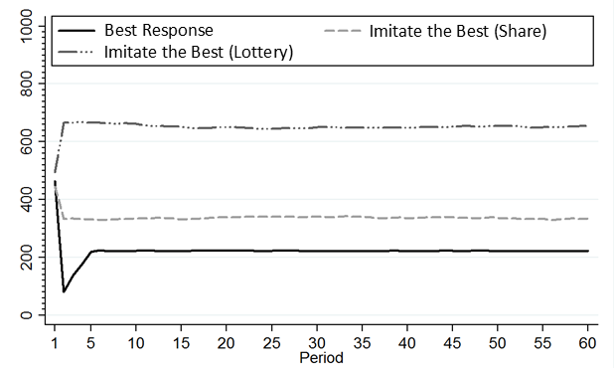**Figure 1. Simulated Best Response and Imitation dynamics.**

Each line displays the average expenditure per group member

for ten groups of three contestants and a rent of 1000.

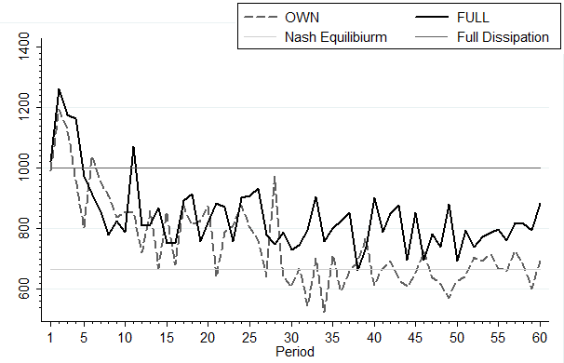

**Figure 2. Average group expenditures in SHARE treatments.**

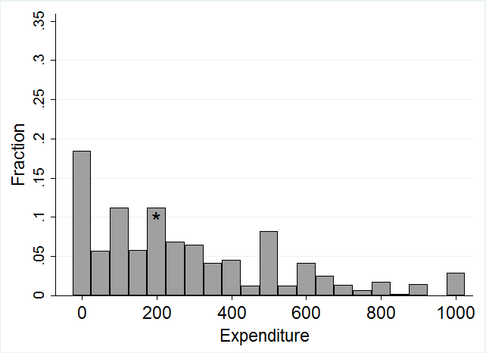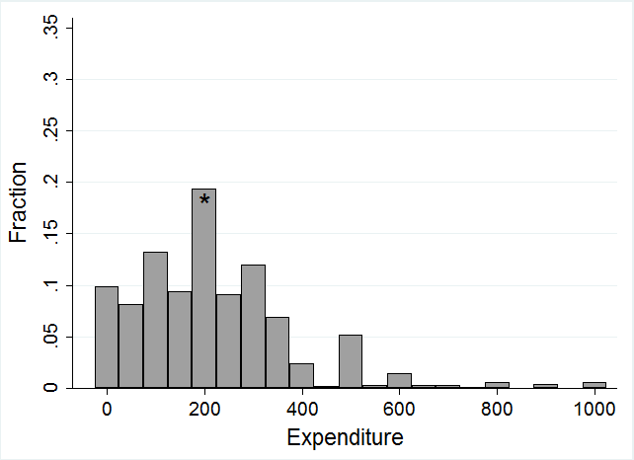

1. OWN periods 1-30 (b) OWN periods 31-60

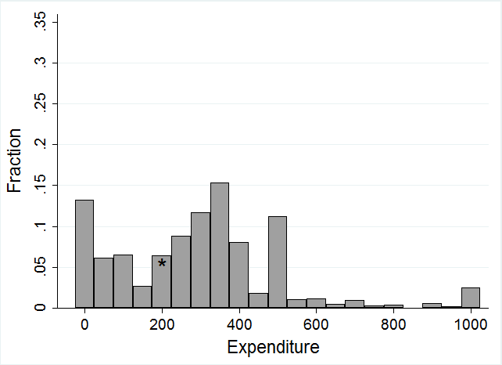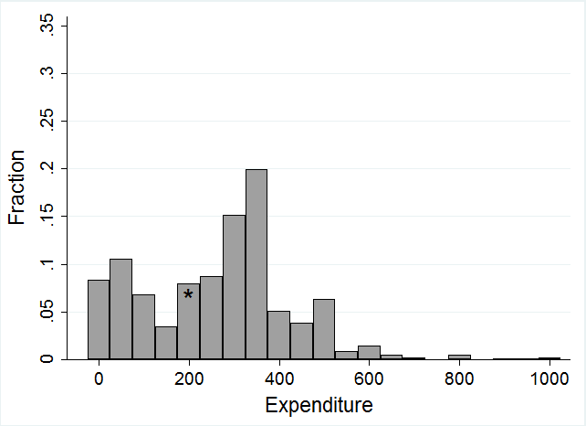

1. FULL periods 1-30 (d) FULL periods 31-60

**Figure 3. Distributions of individual expenditures in SHARE treatments.**

Intervals containing Nash Equilibrium indicated by asterisks.

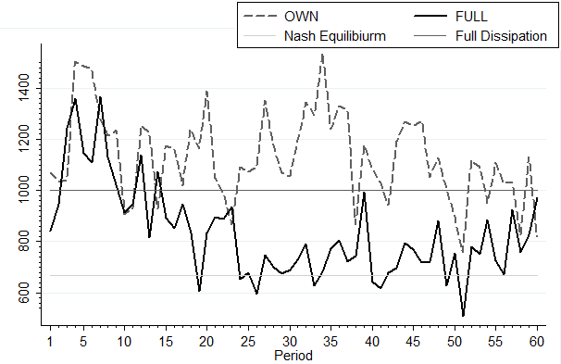

**Figure 4. Average group expenditures in LOTTERY treatments**

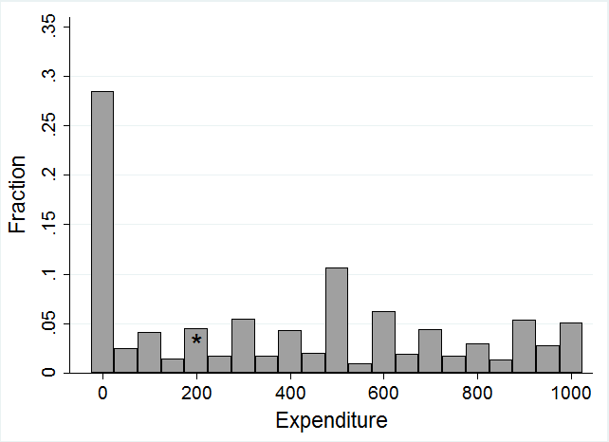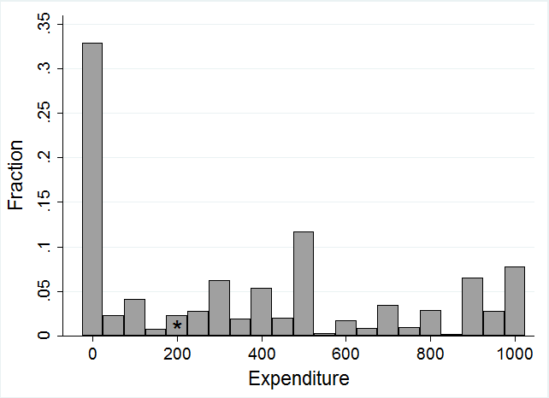

1. OWN periods 1-30 (b) OWN periods 31-60

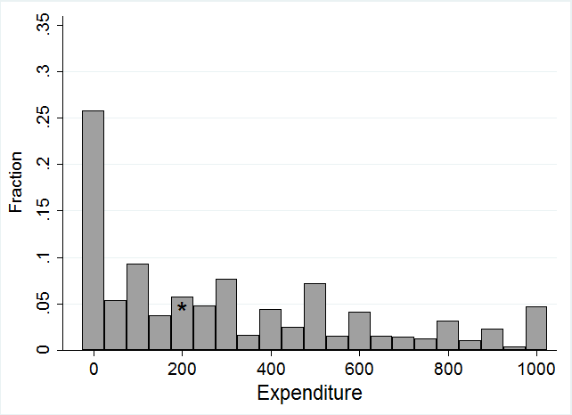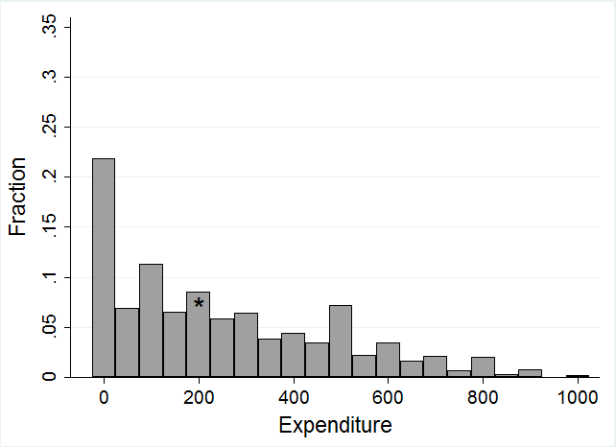

1. FULL periods 1-30 (d) FULL periods 31-60

**Figure 5. Distributions of individual expenditures in LOTTERY treatments.** Intervals containing Nash Equilibrium indicated by asterisks.

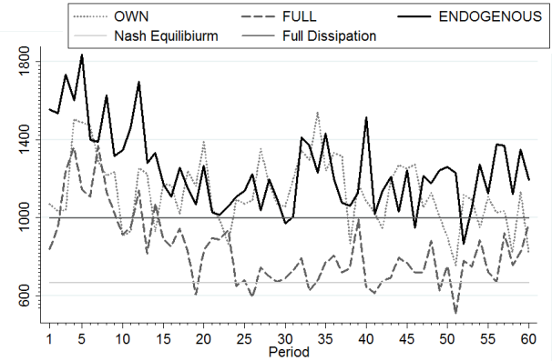

**Figure 6.** **Average group expenditures in ENDOGENOUS and LOTTERY treatments**

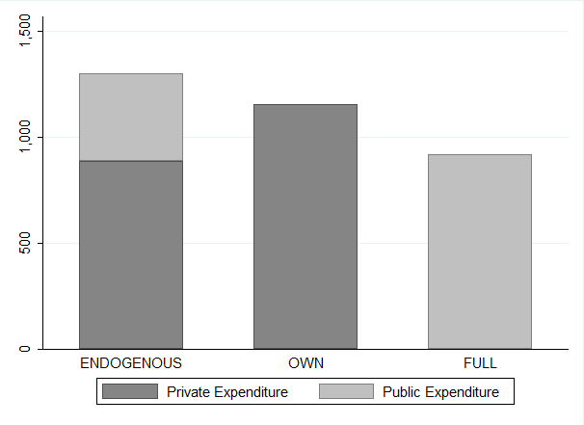 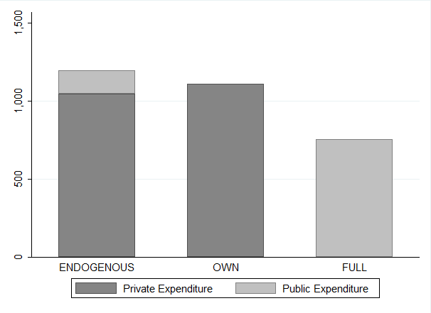

1. Periods 1-30 b) Periods 31-60

**Figure 7. Public and Private Group Expenditures**

|  |  |  |  |  |  |  |  |  |  |  |  |  |
| --- | --- | --- | --- | --- | --- | --- | --- | --- | --- | --- | --- | --- |
| **Study** | **Year** | **Treatment** | **N** | **E** | **V** | **Equilibrium group expenditure** | **Periods** | **Matching** | **Subjects** | **Expenditure as % of equilibrium** | **Expenditure as % of equilibrium (later periods)** | **Feedback** |
| **Potters et al.** | 1998 | r=1 | 2 | 15 | 13 | 6.5 | 30 | Random | 66 | **168.3** | 150 (last 10) | Full |
| **Schmitt et al.** | 2004 | Static | 2 | 15 | 12 | 3 | 5 | Random | 98 | **175.7** |  | Full |
| **Shupp** | 2004 | low info | 4 | 40 | 144 | 108 | 15 | Random | 12 | **67.9** |  | Own |
| high info | 4 | 40 | 144 | 108 | 15 | Random | 24 | **70.6** |  | Full |
| **Herrmann and Orzen** | 2008 | Direct, repeated | 2 | 16 | 16 | 8 | 15 | Random | 46 | **216.2** |  | Partial |
| **Kong** | 2008 | more loss averse | 3 | 300 | 200 | 133.3 | 30 | Fixed | 30 | **127.9** | 135.5 (last 10) | Full |
| less loss averse | 3 | 300 | 200 | 133.3 | 30 | Fixed | 30 | **156.2** | 151.6 (last 10) | Full |
| **Fonseca** | 2009 | simultaneous – symmetric | 2 | 300 | 200 | 100 | 30 | Random | 30 | **200.2** | 170.8 (last 10) | Full |
| **Abbink et al.** | 2010 | 1:1 | 2 | 1000 | 1000 | 500 | 20 | Fixed | 28 | **205.2** | 179 (last 5) | Partial |
| **Sheremeta** | 2010 | Single | 4 | 120 | 120 | 90 | 30 | Random | 84 | **151.5** |  | Partial |
| **Sheremeta and Zhang** | 2010 | Individual | 4 | 120 | 120 | 90 | 30 | Random | 36 | **194.7** |  | Partial |
| **Price and Sheremeta** | 2011 | P | 4 | 120 | 120 | 90 | 30 | Random | 48 | **232.0** |  | Partial |
| **Sheremeta** | 2011 | GC | 4 | 60 | 120 | 90 | 30 | Random | 48 | **133.3** |  | Partial |
| GC (40) | 4 | 40 | 120 | 90 | 30 | Random | 12 | **96.0** |  | Partial |
| SC | 2 | 60 | 60 | 30 | 30 | Random | 48 | **131.3** |  | Full |
| **Cason et al.** | 2012 | Individual-NC | 2 | 60 | 60 | 30 | 30 | Fixed | 16 | **126.4** |  | Full |
| **Faravelli and Stanca** | 2012 | LOT | 2 | 800 | 1600 | 400 | 20 | Random | 32 | **110.2** | 105.5 (last 5) | Own |
| **Lim et al.** | 2012 | 2 | 2 | 1200 | 1000 | 500 | 10 | Random | 50 | **130.0** |  | Full |
| 4 | 4 | 1200 | 1000 | 752 | 10 | Random | 52 | **160.6** |  | Partial |
| 9 | 9 | 1200 | 1000 | 891 | 10 | Random | 54 | **329.3** |  | Partial |
| **Mago et al.** | 2013 | NP-NI | 4 | 80 | 80 | 60 | 20 | Fixed | 60 | **194.0** |  | Own |
| NP-I | 4 | 80 | 80 | 60 | 20 | Fixed | 60 | **188.7** |  | Full |
| **Savikhin and Sheremeta** | 2013 | Baseline | 4 | 80 | 80 | 60 | 20 | Fixed | 40 | **223.0** |  | Partial |

**Table 1. Summary of previous Tullock contest treatments**

|  |  |  |  |  |
| --- | --- | --- | --- | --- |
| **Average Expenditures** | **OWN** | **FULL** | **Difference** | **p-value** |
| **Overall** | 749.26 | 838.66 | -89.40 | 0.121 |
| **Period 1-30** | 841.79 | 883.79 | -42.00 | 0.481 |
| **Period 31-60** | 656.73 | 793.54 | -136.81 | 0.024 |

**Table 2. Average group expenditures in SHARE treatments**

|  |  |  |  |  |  |  |
| --- | --- | --- | --- | --- | --- | --- |
|  | **Periods 1-30** | | | **Periods 31-60** | | |
|  | **OWN** | **FULL** | | **OWN** | **FULL** | |
| **Best Response** | 0.57*** (0.04) | 0.53*** (0.03) | 0.41*** (0.04) | 0.56***(0.04) | 0.60***  (0.04) | 0.50*** (0.05) |
| **Imitate the Average** | 0.18***  (0.03) | 0.22***  (0.03) | 0.16***  (0.03) | 0.29***  (0.03) | 0.22***  (0.03) | 0.21***  (0.03) |
| **Imitate the Best** | - | - | 0.18***  (0.04) | - | - | 0.10**  (0.04) |
| **Constant** | 65.00***  (19.63) | 73.86***  (13.30) | 54.44***  (13.37) | 8.94  (18.30) | 58.37***  (19.90) | 44.19**  (17.28) |
| **Observations** | 870 | 957 | 957 | 900 | 990 | 990 |

**Table 3. Adjustment Model Estimates for SHARE treatments.**

All regressions are estimated using mixed-effects with nested random effects at the group and individual levels. The dependent variable is the change in individual expenditure from period t-1 to period t, the “Best Response” regressor is the change in expenditure required to best respond in period t to rivals’ choices in t-1, and the other regressors are defined similarly. Standard errors are in parentheses. Asterisks denote significance at 10%*, 5%**, or 1%***.

|  |  |  |  |  |
| --- | --- | --- | --- | --- |
| **Average Expenditures** | **OWN** | **FULL** | **Difference** | **p-value** |
| **Overall** | 1131.03 | 834.22 | 296.81 | 0.041 |
| **Period 1-30** | 1151.90 | 916.14 | 235.76 | 0.041 |
| **Period 31-60** | 1110.17 | 752.30 | 357.87 | 0.023 |

**Table 4. Average group expenditures in LOTTERY treatments**

|  |  |  |  |  |
| --- | --- | --- | --- | --- |
|  | **Periods 1-30** | | **Periods 31-60** | |
| **Best Response** | 0.52***  (0.04) | 0.49***  (0.05) | 0.63***  (0.04) | 0.64***  (0.05) |
| **Imitate the Average** | 0.26***  (0.05) | 0.25***  (0.05) | 0.18***  (0.05) | 0.18***  (0.05) |
| **Imitate the Best** | 0.12**  (0.05) | 0.11**  (0.05) | 0.13***  (0.04) | 0.13***  (0.05) |
| **Imitate the Expected Best** | - | 0.04  (0.04) | - | -0.01  (0.04) |
| **Constant** | 72.12***  (25.55) | 68.34***  (25.39) | 38.51  (26.78) | 39.17  (27.03) |
| **Observations** | 870 | 870 | 900 | 900 |

**Table 5. Adjustment Model Estimates for LOTTERY-FULL treatment.**

All regressions are estimated using mixed-effects with nested random effects at the group and individual levels. The dependent variable is the change in individual expenditure from period t-1 to period t, the “Best Response” regressor is the change in expenditure required to best respond in period t to rivals’ choices in t-1, and the other regressors are defined similarly. Standard errors are in parentheses. Asterisks denote significance at 10%*, 5%**, or 1%***.

|  |  |  |  |  |  |  |
| --- | --- | --- | --- | --- | --- | --- |
| **Treatment** | **Expenditure as % of equilibrium expenditure** | | **% of contests with group expenditure exceeding the rent** | | **% of subjects earning less than their endowment** | |
| Period  1-30 | Period  31-60 | Period  1-30 | Period  31-60 | Period  1-30 | Period  31-60 |
| **SHARE-OWN** | 126 | 98 | 26 | 6 | 27 | 0 |
| **SHARE-FULL** | 133 | 119 | 34 | 23 | 39 | 12 |
| **LOTTERY-OWN** | 173 | 166 | 59 | 59 | 63 | 70 |
| **LOTTERY-FULL** | 137 | 113 | 41 | 26 | 27 | 27 |

**Table 6. Rent-dissipation.**

**Appendix A. Instructions for OWN and FULL treatments**

Below are the instructions given to experimental subjects for the OWN and FULL treatments. Differences between treatments are indicated in square brackets.

**Instructions**

Welcome! You are about to participate in an experiment in the economics of decision making. Please do not talk to any of the other participants until the experiment is over. If you have a question at any time please raise your hand and an experimenter will come to your desk to answer it.

The experiment will consist of 60 periods. In each period you will have the chance to earn points. At the end of the experiment each participant’s accumulated point earnings from all periods will be converted into cash at the exchange rate of 0.015 pence per point. Each participant will be paid in cash and in private.

At the beginning of the experiment you will be matched with two other people, randomly selected from the participants in this room, to form a group of three. The composition of the group will stay the same throughout the experiment, i.e. you will form a group with the same two other participants during the whole experiment. Your earnings will depend on the decisions made within your group, as described below. Your earnings will not be affected by decisions made in other groups.

All decisions are made anonymously and you will not learn the identity of the other participants in your group.

**Decision task in each period**

Each period has the same structure. In each period the three participants in each group will be competing for a prize of 1000 points.

At the beginning of the period each participant will be given **an endowment of 1000 points**. Each participant has to decide how many of these points they want to use to buy “contest tokens”. Each contest token costs 1 point, so each participant can purchase up to 1000 of these tokens. **Any part of the endowment that is not spent on contest tokens is kept by the participant**. Each participant must enter his or her decision via the computer. An example screenshot is shown below.

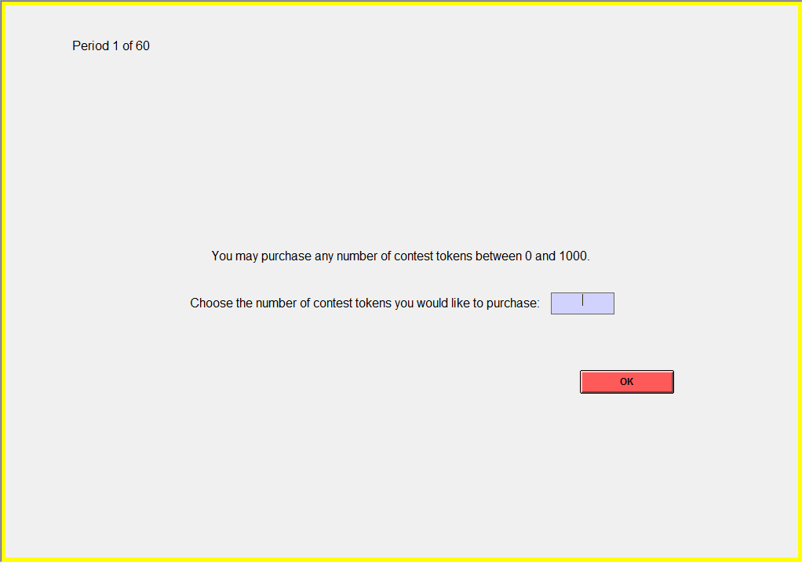

**[LOTTERY:** Once everybody has chosen how many contest tokens to purchase, the computer will determine which participant in your group wins the prize of 1000 points. Your chances of winning the prize will depend on how many contest tokens you have purchased and the total number of contest tokens purchased in your group.

If nobody in your group purchases any contest tokens, none of you will win the prize. Otherwise, the computer will determine which participant wins the prize in a way that will ensure that **the probability that you will win the prize is equal to the number of contest tokens that you have purchased divided by the total number of contest tokens purchased in your group**. That is, if you buy a number of *X* contest tokens and if the other two participants in your group buy *Y* and *Z* contest tokens each, then the probability that you win the prize will be *X/(X+Y+Z).* **Your contest earnings will be either 0 (if you do not win the prize), or 1000 (if you win the prize).]**

**[SHARE:** Once everybody has chosen how many contest tokens to purchase, the computer will calculate each participant’s share of the prize of 1000 points. Your share of the prize will depend on how many contest tokens you have purchased and the total number of contest tokens purchased in your group.

If nobody in your group purchases any contest tokens, none of you will receive a share of the prize. Otherwise, the computer will calculate each participant’s share of the prize so that **your share of the prize will be equal to the number of contest tokens that you have purchased divided by the total number of contest tokens purchased in your group**. That is, if you buy a number of *X* contest tokens and if the other two participants in your group buy *Y* and *Z* contest tokens each, then your share of the prize will be *X/(X+Y+Z).* Your **contest earnings will be your share times 1000 points (rounded to the nearest point)**.]

Your point earnings for the period will be calculated as follows:

**point earnings = 1000 – contest tokens purchased + contest earnings**

After all participants have made a decision, a result screen will appear. An example screenshot is shown below. This is like the screen you will see during the experiment except that the blacked out fields will be filled in according to the decisions made and the outcome of the contest in that round.

**[FULL:**

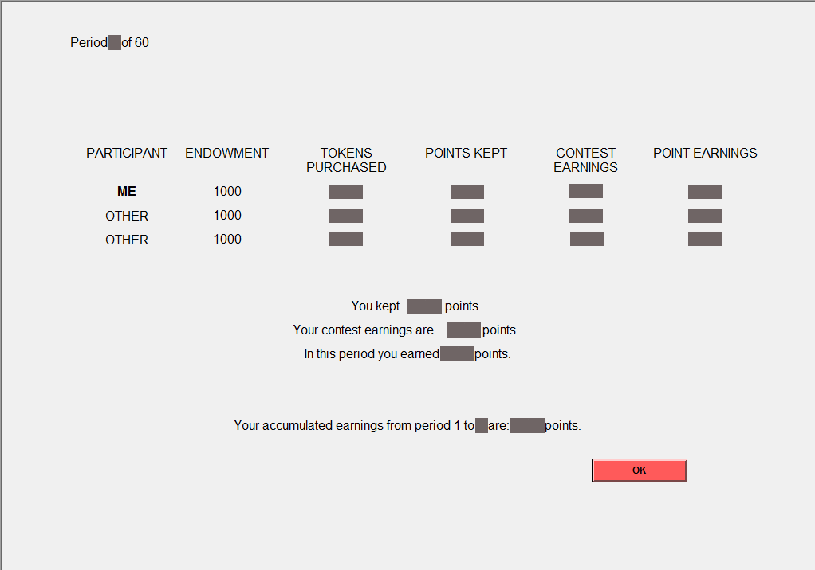

Each participant will be informed of the number of contest tokens they and the other two participants have purchased, the points remaining from their respective endowments, their respective contest earnings, and their respective point earnings for the period. The information is listed according to contest tokens purchased in descending order (with the participant who purchased most contest tokens listed first). Thus a participant’s information may be listed on different lines in different periods.**]**

**[OWN:**

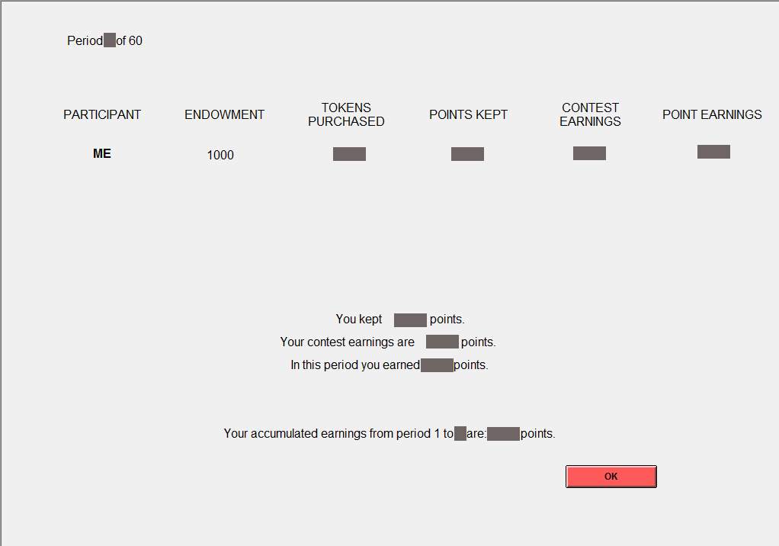

Each participant will be informed of the number of contest tokens they have purchased, the points remaining from their endowment after making their purchase, their contest earnings, and their point earnings for the period.**]**

In addition, the results screen will inform each participant of his or her accumulated points from all periods so far.

**Beginning the experiment**

If you have any questions please raise your hand and an experimenter will come to your desk to answer it.

We are now ready to begin the decision-making part of the experiment. Please look at your computer screen and begin making your decisions.

**Appendix B. Instructions for ENDOGENOUS treatment**

**Instructions**

Welcome! You are about to participate in an experiment in the economics of decision making. Please do not talk to any of the other participants until the experiment is over. If you have a question at any time please raise your hand and an experimenter will come to your desk to answer it.

The experiment will consist of 60 periods. In each period you will have the chance to earn points. At the end of the experiment each participant’s accumulated point earnings from all periods will be converted into cash at the exchange rate of 0.015 pence per point. Each participant will be paid in cash and in private.

At the beginning of the experiment you will be matched with two other people, randomly selected from the participants in this room, to form a group of three. The composition of the group will stay the same throughout the experiment, i.e. you will form a group with the same two other participants during the whole experiment. Your earnings will depend on the decisions made within your group, as described below. Your earnings will not be affected by decisions made in other groups.

All decisions are made anonymously and you will not learn the identity of the other participants in your group.

**Decision task in each period**

Each period has the same structure. In each period the three participants in each group will be competing for a prize of 1000 points.

At the beginning of the period each participant will be given **an endowment of 1000 points**. Each participant has to decide how many of these points they want to use to buy “contest tokens”. There are two types of contest tokens: public and private. The difference between these two types of tokens will be explained later in the instructions. Each contest token costs 1 point, so each participant can purchase up to 1000 of these tokens. **Any part of the endowment that is not spent on contest tokens is kept by the participant**. Each participant must enter his or her decision via the computer. An example screenshot is shown below.

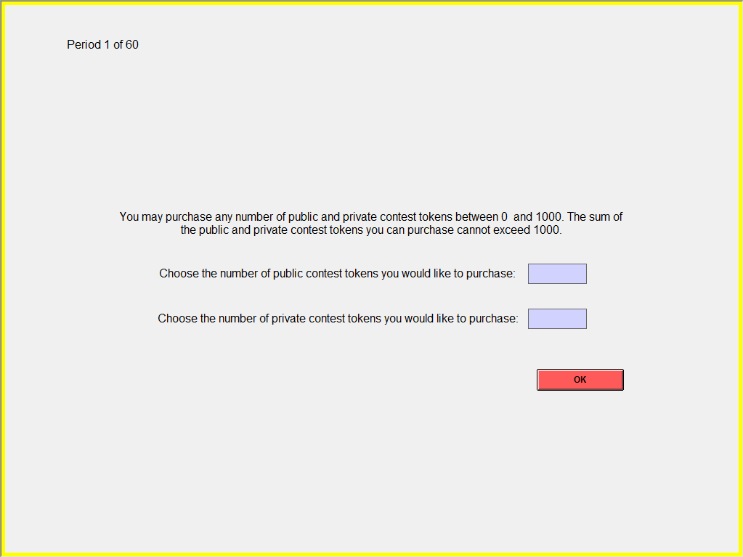

Once everybody has chosen how many contest tokens to purchase, the computer will determine which participant in your group wins the prize of 1000 points. Your chances of winning the prize will depend on how many contest tokens you have purchased and the total number of contest tokens purchased in your group. Note: The number of contest tokens you have purchased will be the sum of public and private contest tokens you have purchased. Similarly, the total number of contest tokens purchased in your group will be the sum of public and private contest tokens purchased in your group.

If nobody in your group purchases any contest tokens, none of you will win the prize. Otherwise, the computer will determine which participant wins the prize in a way that will ensure that **the probability that you will win the prize is equal to the number of contest tokens that you have purchased divided by the total number of contest tokens purchased in your group**. That is, if you buy a number of *X* contest tokens and if the other two participants in your group buy *Y* and *Z* contest tokens each, then the probability that you win the prize will be *X/(X+Y+Z).* **Your contest earnings will be either 0 (if you do not win the prize), or 1000 (if you win the prize).**

Your point earnings for the period will be calculated as follows:

**point earnings = 1000 – contest tokens purchased + contest earnings**

After all participants have made a decision, a result screen will appear. An example screenshot is shown below. This is like the screen you will see during the experiment except that the blacked out fields will be filled in according to the decisions made and the outcome of the contest in that round.

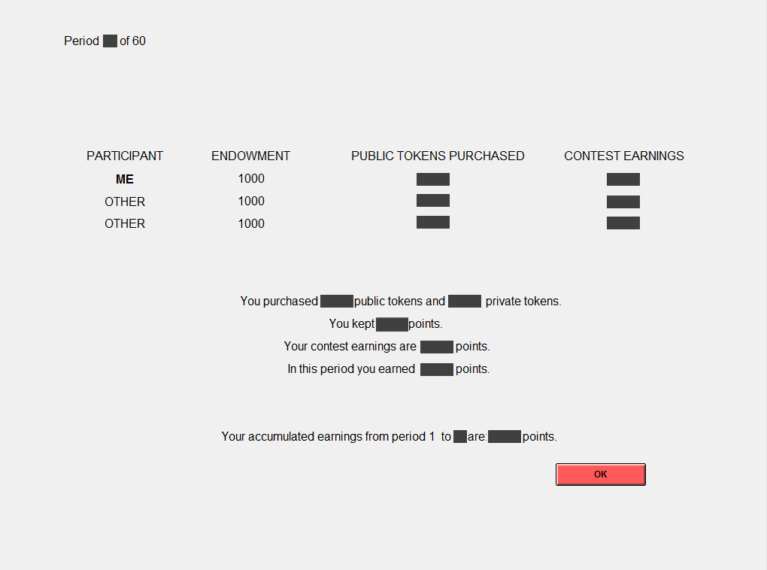

Each participant will be informed of the number of public contest tokens they and the other two participants have purchased and their respective contest earnings. The information is listed according to public contest tokens purchased in descending order (with the participant who purchased most public contest tokens listed first). Thus a participant’s information may be listed on different lines in different periods. In addition, the results screen will inform each participant of his or her public and private tokens purchased, the points remaining from the endowment, the point earnings for the period and the accumulated points from all periods so far.

Note that you will see how many public tokens the other two participants have purchased but you will not see how many private tokens they have purchased. Similarly the other participants will see how many public tokens you have purchased, but they will not see how many private tokens you have purchased.

**Beginning the experiment**

If you have any questions please raise your hand and an experimenter will come to your desk to answer it.

We are now ready to begin the decision-making part of the experiment. Please look at your computer screen and begin making your decisions.

1. School of Economics, University of Nottingham, University Park, Nottingham, NG7 2RD, United Kingdom. E-mail: francesco.fallucchi@nottingham.ac.uk
2. School of Economics, University of Nottingham, University Park, Nottingham, NG7 2RD, United Kingdom. E-mail: elke.renner@nottingham.ac.uk
3. Corresponding author. School of Economics, University of Nottingham, University Park, Nottingham, NG7 2RD, United Kingdom. E-mail: martin.sefton@nottingham.ac.uk. Tel: +44 (0) 115 846 6130. Fax: +44 (0) 115 951 4159.
4. A variety of potential explanations for deviations from equilibrium have been discussed in the literature. Risk aversion can account for departures from risk-neutral predictions. Konrad and Schlesinger (1997) show that, theoretically, risk aversion can either increase or decrease contest expenditures. However, empirical findings suggest more risk averse subjects spend less (e.g. Millner and Pratt, 1991), and so it is unlikely that risk aversion can account for the observed excess expenditure. Collusive behaviour might also create deviations from the equilibrium, although we would expect collusion to lead to lower than equilibrium expenditures. Herrmann and Orzen (2008) show that, theoretically, inequality aversion can lead to excessive expenditures, but patterns in their experimental data do not support this explanation, and in fact their subjects act as if they get additional utility from earning more than an opponent. They speculate that a “joy of winning” motive may explain excessive expenditures. Sheremeta (2010) introduces a method for measuring the joy of winning and finds support for this explanation. Some models of mistakes can also predict excessive expenditures. As shown by Lim et al. (2012), McKelvey and Palfrey’s (1995) model of Quantal Response Equilibrium predicts excessive expenditures when the equilibrium expenditure is less than half the endowment (as is commonly the case in experiments).
5. Many studies are excluded from Table 1 because they deviate from the description given at the beginning of this section in some respect. For example, the pioneering studies of Millner and Pratt (1989, 1991) employ a design in which expenditures are made continuously during a period with real-time updating of information about all contestants’ purchases, while Shogren and Baik (1991) use a design in which subjects receive an initial endowment to cover expenditures for the entire sequence of contests. See Sheremeta (2013) for a more extensive summary of experiments and findings.
6. Information feedback *within contests* has been extensively studied in experiments on dynamic contests and tournaments (see the discussion in Dechenaux et al., 2012). Our focus is different since we study information feedback *between contests*. Mago et al. (2013) also vary between-contest feedback holding other variables constant. We discuss their experiment and how our results relate to theirs in Section 7.
7. This is also equivalent (up to addition of a constant) to a Cournot competition game where firm *i* chooses a level of output, $x_{i}$, has linear costs, and market price is given by the isoelastic inverse demand function $p=V/X$ where $X$ represents aggregate output.
8. They do find significant differences when the cost functions are convex. In this case the lottery contest results in excess expenditures relative to equilibrium, while the share contest results are closer to equilibrium.
9. This is the case as long as the winner’s expenditures do not exceed the rent (as in our experiment, where *V = e*). As long as *xi ≤ V* it follows that the winner’s payoff is $e-x_{i}+V≥e$, and a loser’s payoff is $e-x_{i}≤e$ and so the winner has the highest payoff. Letting ${\overline{x}}_{0}$ and $σ_{0}^{2}$ denote the average and standard deviation of individual expenditures in period 0 then under the imitate-the-best rule the expected value of subject *i*’s expenditure in period 1 is .
10. The large number of periods distinguishes our experiment from most of the previous contest experiments, and was chosen because of our interest in the effect of information feedback. Brookins and Ryvkin (2011) is the only study we are aware of that has as many periods.
11. If none of the subjects bought any tokens the prize was not shared or assigned.
12. Screenshots of the feedback screens are included in the instructions, reproduced in Appendix A.
13. Note however, that we do not observe convergence to the equilibrium at the individual group level, and that in fact there is substantial dispersion in expenditures within groups. Taking the difference between the highest and lowest expenditure in a group in a period as a measure of dispersion, dispersion averaged across all groups and periods is 363.22 in OWN, and significantly lower, 249.48, in FULL (p = 0.067).
14. A formal Wald test rejects the hypothesis that the coefficients on best response and imitate the average are equal (periods 1-30: χ2(1) = 31.78, p = 0.000; periods 31-60: χ2(1) = 15.54, p = 0.000).
15. This upward drift is not inconsistent with the absence of trend noted earlier, as it is offset by adjustments in the direction of the best response, which tend to pull down expenditures.
16. There is also a clear treatment effect in terms of dispersion. As for the SHARE treatments, within-group dispersion of expenditures in the LOTTERY treatments is significantly lower in FULL, where it averages 402.85, compared to OWN, where it averages 628.19 (p = 0.002).
17. It is also interesting to compare lottery and share contests in a given information condition. Expenditures are significantly higher in LOTTERY-OWN than SHARE-OWN (periods 1-30: p = 0.004; periods 31-60: p = 0.001), but expenditures in LOTTERY-FULL and SHARE-FULL are not significantly different (periods 1-30: p = 0.833; periods 31-60: p = 0.778). The latter result contrasts with Sheremeta et al. (2012) who report substantial differences in rent dissipation between lottery and share contests with full information feedback. Note, however, that in addition to numerous other design differences, their results are based on a twenty-period experiment whereas ours is based on sixty periods. In the first twenty periods of our experiment we also observe substantially higher dissipation rates in our LOTTERY-FULL treatment (150% of equilibrium levels) compared to our SHARE-FULL treatment (136% of equilibrium levels), although this difference is not significant in our data.
18. We did not estimate the model for the LOTTERY-OWN treatment since subjects could not observe any of the variables.
19. Excessive expenditures and limited learning in low information settings is reminiscent of findings from experiments using the “Buying a Company” task (Samuelson and Bazerman, 1985). In these experiments subjects’ bids result in losses, on average, and losses persist even when the task is repeated with own-earnings information at the end of each task (see, for example, Selten et al., 2005). Interestingly, Bereby-Meyer and Grosskopf (2008) find that one reason for persistent over-bidding is the stochastic link between bids and outcomes.