**Method description**

**Longitudinal study**

This study tracked oral vocabulary and reading abilities longitudinally across three phases. For Phase 1, pupils were aged 11-12 years (Year 7), for Phase 2, 12-13 years (Year 8), and for Phase 3, 13-14 years (Year 9). The initial sample size was 210 in Phase 1, with minimal attrition resulting in 195 pupils in Phase 2 and a final sample size of 186 in Phase 3.

A battery of standardised assessments of oral vocabulary and reading were administered annually during two sessions of approximately 1 hour each. The battery also included a measure of nonverbal reasoning. We followed manual instructions. Where there were parallel forms, we used the same form each year. For the reading comprehension task, participants read the same passages each year.

Oral vocabulary: the British Picture Vocabulary Scale – Third Edition (BPVS-3; Dunn, Dunn, & NFER, 2009) and the Vocabulary subtest of the Wechsler Abbreviated Scale of Intelligence – Second Edition (WASI-II; Wechsler, 2011).

Word-level reading: the Test of Word Reading Efficiency – Second Edition (TOWRE-2; Wagner, Torgesen, & Rashotte, 2011), the revised Castles and Coltheart test (CC2; Castles et al., 2009) and the Single Word Reading Test (SWRT) published within the York Assessment of Reading Comprehension (Stothard, Hulme, Clarke, Barnby, & Snowling, 2010).

Reading comprehension: four passages from the secondary version of the York Assessment of Reading for Comprehension (YARC; Stothard et al., 2010).

Nonverbal reasoning: the Matrix Reasoning subtest of the WASI-II (Wechsler, 2011).

Schools provided information about gender, date of birth (translated into birth year to protect child identities), free school meals eligibility, special educational needs and English as an additional language.

**Experiment 1**

Participants took part in an experiment in which they learned words.

Participants: Seventy-four children took part: 33 formed an older age group and 41 formed a younger age group. Participants in the older age group also took part in the longitudinal study described above. Older participants completed Time 1 only. Younger participants were invited to take part in Time 2.

Procedure: At Time 1, participants were taught spoken forms and meanings for each word. The presence of orthography during teaching was manipulated within participants: half of the words appeared with orthography present and half without orthography. Instructions was manipulated between participants: instructions were used to alert half of the children to the presence of orthography; for remaining children the presence of orthography was incidental. Post-tests indexed newly learned knowledge of word meanings and orthographic forms one week after training. A subsample repeated the post-tests nine months later at Time 2.

Experimental stimuli (words and definitions learned):

| *Stimuli* | *Definitions* |
| --- | --- |
| accolade | a strong compliment |
| cataclysm | a violent event |
| contrition | a sorry feeling |
| debacle | a sudden failure |
| dormancy | a sleepy state |
| epigram | a witty remark |
| foible | a personality weakness |
| fracas | a noisy argument |
| lassitude | a tired mood |
| luminary | an inspirational person |
| nonentity | an unimportant character |
| platitude | a meaningless comment |
| propensity | a predictable behaviour |
| raconteur | a good storyteller |
| syncopation | a musical pattern |
| veracity | a truthful situation |

Post-tests used to measure learning:

* Orthographic post-test (spelling), maximum score: 1 per word, 16 overall
* Semantic post-test (production only), maximum score: 2 per word, 32 overall
* Semantic post-test (recognition or production), maximum score: 1 per word, 16 overall

**Experiment 2**

Participants took part in an experiment in which they learned novel words.

Participants: Twenty-nine children took part. All also took part in the longitudinal study so background measures were taken from Phase 3 of the longitudinal study, which occurred approximately nine months earlier. Experiment 2 participants additionally completed two subtests from the Clinical Evaluation of Language Fundamentals – Fourth UK Edition (CELF-4; Semel, Wiig, & Secord, 2006).

Procedure: Participants read nonfiction passages on four topics (brain, glaciers, pottery, Tudors), which contained the novel words and provided cues to meaning. Prior to reading, each participant received pre-training for half of the words and no pre-training for the remaining words. For half of the participants pre-training focused on spoken forms only (phonology), for the other participants pre-training included spoken forms and meanings (phonology and semantics). Post-tests were administered at three points to index learning of spelling patterns and meanings. Post-test 1 was after pre-training and the first reading opportunity (Exposure 1), Post-test 2 was the next day, and Post-test 3 was after Exposure 2 (see figure below). At the end of the study participants received a crib sheet with the real spoken forms for the words.

Overview of procedure:

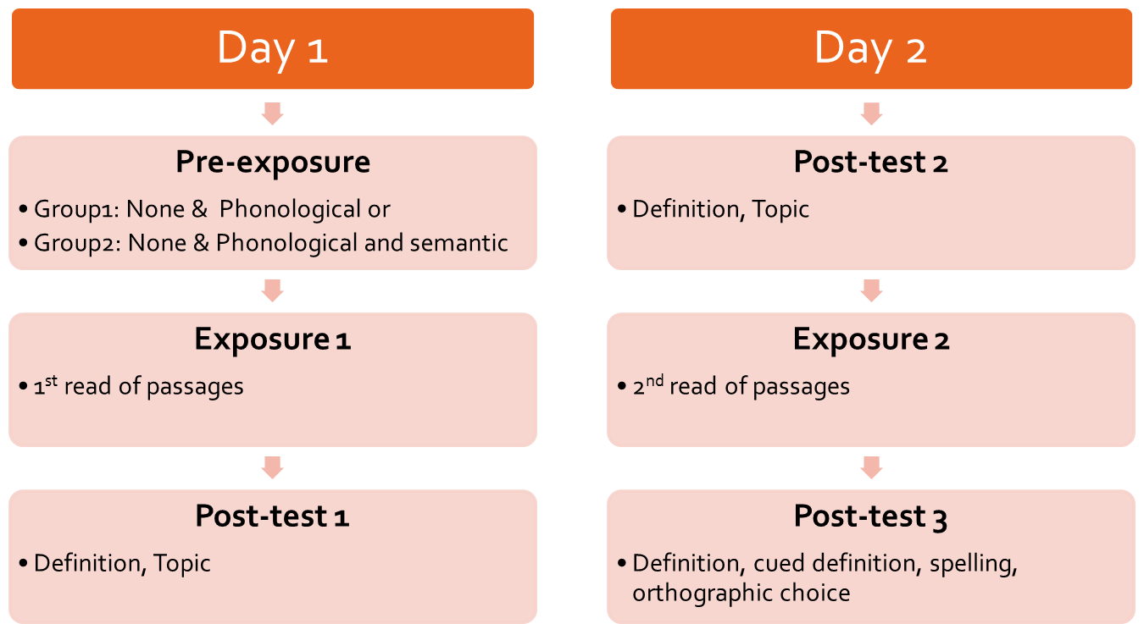

Experimental stimuli (items learned): Nonwords (Mousikou, Sadat, Lucas, & Rastle, 2017) were paired with the meanings of real words.

|  |  |  |
| --- | --- | --- |
| *Nonword* | *Topic* | *Word* |
| shactoun | Brain | meninges |
| danchoff | Brain | pons |
| pavil | Brain | glia |
| cunod | Brain | electroencephalogram |
| prulli | Glaciers | firn |
| hoolab | Glaciers | serac |
| tamcem | Glaciers | pingo |
| glorak | Glaciers | ungulate |
| baranx | Pottery | jolley |
| murrop | Pottery | bagwall |
| flastib | Pottery | saggar |
| virtam | Pottery | dunt |
| stiggup | Tudors | carnelian |
| teltike | Tudors | sarcanet |
| gudsete | Tudors | clocking |
| hirbund | Tudors | pauldron |

**References**

Castles, A., Coltheart, M., Larsen, L., Jones, P., Saunders, S., & McArthur, G. (2009). Assessing the basic components of reading: A revision of the Castles and Coltheart test with new norms. *Australian Journal of Learning Difficulties, 14*(1), 67-88.

Dunn, L. M., Dunn, D. M., & NFER. (2009). *British Picture Vocabulary Scale - Third Edition* (3rd ed.). London: GL Assessment Ltd.

Mousikou, P., Sadat, J., Lucas, R., & Rastle, K. (2017). Moving beyond the monosyllable in models of skilled reading: Mega-study of disyllabic nonword reading. *Journal of Memory and Language, 93*, 169-192. doi:<http://dx.doi.org/10.1016/j.jml.2016.09.003>

Semel, E., Wiig, E., & Secord, W. (2006). *Clinical Evaluation of Language Fundamentals - Fourth UK Edition (CELF-4 UK)*. London: Pearson Assessment.

Stothard, S., Hulme, C., Clarke, P. J., Barnby, P., & Snowling, M. (2010). *The York Assessment of Reading for Comprehension (YARC): Passage Reading Secondary*. London: GL Assessment.

Wagner, R. K., Torgesen, J. K., & Rashotte, C. A. (2011). *Test of Word Reading Efficiency - Second Edition (TOWRE-2)*. Austin, TX: Pro-Ed.

Wechsler, D. (2011). *Wechsler Abbreviated Scale of Intelligence - Second Edition (WASI-II)*. San Antonio, TX Pearson.