ESRC/FSA Survey objective (from grant): An in-home face-to-face Computer Assisted Personal Interview (CAPI) survey with a quota sample (n=650) to include males and females, from a variety of ages (18-65 age range) and social classes in the North and South of England to examine the effectiveness of food fraud prevention strategies for increasing consumer trust in the food chain as well as adding value and increasing sales.

Questionnaire items: Questionnaire items were defined, taking into account Ajzen’s conceptual and methodological considerations for constructing a theory of planned behavior (TPB) questionnaire (Ajzen, 1991, 2006) and the previous findings on similar topics (especially doi:10.1016/j.foodcont.2013.09.006 which explores intention to buy traceable chicken/honey). Figure below shows the model structure. We have adapted the questions to explore intention to buy traceable minced beef and beef steak; 50 % of consumers answer questions in relation to minced beef and 50% answer questions in relation to beef steak. Note: circles represent latent variables and rectangles represent observed variables. In grey, we show the original structure of the TPB model; in white, we show the added variables in the extended TPB model by doi:10.1016/j.foodcont.2013.09.006; in blue, we show the variables which have been added by ourselves.
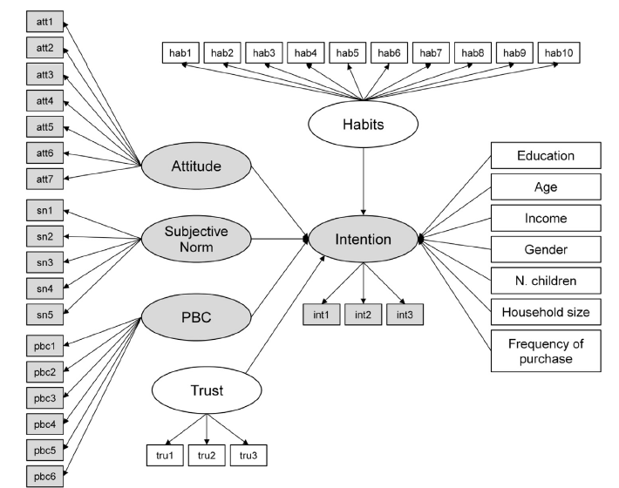
Need for information scale
Food hazard concern and structural trust
WTP N=1
Reduced Attitudes to n=4
General beef purchasing habits
Beliefs N=9
Hab 12
Hab 11
Variable type | Variable / source / interpretation | Questionnaire items | Items
SCREENING QUESTIONS  “at least 40% of respondents should use food labels ‘almost every time’ when buying a product for the first time or choosing between two or more food products”.  “each respondent should have at least some responsibility for buying beef and beef products for their family” | Label use doi: 10.1017/S136898001100156X  Beef purchasing and use  Unprocessed beef frequency of purchase  Place of purchase of unprocessed beef  Minced beef frequency of purchase  Place of purchase for minced beef  Purchase of beef products – as we only ask about steak or mince within questionnaire I have not asked these question in depth | Q: How often do you use food labels when you buy a product for the first time?  Never 1  Almost never 2  Occasionally/Sometimes 3  Almost every time 4 40% of respondents  Every time 5  Q: How often do you use food labels when you choose between two or more food products?  Never 1  Almost never 2  Occasionally/Sometimes 3  Almost every time 4 40% of respondents  Every time 5  Q: To what extent are you responsible for each of the following in your household: SHOWCARD A  all or most more than half about half less than half not responsible for any  Buying beef and beef products 1 2 3 4 5 (exclude)  Cooking and preparing meals made with beef and beef products 1 2 3 4 5  Q: How often do you purchase unprocessed beef such as beef steaks, steak pieces and roasts for your household?: SHOWCARD B CODE ONLY ONE  Every day or almost everyday 1  Several times a week 2  Once a week 3  Several times a month 4  Once a month 5  Every two months 6  Every three/four months 7  Twice per year 8  Once per year 9  Never 10  Q: Where do you typically purchase these from?: SHOWCARD C  CODE ALL THAT APPLY  Tesco 1  Asda 2  Sainsbury’s 3  Morrisons 4  Co-op 5  Marks and Spencer 6  Waitrose 7  Aldi 8  Lidl 9  Iceland 10  Wholesalers 11  Butcher shop 12  Specialty health store 13  Farm shop 14  Market 15  Other, please specify:  Q: How often do you purchase minced beef for your household? SHOWCARD B CODE ONLY ONE  Every day or almost everyday 1  Several times a week 2  Once a week 3  Several times a month 4  Once a month 5  Every two months 6  Every three/four months 7  Twice per year 8  Once per year 9  Never 10  Q: Where do you typically purchase this from?: SHOWCARD C  CODE ALL THAT APPLY  Tesco 1  Asda 2  Sainsbury’s 3  Morrisons 4  Co-op 5  Marks and Spencer 6  Waitrose 7  Aldi 8  Lidl 9  Iceland 10  Wholesalers 11  Butcher shop 12  Specialty health store 13  Farm shop 14  Market 15  Other, please specify:  Q: Do you purchase products made with processed beef e.g. burgers, ready meals, sausages, and meat balls for your household?  Yes 1  No 2 | 8
SECTION ONE: FOOD HAZARD CONCERN AND STRUCTURAL TRUST
PERSONAL CONCERN ABOUT GENERAL FOOD HAZARDS | 1.1 Food integrity questionnaire (I modified the wording and scale (previously agreement) because I don’t think they match in the original)  (Rationale: I’ve chosen 1.1 rather than 1.2 because I think 1.1 covers personal concern rather than society concern (1.2). | Q: Please use the scale from 1 to 5 on SHOWCARD D to indicate how concerned you are about each of the following food and drink hazards for you and your family: (CODE FOR EACH)  Not at all concerned Slightly concerned Somewhat concerned Moderately concerned Extremely concerned  Counterfeit food and drink 1 2 3 4 5  Inferior quality food and drink 1 2 3 4 5  Food and drink containing residues of pesticides or veterinary drugs 1 2 3 4 5  Deteriorated food and drink (for example, mould and bacteria) 1 2 3 4 5  Nutritionally imbalanced food and drink 1 2 3 4 5  Food and drink containing additives 1 2 3 4 5  Genetically modified food and drink 1 2 3 4 5  Food and drink that has been misdescribed 1 2 3 4 5  Adulterated food and drink (for example: tainted food and drink, food and drink that has been diluted or had chemicals added) 1 2 3 4 5  Q: Do you have any concerns in relation to the quality and safety of beef? | 10
STRUCTURAL TRUST | 3.4 Food Integrity questionnaire (changed wording because question does not agree with responses and added in other organisations in 3.4, changed scale to 7 point)  Trust in current regulations and procedures  Trust in organisations | I am now going to ask you questions about authentic food and drink. By ‘authentic food and drink’ I mean that the food and drink has not been tampered with in any way and it is what it says it is.  Q: I will read a list of organisations and individuals and I would like you to tell me the extent to which you disagree or agree that they can be trusted to provide consumers with accurate sources of information about the authenticity of food and drink? Please use the scale from 1 to 7 on SHOWCARD E: (CODE FOR EACH)  Scale: Strongly disagree (1) to strongly agree (7)  Food and drink supermarkets  Food and drink manufacturers  Consumer organisations e.g. Which?  University research scientists  Industry scientists  The media  The Food Standards Agency (FSA)  Environmental organisations  Other please specify: | 8-10
SECTION TWO: GENERAL BEEF PURCHASING HABITS AND VALUES
NOTE: 50% OF RESPONDENTS WILL BE ASKED ABOUT MINCED BEEF AND 50% WILL BE ASKED ABOUT BEEF STEAK FROM THIS POINT ONWARDS.
IMPORTANCE OF BEEF ATTRIBUTES  Shopping behavior after horsemeat scandal |  | Q: I will read out a list of qualities associated with <minced beef/beef steak> and I would like you to tell me the extent to which they are not important or important to you when buying <minced beef/beef steak>. Please use the scale from 1 to 7 on SHOWCARD F: (CODE FOR EACH)  Scale: Not at all important (1) to extremely important (7)  Price  Origin information  Where you buy it from  Locally produced  Tenderness  Freshness  Colour  Taste  Quality  The brand  Healthiness / nutritional content  Food assurance schemes (e.g. red tractor)  Animal welfare practices  Environmental friendliness  Organic production methods  The kind of packaging  Other please specify:  Q: Did you change your beef shopping behavior immediately after the horsemeat scandal?  Yes 1 - go to next question  No 2 - skip to question ?  Q: Please read the behaviours on SHOWCARD G and tell me which apply?  CODE ALL THAT APPLY  Not buying the product affected by the scare 1  Reading food labels more carefully 2  Changing towards well known and brands of confidence 3  Changing the retail outlet where I do my shopping 4  Buying less unprocessed beef e.g. steak, roasts. 5  Buying less products containing processed beef e.g. burgers, sausages, ready meals, meat balls. 6  Buying more unprocessed beef e.g. steak, roasts. 7  Buying more products containing processed beef e.g. burgers, sausages, ready meals, meat balls. 8  Q: Do you still continue to do those behaviours?  Yes 1 - go to next question  No 2 - skip next question  Q: Which behaviours have you continued? SHOWCARD G  CODE ALL THAT APPLY  Not buying the product affected by the scare 1  Reading food labels more carefully 2  Changing towards well known and brands of confidence 3  Changing the retail outlet where I do my shopping 4  Buying less unprocessed beef e.g. steak, roasts. 5  Buying less products containing processed beef e.g. burgers, sausages, ready meals, meat balls. 6  Buying more unprocessed beef e.g. steak, roasts. 7  Buying more products containing processed beef e.g. burgers, sausages, ready meals, meat balls. 8 | 17
BEEF PURCHASING HABITS (TPB exploring minced beef and beef steak))  This recent fruit and veg habit paper in appetite is of interest: doi:10.1016/j.appet.2009.08.007 | doi:10.1016/j.foodcont.2013.09.006  The authors ask about whether consumers look for 4 types of info: farmer, country and region of origin, production process and certification of all of the above. In relation to farmer and certification, they also ask 3 further questions which characterise habit by automaticity, frequency, and self-identity. N=10 in total  Modification: I deleted the farmer as we don’t normally have this on packs, and made certification unique to farm assurance and other niche schemes. I used the 4-item automaticity subscale (the ‘self-report behavioural automaticity index’; SRBAI) (DOI: 10.1186/1479-5868-9-102) to assess country, production process, and schemes. Note: the original SRHI is a 12 item measure (DOI: 10.1111/j.1559-1816.2003.tb01951.x.).  Based on 4.3 food integrity (changed certification labels to assurance schemes)  Trust in shopping places. These are all the major supermarkets with the largest market share: I have not included convenience stores such as Costcutter, Mace, SPAR etc. We also need them to rate where they buy steak/minced beef in the other box. | Q: Use the scale from 1 to 7 on SHOWCARD E to rate your disagreement or agreement with the following statements: (CODE FOR EACH)  Scale: Strongly disagree (1) to strongly agree (7)  When I buy <minced beef/beef steak>, looking for information about the country or region of origin is something I do automatically  When I buy <minced beef/beef steak>, looking for information about the country or region of origin is something I do without having to consciously remember  When I buy <minced beef/beef steak>, looking for information about the country or region of origin is something I start doing before I realise I’m doing it  When I buy <minced beef/beef steak>, looking for information about the country or region of origin is something I do without thinking  When I buy <minced beef/beef steak>, looking for information about the production process that is needed to make the beef (e.g. feed, rearing conditions, transport, slaughter and processing) is something I do automatically  When I buy <minced beef/beef steak>, looking for information about the production process that is needed to make the beef (e.g. feed, rearing conditions, transport, slaughter and processing) is something I do without having to consciously remember  When I buy <minced beef/beef steak>, looking for information about the production process that is needed to make the beef (e.g. feed, rearing conditions, transport, slaughter and processing) is something I start doing before I realise I’m doing it  When I buy <minced beef/beef steak>, looking for information about the production process that is needed to make the beef (e.g. feed, rearing conditions, transport, slaughter and processing) is something I do without thinking  When I buy <minced beef/beef steak>, looking for food assurance schemes such as red tractor, or smaller ‘niche’ schemes that aim to meet particular consumer demands such as higher welfare, environmental or organic standards, is something I do automatically  When I buy <minced beef/beef steak>, looking for food assurance schemes such as red tractor, or smaller ‘niche’ schemes that aim to meet particular consumer demands such as higher welfare, environmental or organic standards, is something I do without having to consciously remember  When I buy <minced beef/beef steak>, looking for food assurance schemes such as red tractor, or smaller ‘niche’ schemes that aim to meet particular consumer demands such as higher welfare, environmental or organic standards, is something I start doing before I realise I’m doing it  When I buy <minced beef/beef steak>, looking for food assurance schemes such as red tractor, or smaller ‘niche’ schemes that aim to meet particular consumer demands such as higher welfare, environmental or organic standards, is something I do without thinking  Q: Do you look for any assurance schemes/logos (not brands) when buying beef?  Yes 1 - go to next question  No 2 - skip next question  Q: Please name the labels/logos (not brands!) and tell me why these are of interest to you: INTERVIEWER INSERT RESPONSE  Q: I will read a list shopping places and I would like you to tell me the extent to which you disagree or agree that they can be trusted to protect the consumer from adulterated and unsafe beef? Please use the scale from 1 to 7 on SHOWCARD E: (CODE FOR EACH)  Scale: Strongly disagree (1) to strongly agree (7)  Tesco  Asda  Sainsbury’s  Morrisons  Co-op  Marks and Spencer  Waitrose  Aldi  Lidl  Iceland  Wholesalers  Butcher shop  Specialty health store  Farm shop  Market  Other please specify: | 12  1  1 optional open  16
SECTION THREE: PERCEPTION TOWARDS TRACEABLE MINCED BEEF/BEEF STEAK
DEFINITION OF TRACEABLE BEEF STEAK/MINCED BEEF | Adapted from: doi:10.1016/j.foodcont.2013.09.006 | In the following part of the questionnaire, you will be asked questions about a traceable beef product. The product is traceable <minced beef/beef steak>.  Traceable <minced beef/beef steak> is different to other <minced beef/beef steak> widely available in stores because it has unique details by which you can trace it back to the specific farm or farms on which it was raised. As a consumer, you can check the whole life story of traceable <minced beef/beef steak>, from the farm on which it was bred - to the retailer, by entering a code online or by scanning a QR code on the pack via your smart phone.  You can obtain Information about its farmer, the production process of the <beef steak/minced beef> (e.g., feed, rearing conditions, transport, slaughter and processing), country and region of origin, and an assurance from an independent body that this information can be trusted.  For example, SHOWCARD H <minced beef/beef steak>, this code can be instantly checked to verify any claims on the pack and find out specifically where and how your <minced beef/beef steak> was farmed and processed.  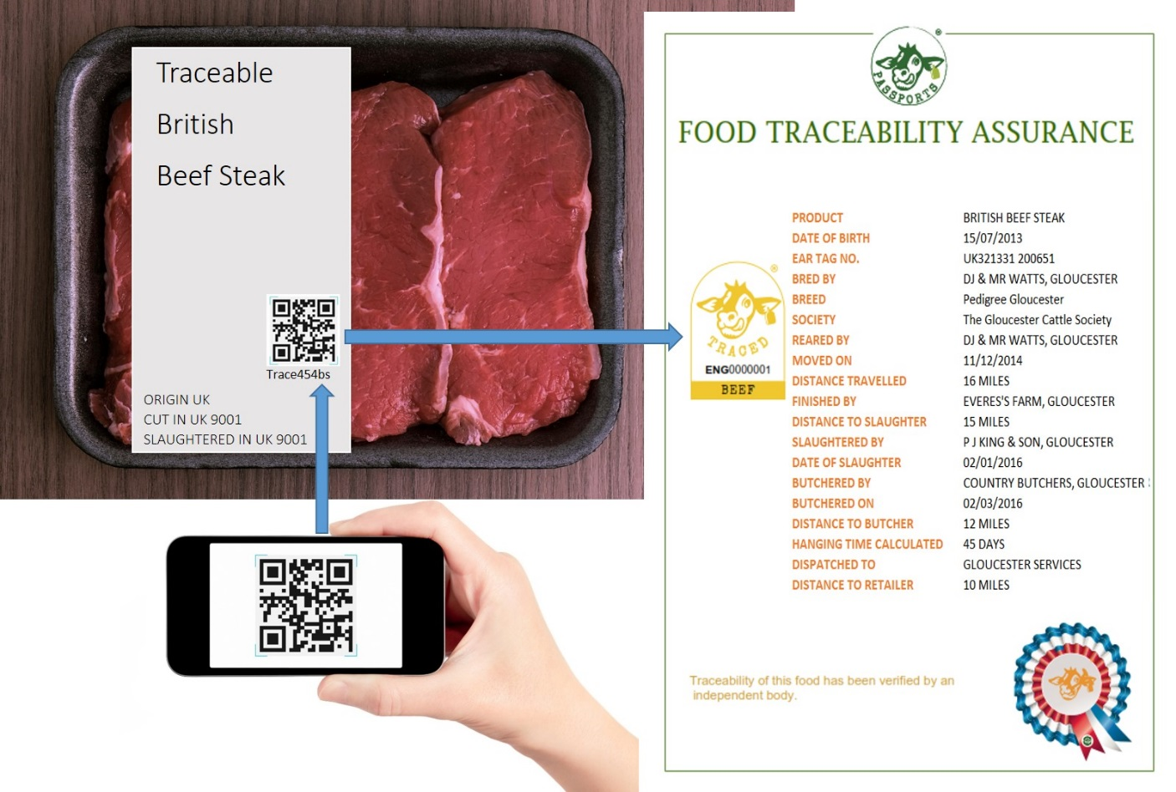  This is just one example, the information obtained will be dependent on the specific <minced beef/beef steak > product. If it is, for example, organic, this information will also be available.  Q: Any thoughts or comments on this?  INTERVIEWER INSERT RESPONSE
BELIEFS TOWARDS PURCHASING TRACEABLE BEEF IN COMPARISON TO BEEF CURRENTLY AVAILABLE IN STORES | doi:10.1016/j.foodcont.2013.09.006  We adopted these as beliefs rather than attitudes which is the way they were described in the above reference. Inserted the word ‘more’ in the origin statement and replaced the controlled statement for an authentic statement | Q: Thinking about traceable beef, in comparison to other beef now available in supermarkets, please use the scale from 1 to 7 on SHOWCARD E to rate your disagreement or agreement with the following statements: (CODE FOR EACH)  Scale: Strongly disagree (1) to strongly agree (7)  Traceable <minced beef/beef steak> will likely be healthier  Traceable <minced beef/beef steak> will likely be tastier  Traceable <minced beef/beef steak> will likely be more expensive  Traceable <minced beef/beef steak> will more likely be of known origin  Traceable <minced beef/beef steak> will likely be safer  Traceable <minced beef/beef steak> will likely be of more satisfying quality  Traceable <minced beef/beef steak> will more likely be authentic which means it has not been tampered with in any way and it is what it says it is  Traceable <minced beef/beef steak> will likely be more environmentally friendly  Traceable <minced beef/beef steak> will likely have higher animal welfare standards | 9
ATTITUDES TOWARDS PURCHASING TRACEABLE BEEF IN COMPARISON TO BEEF CURRENTLY AVAILABLE IN STORES | Based on Dean et al,. 2011 Intention to purchase organic tomatoes | Q: Please use the two scales from 1 to 7 on SHOWCARD I to complete this statement: buying traceable <minced beef/beef steak> instead of <minced beef/beef steak> now available in supermarkets would make me feel:  Scale: bad (1) good (7)  Scale: displeased (1) pleased (7)  Q: Please use the two scales from 1 to 7 on SHOWCARD J to complete this statement: I think that buying traceable <minced beef/beef steak> instead of conventional <minced beef/beef steak> is:  Scale: foolish (1) wise (7)  Scale: harmful (1) beneficial (7) | 4
PERCEIVED SUBJECTIVE NORMS TOWARDS PURCHASING TRACEABLE BEEF AMONG FAMILY AND FRIENDS, DOCTORS AND NUTRITIIONISTS, MEDIA, THE FOOD INDUSTRY, AND OTHER IMPORTANT PEOPLE | doi:10.1016/j.foodcont.2013.09.006  University scientists were added in and nutritionist and doctors removed. | Q: Use the scale from 1 to 7 on SHOWCARD E to rate your disagreement or agreement with the following statements: (CODE FOR EACH)  Scale: Strongly disagree (1) to strongly agree (7)  I would buy traceable <minced beef/beef steak> because my family, partner and friends approve  I would buy traceable <minced beef/beef steak> because university scientists are in favour of it  I would buy traceable <minced beef/beef steak> because the media (TV, radio) are in favour of it  I would buy traceable <minced beef/beef steak> because the food industry and/or food supermarkets promote it  I would buy traceable <minced beef/beef steak> because people important to me buy this type of beef | 5
PERCEIVED BEHAVIOURAL CONTROL REGARDING THE IDENTIFICATION OF ADDITIONAL INFORMATION ABOUT THE PRODUCTION PROCESS AND ORIGIN OF TRACEABLE BEEF | doi:10.1016/j.foodcont.2013.09.006  ‘be able to’ was added to two of the statements | Q: Use the scale from 1 to 7 on SHOWCARD E to rate your disagreement or agreement with the following statements: (CODE FOR EACH)  Scale: Strongly disagree (1) to strongly agree (7)  It will be easy to find additional information (via the code) about the production process and origin of traceable <minced beef/beef steak>  I will be confident that I’ll find additional information (via the code) about the production process and origin of traceable <minced beef/beef steak>  I will be able to find additional information (via the code) about the production process and origin of traceable <minced beef/beef steak> without help from others  It will be easy to understand the additional information (via the code) about the production process and origin of traceable <minced beef/beef steak>  I will be confident that I’ll understand additional information (via the code) about the production process and origin of traceable <minced beef/beef steak>  I will be able to understand additional information (via the code) about the production process and origin of traceable <minced beef/beef steak> without help from others | 6
INTENTION TO BUY TRACEABLE BEEF | doi:10.1016/j.foodcont.2013.09.006 | Q: Use the scale from 1 to 7 on SHOWCARD E to rate your disagreement or agreement with the following statements: (CODE FOR EACH)  Scale: Strongly disagree (1) to strongly agree (7)  When traceable <minced beef/beef steak> becomes available, I intend to buy it  When traceable <minced beef/beef steak> becomes available, I will look for it  When traceable <minced beef/beef steak> becomes available, it will be important to me to buy it | 3
TRUST IN TRACEABLE BEEF | doi:10.1016/j.foodcont.2013.09.006 | Q: Use the scale from 1 to 7 on SHOWCARD E to rate your disagreement or agreement with the following statements: (CODE FOR EACH)  Scale: Strongly disagree (1) to strongly agree (7)  I trust that traceable <minced beef/beef steak> can be traced back to the <actual farm>  I trust the information provided about the production process and origin of the traceable <minced beef/beef steak>  I trust that traceable <minced beef/beef steak> is authentic which means it has not been tampered with in any way and it is what it says it is | 3
WTP | doi:10.1016/j.foodcont.2013.09.006  Prices were displayed per kg but we changed them per pack.  Based on Tesco lean beef steak mince 500g pack 5%  And sirloin steak 2 pack 17.34 per kg | Q: Suppose the price of <minced beef/beef steak> currently available in the supermarket is <£4.00 for a 500g pack/£8.67 for two steaks >. The price of the traced <minced beef/beef steak> with the unique identity details and the additional available information will be higher but it is not determined yet. How much more would you be willing to pay to purchase <500g of traceable minced beef/two traceable beef steaks>? SHOWCARD K  Nothing more 1  +5% (= £4.20/9.10) 2  +10% (= £4.40/9.54) 3  +15% (= £4.60/9.97) 4  +20% (= £4.80/10.40) 5  +30% (= £5.20/11.27) 6  +40% (= £5.60/12.14) 7  +50% (= £6.00/13.01) 8  +60% (= £6.40/13.87) 9  +70% (= £6.80/14.74) 10  +80% (= £7.20/15.61) 11  +90% (= £7.60/16.47) 12  +100% (= £8.00/17.34) 13  Other please specify:
SECTION FOUR: DEMOGRAPHICS
SOCIO-DEMOGRAPHICS | Need for information  Gender  INSERT RACE QUESTION  Age  Marital status  Education  Occupation status  Highest income earner in household  SES  Number of children in household (<16 & >16)  Total household income  Smartphone and QR code use | Use the scale from 1 to 7 on SHOWCARD E to rate your disagreement or agreement with the following statements which describe your approach to life: (CODE FOR EACH)  Scale: Strongly disagree (1) to strongly agree (7)  I don’t like to have to do a lot of thinking  My initial impressions of things are almost always right  I try to avoid situations that require thinking in depth about something  I trust my initial feelings about things  I prefer to do something that challenges my thinking abilities rather than something that requires little thought  When it comes to trusting something, I can usually rely on my “gut feelings”  I believe in trusting my hunches  I prefer complex to simple problems  I can usually feel when something is right or wrong, even if I can’t explain how I know  Thinking hard and for a long time about something gives me little satisfaction  Q. INTERVIEWER RECORD RESPONDENT GENDER: CODE ONE ONLY  MALE 1  FEMALE 2  Q:  Q. What is your age? INSERT AGE  Q: What is your marital status? CODE ONE ONLY  Married 1  Single 2  Widowed 3  Divorced 4  Separated 5  Living with partner 6  Q: What is the highest level of education you have attained? CODE ONE ONLY– SHOWCARD L  None 0  Primary school 1  Secondary school to age 15/16 or junior group certificate, GCSE or O’Level 2  Secondary school to age 17/18 or leaving group certificate or A’Level, HNC 3  Additional training (e.g. NVQ, BTEC, FETAC, FAS, other) 4  University undergraduate / nursing qualification 5  University postgraduate 6  Q. What is your current occupation status? CODE ONE ONLY  Full time paid work (30+ hours per week) 1  Part-time paid work (8-29 hours per week) 2  Part-time paid work (under 8 hours per week) 3  Retired 4  At school 5  In full-time higher education 6  Unemployed (seeking work) 7  Unemployed (not seeking work) 8  Full-time homemaker 9  Q. What is or was the occupation of the highest income earner in your household?  INTERVIEWER RECORD OCCUPATION  Q: INTERVIEWER CODE SOCIAL CLASS OF CHIEF INCOME EARNER: CODE ONE ONLY  A 1  B 2  C1 3  C2 4  D 5  E 6  F (50+) 7  F (LESS THAN 50) 8  Q: How many children aged under 16 live in your household? INSERT NUMBER  Q: Including you, how many adults aged over 16 live in your household? INSERT NUMBER  Q: What is the total income of your household from all sources before tax and national insurance contributions? INCLUDE ALL INCOME FROM EMPLOYMENT AND BENEFITS SHOWCARD M  Under £6,999 per annum (less than £135 per week) 1  £7,000 - £9,999 per annum (£135 - £195 per week) 2  £10,000 - £14,999 per annum (£195 - £290 per week) 3  £15,000 - £19,999 per annum (£290 - £385 per week) 4  £20,000 - £25,999 per annum (£385 - £500 per week) 5  £26,000 - £29,999 per annum (£500 - £580 per week) 6  £30,000 - £39,999 per annum (£580 - £770 per week) 7  £40,000 - £49,999 per annum (£770 - £960 per week) 8  £50,000 - £59.999 per annum (£960 - £1,150 per week) 9  £60,000 + per annum (£1,150 per week) 10  (Don't know) 12  REFUSED 99  Q: Are you a smart phone user?  Yes 1 - go to next question  No 2 - skip next question  Q: have you ever scanned a QR code with your smartphone?  Yes 1  No 2  Q: INTERVIEWER RECORD LOCAL GOVERNMENT DISTRICT (OR SIMILAR): CODE ONE ONLY  THANK AND CLOSE

