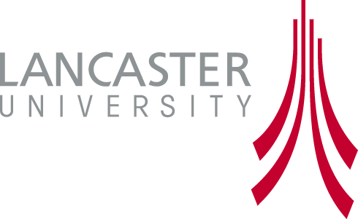
Information Sheet

Low Carbon Innovation in China
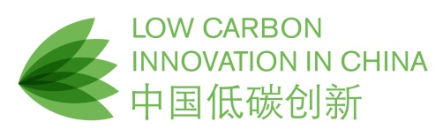
ESRC Project ES/K006002/1

Lancaster University
Principal Investigator: Professor John Urry

China's efforts to low-carbon transition are a key issue for the whole world in the coming decades. China's spectacular economic growth over 30 years has both propelled it to the core of the global economy while also generating massive and growing greenhouse gas emissions; China is now the top global emitter in absolute terms. There are now many programmes of low-carbon innovation in China. Beyond energy generation, system change in various sectors, such as agriculture and transport, is vital. These also interact closely with a top Chinese policy priority to upgrade innovation capacities and economic competitiveness alongside the continuation of an important role for the state in these sectors.
There is a growing literature on low-carbon innovation in China, especially from thinktanks, global institutions and INGOs, but most of these reports focus on technology development. They also overlook the significant differences in socio-political contexts between China and rich Western countries. They thus tend to restate conventional policy recommendations that remain ignored or are proving impossible to implement. Such obstacles are to be expected, however, when understanding transitions from a broader systems perspective that acknowledges their 'socio-technical' nature. Social, institutional and cultural factors linked to changing technologies and practices are crucial in both explaining and eliciting low-carbon transition. Examining the actual practices of users who are expected by policy or corporate strategy to shift to low-carbon technologies can provide a different, more informative picture about what, how and why particular low-carbon innovations are succeeding or failing.
This project aims to fill these gaps and insert a social science, rather than economic, paradigm into conceiving what a low-carbon future could be like. It will explore the prospects of low-carbon system transition in China in three overlapping, but importantly different, domains: solar energy, urban mobility and agri-food. To make research practicable, we focus on specific case studies, chosen to provide comparative insights regarding differing models of innovation in each domain: solar energy (PV vs. thermal), urban mobility (electric vehicles vs. e-2-wheelers) and agriculture (GM vs. agro-ecological cultivation of maize). In each case we thus compare the globally dominant model of high-technology, IP-intensive innovation favoured by current Chinese policy and an alternative model that is mobilizing other indigenous innovation resources and capabilities, but without such government support.
The project will examine 4 research questions:
1. Are low-carbon transitions emerging in the case study areas and why?
2. With what effects regarding broader systemic decarbonisation?
3. What qualitative sociological changes are emerging in China with implications for these socio-technical systems and social practices?
4. What lessons does China's approach to low-carbon innovation offer the UK regarding a) low-carbon transition & b) globally competitive low-carbon industries?
In participating in this research, we will be asking you questions regarding your experience and thoughts on the specific low-carbon innovation with which you are involved. The results will be used for academic publications, policy reports and related media articles. Responses will not be recorded via audio/video equipment, but noted and typed up by hand. All responses will also be anonymized and kept secure on a password-protected laptop, where they will remain until the end of the project, at which point they will be destroyed and not archived. No quotations attributable to you will be quoted in subsequent publications without your express consent. You are free to withdraw from the study at any time up to 2 weeks after your interview, whereupon data from your participation will be destroyed and not included in the analysis.
Brief project details

Title: Low Carbon Innovation in China
Funded by: UK National Economic and Social Research Council
Duration: December 2013 to June 2016
Principal Investigator: Distinguished Professor John Urry, Sociology Department, Lancaster University
Project Coordinator and Contact: Dr David Tyfield, Director, International Research and Innovation Centre for the Environment (I-RICE), Lancaster Environment Centre, Lancaster University, Guangzhou (d.tyfield@lancaster.ac.uk)
Project partners: Lancaster University; STEPS Centre, Sussex University; School of Oriental and African Studies, University of London; Tsinghua University; Graduate School, Tsinghua University, Shenzhen; Chinese Academy of Sciences Centre for Agricultural Policy (CCAP), Beijing.
Independent Contact (in case of concerns/complaints): Dr Bronislaw Szerszynski, Head of Department, Sociology Department, Lancaster University, LA1 4YT, UK (b.szerszynski@lancaster.ac.uk)

Draft email invitation to research participants

Dear []

[Contact through which we have been introduced]

I am writing regarding a new research project on ‘Low Carbon Innovation in China’, which is being run by colleagues at leading British and Chinese universities between 2014-2016, and is being funded by the UK national research council for the social sciences. I have included some brief further details on the project below, for your convenience, and I have attached a brief information sheet summarizing the project and its goals and research questions. But please feel free to browse our project website for more information.

I am [conducting/leading] the research work package on [solar energy/ urban e-mobility/ maize agriculture] and I would be very grateful if you could spare an hour or so of your busy schedule to meet with me to discuss your current work on [case study innovation], the prospects for a broader ‘system’ transition in China in this domain, and the obstacles to this. In this work I will be working with colleagues from [Tsinghua/Tsinghua Shenzhen/CAS CAP].

I will be in [Shanghai/Beijing …] [Arrangements/logistics – scheduling]. If you are available at any point during this period, please do let me know. Your thoughts and discussion would make a great contribution to our research.

I look forward to hearing from you shortly.

Best wishes

[Name]

Brief project details

Title: Low Carbon Innovation in China
Funded by: UK National Economic and Social Research Council
Duration: December 2013 to June 2016
Principal Investigator: Professor John Urry, Sociology Department, Lancaster University
Project Coordinator and Contact: Dr David Tyfield, Director, International Research and Innovation Centre for the Environment (I-RICE), Lancaster Environment Centre, Lancaster University, Guangzhou (d.tyfield@lancaster.ac.uk)
Project partners: Lancaster University; STEPS Centre, Sussex University; School of Oriental and African Studies, University of London; Tsinghua University; Graduate School, Tsinghua University, Shenzhen; Chinese Academy of Sciences Centre for Agricultural Policy (CCAP), Beijing.
Independent Contact (in case of concerns/complaints): Dr Bronislaw Szerszynski, Head of Department, Sociology Department, Lancaster University, LA1 4YT, UK (b.szerszynski@lancaster.ac.uk)

