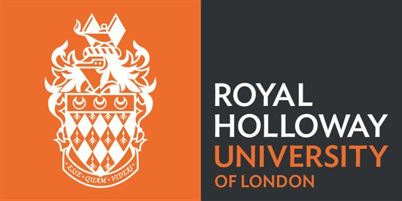

**Dr. Lara Maister**

Laboratory of Action and Body

Department of Psychology Royal Holloway | University of London

Email: [Lara.Maister@rhul.ac.uk](mailto:Lara.Maister@rhul.ac.uk)

**The ‘Love’ Study: Mouth and Motion Experiment**

My name is Dr. Lara Maister, and together with Prof. Manos Tsakiris, I am carrying out a large study investigating how romantic attachment affects the way in which we process basic social information (like other people’s sensations, emotions and actions). The current experiment is specifically looking at the relationship between relationship quality and the way you perceive others’ actions. This experiment consists of two sessions, done on separate days. The first session is a recording session, where we will record videos and images of yourself, your partner and your nominated friend. The second session consists of the experiment. You must complete both sessions.

The sessions involve completing several questionnaires about your relationship with your partner and your friend. Whenever you are asked about your friend, please remember that we are asking specifically about the friend you nominated for the recording session.

IMPORTANT: Some of the questions may seem personal or sensitive. Please note that your answers are strictly confidential – they will never be shown to anyone else and are associated with an anonymous participant number. Your partner and friend will never see your answers. So, please be as honest and truthful as you can. Please note, you do not have to answer any question that you do not wish to answer.

The other task in the sessions involves making two mouth movements (either shutting your mouth, or opening it wide) according to signals on the screen. We want to measure how fast you can respond with the correct movement. To measure your accuracy and your reaction times, we will put three small motion sensors on your face (two just under your bottom lip, and one on your forehead).

The study will take place in the Psychology Department in the Wolfson Building at Royal Holloway. The information you make available to the study is kept strictly confidential; nobody except Drs. Lara Maister and Manos Tsakiris will be allowed to see your results, and in the study you will be known only by number. You do not have to take part in this study if you do not wish to. If you decide to take part you may withdraw at any time without having to give a reason. Please keep this part of the sheet yourself for reference. Please feel free to ask any questions before you complete the consent form attached, then hand the completed consent form to the researcher. It will be stored separately from the anonymous information you provide for the research project. This study has been reviewed and approved by the Psychology Department internal ethical procedure at Royal Holloway, University of London.

**Mouth and Motion Experiment: Consent form**

You have been asked to participate in a study investigating romantic relationships and action perception. This study is being carried out by Dr. Lara Maister. Have you (please circle yes or no):

* Read the information sheet about the study? yes no
* Had an opportunity to ask questions? yes no
* Received satisfactory answers to any questions you did ask? yes no N/A
* Understood that you’re free to withdraw from the study

at any time, without giving a reason? yes no

Do you agree to take part in the study ? yes no

Signature________________ Name in block letters ___________________Date ­­­­_______

NB: This consent form will be stored separately from the anonymous information you provide.