[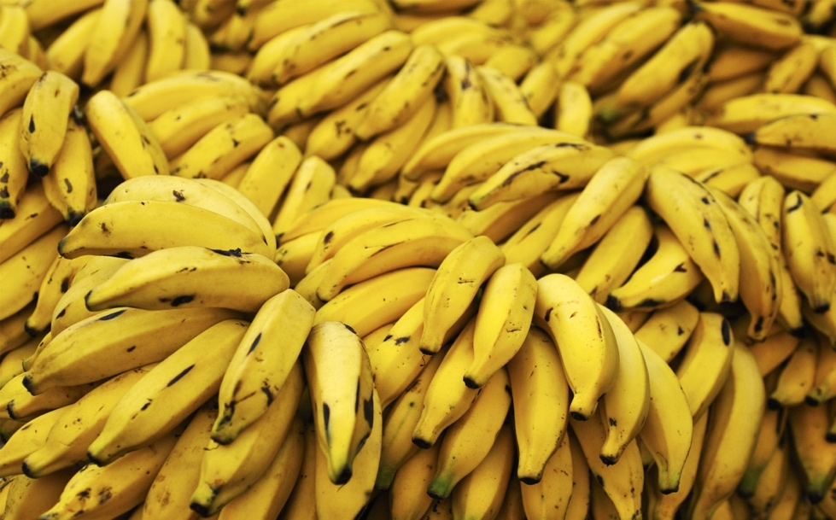](http://www.google.co.uk/url?sa=i&rct=j&q=&esrc=s&frm=1&source=images&cd=&cad=rja&uact=8&docid=o96oef8urwJaiM&tbnid=4bo3Ho7JeO4hgM:&ved=0CAUQjRw&url=http://www.comicvine.com/forums/off-topic-5/banana-discussion-thread-1494740/&ei=X6GMU7TKL-yY0AXSqYDIBg&psig=AFQjCNH8S5MEMlu4Mzue91hJbGPGhlVBHA&ust=1401811665526223) [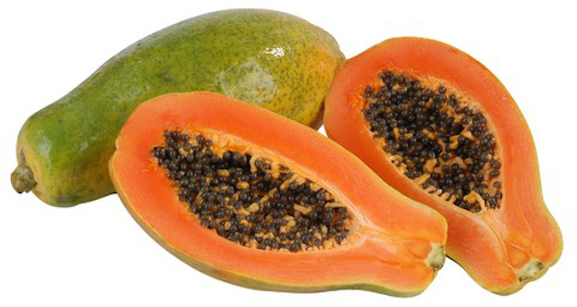](http://www.google.co.uk/url?sa=i&rct=j&q=&esrc=s&frm=1&source=images&cd=&cad=rja&uact=8&docid=LSyLpCj-yZFG5M&tbnid=qRklHSdI7WdHKM:&ved=0CAUQjRw&url=http://talkmedianigeria.com/2013/09/15/feature-strange-facts-pawpaw-cure-asthma-pile-impotency/&ei=6aGMU-urJcWb0wXMxoHYDw&psig=AFQjCNEUaa1kqB8VcFbqE07HUOtJ-9jRQA&ust=1401811811080133)

3. PAPAYA

1.BANANAS

[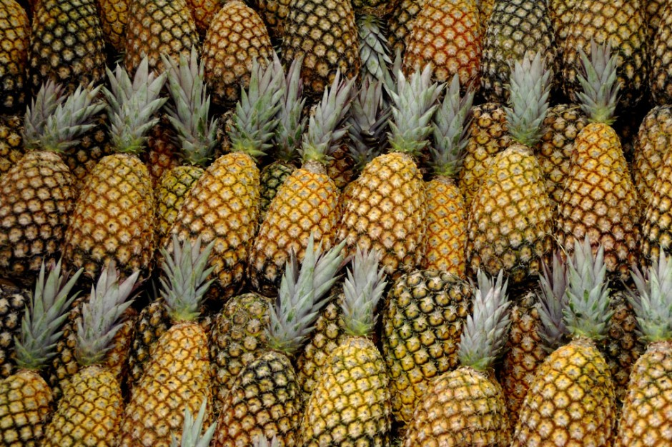](http://www.google.co.uk/url?sa=i&rct=j&q=&esrc=s&frm=1&source=images&cd=&cad=rja&uact=8&docid=H1GqZFgR-HsUXM&tbnid=iTl1QRYLe9WQpM:&ved=0CAUQjRw&url=http://www.getmynutri.com/shop-by--/herbs/pineapple&ei=J6KMU5CiHZSZ0QW284HIAQ&psig=AFQjCNGuuD4nM6phanhpBZYKu5SAL40L4w&ust=1401811864508428) [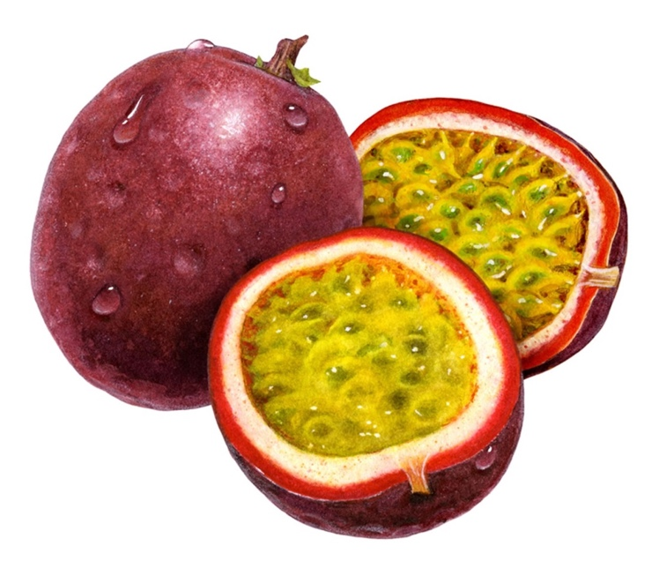](http://www.google.co.uk/url?sa=i&rct=j&q=&esrc=s&frm=1&source=images&cd=&cad=rja&uact=8&docid=eo1mDjZYlWO-uM&tbnid=v19nx68qEEZm9M:&ved=0CAUQjRw&url=http://www.dfwvapor.com/passion-fruit-us-e-liquid.html&ei=kqKMU9vPAfOY0QXS44D4Bg&psig=AFQjCNGts3a0Ol03hhHgtvUrMlaUGV1e5A&ust=1401811977921093)

4. PASSIONFRUIT

2. PINEAPPLE