# Ruhatwe Participatory Video

**Prepared by:** Nicole Gross-Camp

**Dates:** 3-7 October 2014

**Facilitators**: Glory Massao, Peter Paul and Nicole Gross-Camp

**Training**: Lasima Nzao

**Participants** [accompanying details were learned through ‘Think & Listen’] exercise:

1. BushiriOmary – VNRC representative [does not have a good life, he has many children that depend on him]
2. MwanahawaNjengule – VC representative (female) [he is a farmer with 4 children, he cultivates sesame, mchicha and okra]
3. Mwanahawa Ally Kikwakawa – female representative [she is a farmer and raises livestock, she has no children is unmarried and lives with her parents]
4. Hassan Saidi Mata – youth representative [he was raised here in Ruhatwe, he is married and has one child, he is preparing to cultivate sesame, and sometimes goes to cut trees]
5. Saidi Mohammed Kalupula – ‘pastoralist’ (this individual is not a pastoralist but raises chickens) [he has two children and is married, he would like to know more about forests and is a farmer]
6. Abraham Ajuta – elder representative [he has 10 children, he is a farmer and has a small business, but his life is not good]
7. Mseula H Ngunde – CUF representative (political party) [carpenter, would like to keep livestock, to be married and has one child]
8. MakulaAinaJuma – CHADEMA representative (political party) [he was very poor until he cultivated sesame, which helped him a lot, he has three children]
9. MaulidiShindo – MbuyuKibaba sub-village [owns a bicycle and house, he is a farmer, keeps chickens, has a wife and two children]
10. Asha Jaribu – Kimeremeta sub-village representative (female) [she was absent during this exercise]

**Overview of activities:**

|  |  |
| --- | --- |
| Day (date) | Activities |
| Day 1 (3 October 2014) | * Introduction of the project * Schedule of PV * Group agreement * Participatory games to facilitate technical learning: Think & Listen, Name Game, Show & Tell (with and without planning) |
| Day 2 (4 October 2014) | * Recap by participant * Additional games including: Searching for Beauty, Questions in a Row, Disappearing Game & Fixed camera role play * Transition to PRA: Community Mapping and Pictures of (In)Justice, & Venn Diagram |
| Day 3 (5 October 2014) | * Problem Tree * Creation of the storyboard * Begin filming |
| Day 4 (6 October 2014) | * Filming continued * Community screening of the rushes in the evening followed by community feedback |
| Day 5 (7 October 2014) | * Creation of introduction * Consent of group to share film * Additional filming * Paper edit for rough cut |
| Day 6 (8 October 2014) | * Creation of the rough cut (paper edit) |
| Day 7 (10-11 October 2014 – projected) | * Showing of rough cut * Additional filming (VC & Sukuma) * Community screening of rough cut and new rushes followed by feedback |
| Day 8 (29 October 2014) | * Community screening of completed film followed by feedback |

**Daily notes:**

**3 October 2014**

At the end of the first day, participants (all of them) remain to discuss the payment that they are receiving (4,000 TSH and lunch). They are not impressed with what we are offering. The elder states that even though they were chosen as volunteers by the community, the time commitment is rather long and they wish for us to ask at the office [MCDI] for more money. Glory indicates [in English only] that the upper limit for MCDI is 7,000 TSH/day/person, which includes the cost of food and the food preparation. We agree to review the actual expenditures on food in the evening and inform them tomorrow if we are able to pay more.

In reviewing the actual expenditures, Peter determines that we can provide an additional 1,000 TSH (total daily rate = 5,000 TSH) and maintain the overall cost at 7,000 TSH/day/person. [I cannot help but wonder if we had been more upfront with people, i.e. stated the daily rate at the village assembly meeting, that this could’ve been avoided].

The following day, first thing in the morning, we state that we can pay folks an additional 1,000 TSH per day, which they accept without further discussion.

**4 October 2014**

‘Questions in a row’ footage involved describing a situation that a participant viewed as unjust. Similarly, ‘Fixed camera role play’ involved the depiction of a situation that was unjust

**Translation of Questions in a Row** (by Glory Massao)

**Questions in a row**

What kind of justice or Injustice have you experienced in your village?

Answer

**1st Respondent**

The type of injustice I see in our village people are harvesting illegally in our forest without informing the villagers

**2nd Respondent**

Injustice which has happen to our village is the boundary conflict between us and Migeregere and another thing is illegal logging that is taking place in our village

**3rd Respondent**

There was a village committee that was managing payments that was generated by the village tractor, it was found out by the villagers that the committee was exploiting the money and was removed from their duties and other members were then selected

**4th Respondent**

The boundary conflict between migeregere and Ruhatwe

**5th Respondent**

Injustice to the villagers was the Introduction of Livestock into our village which we didn’t want them

**6th Respondent**

What I had seen in our village in terms of injustice was the VEO and few of the village council had misused village money and it had reached a point where we don’t trust the village government

**7th Respondent**

What I had seen in our village interms of injustice was we have seen a lot of VEO who come to our village they tend to misuse village [funds?] the Current VEO has done the same thing by misuse of village Money

**8th Respondent**

There is a lot of illegal logging taking place

**9th Respondent**

One of the pastoralists had thrown an arrow to villager and went to the head

**10th Respondent**

Two water pump machines were stolen in the village

**Fixed camera role play transcript** (by Glory Massao)

**Village Chairperson :** Member of the Village council I have called you here to tell you that in our forest there is illegal logging that is taking place so we have to arrange as soon as possible and tell the VNRC and the local guard they must go to the forest to catch the guys

**Member of village council**: So chairperson I have managed to find the VNRC and the local guard so you can tell them what they are supposed to do.

**Village Chairperson:** I have been informed that in our forest there are people who are harvesting without any permit so your responsibility is to catch them as soon as possible before they escape.

**Illegal loggers**: What do you want! what do you want!

**VNRC and Local guards:** We have been told by the village leaders to come and arrest all of you because you are doing illegal harvesting,

**Illegal loggers:** Please take this money and leave us.

**VNRC and Local guards**: I think its best we take their money and leave

[NOTE: Time up – exercise not completed]

Discussion of the **fixed camera role play** in which villagers are warned by village leaders to clear off the floodplains due to the potential for severe flooding, villagers do not listen and subsequently some lose everything. A couple goes to ask the village leader for help but are turned away because they have been warned.

In probing deeper, we learn that there is a hazards compensation scheme at the District level and that some individuals were in fact compensated for their loss whilst others were not. The group states that the village leader decided who would receive compensation and who would not and that many of those ‘on the list’ were not in the greatest need. There is an explicit suggestion that the village leader was acting unjustly and in a corrupt way.

The elder contradicts the above statement claiming that justice was done when people were warned to move but chose not to listen. He states that if the leader had helped those that were warned but did not move, he would be setting a precedence for the future.

Ultimately this discussion results in a decision to revise their skit to be more explicit in the (in)justice issues that they are trying to depict.

‘Community mapping’ (see image) revealed three areas of open forest within Ruhatwe’s boundaries – Kikakone towards Kikole, Mbate near MbuyuKibaba sub-village, and Migeregere (or Migeregere). The disputed area with Miegeregere is that of Mbate, which, according to the community mapping exercise ‘neither village is using’ although there are apparently illegal loggers there.

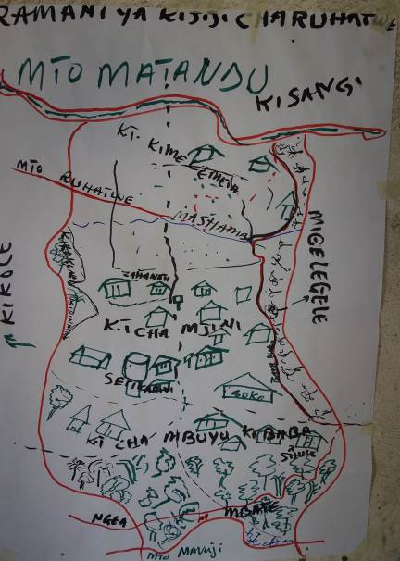

‘Photo elicitation’ in which participants were asked to take three pictures of something just and three pictures of something unjust.

Just pictures included:

1. Tractor: a new committee to manage the use of the tractor was selected about 5 months ago due to the previous committee misusing the income derived from the tractor’s use.
2. A small building: this structure was built for the purposes of a kindergarten/ daycare. It was built with the support from all three sub-villages and is considered to have been a good use of village resources.
3. Road: The villagers of Ruhatwe are very proud of the road because they cleared it themselves (approximately 7 km). They were supervised by TASAF but only received water as compensation. All the villagers felt very satisfied with this.

Unjust pictures included:

1. Landscape of woodland area: They do not know anything about the harvest of timber or bamboo in this area [specifically referring to the disputed area with Migeregere called Mbate]. Some of the participants state that they are afraid to even go there because they fear that the people of Migeregere will attack them. [When I ask if this has ever happened, however, the answer is no.]
2. Water tap in the main village: The budget for the construction of this was to be used for fresh water but is in fact salt water. The villagers had expected that the budget would be used to construct and bring fresh water to their village; they feel that they were not well consulted and suspect that the few involved in its creation pocketed much of the money for themselves. In addition the people of Kibaba sub-village do not get any water so they use a motorbike to travel back and forth to fetch water.
3. Mango tree: This tree had to be pruned to allow vehicles by for which the owner was compensated as he anticipated the pruning (of the roots) would likely kill it. The pruning did not affect its vigor and the villagers feel that this money should be returned.

‘Venn diagram’ (image below) included the following at the respective layers:

1 (most important): soil, trees, water, grass, and bamboo

2 (middle): wild animal (meat), fish, rocks, honey, and sand

3 (least important): birds, mushrooms and minerals

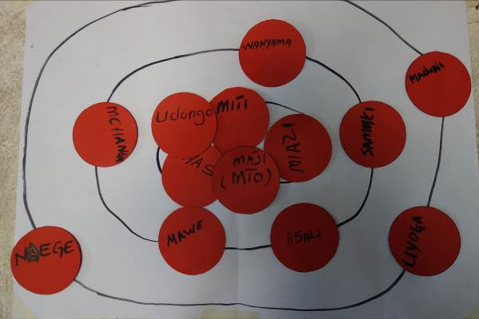

‘Problem tree’ was limited to two resources selected by the community from the most important and included water and trees. The challenges of water identified included flooding, erosion, access to fresh versus salt water, problems from cows (in particular associated with the presence of the Sukuma peoples) including erosion of riverbanks, compacting of soil, fouling of water, disease spread through cow dung into fresh water source, burning of crops from cow dung due to high fertility of the soil, and consumption of crops by cows.

The challenges identified involving trees included:

* Conflict **within** the village concerning illegal logging
* There are a lot of processes that the average villager needs to go through in order to simply get building materials/ Need to pay a lot of money/ It didn’t used to be like that/ When asked when this change began, the participant stated that it was when Kikwete (current TZ president) took power [This is the CUF political party representative – whilst I do not doubt that there are some real hassles in ‘simply cutting building poles,’ I wonder if it really has any connection to Kikwete’s inauguration, 2002-2005].
* Fire which is lit by people to clear land for agriculture gets out of control and burns the forest causing some of the trees to die
* Problem animals that live in the forest (ie baboon, vervet monkey, lion, elephant) and eat crops. Apparently two people were killed in Ruhatwe in 2014 by elephants.
* Legal but unsustainable harvesting of timber leading to the loss of forest and severe soil erosion.

The elder interjects at this point and claims that this area in unlike other areas in Kilwa in that it is highly fertile. He states that you can cut a tree and in 5 years it will have regenerated [Whilst this is clearly an exaggeration, part of the village lands appear to be highly fertile (floodplain) where they grow rice during the rainy season when the lands become inundated with water. At present they are hard, cracked heavy clay soils (see image below)].

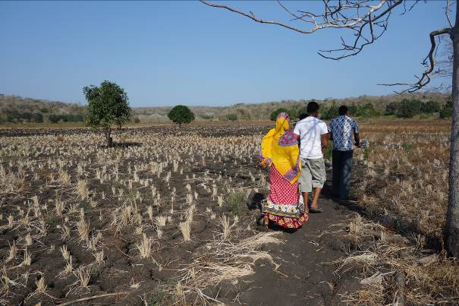

* [Up to this point no one has mentioned the area of conflict, Mbate. Glory asks if conflicts with external villagers are not also a challenge.] When a project [no mention of MCDI but the implication is there] comes to help the community to conserve the forest, there will inevitably be conflict, even if things are now quiet [In hindsight, I’m not sure why we didn’t follow this up with additional questions but perhaps something to do in the future].

**5 October 2014**

The main focus of this day was the development of the storyboard, which was an arduous process. The group initially decided to focus on water and developed a storyboard over a period of approximately 2.5 hours. Upon its completion, the group was visibly distressed by the fact that they had not included trees – we suggested that to try and cover more in the allotted time would be difficult. Noticeably the three women in the group that had been largely silent throughout the development of the water storyboard, stated that had they had known they had limited time, they would’ve chosen to focus on the trees (forest). We told them they could certainly develop a new storyboard or try to incorporate their concerns in the present storyboard. After about 30 minutes into the development of a new tree-focussed storyboard, the group gave up and decided to continue with the creation of their first, water-focussed storyboard. [My impression is that this was a decision primarily driven by fatigue].

**6 October 2014**

A smaller group of us (4 participants) drove out to film the impact of the cattle and flooding (~ 5 km from the main village); this is also where the Sukuma are. On the way back I asked a young Sukuma girl if she had been born in the village. She replied that she had in fact been born in Morogoro. In asking further I learned that a few years ago the TZ government relocated a large number of Sukuma from Morogoro due to conflicts between their cattle and famers. Apparently Lindi and Mtwara Regions were designated for the re-homing of the Sukuma, but no infrastructure (ie water) was put in place, so naturally the Sukuma began to move elsewhere. At this time, village leaders in these regions were told [not sure by whom – perhaps the District?] that if the Sukuma came and asked for land, the village should not refuse them. The Ruhatwe participatory video group claims that although Kikole offered them land, Ruhatwe never agree [as a village] to do so.

I also asked how/if the history of the Sukuma, having been removed from their home, gave them any pause – whether they [Ruhatwe] felt any sympathy for them. The PV folks responded that being removed from your home is ‘serious’ and that they do in fact feel for them because of this. BUT, when the Sukuma came to Ruhatwe they moved to an area where there were already people living (from Ruhatwe) and ‘disturbed their way of life.’ So the way they see it is, although they feel for them, they also feel for their people and that this is an injustice. [I think this may be a potential recognition issue for us to explore].

Apparently the Sukuma began to come to Ruhatwe in 2012 [according to the PV group].

Responses of community members who attended rush screening

Prepared by Peter Paul (MCDI)

 1.     During the meeting with expert from the district (in this scene) people should not have interrupted each other, they should have given each other sometime to talk rather than interrupting.

2.     There should be an Interview scene of the pastoralist so that we can get responses on accusation of their cattle’s destruction.

3.     Pastoralists were provided with an area (Matandu area) where they can graze their cattle and they were restricted not to move to the farms but they still graze in our farms.  We need this to be included in the video. The pastoralists came to our village on June and left on November last year, this year they came on June and we want them to go away and never come back. They only come during dry season, for search of water and pastures for their cattle.

4.     We want the village leaders to be interviewed and hear their side this also should be included in the PV [of why the bore hole was built where it was].

5.     Local water tank should be included in the Video – this is a good example to depict that community members were not involved in the process of deciding what kind of water they want, water was drilled but it was too salty and people could not use it....if we were involved we could have suggested to improve our local water well instead of bringing water which is not fit for consumption.

Mseula[PV participant] said that– Village government is the one who decided where Pastoralist can stay – community members wanted the village leaders to make decision on this particular matter.

Village government set aside areas (Matandu) where Pastoralist can stay- and they were prohibited to go to the farms of Ruhatwe community members.

 AbrahamaniAjuti- (Babu/ PV participant) We do not know the number of pastoralists who were given the permission by the government of Ruhatwe to stay (in Matandu area). We suspect more than one pastoralist uses same permit, just yesterday I saw a new face (pastoralist) in our village.

**10-11 October 2014**

(prepared by Glory Massao)

Additional filming was done with a Sukuma staying in the village. The PV group tried to interview the Sukuma to find out what kind of process they had used to stay in the village. The interview went very well, the Sukuma tried to explain that he had paid some money to the village so that he could stay in the village.

Then the PV group tried to do filming with the village leaders but they refused to be filmed. They asked to be paid to talk, but we refused because we had not paid anyone since the start of the filming. The PV group members claim that the village leaders didn't want to be interviewed because they knew what kind of questions they will be asked relating to issue of water and pastoralist in the village and weren't ready to talk. The PV group knew what the village leaders had done by taking bribes from the pastoralist, and allowing the pastoralist to stay in the village without looking at what kind of impact it will bring to the village. The village leaders are the ones who didn't give a chance for communities to decide where they wanted the water project to be constructed

After the filming there was a village meeting where we [Peter and Glory] had a chance to talk and one of the things that came up in the meeting was the interview with the Sukuma. In the film the Sukuma says he had paid some money to the village leaders, yet the village leaders said that they had only paid a sitting allowance for village council to discuss of the Sukuma’s request to stay in the village. An additional fee to remain in the village had yet to be paid. So the filming of the Sukuma had brought a way for communities to start to talk on issues of injustice. Communities reaction on the matter they were very furious because the village leaders was saying different as the Sukuma.

Community screening of rough cut and new rushes followed by feedback.

The rush screening was done in the evening around 7:00 and a lot of people had attended , children, village leaders, Men and Women and the PV group member. But after the rush screening they was no feedback that was been given [ I think the communities were satisfied on want had been show and the film had deliver the actually problems of injustice they have in the village]

**Community Screening in Ruhatwe**

(prepared by Glory Massao)

**29th October 2014**

The screening started around 7:30 at night a lot of people participated (children, village leaders, Men and women). The video took about 30 minutes, after that we then had a discuss with the communities the aim was to separate them into small groups but it was dark and they were a lot of people who attend the screening so want we did is to talk with the whole group on how did they see about the video.

Comments were made as follows:

* I don't think the village government accepted cattle without the permission from the community as the video portrays the decision of allowing cattle's was agreed by the whole community
* Everyone who participated liked the video they said it has describe the really situation in the community like the problem of water and the issue of livestock. Someone shouted in the middle of the crowed we don't want livestock in our village
* Someone said “Samwel" (pastoralist guy on the film) did not pay entry fee/tax to the village government he just paid sitting allowance for a meeting that was discussing request letter an area in the village for grazing
* They wasn't any women who was interviewed on the issue scene, women should have been interviewed about water problem because they are the most affected group in society due water problem.
* A female community member said that she did not like that no women were interviewed especially because this [water] is an issue that concerns women
* We didn’t accept cattle at the first place so the pastoralist went to neighbouring village (Kisangi) and they were accepted but the pastoralist grazed cattle in Ruhatwe lands while staying in Kisangi so we decided to accept them under some conditions so that we can benefit from them because we were not benefiting from them though they were fed in our lands.
* Village Council felt that the community had been consulted. Consultation was occurring in village assembly meetings. All the comms were involved and consulted. The video was not accurate in its representation of this. [there was no follow up discussion on these comments]