**Participatory Video In Kikole**

**Dates: 4-10 November** 2014

**Facilitators**: Glory Massao and Peter Paul

**Participants** [accompanying details were learned through ‘Think & Listen’] exercise:

1. Halima H. Mbulula – VNRC representative (female)[studied until standard seven, farmer, married and has one child]
2. Amina S. Kipunga - VC representative(female)
3. Asha S. Kaputi - women representative
4. Fadhili A. Ngunde - Youth representative
5. Ally Makoka - Elder representative[farmer]
6. Abdallah Ndunduke – Mbunga Sub village representative [Farmer, likes to be musician]
7. Dini A. Matimbanya – Nanyati sub village representatives
8. Saidi A. Njaule – Animal keeper
9. Habibu A. Matimbanya - CUF representatives [likes to see his children go to school, Farmer]
10. Omary H. Hawadhi - CCM representatives

|  |  |
| --- | --- |
| **Day (date)** | **Activities** |
| Day 1 (4 November 2014) | * Interviewing the PV group |
| Day 2 (5 November 2014) | * Introduction of the project * Schedule of PV * Group agreement * Participatory games to facilitate technical learning: Think & Listen, Name Game, Show & Tell (with and without planning) |
| Day 3 (6 November 2014) | * Recap by participant * Additional games including: Searching for Beauty, Questions in a Row, & Disappearing Game * Transition to PRA: Community Mapping and Pictures of (In)Justice, & Venn Diagram * Problem Tree |
| Day 4 (7 November 2014) | * Creation of the storyboard * Begin filming |
| Day 5 (8 November 2014) | * Filming continued * Community screening of the rushes in the evening followed by community feedback |
| Day 6 (9 November 2014) | * Creation of introduction * Additional filming * Consent of group to share film * Paper edit for rough cut |
| Day 7(20-21 November 2014) | * Showing of rough cut * Additional filming (PETS) * Community screening of rough cut and new rushes followed by feedback |
| Day 8 (13 January 2015) | * Community screening of completed film followed by feedback |
| Day 9 (5 March 2015) | * Second Community Screening of completed film followed by feedback |

**The first day**

The first day we had a chat with the ten representatives that will be participating in the PV. It was a very brief discussion not more than ten minutes with each individual looking on the general overview on how they feel in working in a group and if they will be keen to work the whole day from morning to evening, two representative had to drop out because they said they had other obligation so it will be difficult for them to participate. These individuals were then replaced and the participants listed above were the ones that participated in the PV process.

**The second day**

The training started at 9 a.m. in the morning every day and end at 5 p.m.

* **Think and listen**

what the participant had learn being attentive to listen to someone to familiarize with each other and having Fun

what didn't go very well some of the participants hadn't being listening to others talking

* **Name game**

**what went well**

learn by doing, participants to teach each others

what didn't go well

It was the first time to hold the equipments people were trembling, participants started to record before they were ready , some of the clips didn't have sounds, some of clips were dark

* **Show and tell**: Was a bit hard for them to understand it took more time

**what went well**

participants understanding had started to improve and clips have improved interms of sound

**what didn't go well**

still the control of light wasn't fine ,poor communication between the person holding the camera, Microphone and headphones.

They was a lot of wind

want should be improved

we need to plan

* **Show and tell (5 minutes was given for planning)**

**what went well**

Holding of the camera has improved and some of the clips they have tried to control light.

**what didn't go well**

Poor communication between the person holding the camera, Microphone and headphones. some of the clips were been taken in a dark room.

* **Disappearing game** (Aim of the exercises was the use of tripod stand)

**what went well**

proper use of time , use of new equipment (tripod), use of the frame all people could be seen at once.

**what didn't go very well**

started recording without following instructions

* **Searching of beauty**

**what went well**

To take sound and images separate

The use of the short gun microphone

the game was more fun than any other game we had

**The third day**

* **Questions in a row**: In actual fact it was hard for some of the people to understand what kind of justice and injustice is taking place in their village half of the member of the group had managed to answer

Question that was asked Is there any kind of environmental Injustice and justice you have experience in your village?

**1st Respondent "Saidi Njaule"**

Justice both men and women are involved/participant in forest conservation while the injustice is community haven't benefited in any health service.

**2nd Respondent "Hemedi Awadhi"**

there no any injustice in the village everything is going on fine

**3rd Respondent "Asha Kaputi"**

everything in the village is going fine but we are facing problem with livestocks in our village, they are destroying our environment we don't want livestocks

**4th Respondent" Amina Kipunga"**

Communities and even the VC are involved/participant in forest conservation such as forest patrol. we wanted as well for our village land to be demarcated so we can have customary rights of ownership

**5th Respondent "Amina Hemedi Mburura"**

Everyone is involved in conservation but the problem we are facing is wildfires that are occurring in the forest

**6th respondent "Habibu Matimbanya"**

Justice there is Involvement of communities in forest community.

injustice most of issues that is going on in the village isn't transparent example when there is any harvesting in the village there must be an advertisement that shows there is a customer harvesting in the village and it must be placed in the village notice board so every village member could know what’s going on but that isn't been done.

**7th Respondent "Fadhili Ngunde"**

Involvement of communities in forest conservation,

injustice: land is owned by the government and if communities want land for house construction they are supposed to buy

**8th Respondent "Dini Habibu Matimbanya"**

very few communities are involved in conservation of forest especially in the VLFR and they are always the same people who participate in forest activity.

forest income and expenditure should be advertised in the village notice board rather than be read at the village meeting

**9th Respondent "Abdallah Ndunduke"**

Interms of justice communities have a chance of getting temporary employment when there is harvesting of timber and early burning taking place in the village

**10th Respondent "Asha Kaputi"**

Injustice encroachment of neighbouring village going to do farming activities

**Pictures that show Injustice and Justice**

**Injustice Pictures**

**Road:** has a lot of erosion and it's the responsibility of the village leaders to make sure it has been maintained

**Primary school toilet:** The school toilet it's in bad situation , communities have raised some funds so that the toilet can be build but until now nothing has been done

**Logs**: logs which have been harvested illegally in open forest areas

**Justice**

**Market :**They have built a market in which everyone in the village can be able to use the place

**Forest:** Improvement of the forest that has brought benefit to the community

**Water tap:** Building of a water tap, money that had come from the sale of timber, has helped a lot in solving the problem of water in the village .

* **Fixed Camera role playing:** The exercise went very well and the group liked a lot doing the role play . The role playing had relieved issues of injustice, the VNRC had gone to do patrol in the Forest , before going to the forest they first informed the village leader of the activity.

The village leader knew that they was illegal logging that was taking place in the forest he then immediately informed the illegal loggers they should leave as soon as possible before the patrol is done. When the VNRC went to the forest they had found no one, they then suspected it must be the village leader who had told them because no one knew they were coming.

* **Community Mapping:**

The community map consist of VLFR, Social services (roads, water wheels, dispensary, school and Mosque) settlements, open forest, rivers and farming

The community map revealed that within the village boundary there are two open forests near Mbunga Subvillage and most of the illegal logging taking place is in these areas. There is a proposed VLFR known as Miwiluwhich is near Nanyati Sub village they claim that the neighbouring village ofNambondo have enroached and started farming and also illegal logging this area. Another forest is the VLFR known as Namanjogoo there is no illegal activities taking placeand that is where they had harvested

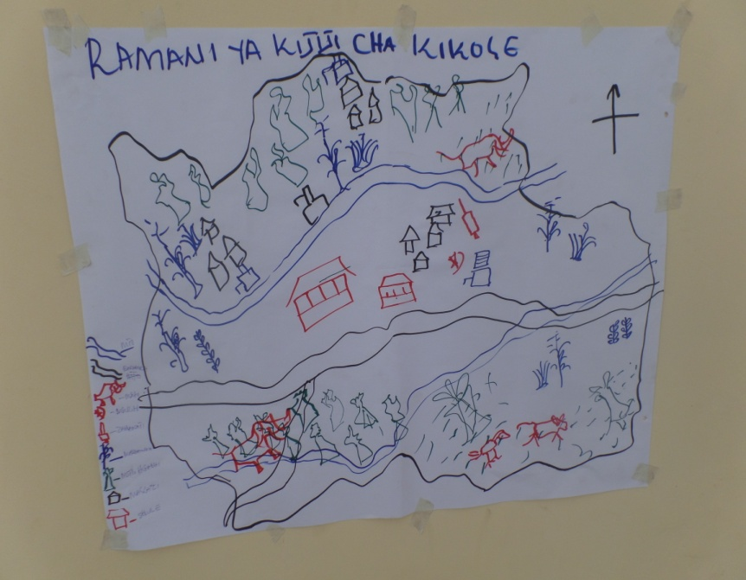

* **Venn diagram**: These are the resources which are found in the village water, land, forest, wildlife, Mushrooms, insects, rocks, fish, bamboo, birds, sand and grasses.

**1. (most important**): soil, trees, water

these resource are very important to them soil for instance is been used for growing crops, for building house, water can have different uses such as drinking, washing, cooking, construction and irrigation

**2 . (middle):**fish, grasses, sand, bamboo and stones

**3. (least important):** birds, Insects, mushrooms and wild animals (meat)

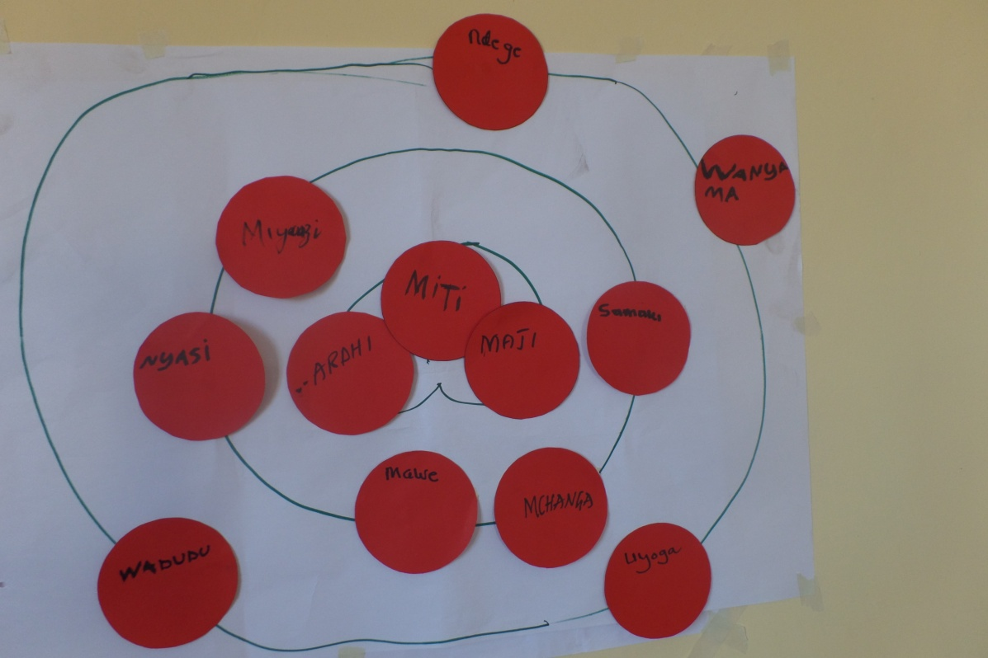

* **Problem Tree:** ‘Problem tree’ was limited to two resources selected by the community from the most important and included water and trees then for their story they decided to talk more about the forest

**Challenges identified in water**

**Flood**s: have resulted in destroying properties and death

**Soil erosion** which result on having poor soil fertility

**Dangerous** animals that are found in the water some time kill people such as crocodiles

**Connection:** when there is too much water during the rain it's very difficult for people in Mbunga and Nanyati sub village to cross to the main village because there is no bridge and all the children go to school in the main village

**water Shortage** : Not all the year there is water there sometimes shortage of water which result to communities to protest and conflict (if there is little water communities will tend to fight).

Corruption: A water committee that is responsible to collect money that comes from the water project but it was found out that the committee is misusing the money

**Challenges identified in forest**

**Illegal Loggers:** Village leaders are allowing loggers to harvest in the forest without proper permits

**Increase of wild animals in the forest**

**Wildfires:** they has been of wildfires in the forest that are caused by people lighting fires without any reason

**Boundary Conflicts:** Boundary conflicts with Kisangi

**Shifting Cultivation**

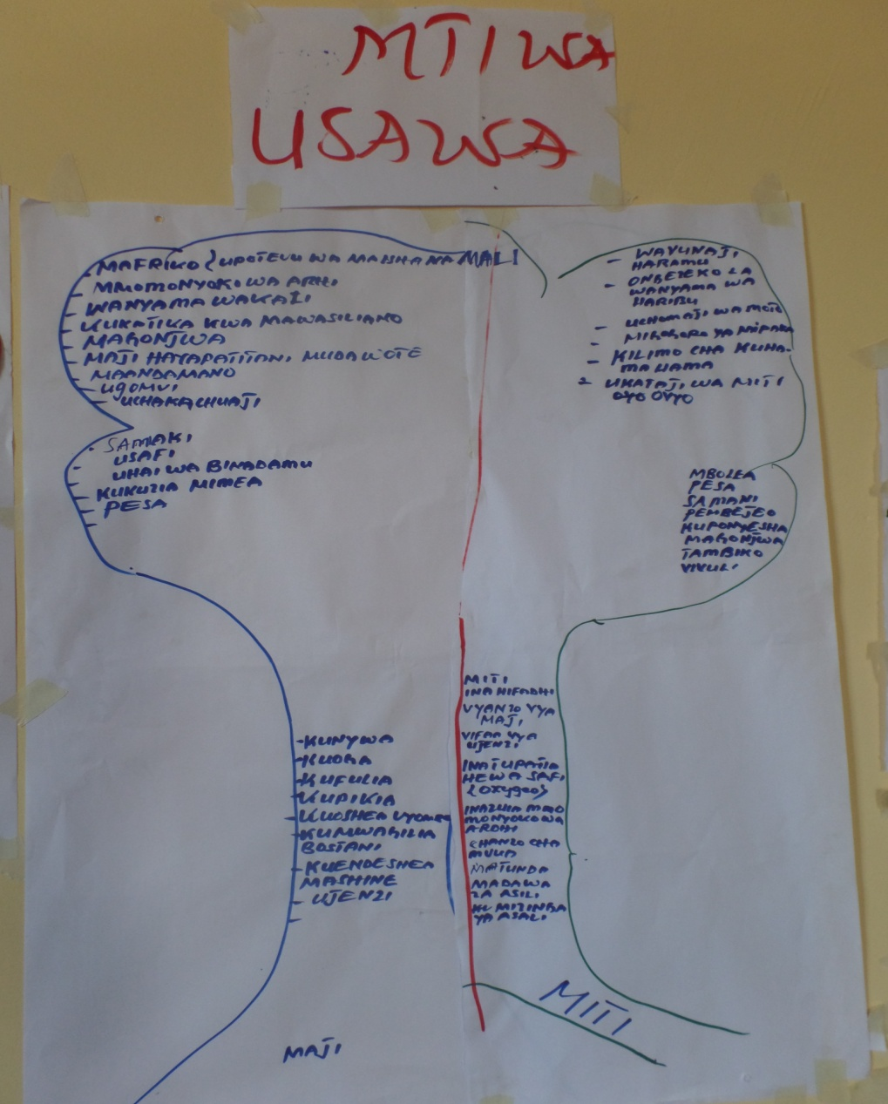

**The fourth day**

* The person responsible to do the recap didn't do so we decide everyone to do a recap
* Then followed on making of the story board they had develop six scene and they left out the 2 scene that will be done after the final 6 scene are final
* **Story board:** The story was all about the issue of **transparency (Uwazi)**. They tried to explain that the village council hasn't been transparent enough to the community. The people feel that the government make a decision on an issue with little? Involvement of community and if the community was involved the community at the end are been provided with report. It was found that 900,000/- Tsh that are funds which had come from the forest was budgeted for renovating the village dispensary but it was found out that they has been misuse of funds by the village council. Community decided an investigation should been on how the funds were PETS (Public Expenditure tracking system)[1] was given that role of conducting the investigation and when PETS tried to arrange a meeting with the Village construction committee, the committee didn’t turn up. **Corruption (they had used a proverb to explain what corruption is "tunawasiwasina hii meza"we are worried with the village leaders)** is also another issue that was mentioned in the film. They think it's unfair that few people are benefiting from the forest through receiving bribes. It was found out that the village leaders are taking bribes from illegal loggers, who are harvesting inside the village [forest?] and when the community complains they are ignored. The village leader gives them false hope that he will call a meeting where the community would be informed on the illegal activities that are going in the forest, but he never calls the meeting, all the meetings must be arranged and called by the VEO or Village leaders no one else is supposed to call village meeting, and if just normal communities call a meeting that won't be regarded as an official meeting and anything that will be discussed they won't be accomplished "Kutekelezwa" .

But they tried to explain that conservation of the forest through CBFM has brought a lot of benefit to the community. They had, had a problem before which has now been resolved - women can fetch water very easily without walking. Very far distance to find water. They tried to explain that before the introduction of CBFM they were receiving 100/- Tsh per log but after introduction of CBFM they can sell 1 cubic meter of Mpingo 240,000/- Tsh, and other species for 204,800/- Tsh per and all the money stays in the village only 5% goes to the District council

They explained that there has been a lot of forest encroachment. There was a forest inside the village known as Miwilu that was set aside for piloting the REDD project, but unfortunality it had started to be encroached by neighbouring village. So the communities agreed at the general assembly that they should stay until they harvest and must pay tax as well as leaving that area but until today we don’t know why they are still expanding the farms. No report on whether they paid or refused to pay but we have heard that some of the farmers paid money to village leaders.

* Filming in the afternoon
* Then rush screening which was done in the evening about 40 people attended. After the Screening we had a discussion with the participants here are some of the comments that had been raised:

The following are comments from the community members who attended the community screening on the first day

Because it was dark and they had been several people who attended the rash screening, what had been done to obtain comments from the participants we had asked if any one has any comments should speak and the Volunteers, PV group and MCDI staff had then been taking notes.

**[Man respondent]** All scenes are not bad so far, but you can improve them for example the scene which shows the Village chairman in the office with two VNRC members who just got back from the forest patrol. The scene portrays that the village chairperson is a dictatorship a leader should think it is not necessary the leader should be polite.

**[ primary school teacher],** I think in chairman’s office there should be a wooden bench or few chairs for the visitors so that they can talk while seated.

[**Man, member of the VNRC**]I suggest that the PV group should film good things about the forest (things which are fair about their village). This will be a good distinction between our village(on which we practice PFM) versus the villages which do not conserve forest for example Ruhatwe. When we did the filming we had started filming issues of injustice so people had thought that they had not been any issues of justice

**[women respondent]**I think the film aims at showing things which are not done in a fair manner and this will help the coming leadership not to repeat the same mistake (interms of injustice)

"*Village Chairperson*" ask that we know the forest patrols are normally be done by VNRC - May I ask have we ever talked in an aggressive tone to the VNRCS after they have come back from the forest? As we have seen on film.

One of the PV participant *"Mr Njaule"* said-Those who are criticizing these footages are the village leaders and they don’t want to be noted as bad leaders by the community.

**[young man]** We don’t have a dictator in our village otherwise we would have no more forest left.

**[women and man ]** In the patrol scene the guy is talking very lazy while the lady is active so it will be better if they re-film that scene and both speak loudly and more active in role-play.

**The Fifth day**

* Filming

The scenes that had remained had been filmed in the morning and in the evening. But before the starting of filming we had a meeting with the PV group to discuss on the comments that had been given to the community during the rash screen. Some of the scene that the communities didn't like the PV group discussed and come to agreement that they will re-film again those scenes.

But they had been other comments that the PV group didn't agree such as filming more issues of PFM benefits and the different between Kikole and other non PFM village.

* **2nd  Rush Screening**

**Comments from the community during Rash screening**

The scene which portrays that the Matumbi (people who encroaching in the forest) haven’t paid the tax is not true- Tax is already been paid, amount of 100,000/- Tsh.

**[man]**The general assembly scene would have been good if they would have opened the general assembly with an introduction so that everyone who attends may know what is going on even if s/he didn’t attend the previous General Assembly.

**[man ]** There should be a scene portraying the boundary conflict between Kikole and Kisangi, this was suggested during the rush screening but when we discussed it with the PV group they said it is not important to talk about the conflict because the issue is almost over (resolved).

**The sixth day**

* Finalised film

then we had a discussion that we will come back for filming the remaining scenes including interview with the PETS and the patrol guys in the office.

we then discussed if they will want to talk anything about the conflict they had with Kisangi and the PV group said that it's not important to talk because the issue with Kisangi has already been resolved.

* Paper edit
* Then we did the consent to share

**The seventh Day**

We went to Kikole for the second time and the purpose was to re-film few scenes which needed to be filmed again and filming new scene which was proposed in the last screening. This was a two day field trip, whereby the first day the PV group tried to remind each other about the comments/ what was proposed in the last screening. They had five scenes to film so they decided to film three scenes out of five in the first day and the second day completed the remaining two scenes. These scenes are Forest patrol scene, village chairman and patrol team in the office, interview scene with PETS the scene had involved PETS chairperson and member they had tried to explain that they have tried to call a meeting with the health committee on the use of money for the construction of the dispensary but they haven't any support from any of the committee, and general assembly scene.

They were able to film three scenes and we both watched them, then we agreed that the following day we would continue with filming and do the community screening during the evening (on Friday).

The second day it was a busy day for everybody in the village and I was not aware of that in advance (nobody told me) that Friday 21st November will be a busy day so we had to push things, try to do all the filming during morning hours this is because in the village they were hosting a ward football league and netball league events. This was a part of a campaign for prevention of new HIV infection which was sponsored by Tanganyika Christian Refugee Service (TCRS) the event took most of their time therefore people were tired and they could not make it to the screening until 7:30 pm there were about 15 people including the PV group at the screening venue and we expected to start 6:45pm so we decided to postpone until another time.

**First Community Screening on 13/01/2015**

Screening had started around 07:20 PM with around 30 participants attending. The screening had children, women and men. The majority of people who participated were middle aged group of 30. The screening had very few participate because most of the communities had already moved from their houses/ main village to their farms and as well it was bad timing because most teenagers had gone to watch football.

After the Screening we had asked feedback on how they have felt about the film. About 5 participants to provide their contribution. When we started asking for comments everyone was welcomed to try to contribute and one person [man] contributed by saying that the video was perfect it had portrait everything that had been going on in the village but they was one scene in the video, which had revealed a woman doing harvesting, but reality that in the case of our village that women have never participated in harvesting all the work is done with men. One the PV member told the person that it doesn't matter if it's was a women who was doing the harvest because the important thing is that the message has been deliver to the communities, then two started arguing resulting to other people to arguing as well [it had shown the two guys are rivals, belonging from different political parties] , the argument wasn't big but it had resulted in some of the participants to leave.

We had to try to ask them not to go and told them that if they aren't comfortable talking in public everyone who wish to contribute can talk in private. [that had seemed a relief to some of the participants].

**The first participant [this was an old lady]**

The video has nice message but the film has very few representative of old people and the one who participated was a man how about old women? so If they will be a next time will propose to include women I myself will even participate.

**Second participant [Man]**

There is a scene in which Matimbaya was talking on the forest benefit, will proposed that before staring of filming its best to write so that you won't miss out things this will help also to have a better flow of the message that is delivered to the communities.

**Third participant [These was the Ward Executive officer]**

There is a scene in the film which described how the benefits from the forest had contributed in the presence of water in the village. My concern is that the water project was not only established through money from the forest but also money from TASAF[2] (Tanzania Social Action Fund) program. TASAF had contributed 30 million for the project. Forest had contributed less to water project while TASAF has contributed much and it has mentioned (acknowledged) in the film, how will the District feel when they watch the film? [if these person had been in the rush screening it could have help with this kind of suggestion to go in the film].

**Fourth Participant [These was a Man]**

Money that had come from the forest for the water project was very little, and was used to buy water pipes.

The number of participants in the PV is relatively very small to compare with the total number of people in the village (the whole population) I suggest the PV group it could have at least have 20 participants rather than 10.

The participant must write down the materials that they want to talk before they speak in front of the camera.

The PV group members they seem they aren't ready to accept suggestions or comments during should the screening

**Firth Participant [These was a man and women**]

The film has very few representatives from the communities excluding the PV group members so if they will be next time will propose that other community members to be involved also.[ the whole point was to involve as well other people who wanted to be in the film but during the filming people had refused to participate especially in the general assembly meeting ]

**Second Community Screening 05/03/2015**

The second screening started around 7:10pm more than 60 people attended the screening, children, old, teenagers, women and men. It was something that we hadn't expected to have so many people attending because we knew that most of the villagers have already move to their famers. After the screening we had asked the communities to give their views on how they think about the film. we had face a bit of a challenge with the speakers, they speakers hadn't been that strong for everyone to hear well.

After the Screening we had asked if anyone had comments from the community most of the comments had been given by man, no women didn't speak .

**First respondent [Man]**One of the respondent said that we think "MCDI film " had very few people who had participated next time I think its best we involve a lot of people in the PV. The respondent who had given this comment still think that the film was made by MCDI and the owner are MCDI we tried and the PV member who were present in the screening that that the Film was not made by MCDI its made by the community of Kikole with facilitation from MCDI .

**second Respondent [Man]** In a really situation women in our village are never involved in timber harvest, so what the film is telling is not want we are doing in our village. **[Respond from the PV member "Njaule"]** it doesn't matter who was doing the harvesting the only thing was to try to deliver the Wright message to the community.

**[PV member]** we would like our Film to be shown very soon to the whole world so they can see how Kikole is.

**General Observation**: The community like very much the film they had be laugh a lot they wanted to show the film for the second time and we did.

**Views from different people on the change of power from CCM to CUF -Informal meetings**

Had a chance to talk with about four villagers on how the election had gone and if they had something they would like to say about the whole changing of parties.

CUF had won in the village, with the village chairperson and four other member of VC coming from CUF. While the remaining 20 VC members came from CCM, having two political parties in power will make a lot of things to be more transparent, rather than only one political party ruling.

The main reason that we had decided to have village chairperson from a different political party than from the previous, communities were tired with the chairperson [who also was running again for village chairperson]. He was misusing of village money for his own benefit, he wasn't listening to community’s problem, he didn't want to be given advice. We got tired of the village chairperson and we decide it's time we have a different leader. Even if am CCM but I elected the chairperson from CUF [women was responding].

PV in same way had tried to send message too few of the villagers who didn't know what is going on in the village such as the issue of the village chairperson by allowing illegal activities to take place in the forest [One way or another it had change some of the few individuals to elect a different village chairperson].

**Skype meeting with Sole Jan 2015**

* Issues of national importance raised – livestock (conflict bet pastoralists and agriculturalist), corruption of forest management (elite capture)
* [Glory] MCDIs intention to use films in other villages specifically the one in Kisangi to discuss issues of benefits of the forest from its conservation/ kind of promotional material (?) for MCDI/ the video is a kind of support tool to help persuade villages to adopt the CBFM model that MCDI promotes/ very useful from MCDIs perspective (unintended outcome on our part?)
* [Sole] who do ‘we’ [as researchers/ the communities] want to reach with the videos?

1. PETS empowers ordinary people to follow the spending of public resources allocated to their area. This naturally improves the delivery of services at the local level.
2. The Tanzania Social Action Fund (TASAF) is an instrument instituted by the Government to empower communities, facilitate their participation in planning and implementation of interventions that would improve their livelihood and make them benefit from macro level achievements.