**The speed of serial attention shifts in visual search:**

**Evidence from the N2pc component**

Anna Grubert and Martin Eimer*

*Corresponding author

Department of Psychological Sciences, Birkbeck, University of London,

Malet Street, London WC1E 7HX, UK

Phone: 0044 20 76316358

Fax: 0044 20 76316312

Email: m.eimer@bbk.ac.uk

Short title: Rapid serial attention shifts

**Abstract**

Finding target objects among distractors in visual search display is often assumed to be based on sequential movements of attention between different objects. However, the speed of such serial attention shifts is still under dispute. We employed a search task that encouraged the successive allocation of attention to two target objects in the same search display, and measured N2pc components to determine how fast attention moved between these objects. Each display contained one digit in a known color (fixed-color target) and another digit whose color changed unpredictably across trials (variable-color target) together with two grey distractor digits. Participants’ task was to find the fixed-color digit and compare its numerical value to that of the variable-color digit. N2pc components to fixed-color targets preceded N2pc components to variable-color digits, demonstrating that these two targets were indeed selected in a fixed serial order. The N2pc to variable-color digits emerged approximately 60 ms after the N2pc to fixed-color digits, which shows that attention can be re-allocated very rapidly between different target objects in the visual field. When search display durations were increased, thereby relaxing the temporal demands on serial selection, the two N2pc components to fixed-color and variable-color targets were elicited within 90 ms of each other. Results demonstrate that sequential shifts of attention between different target locations can operate very rapidly, at speeds that are in line with the assumptions of serial selection models of visual search.

Keywords: visual attention, top-down control, visual search, event-related brain potentials, serial attention shifts

**Introduction**

In visual search tasks, observers have to find target objects when their identity is known, but their location among task-irrelevant distractors in the visual field is unpredictable. Several models of visual search assume that during such goal-directed explorations of visual scenes, attention is allocated sequentially to different objects until the target is found (e.g., Treisman, 1988; Wolfe, 1994, 2007). Such serial accounts of visual search raise a number of important and controversial questions. How fast does attention move between different objects in the visual field? Does the speed of such attention movements differ for different types of attentional selection tasks? And most fundamentally, is attention always allocated serially to individual objects in visual search displays or are there situations where multiple objects can be selected in parallel?

In many visual search experiments, the time to find a target increases linearly as a function of the number of items in a search display (e.g., Treisman & Gelade, 1980; see Wolfe, 1998a, for a detailed review). Serial models of visual search have used these display size effects (“search slopes”) to estimate the time required for attention to move between individual objects. Empirically observed search slopes suggest that attentional selection processes operate rapidly, at rates of about 50 ms per object, or even faster (e.g., Wolfe, 1998b). However, this conclusion has remained controversial. It assumes that visual objects are selected in a strictly serial fashion, but alternative parallel models are difficult to rule out (see Townsend, 1990, on the problem of deciding between serial and parallel accounts of visual search performance). If attentional selection operates in parallel, with focal attention directed simultaneously to multiple objects (e.g., Desimone & Duncan, 1995), the search slopes observed during visual search are consistent with relatively slow movements of attention between different parts in the visual field, and “attentional dwell times” of 200 to 500 ms (Duncan, Ward, & Shapiro, 1994; Moore et al., 1996).

To determine the involvement of serial or parallel object selection mechanisms during visual search, these mechanisms need be investigated with measures that can track their time course precisely. Electrophysiological studies using single-unit recordings from cortical neurons in non-human primates during visual search tasks have suggested that search can sometimes be based on a serial selection strategy (e.g., Buschman & Miller, 2009), but will usually involve both parallel and serial mechanisms (e.g., Bichot, Rossi, & Desimone, 2005). In humans, the N2pc component of the event-related potential (ERP) provides a temporally accurate marker of attentional object selection processes that can be employed to study the parallel versus serial nature of visual search processes. The N2pc is an enhanced negativity at posterior electrodes contralateral to the visual field of candidate target objects that appear among distractors in visual search displays. This component typically emerges 180-200 ms after stimulus onset, is generated in extrastriate areas of the ventral visual processing stream, and reflects the allocation of spatial attention to objects that match target-defining features (e.g., Luck & Hillyard, 1994; Eimer, 1996; Woodman & Luck, 1999, 2003; Hopf et al., 2004; Kiss, Driver, & Eimer, 2009). Although the N2pc is typically measured in response to search displays that contain a single target among several distractor objects, it can also be used to assess the processes involved in the attentional selection of multiple targets. Because the N2pc is elicited contralaterally to candidate target objects in the left or right visual field, this component is absent for displays where an object with target-matching features appears on the vertical meridian (above or below central fixation). For search displays that contain one target on the vertical meridian and another target on the left or right side, the N2pc will therefore exclusively reflect the attentional selection of the lateral target object, independently of the simultaneous attentional processing of the other vertical target (e.g., Woodman & Luck, 2003; Hickey, McDonald, & Theeuwes, 2006; Eimer, Kiss, & Nicholas, 2011).

In a recent ERP study (Eimer & Grubert, 2014; see also Grubert & Eimer, 2015), we employed the N2pc to track attentional object selection processes in a task where two target objects were presented in rapid succession. On each trial, two search displays that each contained a color-defined target and a distractor object in a different color on opposite sides were presented sequentially, and the stimulus onset asynchrony (SOA) between the two displays was either extremely short (10 ms) or slightly longer (100 ms). The two target items in the two displays always had the same color, and participants’ task was to report whether these two color-defined targets belonged to the same alphanumerical category (two letters, two digits) or not (one letter and one digit). The target-nontarget pair in one display always appeared on the horizontal midline, the other stimulus pair was presented on the vertical meridian, and trials where the horizontal display preceded the vertical display and trials where this order was reversed were presented in random order. This procedure allowed us to measure the N2pc as a marker of the attentional selection of horizontal target objects independently of the selection of the vertical target in the other display. When the two displays were separated by a 100 ms SOA, the N2pc to horizontal targets in the first display preceded the N2pc to horizontal targets in the second display by almost exactly 100 ms. When the SOA between the two displays was 10 ms, the latency difference of the N2pc components to horizontal targets in the first versus second display was 10 ms, mirroring this objective time interval between the two displays precisely. Furthermore, these two N2pc components were equal in size and overlapped in time. These observations suggest that attention was directed rapidly and in parallel to different target objects at different locations in the visual field, with each selection process following its own independent time course.

These N2pc results are problematic for strictly serial models of attentional object selection in visual search which assume that attention is always allocated sequentially to individual objects in the visual field, so that the attentional selection of a new object can only be initiated once attention is withdrawn from its previous location. They suggest that when two target objects are both defined by the same feature (i.e., a specific color), attention can be allocated simultaneously and independently to both objects. However, this does not imply that visual attention always operates in a parallel fashion. Serial movements of attention are clearly possible when they are required by the specific demands of an attentional task. For example, when observers monitor a rapid serial visual presentation (RSVP) character stream for a particular cue stimulus that instructs them to move their attention to another RSVP stream at a different location in order to report items in this second stream as rapidly as possible (e.g., Reeves & Sperling, 1986; Sperling & Weichselgartner, 1995), focal attention is intentionally shifted from its original location to the cued RSVP stream. The results of such experiments suggested that it takes about 300 ms to move attention to a new location, indicating that voluntary attentional movements are remarkably slow. Similar estimates of the speed of serial shifts of voluntary attention were obtained by Horowitz et al. (2009) with a different paradigm. Here, observers monitored a rapid sequence of brief displays that contained multiple objects, and had to move their attention in an orderly and sequential fashion to specific locations within these displays (e.g., clockwise within a series of circular frames) in order to detect a target object that was only present at one location at one particular point in time (“commanded search”; see also Wolfe, Alvarez, & Horowitz, 2000). Participants were able to perform this task only when each frame was presented for a minimum duration of approximately 250 ms, which again suggests that serial shifts of voluntary attention operate at a low speed.

The slow pace of serial attention shifts that was suggested by the results of these behavioral experiments appears inconsistent with the claims made by serial models of visual search that sequential movements of attention between different objects can operate at rates of around 50 ms per object (e.g., Wolfe, 1998b). This discrepancy could be due to the fact that the type of attentional control employed in typical visual search tasks differs from the top-down control processes that were investigated by Reeves & Sperling (1986) and in the commanded search task of Horowitz et al. (2009). In these tasks, attention had to be deliberately shifted between different objects in accordance with specific serial selection instructions, irrespective of the visual properties of these objects. During typical visual search tasks, the allocation of attention can be guided by participants’ knowledge about the features of a currently task-relevant target object. When search targets are known in advance, the allocation of attention during the search process is controlled by representations of target features (“attentional templates”; Duncan & Humphreys, 1989). These templates are activated in visual working memory during the preparation for search, and guide the allocation of attention towards objects with target-matching features (e.g., Olivers, Peters, Houtkamp, & Roelfsema, 2011). Once an attentional template for a particular target feature has been activated, attention can be directed rapidly and efficiently to possible target objects in the visual field (see Eimer, 2014, and Eimer, in press, for details on how search templates control attentional target selection processes in visual search). In template-guided visual search tasks, the allocation of attention is determined by a match between visual features and a currently active search template. This type of “priority-driven” attentional selection (Horowitz et al., 2009) may operate considerably faster than deliberate serial deployments of attention that are not controlled by templates for specific target features. This was demonstrated by Horowitz et al. (2009) in another condition of their study, where participants were allowed to move attention freely between different locations in any order (“anarchic search”). Here, the estimated speed of attention shifts was considerably faster than in the commanded search condition, as target detection was now possible when each frame was presented for 100 ms. According to Horowitz et al. (2009), the serial allocation of attention to different objects in such priority-driven visual search tasks may operate at speeds that are in line with the assumptions of serial search models.

To goal of the present study was to test the hypothesis that priority-driven search processes which are controlled by particular search templates can be based on a rapid serial attentional selection mechanism where attention is allocated to objects with template-matching features at speeds of around 50 ms per object. As the attentional selection of multiple objects with known target features can sometimes operate in parallel (e.g., Eimer & Grubert, 2014), this hypothesis needs to be investigated in search tasks where different target objects are selected in a particular sequential order. In the current study, we used a task that imposed such a serial selection strategy, and employed the N2pc component to measure the speed of serial movements of spatial attention.

Each search display contained two colored target digits and two equiluminant grey distractor digits (Figure 1A). The color of one digit remained constant across the experiment (fixed-color target), while the color of other colored digit was selected randomly from one of three possible colors on each trial (variable-color target). Participants’ task was to identify the digit in the known color and to compare its value to the value of the other colored digit in the display. In this task, the attentional selection of the fixed-color target can be guided by a preparatory attentional template for the known target color. Previous N2pc studies have demonstrated that such template-guided attentional selection processes are triggered rapidly and efficiently (e.g., Luck & Hillyard, 1994; Grubert & Eimer, 2013). Observers were therefore expected to adopt a serial selection strategy, by allocating their attention first to fixed-color targets before moving attention to variable-color targets (as illustrated in Figure 1B). Critically, the interval between these two selection processes should reflect the time required to move the focus of attention from its initial location to a new location in the visual field. Task instructions (“find the red digit and decide whether the digit value in the other color is bigger/smaller”) emphasized the serial nature of this task to further encourage observers to select the two target objects in a particular order.

We recorded N2pc components to fixed-color and variable-color targets to assess the speed with which attention was allocated to these targets, and to verify that they were indeed selected in the predicted sequential order. To measure the selection of these two types of target independently of each other, one target object always appeared on the horizontal meridian (to the left or right of fixation) and the other on the vertical meridian (above or below fixation; see Figure 1A). Displays with a fixed-color target on the horizontal meridian and a variable-color target on the vertical meridian and trials where this spatial arrangement was reversed were presented in random order and with equal probability in each block. The template-guided attentional selection of the fixed-color target was expected to be triggered rapidly, as reflected by N2pc components in response to displays with horizontal fixed-color targets that emerge within 200 ms after search display onset. The critical question concerned the onset latency of N2pc components to displays with horizontal variable-color targets. If our task design was successful in imposing a serial selection strategy, the N2pc to variable-color targets should emerge later than the N2pc to fixed-color targets (see Figure 1B). Importantly, the onset delay between these two N2pc components will reflect the time required to move focal attention from its original location to a new target object in the visual field. If such priority-driven serial attention shifts can operate at speeds of around 50 ms per object (e.g., Wolfe et al., 1998b; Horowitz et al., 2009), this should be reflected by a corresponding onset delay of the N2pc to variable-color as compared to fixed-color targets. These predictions were tested in three experiments. Experiment 1 investigated the basic time course of the attentional selection of fixed-color and variable-color targets. The other two experiments assessed whether this time course would change when the time demands on attentional selection were either less stringent (Experiment 2) or more severe (Experiment 3).

**Experiment 1**

**Methods**

*Participants*

Twenty-two paid participants were tested. One was excluded due to excessive eye activity resulting in an exclusion of more than 50% of all trials in the artefact rejection. Another participant was excluded because they reported after the experiment to have adopted the opposite serial target selection strategy (see Methods section below). The remaining twenty participants (aged 20 to 40 years, mean age 31.2 years, twelve females, two left-handed) had normal or corrected-to-normal vision and normal color vision, as substantiated by means of the Ishihara color vision test (Ishihara, 1972).

*Stimuli and procedure*

Search displays were presented on a 22-inch Samsung wide SyncMaster 2233 LCD monitor against a black background at a viewing distance of approximately 100 cm. They contained four different digits (2, 3, 4, 5, 6, or 7; each subtending 0.9° x 0.6° of visual angle) that were presented above, below, to the left, and to the right of a central fixation cross at an eccentricity of 2.5°. Each display contained two colored target digits. The color of one of them remained constant throughout the experiment for each participant (fixed-color target). The color of the other colored digit was randomly chosen from three other colors on each trial (variable-color target). The four possible colors were red (CIE color coordinates: .637/.329), green (.264/.556), blue (.179/.168), and yellow (.423/.461). Each of these four colors served as fixed color for five participants. The two other digits in each display were grey (.333/.353). All digit stimuli were equiluminant (~7.5 cd/m2). One of the two colored digits always appeared on the horizontal meridian (randomly and equiprobably on the left or right of fixation) and the other on the vertical meridian (randomly and equiprobably above or below fixation; see Figure 1A). Displays where the fixed-color digit was presented on the horizontal meridian and trials with the variable-color digit on the horizontal midline appeared in random order and with equal probability in each block. A central grey fixation point (.333/.353; 0.2° x 0.2°) remained continuously present throughout each experimental block.

Each display was presented for 150 ms, and displays of successive trials were separated by an intertrial interval of 2000 ms. Participants were informed that one digit in each display would always have the same fixed color and that another digit would appear in one of the three other colors. They were instructed to identify the digit in the known fixed color and then to compare it to the variable-color digit in order to determine whether the value of this second digit was higher or lower than the value of the first digit. Fixed-color digits were chosen from a set of four digits (3, 4, 5, or 6). The set for variable-color and grey digits was 2, 3, 4, 5, 6, and 7. On each trial, four different digits were randomly selected from these two sets. Half of all participants had to press a response key with the index finger of their left or right hand whenever the variable-color digit was higher than the fixed-color digit, and refrain from responding when it was lower. This Go/Nogo response assignment was reversed for the other half of participants. Response hand was counterbalanced across participants. We chose this Go/Nogo task instead of an alternative choice response task where the increase versus decrease in the value of the variable-color digit relative to the fixed-color digits is mapped to a left versus right response. In a pilot study where this choice response task was tested, participants found it very difficult to maintain these two response mappings simultaneously with the fixed-color and variable-color assignments, resulting in unacceptably high error rates and slow responses.

The experiment contained eight blocks, with 64 trials per block. Each block included four trials for each combination of horizontal target (fixed-color versus variable-color item), fixed/variable-color target locations (horizontal/vertical; vertical/horizontal), and response (Go versus Nogo). One full practice block preceded the experimental blocks. At the end of the experimental session, participants were asked about the target selection strategy that they adopted during the experiment. One participant reported to have strategically and consistently selected the two colored targets in the opposite order than the sequence that was specified in the task instructions (i.e., attending to variable-color targets prior to directing attention to fixed-color targets). This participant was removed from the sample, but their N2pc results (shown in Figure 5) are considered in the General Discussion. All other participants confirmed that they allocated their attention to fixed-color targets before attending to variable-color targets.

*EEG recording and data analyses*

The continuous EEG was DC-recorded from 23 scalp electrodes (Fpz, F7, F3, Fz, F4, F8, FC5, FC6, T7, C3, Cz, C4, T8, CP5, CP6, P7, P3, Pz, P4, P8, PO7, PO8, Oz), sampled at a rate of 500 Hz, and digitally low-pass filtered at 40 Hz. No other offline filters were applied. All channels were online referenced to the left earlobe and re-referenced offline to the average of both earlobes. Trials contaminated with artifacts (eye movements exceeding ±30 µV in the HEOG channels; eye blinks exceeding ±60 µV at Fpz; muscular movements exceeding ±80 µV in all other channels) and Go trials with anticipatory (faster than 200 ms) or very slow (slower than 1500 ms) were excluded from EEG analyses. This led to a rejection of 4.9% of all trials (with individual rejection rates ranging from 0.4% to 18.8%). Go trials with missing responses and Nogo trials where a response was recorded were also excluded from analysis. For the remaining trials, EEG was segmented into epochs ranging from 100 ms prior to 500 ms after the display onset, and was baseline corrected relative to the 100 ms pre-stimulus interval. EEG was averaged separately for each combination of horizontal target (fixed-color versus variable-color) and horizontal target side (left versus right).

N2pc components were quantified on the basis of ERP waveforms measured at lateral posterior electrodes PO7 and PO8. N2pc onset latencies were measured on the basis of difference waveforms, computed by subtracting ERPs at PO7/8 ipsilateral to a horizontal color target from contralateral ERPs. N2pc onset latencies on trials with horizontal fixed-color and horizontal variable-color targets were determined and compared with a jackknife-based procedure (Miller, Patterson, & Ulrich, 1998). Twenty grand-average difference waves were computed for both trial types, each excluding one different participant from the original sample. N2pc onset latency was defined as the point in time when each subsample difference wave reached an absolute onset criterion of -0.5 µV. The N2pc onset latency difference between fixed-color and variable-color targets was assessed with a two-tailed t-test, *t*-values (labelled *tc*) were corrected according to the formula described by Miller et al. (1998). To confirm that N2pc components were reliably elicited for displays with horizontal fixed-color targets and with horizontal variable-color targets, contralateral and ipsilateral ERP waveforms in response to these displays were compared with paired two-tailed t-tests. To measure effect sizes, Cohen’s d (Cohen, 1998) was computed for all significant t-tests comparing behavioral data and N2pc amplitudes. As there is no standardized formula to correct individual group means and standard deviations of jackknifed samples in order to calculate effect size measures such as Cohen’s d, jackknifed group means of N2pc latency values were fed into one-way ANOVAs where the error variance can be corrected according to the formula described by Ulrich and Miller (2001) in order to calculate corrected partial eta squared values (as suggested in a personal communication by Jeff Miller, September 25, 2015). For all t-tests on N2pc latency measures, effect sizes are reported as corrected partial eta squared (labelled ηp2c).

**Results**

*Behavioral performance.* Mean reaction time (RT) was 690 ms, and did not differ between the two display types (horizontal fixed-color target and vertical variable-color target, or vice versa), *t*(19) < 1. Error rates were low: Participants failed to respond on 0.6% of all Go trials, and incorrectly responded on 3.2% of all Nogo trials. There were no differences between the two display types for error rates, both *t*(19) < 1.

*N2pc components.* Figure 2 (top panel) shows ERPs elicited in the 400 ms interval after search display onset at posterior electrodes PO7/8 contralateral and ipsilateral to the side where the horizontal target digit was presented. N2pc components in response to displays with a horizontal fixed-color target (and a vertical variable-color target) and displays with a horizontal variable-color target (and a vertical fixed-color target) are shown separately. The corresponding N2pc difference waveforms obtained by subtracting ipsilateral from contralateral ERPs are shown in Figure 2 (bottom panel). As predicted, the N2pc to displays with fixed-color targets was triggered earlier than the N2pc to displays with variable-color targets. Critically, the onset delay of the N2pc to variable-color targets was much smaller than expected. A jackknife-based latency analysis obtained an onset estimate of 201 ms for the N2pc to fixed-color targets, and 259 ms for the N2pc to variable-color targets. This N2pc onset latency difference of 58 ms was highly significant, *tc*(19) = 9.6; *p* < .001, ηp2c = .83. Analyses of ERP mean amplitudes at electrodes PO7/8 contralateral and ipsilateral to the horizontal colored digit within 100 ms time windows (190-290 ms post-stimulus for fixed-color targets; 260-360 ms post-stimulus for variable-color targets), confirmed that N2pc components were reliably elicited for both types of targets (fixed-color N2pc: *t*(19) = 4.7, *p* < .001, *d* = .19; variable-color N2pc: *t*(19) = 4.1, *p* = .001, *d* = .20).

**Discussion of Experiment 1**

The pattern of N2pc results observed in Experiment 1 was very systematic, and confirmed that fixed-color and variable-color targets were indeed selected in a sequential fashion. The early onset of the N2pc to fixed-color targets (201 ms post-stimulus) is consistent with previous observations from N2pc studies of visual search where target objects were defined by a known color (e.g., Luck & Hillyard, 1994; Kiss et al., 2009; Grubert & Eimer, 2013), and demonstrates that target objects can be selected rapidly when this selection process is guided by a color-specific attentional template. In contrast, no N2pc component was present during the first 260 ms after search display onset for horizontal variable-color targets, in line with our prediction that participants would adopt the instructed serial selection strategy, with attention being directed first to the fixed-color target before being allocated to the variable-color target. The absence of an early N2pc to horizontal variable-color targets that were accompanied by a fixed-color target on the vertical meridian demonstrates that during the initial phase of attentional processing, attention was exclusively focused on the fixed-color target before it was allocated to the variable-color target. If serial movements of attention to new locations in the visual field generally require about 250-300 ms, as suggested by some previous behavioral studies (e.g., e.g., Reeves & Sperling, 1986; Sperling & Weichselgartner, 1995), this should have been reflected by a much longer delay of the N2pc to variable-color targets relative to fixed-color targets, with the variable-color target N2pc only emerging at post-stimulus latencies beyond 400 ms. However, this was clearly not the case. The N2pc to variable-color targets was triggered within 260 ms after search display onset, that is, only approximately 60 ms after the onset of the N2pc to fixed-color targets. This observation suggests that serial movements of focal attention during priority-driven search can be initiated remarkably rapidly, at speeds that are in line with the estimates of attentional shift times that were derived from the search slopes observed in visual search experiments (e.g., Wolfe, 1998a, 1998b).

Experiments 2 and 3 were conducted to confirm these observations, and to investigate whether the speed with which attention can be moved to new target locations depends on the time demands on attentional object selection that are imposed by the specific parameters of a particular search tasks.

**Experiment 2**

The remarkably short onset latency difference between N2pc components to fixed-color and variable-color targets observed in Experiment 1 may be linked to the fact that search displays were only presented for 150 ms. Such short display durations may have encouraged particularly rapid attention movements, as longer dwell times at the location of fixed-color targets may have resulted in participants not being able to selectively process and identify variable-color target digits in the same display. A previous N2pc study from our lab (Kiss et al., 2012) has demonstrated that temporal task demands associated with manipulations of search display durations can have systematic effects on attentional allocation strategies. It is thus possible that the speed of moving attention from fixed-color to variable-color target objects may be considerably slower when search displays remain visible for longer, so that observers will be able to identify both target objects in the search display even with less rapid attention shifts. To test this, all search displays were presented for 500 ms in Experiment 2. In addition, all four digits in each display were flanked by two distractor elements (hash marks) on either side (see Figure 1). As these flankers can interfere with the identification of the central target digits, there presence may encourage longer attentional dwell times at the location of fixed-color targets, thereby further delaying the subsequent allocation of attention to variable-color targets**.**

**Methods**

*Participants*

Twenty-five paid participants were tested. Three participants were excluded for losing more than 50% of all trials due to eye movements. Two other participants were excluded because they reported to have adopted the opposite serial target selection strategy (see below). The remaining twenty participants (aged 20 to 40 years, mean age 30.3 years, eleven females, two left-handed) had normal or corrected-to-normal vision and normal color vision.

*Stimuli and procedure*

These were identical to Experiment 1, with two exceptions. Display duration was now 500 ms, and all digit stimuli were flanked by two hash mark objects in the same color on their left and right side. The size of each hash mark/digit stimulus set was 0.9° x 1.8°. Artefact rejection and the removal of trials with very fast or very slow responses led to the exclusion of 8.7% of all trials (with individual rejection rates ranging from 0.6% to 24.2%, except for one participant who lost 40.2% of all trials due to horizontal eye movements). Two participants were excluded because they reported after the experiment to have consistently attended to variable-color targets prior to shifting attention to fixed-color targets (see Figure 5 for their individual pattern of N2pc results). To compare N2pc onset latency delays for fixed-color versus variable-color targets between Experiments 1 and 2, a repeated-measures ANOVA was used, with the F value (labelled *Fc*) corrected according to Ulrich and Miller (2001).

**Results**

*Behavioral performance.* Mean RT was 720 ms, and there was a small but reliable RT difference between trials with horizontal fixed-color and horizontal variable-color targets (713 ms versus 728 ms; *t*(19) = 2.7, *p* = .013, *d* = .13). Participants failed to respond on 0.7% of all Go trials, and incorrectly responded on 3.7% of all Nogo trials. There were no differences between trials with horizontal fixed-color and horizontal variable-color target for error rates, both *t*(19) < 1.

*N2pc components.* Figure 3 shows ERPs at posterior electrodes PO7/8 contralateral and ipsilateral to the side of horizontal fixed-color targets or horizontal variable-color targets, together with N2pc difference waveforms obtained by subtracting ipsilateral from contralateral ERPs. As in Experiment 1, N2pc components to fixed-color targets emerged earlier than N2pcs to variable-color targets. This N2pc onset latency difference between these two types of targets was 92 ms (192 ms versus 284 ms post-stimulus), and was highly significant, *tc*(19) = 11.4, *p* < .001, ηp2c = .87. Analyses of ERP mean amplitudes at electrodes PO7/8 contralateral and ipsilateral to the horizontal colored digit (190-290 ms post-stimulus for fixed-color trials; 260-360 ms post-stimulus for variable-color trials), confirmed the presence of reliable N2pc components for both types of trials (fixed-color N2pc: *t*(19) = 3.8, *p* = .001, *d* = .15; variable-color N2pc: *t*(19) = 3.7, *p* = .002, *d* = .19). A comparison of N2pc onset latency differences between fixed-color and variable-color targets between Experiments 1 and 2 confirmed that the onset difference observed in Experiment 2 (92 ms) was reliably larger than the corresponding difference in Experiment 1 (58 ms; *Fc*(1,19) = 13.8, *p* = .001, ηp2c = .42).

**Discussion of Experiment 2**

As in Experiment 1, the N2pc to variable-color targets emerged later than the N2pc to fixed-color targets, confirming that the template-based selection of fixed-color targets preceded the selection of variable-color targets. The fact that the N2pc onset latency difference between these two types of targets observed in Experiment 2 (92 ms) was significantly larger than the 58 ms difference measured in Experiment 1 suggests that differences in the temporal demands of an attentional selection task can affect the time course of the sequential selection of two target objects. Because search displays remained visible for 500 ms in Experiment 2, longer attentional dwell times at the location of the fixed-target objects would have been less detrimental for the subsequent selection of variable-color targets than in Experiment 1, where displays were presented for only 150 ms. The fact that targets were flanked by distractor objects in Experiment 2 in order to increase the difficulty of target identification may also have contributed to the increased N2pc onset latency difference observed in this experiment. However, the main insight from Experiment 2 was that the allocation of attention to variable-color targets was still initiated remarkably rapidly, within less than 100 ms after the previous selection of fixed-color targets, in spite of the fact that slower sequential selection speeds would still have been sufficient to successfully select and identify both target items in each search display. This suggests that rapid serial shifts of focal attention between target objects in the same display are not only triggered when they are required by the high temporal demands of a selection task, but that such speeds are the norm rather than the exception during visual search. Experiment 3 tested whether such attention movements can be triggered even more rapidly in a task context that further emphasizes selection speed.

**Experiment 3**

Experiment 2 has shown that relaxing temporal task demands can slightly reduce the speed with which two target objects in the same search display are sequentially selected. In Experiment 3, we investigated whether serial selection may operate even more rapidly than in the first experiment when the demands on selection speed are further increased. Procedures were identical to Experiment 1, except that all four display items were immediately replaced by masking stimuli (see Figure 1A). Because backward masks impede iconic memory (e.g., Coltheart, 1980), their presence may necessitate particularly rapid attention shifts between fixed-color and variable-color targets, to enable observers to identify a variable-color digit before it becomes inaccessible through the intervention of the mask. If this was the case, the onset latency difference between N2pc components to fixed-color and variable-color targets may be even shorter than in Experiment 1.

**Methods**

*Participants*

Twelve paid participants with normal or corrected vision and normal color vision (aged 23 to 38 years, mean age 29.7 years, seven females, one left-handed) were tested.

*Stimuli and procedure*

These were identical to Experiment 1, except that each four-digit display (150 ms duration) was now followed immediately by a four-hash mark display (50 ms duration). Each hash mark had the same color and occupied the same location as the preceding digit it masked. The size of each hash mark item was 0.9° x 0.6°. 7% of all trials were removed due to artefacts or extremely fast/slow RTs (ranging between 1.6% and 20.1% for individual participants).

**Results**

*Behavioral performance.* Mean RT was 724 ms, and there was no significant difference between trials with horizontal fixed-color and variable-color targets, *t*(11) = 1.9, *p* = .079. Participants failed to respond on 2.1% of all Go trials, and incorrectly responded on 3.7% of all Nogo trials. There were no differences between trials with horizontal fixed-color and variable-color targets for error rates, both *t*(11) < 1.

*N2pc components.* Figure 4 shows ERPs at posterior electrodes PO7/8 contralateral and ipsilateral to the side of horizontal fixed-color or variable-color targets, together with N2pc difference waveforms obtained by subtracting ipsilateral from contralateral ERPs. As in Experiments 1 and 2, N2pc components to fixed-color targets preceded N2pc components to variable-color targets. This N2pc onset latency difference was 59 ms (190 ms versus 249 ms post-stimulus), and was highly significant, *tc*(11) = 8.6, *p* < .001, ηp2c = .87. Analyses of ERP mean amplitudes at electrodes PO7/8 contralateral and ipsilateral to the horizontal targets (190-290 ms post-stimulus for fixed-color targets; 260-360 ms post-stimulus for variable-color targets) confirmed the presence of reliable N2pc components for both types of targets (fixed-color N2pc: *t*(19) = 2.6, *p* = .025, *d* = .09; variable-color N2pc: *t*(19) = 3.3, *p* = .007, *d* = .17).

**Discussion of Experiment 3**

The N2pc results of Experiment 3 were very similar to those observed in Experiment 1. Again, the time course of N2pc components to fixed-color and variable-color targets demonstrated that these two types of targets were selected in a sequential order, with the template-based selection of fixed-color targets preceding the selection of variable-color targets. The N2pc onset latency difference between these two types of targets (59 ms) was virtually identical to the corresponding difference observed in Experiment 1, in spite of the fact that all items were now immediately replaced by backward masks. As these masks prevent the use of iconic memory traces of the two target objects for their identification, their presence should have further emphasized the need for rapid attention shifts from the fixed-color to the variable-color target. The observation that the speed of serial attention movements, as reflected by the onset of N2pc components to these two types of targets, was identical to Experiment 1, where no backward masks were employed, suggests that a value of approximately 60 ms may represent a lower limit for the initiation of serial attention movements to new target locations.

**General Discussion**

In three experiments, we employed the N2pc as a temporal marker of attentional selection processes in a new experimental procedure that was designed to impose a serial selection order with respect to two target objects in the same display. Observers had to identify one target digit in a known color (fixed-color target) and compare its value to another digit in a different unpredictable color (variable-color target). Because the fixed color of one target object was known in advance, its selection could be controlled by a preparatory color-specific attentional template. In contrast, the selection of the other target object in the unpredictable variable color could not be guided by a color-specific search template. Because template-based selection processes are known to be fast and efficient, the two target objects were expected to be selected in a fixed serial order, with the selection of fixed-color targets preceding the selection of variable-color targets. By measuring the N2pc to these two types of targets, we confirmed that they were indeed selected in the predicted sequential fashion, and obtained new insights into the speed with which focal attention can be allocated serially to a new target object.

In all three experiments, N2pc components to fixed-color targets were elicited within 190-200 ms after stimulus onset, confirming previous observations from N2pc experiments that attentional selection processes that are guided by feature-specific attentional templates can be triggered rapidly (e.g., Luck & Hillyard, 1994; Grubert & Eimer, 2013). While the N2pc to fixed-color targets was reliably present between 200-250 ms post-stimulus, horizontal variable-color targets did not elicit any contralateral negativity during this time interval in any of the three experiments. This demonstrates that the template-based selection of fixed-color targets did indeed precede the allocation of attention to variable-color targets. However, and critically, the N2pc to variable-color targets emerged much earlier than would have been expected on the basis of previous behavioral evidence suggesting that serial movements of spatial attention to new object locations operate at rates of approximately 250-300 ms per object (e.g., Reeves & Sperling, 1986). The N2pc to variable-color target objects was consistently triggered within less than 100 ms after the emergence of the N2pc to fixed-color targets. In Experiments 1 and 3, where displays were presented for only 150 ms, the N2pc onset latency differences between fixed-color and variable-color targets were 58 ms and 59 ms, respectively, suggesting that attention can be allocated to a new target location within 60 ms after another target has been selected. In Experiment 2, where search displays were visible for 500 ms, this latency difference was slightly but reliably increased (92 ms). This suggests that the relaxation of the temporal demands on attentional object selection has a moderate but systematic effect on the speed of attentional movements between visual objects. Overall, the N2pc results observed in this study confirm that our experimental procedures were successful in imposing a specific sequential order in which two targets in the same display were selected. They also demonstrate that serial attention shifts can be initiated very rapidly, within approximately 60 ms after another target object in the same search display has been selected.

It should be noted that in the current experiments, one colored target was always presented on the horizontal meridian and the other on the vertical meridian, in order to use the N2pc as a marker of the attentional selection of the colored target on the left or right side, independently of the allocation of attention to the other vertical colored target. The observed temporal sequence of N2pc components to fixed-color targets preceding N2pcs to variable-color targets therefore reflects selection processes that are elicited when these targets are presented on the horizontal midline, and are accompanied by the other colored item on the vertical meridian. The implicit assumption in this and previous N2pc studies that used the same horizontal/vertical target presentation procedure (e.g., Woodman & Luck, 2003; Hickey et al., 2006; Eimer et al., 2011; Eimer & Grubert, 2014) is that there are no systematic differences in the time course of allocating attention to target objects on the horizontal and vertical midline. Because the N2pc can only be measured in response to targets in the left versus right visual field, this assumption cannot be directly verified.

A series of previous N2pc experiments that investigated the speed of serial attention shifts during visual search (Woodman & Luck, 1999, 2003) have employed different procedures to ensure that observers would allocate their attention in a fixed order to different objects in a search display. Four differently colored objects were presented among black background items, and participants were informed that target objects would have one specific color (e.g. red) on 75% of all target-present trials, and another color (e.g. blue) on 25% of these trials. N2pc components were elicited earlier for objects in the more likely target color relative to objects in the less likely color, indicating that observers did allocate their attention sequentially to these two objects. However, the onset delay between the two N2pc components to more versus less likely color target objects (100 – 150 ms) was approximately twice as large as the N2pc onset difference between fixed-color and variable-color targets observed in the present study, suggesting that the speed of sequential selection processes may be considerably slower than the 50 ms assumed by models of visual search (e.g., Wolfe, 1998b). This difference between the N2pc results reported by Woodman and Luck (1999, 2003) and the current findings is likely due to the fact that search displays were more complex and crowded and targets more difficult to identify in these earlier experiments.

How can the conclusion from the present study that serial shifts of visual attention between different target objects can be elicited within 60 ms of each other be reconciled with previous findings from behavioral studies which suggest that attention moves much more slowly, at speeds of about 250-300 ms per object? In these studies, the time and target location for a particular attention shift were determined entirely by cue stimuli (Reeves & Sperling, 1986; Sperling & Weichselgartner, 1995), or by specific sequential selection instructions (the “commanded search” condition in Horowitz et al., 2009), but not by the presence of target-defining features at a particular location in the visual field. In such situations, the allocation of attention cannot be guided by the visual properties of the stimulus displays, and attention shifts can therefore only be based on internally generated top-down attentional control signals. Such fully voluntary attentional movements may indeed be considerably slower than the serial attention shifts observed in the present experiments that could be guided by the presence of task-relevant color signals in the search displays. This type of visual search for known target features that was described as priority-driven selection by Horowitz et al. (2009) is based on an interplay of top-down and stimulus driven factors, and is therefore neither completely automatic nor entirely voluntary. It is not fully automatic because it depends on the activation of a particular search template in working memory that is set up in a voluntary fashion prior to the start of a search episode, after the task-relevant features of target objects have been specified. However, once such preparatory search templates are activated, they can guide the allocation of spatial attention to candidate target objects without the additional intervention of voluntary top-down control. The fact that attention can be captured in a task-set contingent fashion by irrelevant visual objects with features that match a currently active attentional template (e.g., Folk et al., 1992; Eimer & Kiss, 2008) demonstrates this automatic aspect of priority-driven attentional guidance processes during visual search. The difference between the slow speed of fully voluntary attention shifts observed in previous behavioral studies (e.g., Reeves & Sperling, 1986; “commanded search” in Horowitz et al., 2009) and the rapid serial attention shifts found for priority-driven selection processes in the present experiments may therefore reflect the time demands of endogenous voluntary control processes that were required prior to the start of each new attention movement in these behavioral studies, but not in the current study.

The serial selection order revealed by the time course of N2pc components to fixed-color and variable-color targets suggests that in line with task instructions, participants voluntarily adopted a specific search strategy and therefore attended first to fixed-color targets before allocating attention to variable-color targets. There is however an alternative interpretation of this pattern of N2pc results. Instead of allocating attention serially, participants may have activated separate attentional templates for fixed-color and variable-color targets simultaneously and in parallel. In this case, the delayed onset of N2pc components to variable-color targets may not reflect a voluntary serial selection strategy, but instead the slower speed of selection processes mediated by a variable-color template (e.g., “any colored item”) relative to the selection of a target in a known fixed color. Previous ERP studies that have measured N2pc components to color-defined singleton targets have found little evidence for such a speed difference between the selection of fixed-color and variable-color targets. For example, Mazza, Turatto, & Caramazza (2009, Exp.1) found no N2pc differences between a task where the target color was known in advance and another task where this color varied unpredictably across trials, so that participants had to adopt a feature-unspecific singleton search mode (Bacon & Egeth, 1994) for any color discontinuity (see also Eimer & Kiss, 2010, for similar N2pc components to color targets during feature and singleton search). These observations show that the selection of targets in a known color and the selection of color singletons irrespective of their feature value can operate at similar speeds, and suggest that the N2pc latency differences between fixed-color and variable color targets observed in the present study primarily reflect a voluntary serial selection strategy, and not two parallel selection processes that differ in their time course.

If the N2pc latency differences between fixed-color and variable-color targets reflect participants following task instructions by adopting a serial attentional allocation strategy, alternative strategies should in principle have been available. Indeed, one participant in Experiment 1 and two participants in Experiment 2 revealed during the post-experimental debriefing that they had chosen to ignore the task instructions which emphasized a particular selection order, and had instead decided to consistently allocate attention first to the variable-color target before shifting attention to the fixed-color target. These participants were excluded from the analyses reported above, but an inspection of their individual pattern of N2pc results demonstrated that their introspective reports were remarkably accurate. As shown in Figure 5, N2pc components to horizontal variable-color targets preceded the N2pc to fixed-color targets for those three participants who reported to have adopted this reverse target selection strategy. These observations underline the fact that the serial allocation of attention to fixed-color and then to variable-color targets did indeed reflect a voluntary selection strategy that could be replaced by a different strategy if participants were minded to do so. They also show that N2pc measures can be employed to detect such idiosyncratic attentional allocation policies at the level of individual participants.

The N2pc results observed in the present experiment provide clear-cut electrophysiological evidence that target objects can be selected in a serial fashion when this is encouraged by the specific demands of a search task. However, this does not necessarily support strictly serial models of visual search which assume that attention has to be completely withdrawn from one object before it can be allocated to another object. The N2pc component reflects a relatively early phase of the attentional processing of visual information (i.e., the spatially selective enhancement of visual activity at the location of possible target events) that takes place prior to the attention-dependent encoding and maintenance of selected objects in working memory (see Eimer, 2014, and Eimer, in press, for detailed discussions of object selection and identification as dissociable stages of attentional processing in visual search). The emergence of an N2pc to variable-color targets should therefore not be interpreted as evidence that attention had been fully de-allocated from fixed-color targets. Although this was not the focus of the current research, the N2pc difference waveforms in Figures 2 to 4 show that at around 380 ms post-stimulus, a second enhanced contralateral negativity emerged for horizontal fixed-color targets. This late sustained posterior contralateral negativity (SPCN) is assumed to reflect the spatially selective activation of target representations in visual working memory (e.g., Mazza et al., 2007; see also Eimer, 2015, for further discussion). Its presence suggests that the attention-mediated working memory processing of fixed-color targets was taking place during and after the deployment of attention to variable-color targets (see also Wolfe, 2007, for a similar argument that serial selection mechanisms can co-exist with attentional identification processes that operate in parallel for multiple objects).

In summary, the current results provide novel electrophysiological evidence that sequential shifts of spatial attention between different target objects in the same search displays can be elicited remarkably rapidly, within approximately 60 ms of each other. This fast speed of attentional movements is consistent with the central assumption made by serial models of visual search that successive attentional selection processes follow each other rapidly, at rates of at least 50 ms per object (e.g., Wolfe, 1998b). Even though the idea that attentional selection processes during visual search always operate in a strictly serial fashion has been challenged by recent N2pc findings (e.g., Eimer & Grubert, 2014; see also Grubert & Eimer, 2015), there is no doubt that sequential selection strategies can be employed when they are required by the specific demands of a particular search task. The rapid speed of such serial selection mechanisms revealed by the current experiments demonstrates that one of the core assumptions of serial models of visual search is neurophysiologically sound.

**Acknowledgement**

This work was supported by grant ES/K006142/1 from the Economic and Social Research Council (ESRC), UK. We thank Sue Nicholas for help with the data collection, and Todd Horowitz and Geoff Woodman for valuable comments on an earlier version of this article.

**References**

Bacon, W. F. & Egeth, H., (1994). Overriding stimulus-driven attentional capture. *Perception & Psychophysics, 55*, 485-496.

Bichot, N. P., Rossi, A. F., & Desimone, R. (2005) Parallel and serial neural mechanisms for visual search in macaque area V4. *Science, 308*, 520-534.

Buschman, T. J. & Miller, E. K. (2009). Serial, covert shifts of attention during visual search are reflected by the frontal eye fields and correlated with population oscillations. *Neuron, 63*, 386-396.

Cohen, J. (1988). *Statistical power analysis for the behavioral sciences* (2nd ed.). Hillsdale, NJ: Lawrence Earlbaum Associates.

Coltheart, M. (1980). Iconic memory and visible persistence. *Perception and Psychophysics, 27*, 183-228.

Desimone, R., & Duncan, J. (1995). Neural mechanisms of selective visual attention. *Annual Review of Neuroscience, 18,* 193-222.

Duncan, J., & Humphreys, G. W. (1989). Visual search and stimulus similarity. *Psychological Review, 96*, 433-458.

Duncan, J., Ward, R., & Shapiro, K. (1994). Direct measurement of attentional dwell time in human vision. *Nature, 369*, 313-315.

Eimer, M. (1996). The N2pc component as an indicator of attentional selectivity. *Electroencephalography and Clinical Neurophysiology*, *99*, 225-234.

Eimer, M. (2014). The neural basis of attentional control in visual search. *Trends in Cognitive Sciences, 18*, 526-535.

Eimer, M. (2015). Visual working memory and attentional object selection. In: Jolicoeur, P., Lefebvre, C., & Martinez-Trujillo, J. (Eds). *Mechanisms of sensory working memory, Attention and Performance XXV; Chapter 8* (pp.90-104). Amsterdam: Elsevier.

Eimer, M. (in press). EPS Mid-Career Award 2014: The control of attention in visual search - Cognitive and neural mechanisms. *The Quarterly Journal of Experimental Psychology*.

Eimer, M., & Grubert, A. (2014). Spatial attention can be allocated rapidly and in parallel to new visual objects. *Current Biology, 24*, 193-198.

Eimer, M., & Kiss, M. (2008). Involuntary attentional capture is determined by task set: Evidence from event-related brain potentials. *Journal of Cognitive Neuroscience, 20*, 1423-1433.

Eimer, M. & Kiss, M. (2010). Top-down search strategies determine attentional capture in visual search: Behavioral and electrophysiological evidence. *Attention, Perception, & Psychophysics, 72*, 951-962.

Eimer, M., Kiss, M., & Nicholas, S. (2011). What top-down task sets do for us: An ERP study on the benefits of advance preparation in visual search. *Journal of Experimental Psychology: Human Perception and Performance, 37*, 1758-1766.

Folk, C. L., Remington, R. W., & Johnston, J. C. (1992). Involuntary covert orienting is contingent on attentional control settings. *Journal of Experimental Psychology: Human Perception and Performance, 18*, 1030-1044.

Grubert, A., & Eimer, M. (2013). Qualitative differences in the guidance of attention during single-color and multiple-color visual search: Behavioral and electrophysiological evidence. *Journal of Experimental Psychology: Human Perception and Performance, 39*, 1433-1442.

Grubert, A., & Eimer, M. (2015). Rapid parallel attentional target selection in single-color and multiple-color visual search. *Journal of Experimental Psychology: Human Perception and Performance, 41*, 86-101.

Hickey, C., McDonald, J. J., & Theeuwes, J. (2006). Electrophysiological evidence of the capture of visual attention. *Journal of Cognitive Neuroscience, 18*, 604-613.

Hopf, J. M., Boelmans, K., Schoenfeld, A., Luck, S. J., & Heinze, H.-J. (2004). Attention to features precedes attention to locations in visual search: Evidence from electromagnetic brain responses in humans. *Journal of Neuroscience, 24*, 1822-1832.

Horowitz, T. S., Wolfe, J. M., Alvarez, G. A., Cohen, M. A., & Kuzmova, Y. I. (2009). The speed of free will. *The Quarterly Journal of Experimental Psychology, 62*, 2262-2288.

Ishihara, S. (1972). *Tests for color-blindness*. Tokyo: Kanehara Shuppan.

Kiss, M., Driver, J., & Eimer, M. (2009). Reward priority of visual target singletons modulates ERP signatures of attentional selection. *Psychological Science, 20*, 245-251.

Kiss, M., Grubert, A., Petersen, A., & Eimer, M. (2012). Attentional capture by salient distractors during visual search is determined by temporal task demands. *Journal of Cognitive Neuroscience, 24*, 749-759.

Luck, S. J., & Hillyard, S. A. (1994). Spatial filtering during visual search: Evidence from human electrophysiology. *Journal of Experimental Psychology: Human Perception and Performance*, *20*, 1000-1014.

Mazza, V., Turatto, M., & Caramazza, A. (2009). Attention selection, distractor suppression and N2pc. *Cortex*, *45*, 879-890.

Mazza, V., Turatto, M., Umiltà, C., & Eimer, M. (2007). Attentional selection and identification of visual objects are reflected by distinct electrophysiological responses. *Experimental Brain Research, 181*, 531-536.

Miller, J., Patterson, T., & Ulrich, R. (1998). Jackknife-based method for measuring LRP onset latency differences. *Psychophysiology, 35*, 99-115.

Moore, C. M., Egeth, H., Berglan, L. R., & Luck, S. J. (1996). Are attentional dwell times inconsistent with serial visual search? *Psychonomic Bulletin and Review, 3*, 360-365.

Olivers, C. N. L., Peters, J., Houtkamp, R. & Roelfsema, P.R. (2011). Different states in visual working memory: when it guides attention and when it does not. *Trends in Cognitive Sciences, 15*, 327-334.

Reeves, A., & Sperling, G. (1986). Attention gating in short-term visual memory. *Psychological Review, 93*, 180-206.

Sperling, G., & Weichselgartner, E. (1995). Episodic theory of the dynamics of spatial attention. *Psychological Review, 102*, 503-532.

Townsend, J. T. (1990). Serial vs. parallel processing: sometimes they look like Tweedledum and Tweedledee but they can (and should) be distinguished. *Psychological Science, 1*, 46-54.

Treisman, A. (1988). Features and objects: The fourteenth Bartlett memorial lecture. *Quarterly Journal of Experimental Psychology*, *40A*, 201-237.

Treisman, A., & Gelade, G. (1980). A feature-integration theory of attention. *Cognitive Psychology, 12*, 97-136.

Ulrich, R., & Miller, J. O. (2001). Using the jackknife-based scoring method for measuring LRP onset effects in factorial designs. *Psychophysiology, 38*, 816-827.

Wolfe, J. M. (1994). Guided Search 2.0: A revised model of visual search. *Psychonomic Bulletin and Review, 1,* 202-238.

Wolfe, J. M. (1998a). Visual Search. In H. Pashler (Ed.), *Attention* (pp. 13-74). London UK: University College London Press.

Wolfe, J. M. (1998b). What Can 1,000,000 Trials Tell Us About Visual Search? *Psychological Science, 9*, 33-39.

Wolfe, J. M. (2007). Guided Search 4.0: Current Progress with a model of visual search. In W. Gray (Ed.), *Integrated Models of Cognitive Systems* (pp. 99-119). New York: Oxford.

Wolfe, J. M., Alvarez, G. A., & Horowitz, T. S. (2000) Attention is fast but volition is slow. *Nature, 406*, 691.

Woodman, G. F., & Luck, S. J. (1999). Electrophysiological measurement of rapid shifts of attention during visual search. *Nature*, *400*, 867-869.

Woodman, G. F., & Luck, S. J. (2003). Serial deployment of attention during visual search. *Journal of Experimental Psychology: Human Perception and Performance, 29*, 121-138.

**Figure Legends**

**Figure 1.** (A)Schematic illustration of the search display properties in Experiments 1, 2, and 3. All displays included a fixed-color and variable-color target and two grey distractors. One of the two colored objects always appeared on the horizontal midline, and the other on the vertical midline. See text for further details. (B) Illustration of the predicted sequence of attentional target selection processes, with the selection of fixed-color targets (shown here in red) preceding the attentional selection of variable-color targets.

**Figure 2.** Top panels: Grand-average ERP waveforms measured in Experiment 1 in the 500 ms interval after display onset at posterior electrodes PO7/PO8 contralateral and ipsilateral to the side of a horizontal fixed-color target (left) or a horizontal variable-color target (right). Bottom panel: N2pc difference waveforms obtained by subtracting ipsilateral from contralateral ERPs, separately for horizontal fixed-color and variable-color targets.

**Figure 3.** Top panels: Grand-average ERP waveforms measured in Experiment 2 in the 500 ms interval after display onset at posterior electrodes PO7/PO8 contralateral and ipsilateral to the side of a horizontal fixed-color target (left) or a horizontal variable-color target (right). Bottom panel: N2pc difference waveforms obtained by subtracting ipsilateral from contralateral ERPs, separately for horizontal fixed-color and variable-color targets.

**Figure 4.** Top panels: Grand-average ERP waveforms measured in Experiment 3 in the 500 ms interval after display onset at posterior electrodes PO7/PO8 contralateral and ipsilateral to the side of a horizontal fixed-color target (left) or a horizontal variable-color target (right). Bottom panel: N2pc difference waveforms obtained by subtracting ipsilateral from contralateral ERPs, separately for horizontal fixed-color and variable-color targets.

**Figure 5.** N2pc difference waveforms obtained for three individual participants who reported to have attended to variable-color targets prior to fixed-color targets. One of them participated in Experiment 1 (top panel), the other two took part in Experiment 2 (bottom panels). For all three participants, the N2pc to variable-color targets (dashed lines) emerged earlier than the N2pc to fixed-color targets (solid lines).

Figure 1.

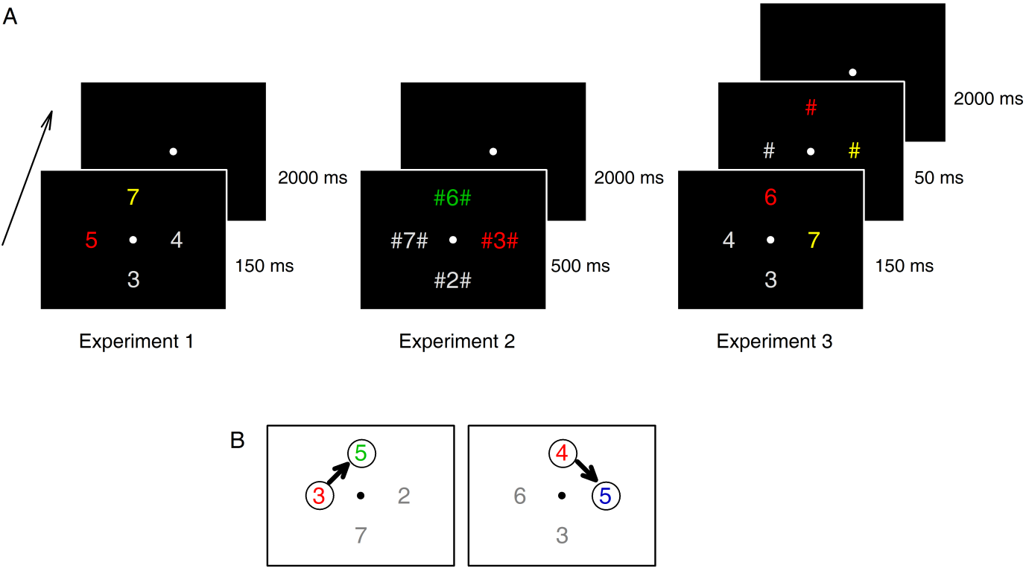

Figure 2.

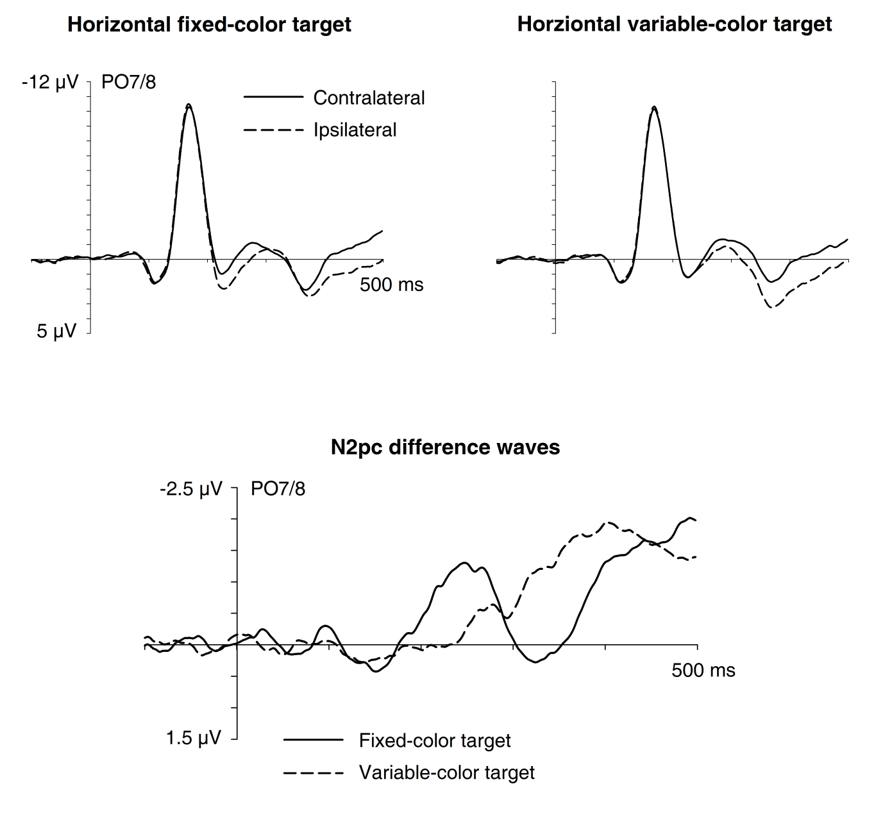

Figure 3.

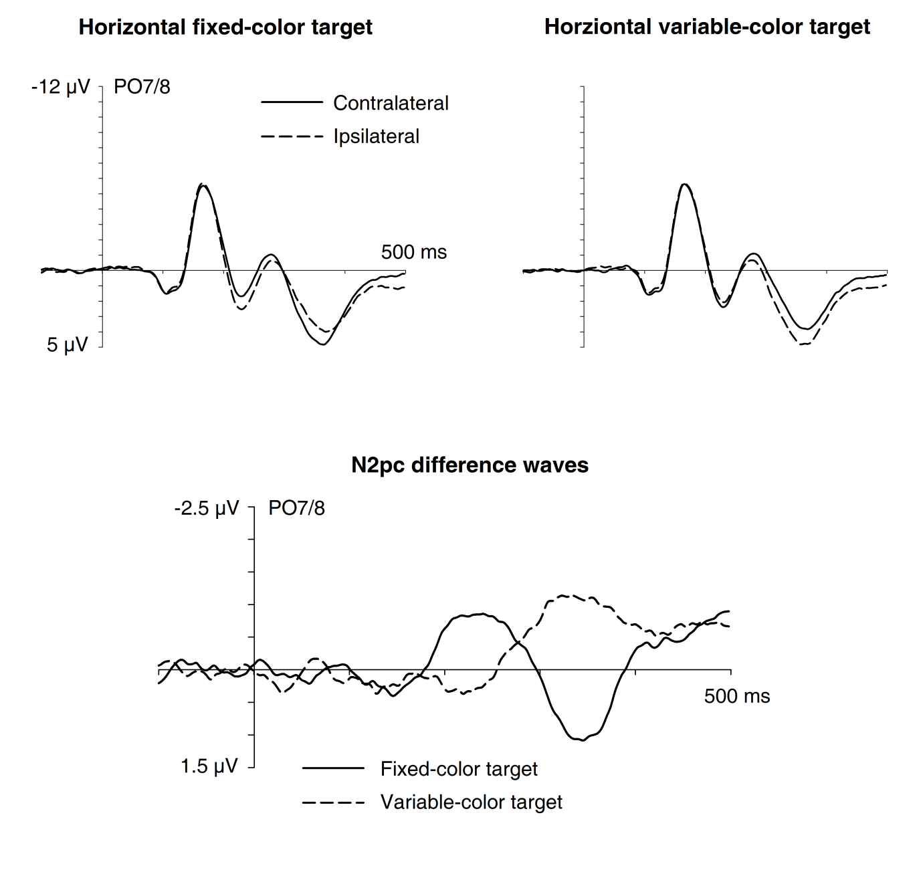

Figure 4.

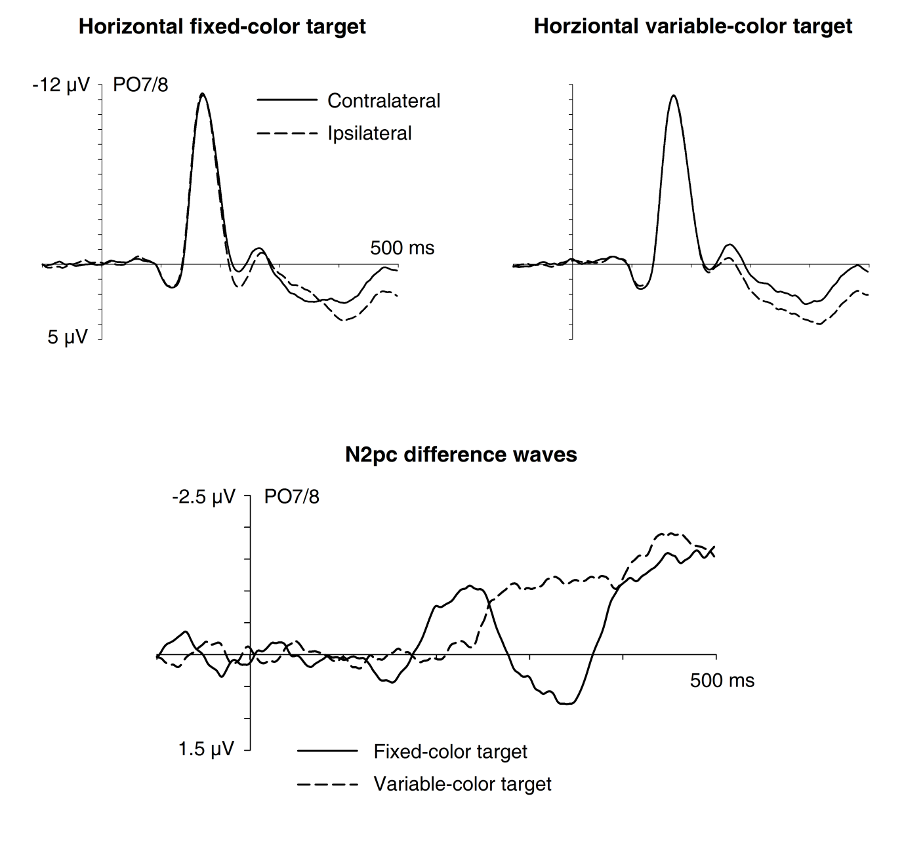

Figure 5.

