**Facial identity and facial expression are initially integrated**

**at visual perceptual stages of face processing**

Katie Fisher*, John Towler, & Martin Eimer

Department of Psychological Sciences

Birkbeck College, University of London, UK

*Corresponding Author

**Corresponding author’s contact details:** Katie Fisher, Department of Psychological

Sciences, Birkbeck College, University of London, Malet Street, London WC1E 7HX, UK.

Phone: 0044 207631 6522. Email: kfishe05@mail.bbk.ac.uk

**Abstract**

It is frequently assumed that facial identity and facial expression are analysed in functionally and anatomically distinct streams within the core visual face processing system. To investigate whether expression and identity interact during the visual processing of faces, we employed a sequential matching procedure where participants compared either the identity or the expression of two successively presented faces, and ignored the other irrelevant dimension. Repetitions versus changes of facial identity and expression were varied independently across trials, and event-related potentials (ERPs) were recorded during task performance. Irrelevant facial identity and irrelevant expression both interfered with performance in the expression and identity matching tasks. These symmetrical interference effects show that neither identity nor expression can be selectively ignored during face matching, and suggest that they are not processed independently. N250r components to identity repetitions that reflect identity matching mechanisms in face-selective visual cortex were delayed and attenuated when there was an expression change, demonstrating that facial expression interferes with visual identity matching. These findings provide new evidence for interactions between facial identity and expression within the core visual processing system, and question the hypothesis that these two attributes are processed independently.

**Keywords:** face perception; face recognition; facial expression; emotion; ERP; N250r

1. **Introduction**

Faces provide different socially important signals, including information related to identity, emotional state, gender, the direction of attention, or speech. The question whether facial attributes such as identity and emotional expression are processed independently by specialised cognitive and neural mechanisms, or are initially analysed together by shared face-selective visual processes, remains an issue of considerable debate. Two influential models of face processing (Bruce & Young, 1986; Haxby, Hoffman, & Gobbini, 2000) assume that identity and expression recognition are functionally and anatomically separable. According to Bruce and Young (1986), facial identity and emotional expression are processed by different visual routes that separate at an early phase of visual-perceptual processing. Haxby et al. (2000) assume that within the “core system” of visual-perceptual face processing, invariant facial attributes such as identity are analysed in a ventral processing stream that includes the inferior occipital cortex and the fusiform face area (FFA), while changeable attributes such as emotional expression are processed in a separate route from occipital cortex to the superior temporal sulcus (STS).

The hypothesis that the processing of facial identity and facial expression are based on dissociable cognitive and neural mechanisms is supported by neuropsychological evidence from patients that show a selective impairment in their ability to recognize the identity of particular faces but remain able to recognize emotional facial expression (e.g., Bruyer et al., 1983; Jones & Tranel, 2001; Nunn, Postma, & Pearson, 2001). Individuals with developmental prosopagnosia that have severe problems with face recognition also often show little impairment in tasks that require the discrimination of facial expressions (e.g., Duchaine, Parker, & Nakayama, 2003). Additional behavioural evidence for the independence of face identity and facial expression recognition comes from studies of participants with normal face recognition abilities. Bruce (1986) found that facial expression judgments were unaffected by whether a particular face was personally familiar or not (see also Campbell, Brooks, de Hann, & Roberts, 1996; Young, Mcweeny, Hay, and Ellis, 1986). What remains unclear is whether these behavioural findings reflect dissociations between facial identity and expression during face perception or at later memory-related stages of face processing.

Neuroimaging evidence for the functional and anatomical dissociation of identity and expression processing within the core perceptual face system is currently inconclusive. In line with the classic account proposed by Haxby et al (2000), the FFA has been shown to be sensitive to repetitions of face identity (Rotshtein, Henson, Treves, Driver, & Dolan, 2005; Winston, Henson, Fine-Goulden, & Dolan, 2004; Yovel & Kanwisher, 2005), while the STS was found to be sensitive to dynamic aspects of face perception such as repetitions of expression (Andrews & Ewbank, 2004; Ganel, Valyear, Goshen-Gottstein, & Goodale, 2005; Harris, Young, & Andrews, 2012; Winston, Henson, Fine-Goulden, & Dolan, 2004). A recent fMRI adaptation study by Harris, Young, and Andrews (2014) has suggested that brain regions involved in the recognition of facial identity or expression are differentially sensitive to surface-based versus edge-based visual signals. However, other studies suggest that these dissociations may not be clear-cut. Activity in the FFA has been shown to be larger in response to expressive versus neutral faces (Furl, Henson, Friston, & Calder, 2013; Vuilleumier, Armony, Driver, & Dolan, 2001), and adaptation effects by repetitions of facial expressions have been found in the FFA (Ganel et al., 2005; Harris et al., 2012; Fox, Moon, Iaria, & Barton, 2009). Furthermore, there is also fMRI evidence that the STS is sensitive to repetitions of face identity (Fox et al., 2009).

Interactions between facial identity and expression have been observed in behavioural studies that used variations of Garner‘s interference paradigm (Garner, 1976), where observers have to make judgments with respect to one particular attribute of a visual stimulus (e.g., shape) while ignoring another task-irrelevant attribute (e.g., colour). Performance in a baseline condition where the irrelevant attribute is held constant (e.g., all stimuli have the same colour) is compared to performance in a filtering condition where relevant and irrelevant attributes both vary randomly and independently across trials. Impaired performance in the filtering condition (Garner interference) shows that the two stimulus attributes cannot be processed independently. Such interference effects were indeed observed in experiments where facial identity and expression served as relevant and irrelevant attributes in different blocks. In one set of studies, variations of task-irrelevant facial identity interfered with facial expression judgments, but identity judgments were unaffected when the irrelevant expression of faces varied randomly (Schweinberger, Burton, & Kelly, 1999; Schweinberger & Soukup, 1998). In another study, symmetrical Garner interference effects were observed, with changes in facial expression impairing identity judgments, and changes in facial identity having a negative impact on expression judgments (Ganel & Goshen-Gottstein, 2004). The symmetrical or asymmetrical nature of such interference effects between expression and identity may be linked to the relative discriminability of changes within these two dimensions (e.g., Wang, Fu, Johnston, & Yan, 2013). However, and more importantly, the existence of Garner interference effects between facial expression and identity demonstrates that changes in the currently task irrelevant dimension cannot be completely ignored, and therefore strongly suggests that expression and identity are not processed entirely independently.

Based on such behavioural findings, and a critical re-evaluation of neuropsychological and neuroimaging evidence in support of separate visual processing streams for facial identity and facial expression, Calder and Young (2005) argue that the cognitive and neural mechanisms involved in the perceptual analysis of facial identity and expression show considerable overlap. These authors suggest that areas within the core face processing system do not show a strict functional and anatomical segregation between identity and expression processing (see also Calder, 2011, for further discussion). The debate about whether identity and expression have separate and parallel visual processing streams remains unresolved, primarily because it is difficult to determine whether facial identity and expression already interact at relatively early perceptual stages of face processing or only at later post-perceptual stages on the basis of behavioural data alone. For example, Garner interference effects between identity and expression might be primarily generated during a late response-related stage, where the selection of “same” responses is delayed when two faces differ on the irrelevant dimension, and the selection of “different” responses is delayed when they share the same task irrelevant feature (e.g., Garner, 1988; see also Atkinson, Tipples, Burt, & Young, 2005, for evidence that Garner interference between the gender and expression of a face might at least in part reflect interactions during response selection). While fMRI measures are able to identify the anatomical locations where identity and emotion are processed, they cannot provide precise information about the time course of identity and emotion processing. In contrast, event-related potential (ERP) measures can allow more direct insights into whether and how facial identity and expression interact during early visual perceptual face processing stages (see Martens, Leuthhold, & Schweinberger, 2010, for evidence from response-related ERP components that facial identity and expression can be processed in parallel).

The earliest and most frequently studied face-sensitive ERP component is the N170, which reflects an enhanced negativity for faces as compared to non-face objects at lateral posterior occipito-temporal electrodes that is typically maximal around 170ms after stimulus onset (e.g., Bentin, Allison, Puce, Perez, & McCarthy, 1996; Eimer, 2000). Although the N170 component can be sensitive to face identity under specific experimental conditions such as prolonged adaptation to a particular facial identity (e.g. Caharel, d’ Arripe, Ramon, Jacques & Rossion, 2009), many studies have found that the N170 does not differ between familiar and unfamiliar faces (e.g., Eimer, 2000; Bentin & Deouell, 2000). A more robust electrophysiological marker of identity-sensitive face processing is the N250r component that can be observed in experiments where face images are presented sequentially (e.g., Begleiter, Porjesz, & Wang, 1995; Schweinberger, Pfütze, & Sommer, 1995; Schweinberger, Pickering, Burton, & Kaufmann, 2002; Schweinberger, Huddy, & Burton, 2004). When a face of the same individual is repeated, an enhanced negativity emerges approximately 220ms post-stimulus at bilateral occipito-temporal electrodes relative to non-repetition trials. This N250r component is thought to be elicited by an identity match between a perceptual face representation and a stored representation in visual face memory (Schweinberger & Burton, 2003. The fact that N250r components are elicited in response to two different images of the same individual (e.g., Bindemann, Burton, Leuthold, & Schweinberger, 2008; Kaufmann, Schweinberger, & Burton, 2009; Zimmermann & Eimer, 2013, 2014) demonstrates that this component does not simply reflect repetitions of low-level image features, but is sensitive to higher-level visual aspects of facial identity, and may therefore correspond to the activation of view-independent face recognition units in the Bruce and Young (1986) model. Dipole source analyses of the N250r and its MEG counterpart (M250r component) suggest that these components are generated in posterior regions of the fusiform gyrus that are likely to correspond to the FFA (Bindemann et al., 2008; Schweinberger, Pickering, Jentzsch, Burton, & Kaufmann, 2002; Schweinberger, Kaufmann, Moratti, Keil, & Burton, 2007). This is in line with fMRI and intracranial recording studies which found that FFA activity in response to faces is modulated by repetitions versus change of facial identity (Engell & McCarthy, 2014; Kanwisher, McDermott, & Chun, 1997; Rotshtein et al., 2005, Winston et al., 2004; Yovel & Kanwisher, 2005). The identity matching processes that give rise to the N250r component are thus likely to take place within the core visual-perceptual face processing network.

The goal of the current study was to find out whether and how face identity matching processes are affected by facial expression. Previous studies that measured ERP markers of face identity and facial expression processing (Bobes, Martin, Olivares, & Valdes-Sosa, 2000; Münte et al., 1998) found that a mismatch in the identity or expression between two successively presented faces resulted in a broadly distributed negativity (N400) that emerged around 350-400ms post-stimulus. These N400 components were interpreted as reflecting the difficulty of integrating an identity or expression change into the context established by a previously seen face. However, none of these earlier studies measured N250r components as marker of face identity matching processes in visual face memory. In the present experiment, we investigated whether the N250r to identity repetitions is modulated by repetitions versus changes of facial expression, as such modulations would indicate that identity and expression interact at relatively early visual-perceptual stages of face processing. A sequential face matching task was employed, where two face stimuli (S1 and S2) were presented successively at fixation on each trial, and were separated by a short interval (200- 300ms). In two different task conditions (identity and expression tasks), participants had to decide whether or not the S2 face matched the S1 face in terms of its identity or its expression. The other attribute that was task-irrelevant (expression in the identity task; identity in the expression task) was varied orthogonally, giving rise to four possible combinations of repetitions or changes in identity or expression between S1 and S2. On some trials, facial expression and identity were either both repeated or both changed. On other trials, the task-relevant attribute was repeated while the irrelevant attribute changed, or vice versa. These four different types of repetition or change trials were presented in a random order and with equal probability.

If identity and expression are processed by separate mechanisms within the core face processing system, directing attention to one of these dimensions and ignoring the other irrelevant dimension should be straightforward. In this case, performance in the identity matching task should be unaffected by repetitions versus changes in facial expression, and performance in the expression matching task should be independent of facial identity. Furthermore, N250r components that are triggered during face identity matching processes when identity is task-relevant should not be affected by repetitions versus changes in facial expression. In contrast, if identity and expression interact at early perceptual stages within the core visual face processing system, the attentional separation of these two dimensions should be more difficult, resulting in behavioural interference effects from the irrelevant dimension (i.e., impaired detection of a task-relevant repetition when there is a change in the irrelevant attribute, and impaired detection of a task-relevant change when the irrelevant attribute is repeated). Furthermore, N250r components elicited by face identity repetitions in the identity task should be modulated by repetitions versus changes in task-irrelevant facial expression. A facilitation of face identity matching processes by a concurrent repetition of facial expression should result in larger and possibly earlier N250r components to identity repetitions relative to trials with an expression change. Such expression-dependent modulations of N250r components in the identity task would show that task-irrelevant facial expression cannot be ignored during the perceptual matching of facial identity.

To test whether face identity matching processes are also elicited when facial identity is irrelevant, and to investigate whether these processes are affected by facial expression, N250r components to identity repetitions versus changes were also measured in the expression matching task. In a previous study (Zimmermann & Eimer, 2014), task-irrelevant identity repetitions triggered N250r components in a view-matching task, suggesting that when different attributes of a face have to be maintained in working memory, identity will also be encoded and retained even when it can be ignored (see also Neumann, Mohamed, & Schweinberger, 2011, for additional evidence that N250r components can be elicited by face identity repetitions in a context where faces are task-irrelevant). If this is the case, N250r components to identity repetitions should also be observed in the expression task of the present study. If facial expression and identity interact during visual stage of face processing, the effects of expression repetitions versus changes on these N250r components should be similar to those observed in the identity task.

Because identity and expression were varied orthogonally, it was also possible to study electrophysiological correlates of facial expression matching processes independently of facial identity. In a behavioural study, Fox and Barton (2007) found expression-specific adaptation effects even when face identity changed, in line with the existence of identity-independent visual representations of facial expression. If such representations exist, they could be activated when the expression of two sequentially presented faces has to be matched. This might be reflected by N250r-like components to expression repetitions as compared to expression changes in the expression task. To investigate this possibility independently from any simultaneous identity matching processes, we compared ERPs to expression repetitions and expression changes on trials where the S1 and S2 faces showed two different individuals.

**2. Methods**

**2.1. Participants**

Sixteen participants (7 female) aged 21-40 years (mean age 28.3 years) took part in the study. Their face recognition abilities were tested with the Cambridge Face Memory Test (CFMT; Duchaine & Nakayama, 2006). All CFMT scores were within ±1 standard deviation of the mean. One additional participant was tested but removed from the sample because they showed a highly atypical “inverted” N250r component (an enhanced lateral posterior positivity to identity repetitions versus changes) in all task conditions.

**2.2. Stimuli and Procedure**

Stimuli were taken from the NimStim database (Tottenham et al., 2009). Black-and-white photographs of six different male faces were used. In each photograph, the actor showed a happy, fearful, or neutral facial expression. There were two different versions (mouth-open or mouth-closed) for each individual person and facial expression, resulting in a total of 36 different face images (see Figure 1 for examples). External facial features were removed from all face images, and the average luminance of all images was equated (22 cd/m2), using Adobe Photoshop. All stimuli were presented at the centre of a CRT monitor at a viewing distance of approximately 100 cm against a grey background (15 cd/m2). On each trial, two face images (S1 and S2) were presented in succession. To avoid repetitions of physically identical images and thus identical retinal stimulation on trials where both identity and expression of S1 were repeated as S2, all S2 images were 10% larger than the S1 images (4.68º x 6.09º versus 4.25º x 5.67º), and all S1-S2 stimulus pairs differed with respect to their mouth features (mouth-open followed by mouth-closed, or vice versa; see Figure 1). Stimulus presentation and response collection was controlled with the Cogent 2000 toolbox (www.vislab.ucl.ac.uk/Cogent/) for MATLAB(Mathworks, Inc.).

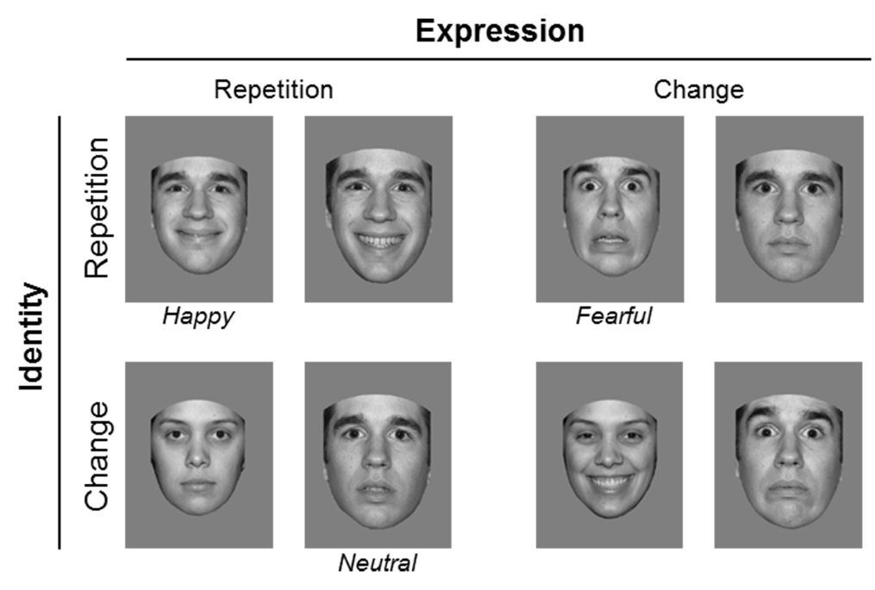

**Figure 1.** Examples of face stimuli pairs shown on different trials. Participants had to match either the identity or the expression of two successively presented faces, and to ignore repetitions or changes in the other currently irrelevant dimension. On each trial, two different versions of face images (mouth-open or mouth-closed) were shown, and the second face was 10% larger than the first face. The top row shows identity repetition trials, and the bottom row identity change trials. Expression repetition and expression change trials are shown on the left and right, respectively. Only images of male faces were included in the stimulus set.

On each trial, the S1 face was presented for 300ms, followed by a jittered inter-stimulus interval of 200-300ms, and the S2 face (300ms duration). The interval between successive trials was varied randomly between 1400ms and 1500ms. On each trial, the identity and the expression of the S1 face could either be the same or differ from the identity and expression of the S2 face. These two factors were varied orthogonally and randomly across trials, resulting in four equiprobable trial types (identity repetition/expression repetition; identity repetition/expression change; identity change/expression repetition; identity change/expression change; see Figure 1). There were two blocked task conditions (identity task and expression task). Each task consisted of 504 trials (126 trials for each of the four different trial types), separated into 8 blocks. In the identity task, participants had to respond to an identity repetition or change between the S1 and S2 face by pressing one of two response buttons, regardless of whether there was an expression repetition or change between these two faces. In the expression task, they had to respond to an expression repetition or change between the S1 and S2 face, and ignore identity repetitions versus changes. Responses were made with the index and middle finger, and response hand was counterbalanced across participants. Images of three different individuals with three different emotional expressions were shown in two different versions (mouth-open or mouth-closed) in each of the two tasks, resulting in 18 face images for the identity task, and 18 different face images for the expression task. The order in which the two tasks were performed was counterbalanced across participants. Prior to the start of the first experimental block, participants completed one training block of 30 trials for the identity task, and an additional training block for the expression task. Following the main experiment, all participants completed the Cambridge Face Memory Task (CFMT), where the faces of six target individuals shown from different viewpoints have to be memorized, in order to be later distinguished from distractor faces (see Duchaine & Nakayama, 2006, for a detailed description of the CFMT).

**2.3. EEG recording and analyses**

EEG was recorded using a BrainAmps DC amplifier with a 40Hz low-pass filter and a sampling rate of 500Hz from 27 Ag-AgCl scalp electrodes. Electrodes at the outer canthi of both eyes were used to record the horizontal electrooculogram (HEOG). During recording, EEG was referenced to an electrode on the left earlobe, and was re-referenced offline relative to the common average of all scalp electrodes. Electrode impedances were kept below 5kΩ. The EEG was epoched from 100ms before to 500ms after the onset of the second face image (S2) on each trial. Epochs with HEOG activity exceeding ±30μV (horizontal eye movements), activity at Fpz exceeding ±60μV (blinks and vertical eye movements), and voltages at any electrode exceeding ±80μV (movement artefacts) were removed from analysis. EEG was averaged relative to a baseline between 50ms prior to 50ms after S2 onset, for each combination of identity (repetition versus change), expression (repetition versus change), separately for the two identity and expression tasks. Only trials with correct responses were included in the ERP analyses. ERPs were averaged across four posterior electrodes over the right hemisphere (P8, PO8, P10 and P10) and the equivalent four electrodes over the left hemisphere (P7, PO7, P9 and PO9).

N250r components were quantified on the basis of ERP mean amplitudes calculated during a window from 220ms to 320ms after S2 onset. Repeated-measures ANOVAs were conducted on these mean amplitude values for the factors identity (repetition versus change), expression (repetition versus change), and hemisphere (left versus right), separately for the identity and expression tasks. An additional ANOVA was conducted across both tasks, with task (identity versus expression) as additional factor. Analogous analyses were conducted on behavioural performance measures for the factors identity and expression. When significant interactions between identity and expression were found in these analyses, these interactions were further explored with follow-up t-tests. Bonferroni corrections for multiple comparisons were applied when appropriate.

To test whether N250r components emerged later on expression change trials relative to expression repetition trials, N250r onset latency analyses were conducted. These analyses were performed with a jackknife-based procedure based on grand-averaged difference waveforms obtained by subtracting ERPs on identity change trials from identity repetition trials, separately for the identity and expression tasks. The jackknifing procedure estimates onset latencies from grand averages that are computed from subsamples of participants where one participant is successively excluded from the original sample (Miller, Patterson, & Ulrich, 1998). N250r onset latencies were computed within a 200-300ms post-stimulus time window, and were defined relative to absolute voltage threshold values of -0.7μV (identity task) and -0.4μV (expression task), which both correspond to 30% of the mean peak amplitude of the two N250r difference waves in these two tasks. N250r onset latencies on expression repetition and expression change trials were compared with t-tests, with t-values corrected according to the formula described by Miller et al. (1998). Because these planned comparisons were testing directional hypotheses, these t-tests were one-tailed. To explore the involvement of identity-independent visual representations of facial expression in face matching processes, we also compared ERPs to expression repetitions versus changes, specifically for those trials with an identity change between the two faces. Because expression repetition effects emerged later than the N250r to identity repetitions, which corresponded with slower reaction times in the expression matching task, ERP mean amplitudes measured at the same four posterior electrode pairs that were used for the standard N250r analyses were analysed within a 280-500ms post-stimulus time window. In addition to the N250r, further analyses were conducted for the earlier visual P1 and N170 components, based on ERP mean amplitudes obtained from 100-130ms (P1 component) and 150-200ms (N170 component) at lateral posterior electrodes.

**3. Results**

**3.1. Behavioural performance**

Figure 2 shows reaction times (RTs) and error rates for the four different types of trials in the identity and expression tasks. Separate ANOVAs were conducted for RTs and error rates in each task, with the factors identity (repetition versus change) and expression (repetition versus change).

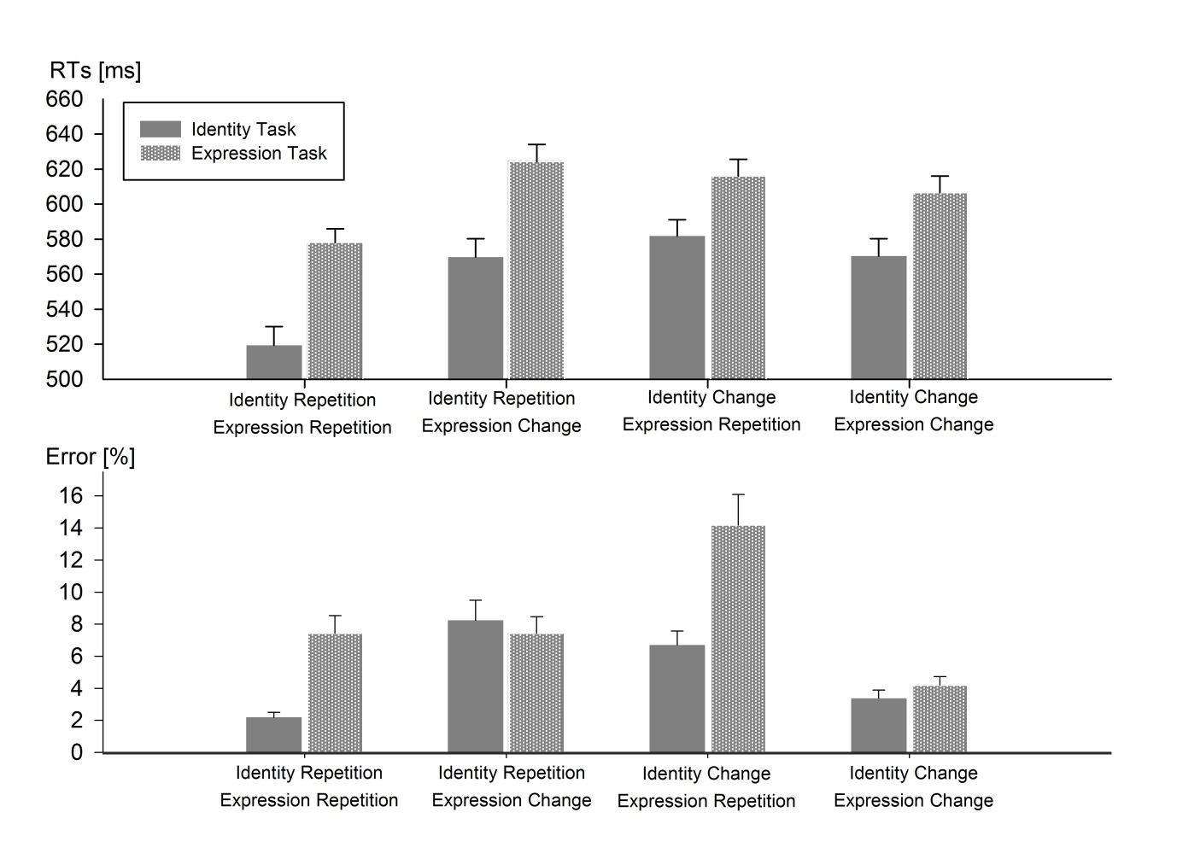

**Figure 2.** Mean reaction times (top panel) and error percentages (bottom panel) in the identity task and the expression task. Results are shown separately for each of the four combinations of identity (repetition versus change) and expression (repetition versus change). Error bars depict standard errors of the mean.

In the identity task, the RT analysis revealed main effects of identity, *F*(1,15)=9.39, p<.008, ηp2=.39, and expression *F*(1,15)=41.85, *p*<.0001, ηp2=.74, with faster RTs for identity repetitions (544ms) than identity changes (576ms), and for expression repetitions (550ms) than expression changes (570ms). There was also an interaction between identity and expression, *F*(1,15)=40.91, *p*<.0001, ηp2=.73. RTs on identity repetition trials were faster when facial expression was also repeated than when expression changed (520ms versus 570ms; *t*(15)=7.86, *p*<.0001). In contrast, RTs on identity change trials were faster when expression changed than when it was repeated (570ms versus 582ms; *t*(15)=2.36, *p*<.05). There were no main effects of identity or expression on error rates, both F<1.1, but an interaction between these two factors was observed, *F*(1,15)=11.54, *p*<.004, ηp2=.44. Errors on identity repetition trials were more frequent when facial expression changed than when it was repeated (8.2% versus 2.1%; *t*(15)=2.53, *p*<.05). On identity change trials, error rate was higher when expression was repeated than when it changed (6.7% versus 3.3%; *t*(15)=2.58, *p*<.05).

A similar pattern of results was observed in the expression task. For RTs, there were main effects of identity, *F*(1,15)=5.73, *p*<.03, ηp2=.28 and expression, *F*(1,15)=6.81, *p*<.02, ηp2=.31, with faster responses for identity repetitions versus changes (601ms versus 611ms), and for expression repetitions versus changes (597ms versus 615ms). An interaction between identity and expression, *F*(1,15)=30.48, *p*<.0001, ηp2=.67, was also observed. RTs on expression repetition trials were faster when facial identity was repeated than when it changed (578ms versus 616 ms; *t*(15)=4.53, *p*<.001). In contrast, RTs on expression change trials were faster when facial identity changed than when it was repeated (607ms versus 624ms; *t*(15)=4.41, *p*<.001). For error rates, main effects of identity, *F*(1,15)=5.14, *p*<.04, ηp2=.26, and expression, *F*(1,15)=7.19, *p*<.02, ηp2=.32, were accompanied by an interaction between both factors, *F*(1,15)=6.51, *p*<.02, ηp2=.30. Errors on expression repetition trials were more frequent when facial identity changed than when it was repeated (14.1% versus 7.4%; *t*(15)=2.55, *p*<.05). On expression change trials, there were more errors when the identity of a face was repeated than when it changed (7.5% versus 4.2%; *t*(15)=2.37, *p*<.05).

To assess whether the interference effects of the currently irrelevant dimension differed as a result of whether or not this dimension had been task-relevant previously, additional analyses of RTs and error rates were conducted for the identity and expression tasks, including the between-participant factor task order (identity task first versus expression task first). There were no interactions between identity, expression, and task order in either task for RTs, both *F*<1, and error rates, both *F*<2.8, ruling out the possibility that the behavioural interference effects in the identity or expression tasks were modulated by transfer effects from the other task.

Analyses conducted across both tasks, with task (identity versus expression) as additional factor, revealed a main effect of task for RTs, with faster responses in the identity task relative to the expression task (560ms versus 606ms; *F*(1,15)=10.02, *p*<.006, ηp2=.40). Error rates did not differ between the two tasks, *F*(1,15)=2.92, *p*>.05. To test whether the size of the interference effects of the currently irrelevant dimension differed between the identity and emotion tasks, RT and accuracy differences between trials where both identity and expression were congruent across S1 and S2 (i.e., both were repeated or both changed) and trials where these two dimensions were incongruent (one was repeated and the other changed) were compared between the two tasks. There was no significant difference in the size of the expression congruency effect in the identity task and the identity congruency effect in the expression task, for RTs (31ms versus 28ms; *t*(15)<1), or error rates, (4.7% versus 5.5% *t*(15)<1). This demonstrates that the interference effects from the currently task-irrelevant dimension on identity and expression matching performance were symmetrical.

**3.2. ERP results**

Figure 3 shows ERP waveforms measured at lateral posterior electrodes over the left and right hemisphere in response to S2 face displays in the identity and expression matching tasks on identity repetition and identity change trials, displayed separately for trials where facial expression was either repeated or changed. There were no systematic differences between task conditions for the early visual P1 and N170 components, except for an apparent reduction of P1 amplitudes on trials where both identity and repetition were repeated (see below). Following the P1 and N170, N250r components to identity repetitions versus changes were present in both tasks, but were larger in the identity task. These N250r components were larger on trials where facial expression was repeated than on trials with an expression change between the S1 and S2 faces. To evaluate these differences, repeated-measures ANOVAs with the factors hemisphere (left, right), identity (repetition, change) and expression (repetition, change) were conducted for ERP mean amplitude values measured during the N250r time window (220-320 ms post-stimulus), separately for the identity and expression matching tasks.

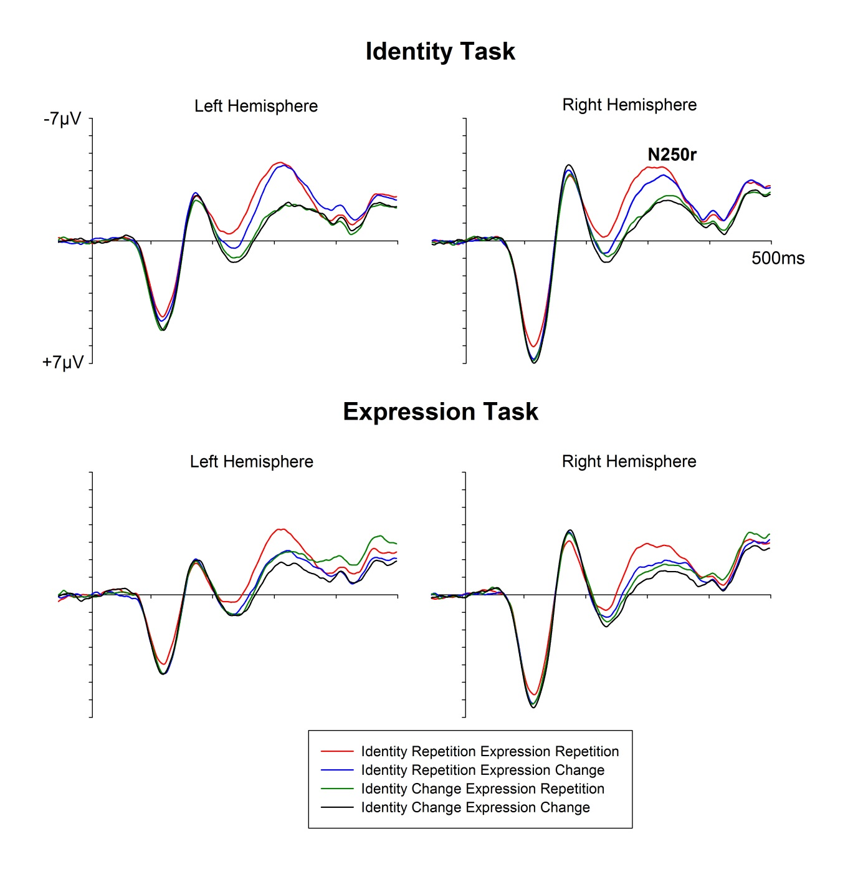

**Figure 3.** Grand-averaged ERPs elicited at lateral posterior electrodes during the 500ms interval after the onset of the S2 face, shown separately for the identity task (top panel) and the expression task (bottom panel). ERPs were averaged across four posterior electrodes over the left hemisphere (P7, PO7, P9 and PO9) and the equivalent four electrodes over the right hemisphere (P8, PO8, P10 and PO10). Waveforms are shown separately for each of the four combinations of identity repetition versus change and expression repetition versus change.

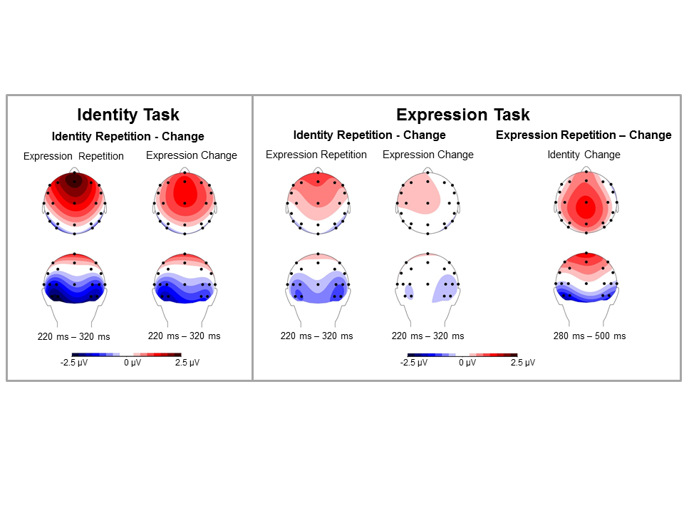

**Figure 4.** Left panel: Scalp distribution of N250r components measured in the identity task on expression repetition and expression change trials. These topographic maps were generated by subtracting ERP mean amplitudes measured in the 220-320ms post-stimulus time window on identity change trials from ERPs on identity repetition trials. Right panel: Topographic maps of N250r components to identity repetitions versus identity changes in the expression task (shown separately for trials with expression repetitions and expression changes), and a scalp map of the difference between expression repetitions and expression changes observed on identity change trials in the expression task. The topography of this expression repetition effect was computed for the 280-500ms post-stimulus time window.

*N250r components in the identity task.* There was a main effect of identity, *F*(1,15)=25.83, *p*<.001, ηp2=.63, reflecting the presence of N250r components to identity repetitions versus changes. There was also a main effect of expression, *F*(1,15)= 50.57, *p*<.0001, ηp2=.77, and, critically, a significant interaction between identity and expression, *F*(1,15)=7.45, *p*<.02, ηp2=.33. N250r amplitudes on trials with identity repetitions versus changes (collapsed across both hemispheres) were larger when facial expression was repeated (-2.58μV versus -0.54μV; *t*(15)=6.39, *p*<.0001) than when expression changed (-1.72μV versus -0.33μV; *t*(15) = 3.53, *p*<.007). Figure 4 (left panels) shows the scalp topography of N250r components elicited on expression repetition and expression change trials. These scalp maps were computed by subtracting ERP mean amplitudes in the N250r time window (220-320ms post-stimulus) on identity change trials from ERPs on identity repetition trials, separately for trials with expression repetitions or changes. Both maps show the typical N250r topography, with a bilateral posterior negativity (that is more pronounced in the identity task) accompanied by a more broadly distributed fronto-central positivity. Although the N250r appears to be more pronounced over the left hemisphere, the interaction between identity and hemisphere was not significant, *F*< 1.7. An additional analysis with task order as a between-participant factor found no three-way interaction between identity, expression, and task order, *F*(1,14)= 2.24, *p*=.16, demonstrating that the effect of expression repetitions versus changes on N250r amplitudes did not depend on whether expression had been task-relevant before.

The time course of the N250r is illustrated in Figure 5 (left panel), which shows N250r difference waveforms obtained by subtracting ERPs on identity change trials from ERPs on identity repetition trials, separately for trials where expression was repeated or changed (collapsed across the four electrode pairs over the left and right hemisphere). N250r amplitudes were larger on expression repetition trials as compared to expression change trials, *t*(15) = 2.73, *p*<.02. There was no three-way interaction between identity, expression, and hemisphere, *F*<1, demonstrating that the N250r amplitude reduction on trials with facial expression changes did not differ between hemispheres. Figure 5 also suggests that N250r components to identity repetitions versus changes emerged later on trials where facial expression changed relative to trials where expression was repeated. This was confirmed by a jackknife-based onset analysis performed on N250r difference waveforms (collapsed across hemispheres) with an absolute onset criterion of -0.7μV (corresponding to approximately 30% of the average peak amplitude of the two difference waves). The N250r component on expression repetition trials preceded the N250r on trials with expression changes by 23ms (215ms versus 238ms), and this onset latency difference was reliable, *tc*(15)=2.96, *p*<.005, one-tailed.

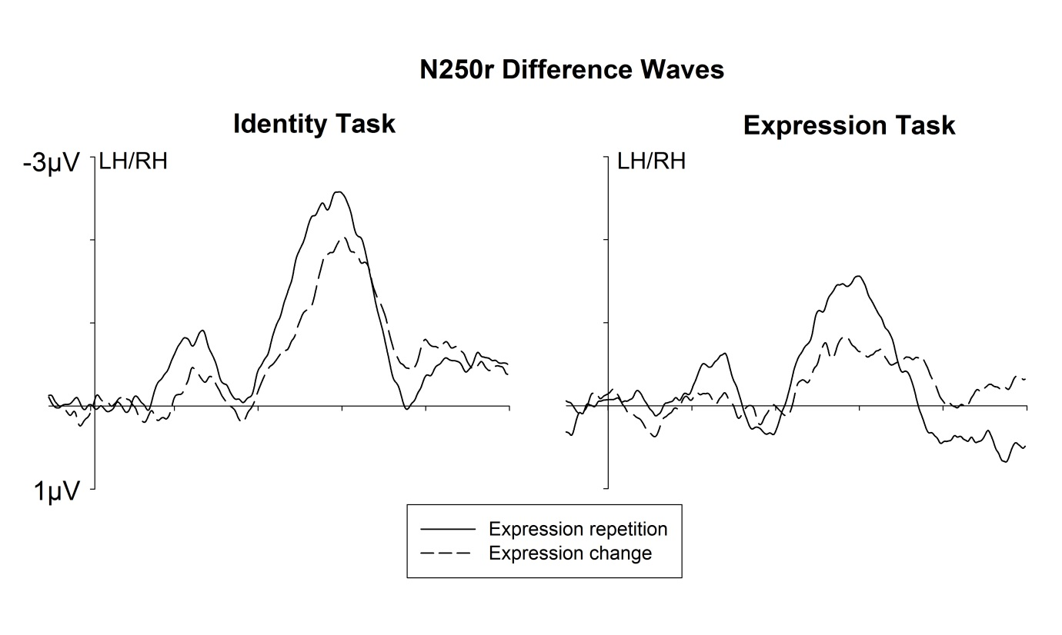

**Figure 5.** N250r difference waveforms obtained by subtracting ERPs on identity change trials from ERPs on identity repetition trials, separately for trials with expression repetitions (solid lines) and for expression change trials (dashed lines). N250r components are shown separately for the identity task (left) and the expression task (right).

*N250r components in the expression task.* A main effect of identity, *F*(1,15)=44.61, *p*<.0001, ηp2=.75, demonstrated that N250r components to identity repetitions versus changes were reliably present in the expression task even though facial identity was now task-irrelevant. There was no interaction between identity and hemisphere, *F*<1. In addition, a significant effect of expression, *F*(1,15)=19.45, *p*<.001, ηp2=.65, was accompanied by an interaction between expression and identity *F*(1,15)=6.85, *p*<.02, ηp2=0.31. N250r components (collapsed across hemispheres) were present not only on trials where facial expression was also repeated (-1.48μV versus -.31μV; *t*(15)=6.58, *p*<.0001), but also on expression change trials (-.54μV versus .02μV; *t*(15)=3.31, *p*<.01). However, as can also be seen in the topographic maps in Figure 4 (right panel), the N250r was significantly larger on expression repetition trials, *t*(15)= 2.62, *p*<.05. There was no three-way interaction between identity, expression, and hemisphere, *F*<1. As in the identity task, an additional analysis of N250r amplitudes with task order as a between-participant factor showed that there was no three-way interaction between identity, expression, and task order, *F*<1. The N250r difference waveforms in Figure 5 (right panel) show that the N250r component to identity repetitions versus changes was not only reduced in size, but also emerged later on trials where facial expression changed relative to expression repetition trials. This was confirmed by a jackknife-based onset analysis performed on N250r difference waveforms (collapsed across hemispheres) with an absolute onset criterion of -0.4μV (corresponding to approximately 30% of the average peak amplitude of the two difference waves). The N250r component on trials where facial expression was repeated preceded the N250r on trials with expression changes by 22ms (221ms versus 243ms), and this onset latency difference was reliable, *tc*(15)=1.86, *p*<.05 (one-tailed).

*Analysis of N250r components across both tasks.* An ANOVA of N250r mean amplitudes measured in both task conditions with the factors task (identity task, expression task), hemisphere (right, left) identity (repetition, change) and expression (repetition, change) confirmed that the N250r to identity repetitions was larger in the identity task than in the expression task, as reflected by an interaction between task and identity, *F*(1,15)= 9.26, p<.01, ηp2=.38. There were no interactions between task and expression, *F*<1.7, and between task, identity, and expression, *F*<1.

*Expression repetition effects on identity change trials.* A differential effect of expression repetitions versus changes that is independent of facial identity can be seen in Figure 3 when comparing ERPs on trials with an expression repetition and an identity change (green lines) and trials where expression and identity both changed (black lines). An enhanced negativity was elicited for expression repetitions versus changes on these trials in the expression task (Figure 3, bottom panels). This effect started later than the N250r to identity repetitions, but remained present during the entire 500ms measurement window. No such differential response to expression repetitions versus changes was apparent in the identity task. Figure 4 (far right panel) shows the scalp topography of the N250r-like component to expression repetitions versus changes on identity change trials in the expression task. This map was computed by subtracting ERPs measured during the 280-500ms post-stimulus time window on expression change trials from ERPs on expression repetition trials. The topography of the differential ERP response to expression repetitions versus changes was similar to the topography of the identity-sensitive N250r components observed in the identity and expression tasks (as shown in Figure 4). In both cases, a negativity over lateral visual areas was accompanied by a broadly distributed positivity. The focus of this positivity is more posterior for the expression repetition effect than for the N250r component, which is likely to reflect a temporal overlap with the P3 component that emerges beyond 300ms post-stimulus, and is sensitive to target events (i.e., the presence of an expression repetition).

To assess this expression-specific repetition effect, an ANOVA was conducted for ERP mean amplitudes measured at lateral posterior electrodes on identity change trials during a 280-500ms post-stimulus time window, for the factors task (identity task, expression task), expression (repetition, change), and hemisphere (right, left). There was a main effect of expression *F*(1,15)=9.32, *p*<.01, ηp2 =.38, confirming the presence of an identity-independent expression repetition effect. Importantly, a significant interaction between task and expression was present, *F*(1,15)=6.67, *p*<.03, ηp2 =.31. In the expression task, there was a significantly enhanced negativity on expression repetition versus expression change trials (-2.05μV versus - 1.32μV; *t*(15)= 3.44, *p*<.02). No such difference was present in the identity task, *t*<1. There was no interaction between expression and hemisphere, *F*<1.4, but a significant three-way interaction between task, expression, and hemisphere, *F*(1,15)= 7.06, *p*<.02, ηp2 =.32. As can be seen in Figure 3 (bottom panels, green versus black lines), and in the topographical map shown in Figure 4 (right panel), the enhanced negativity to expression repetitions versus changes on identity change trials in the expression task was more pronounced over the left hemisphere. A corresponding analysis of ERPs measured during the earlier 220–280ms post-stimulus time window (where the identity-sensitive N250r component was already present) found no significant effects of expression on identity change trials in either task.

*Early visual ERP components (P1, N170).* As in many previous N250r studies, the early visual-evoked P1 component was smaller in both tasks when both facial identity and facial expression were repeated relative to trials where one or both of these attributes changed (see Figure 3), this was the case in both tasks. This is likely to reflect the fact that the total amount of visual change between the two successively presented faces was smallest on trials where expression and identity were both repeated, as the P1 is highly sensitive to low-level visual features changes. An analysis of P1 mean amplitude values (measured during a 100-130ms post-stimulus time window) confirmed that P1 amplitudes were smaller on trials where expression and identity were both repeated relative to trials where expression, identity, or both attributes changed between the S1 and S2 face (all *p* < .05). This differential P1 modulation can also be seen in the N250r difference waveforms (Figure 5) during the 100 -150ms interval after S2 onset. This early low-level sensory effect disappeared at around 180ms post-stimulus, prior to the onset of N250r components. There were no reliable effects of any experimental factor, or any interaction between factors on the amplitude of the face-sensitive N170 component (measured between 150 and 200ms after S2 onset; all *F* < 3.4).

**4. Discussion**

The question whether the processing of facial identity and facial expression is based on separate or shared mechanisms within the core visual face processing system remains controversial (e.g., Calder & Young, 2005). In the present study, we have identified interactions between facial expression and identity that take place during visual-perceptual stages of face processing within the first 300ms after stimulus onset.

The pattern of behavioural results obtained in the identity and expression tasks demonstrated symmetrical interference effects from task-irrelevant facial expression on identity matching, and from task-irrelevant facial identity on expression matching. In the identity task, the detection of an identity repetition between two successively presented faces was slower and less accurate when these faces differed in their emotional expression, and the detection of an identity change was impaired when facial expression was repeated. These symmetrical interference effects of facial expression on the matching of facial identity demonstrate that selective attention could not be exclusively focused on identity as the currently task-relevant dimension, and suggest that identity-related information was not processed independently of facial expression. Exactly the same pattern of interference effects was observed in the expression task. The detection of a facial expression repetition was impaired when there was a change in facial identity, and the detection of an expression change was impaired when face identity was repeated. The size of these behavioural interference effects from the currently task-irrelevant dimension did not differ between the identity and expression tasks, demonstrating the existence of fully symmetrical interactions between facial identity and expression. This is in line with previous behavioural studies that have reported symmetrical interference effects between identity and expression (Ganel & Goshen-Gottstein, 2004; Wang et al., 2013; but see Schweinberger & Soukup, 1998; Schweinberger et al., 1999, for asymmetrical effects). The face matching tasks employed in the present study required comparisons between sequentially presented faces that followed each other in rapid succession, and involved visual memory for individual faces. The presence of symmetrical interference effects from expression on identity judgments, and vice versa, demonstrates that identity and expression were represented in visual face memory even when they were task-irrelevant. Given the short inter-stimulus interval between the two faces in the present study (200–300ms), the possibility remains that representations of task-irrelevant facial expression may not be actively held in working memory over longer periods. If this was the case, asymmetrical interference effects might have been observed with longer retention intervals.

While these behavioural interference effects demonstrate that identity and expression interact at some stage during the face matching process, they do not provide direct evidence that these interactions occurred during the perceptual analysis of faces in the core visual face processing system. These effects could also have been generated at later response selection stages, in line with the interpretation of Garner interference as a stimulus-response compatibility effect (Garner, 1988). However, the N250r results observed in the present study show that facial identity and expression interacted during an early perceptual stage of identity-related face processing where visual representations of seen faces are matched with stored representations in visual face memory. As expected, N250r components were triggered by face identity repetitions as compared to changes in the identity task. Critically, this N250r to face identity repetitions was larger and emerged earlier on trials where facial expression was also repeated as compared to trials with an expression change (Figure 5, left panel). The delay of the N250r component on trials with an expression change as compared to expression repetition trials shows that interactions between identity and expression affect the time course of face identity matching even when facial expression is task-irrelevant and observers are instructed to ignore this dimension.

The N250r component is assumed to be generated in posterior fusiform cortex areas that include the FFA (Bindemann et al., 2008; Schweinberger et al., 2002), which implies that the face identity matching processes reflected by this component take place within the core visual face processing system (Haxby et al., 2000). The fact that N250r amplitudes and onset latencies in the identity task were systematically affected by repetitions versus changes in task-irrelevant facial expression therefore provides direct evidence for interactions between identity and expression within this core face processing system. If the N250r component reflected face identity matching processes within a stream that analyses identity-related visual information and is functionally and anatomically separate from the stream that processes facial expression, the matching of visual representations of facial identity should not be affected by representations of facial expression. In this case, the N250r should be essentially unaffected by repetitions versus changes of emotional facial expression. The observed delay and attenuation of N250r components on expression change trials in the identity task is not in line with this prediction, and demonstrates instead that visual perceptual face identity matching processes are strongly modulated by the presence of alterations in facial structure that accompany changes in emotional expression. The delayed onset of the N250r on expression change trials suggests that perceptual evidence for an identity match between a seen face and a stored visual representation of the identity of a previously encountered face becomes available later when there is a change in facial expression. The attenuation of N250r amplitudes on these trials may reflect a reduction in the efficiency of face identity matching processes in the presence of an expression change. The behavioural interference effects triggered by facial expression changes in the identity task and the interference effects observed at the level of the N250r component are likely to be linked. The fact that the N250r onset delay on expression change trials (23ms) was smaller than the corresponding RT delay for identity matching responses (50ms) suggests that the delay of face identity matching processes on these trials cannot fully explain the observed behavioural costs.

Face identity repetitions also triggered reliable N250r components in the expression task, in spite of the fact that identity was known to be irrelevant in this task. This demonstrates that information about the identity of the S1 face was retained and then matched with the identity of the S2 face, even though matching processes had to be based on facial expression. The presence of N250r components in a task where facial identity is formally task-irrelevant is in line with a previous study which observed reliable N250r components to identity repetitions in a task where observers had to match the view in which two successive faces were presented, and to ignore facial identity (Zimmermann & Eimer, 2014). Such observations show that identity does not have to be explicitly task-relevant in order to be encoded in visual face memory. When a particular face attribute other than identity has to be retained in order to be compared to another face image, facial identity appears to be encoded and stored in a mandatory fashion, regardless of task instructions. Note that task-irrelevant identity repetitions do not trigger an N250r in tasks that do not require observers to maintain a face representation in visual working memory (Zimmermann & Eimer, 2014), demonstrating that face identity matching is not an entirely automatic process, but is under top-down control. The observation that N250r components to identity repetitions were reliably smaller in the expression task than in the identity task shows that this processing of facial identity is not completely automatic, but is modulated to some degree by top-down task settings. While the N250r to identity repetitions was reduced in size in the expression task where identity was task-irrelevant, the effects of repetitions versus changes of facial expression on N250r amplitudes and latencies were very similar in both tasks (see Figure 5). As in the identity task, N250r components to identity repetitions were smaller in size and emerged later on expression change trials in the expression task. The size of this N250r onset delay was nearly identical in the two tasks (23ms versus 22ms). These observations demonstrate that the interference effects of facial expression on face identity matching processes, as reflected by the N250r component, were essentially the same regardless of whether facial identity was task-relevant or not. They suggest that interactions between expression and identity during the early perceptual analysis of face images in the core visual face processing system occur in a largely stimulus-driven fashion, that is, independent of top-down task sets and selective attention to a particular facial dimension.

It could be argued that the attenuation and delay of identity-sensitive N250r components on expression change trials may not exclusively reflect interactions between facial identity and expression during face identity matching processes, but is at least in part the result of low-level visual differences between the two successively presented faces. Such differences may have been more pronounced on expression change trials than on expression repetition trials. As the N250r component reflects identity matching processes that are based on visual comparisons between currently seen faces and stored visual face representations, some residual impact of low-level visual factors is difficult to rule out entirely, because faces that change expression inevitably differ in their low-level image properties. However, these factors are unlikely to fully account for the N250r differences observed in the present study between expression repetition and expression change trials. To minimize differences in the amount of visual change between S1 and S2 faces across different types of trials, we presented two different face images (mouth-open or mouth-closed) on all trials. Furthermore, previous experiments have demonstrated that the N250r component is image-independent (e.g., Bindemann et al., 2008; Kaufmann et al., 2009). For example, in two recent studies (Zimmermann & Eimer, 2013, 2014), N250r amplitudes did not differ reliably between trials where two faces of the same individual were presented sequentially in the same view or in two different views, demonstrating that the N250r is much more sensitive to repetitions of facial identity than to repetitions of low-level visual features.

A novel finding of the present study was the presence of a reliable enhanced negativity to expression repetitions versus changes (see also Werheid, Alpay, Jentzsch, & Sommer, 2005, for ERP modulations produced by priming specific emotional facial expressions). This differential effect was observed in the expression task on trials where S1 and S2 faces differed in their identity (see Figure 3, bottom panels), indicating that it is independent of face identity matching processes. This enhanced negativity for expression repetitions versus changes emerged slightly later than the identity-sensitive N250r component, and remained present in a sustained fashion during the 500ms post-stimulus measurement window. Even though the N250r is primarily sensitive to facial identity, the expression repetition effect on identity change trials in the expression task may reflect an N250r-like response that is triggered when visual representations of the facial expressions of two sequentially presented faces are successfully matched. For this reason, and because the topography of this expression repetition effect was similar to the scalp topography of the N250r to identity repetitions versus changes in the identity task (as shown in Figure 4), we tentatively refer to this N250r-like response to emotion repetitions as the “N250rE”. If this N250rE component reflects an expression match between a seen face and a representation stored in visual face memory, its presence on identity change trials would suggest the existence of identity-independent visual representations of facial expression. Behavioural evidence for such representations comes from a visual adaptation study by Fox and Barton (2007). Prolonged exposure to adaptor faces showing a particular emotional expression biased judgments made in response to a subsequent ambiguous test faces towards the expression opposite to that shown by the adaptor faces. Critically, this effect was observed even when faces of different individuals were shown as adaptor and test stimuli, suggesting that emotional facial expression can be represented independently of facial identity. However, it should be noted that these adaptation effects for facial expression were larger on identity repetition trials, while identity-specific adaptation effects did not differ between expression repetition and expression change trials (Fox, Oruç, & Barton, 2008).

In contrast to the identity-sensitive N250r component that was present also in the expression task where facial identity was irrelevant, the enhanced negativity to expression repetitions on identity change trials was only observed in the expression task, but was absent in the identity task. This suggests that the expressions of two successively presented faces are only matched when this is required by the experimental task. However, the fact that repetitions versus changes of irrelevant facial expressions interfered with task performance in the identity task shows that some visual information about expression was still encoded and retained in this task. The presence of expression-induced behavioural interference and the absence of an N250rE component response to facial expression in the identity task suggest that there is a difference between the passive maintenance of facial attributes and the active matching of such attributes between memorized and seen faces. Because the presence of an N250rE component to repetitions of facial expression has not been observed before, this effect needs to be studied more systematically in future experiments to confirm its reliability and its link to facial expression matching mechanisms. It would also be interesting to investigate whether the perceptual matching of task-relevant facial attributes other than identity and emotional expression is also accompanied by similar ERP components.

In summary, the current study has provided new evidence for interactions between facial identity and expression processing. When the identity or expression of face pairs has to be matched, repetitions or changes in the other task-irrelevant dimension cannot be ignored. Neural processes involved in face identity matching operate less efficiently when faces differ in their expression. These findings support previous suggestions (Calder & Young, 2005; Calder, 2011) that the cognitive and neural mechanisms involved in the visual analysis of facial identity and facial expression are closely linked, and suggest that the recognition of identity and emotional expression are based on shared representations within the core visual face processing system.

**Acknowledgement:** This work was supported by a grant (ES/K002457/1) from the Economic and Social Research Council (ESRC), UK.

**References**

Andrews, T. J., & Ewbank, M. P. (2004). Distinct representations for facial identity and

changeable aspects of faces in the human temporal lobe. *Neuroimage*, *23*(3), 905-913.  
Atkinson, A. P., Tipples, J., Burt, D. M., & Young, A. W. (2005). Asymmetric interference

between sex and emotion in face perception. *Perception & Psychophysics, 67*(7), 1199-1213.

Begleiter, H., Porjesz, B., & Wang, W. (1995). Event-related brain potentials differentiate

priming and recognition to familiar and unfamiliar faces. *Electroencephalography and Clinical*

*Neurophysiology*, *94*(1), 41–49.

Bentin, S., Allison, T., Puce, A., Perez, E., & McCarthy, G. (1996). Electrophysiological studies of face perception in humans. *Journal of Cognitive Neuroscience*, *8*(6), 551–565.

Bentin, S., & Deouell, L. Y. (2000). Structural encoding and identification in face processing: ERP evidence for separate mechanisms. *Cognitive Neuropsychology*, *17*(1-3), 35–55.

Bindemann, M., Burton, A. M., Leuthold, H., & Schweinberger, S. R. (2008). Brain potential

correlates of face recognition: Geometric distortions and the N250r brain response to stimulus repetitions. *Psychophysiology*, *45*(4), 535–544.

Bobes, M. A., Martı́n, M., Olivares, E., & Valdés-Sosa, M. (2000). Different scalp topography of brain potentials related to expression and identity matching of faces. *Cognitive Brain Research*, *9*(3), 249–260.

Bruce, V. (1986). Influences of familiarity on the processing of faces. *Perception*, *15*(4), 387–397.

Bruce, V., & Young, A. (1986). Understanding face recognition. *British Journal of Psychology*, *77*(3),

305-327.

Bruyer, R., Laterre, C., Seron, X., Feyereisen, P., Strypstein, E., Pierrard, E., & Rectem, D.

(1983). A case of prosopagnosia with some preserved covert remembrance of familiar

faces. *Brain and Cognition*, *2*(3), 257–284.

Caharel, S., d’ Arripe, O., Ramon, M., Jacques, C., & Rossion, B. (2009). Early adaptation to repeated unfamiliar faces across viewpoint changes in the right hemisphere: Evidence from the N170 ERP component. *Neuropsychologia*, *47*(3), 639–643.

Calder, A. J. (2011). Does facial identity and facial expression recognition involve separate visual

routes? In A. J. Calder, G. Rhodes, M. H. Johnson & J. V. Haxby (Eds.), *The Oxford*

*handbook of face perception* (pp. 427-448). Oxford, England: Oxford University Press.

Calder, A. J., & Young, A. W. (2005). Understanding the recognition of facial identity and facial

expression. *Nature Reviews Neuroscience*, *6*(8), 641–651.

Campbell, R., Brooks, B., de Hann, E., & Roberts, T. (1996). Dissociating face processing skills:

decisions about lip read speech, expression, and identity. *The Quarterly Journal of*

*Experimental Psychology Section A*, *49*(2), 295–314.

Duchaine, B. C., Parker, H., & Nakayama, K. (2003). Normal recognition of emotion in a

prosopagnosic. *Perception*, *32*(7), 827–838.

Duchaine, B., & Nakayama, K. (2006). The Cambridge Face Memory Test: Results for neurologically intact individuals and an investigation of its validity using inverted face stimuli and prosopagnosic participants. *Neuropsychologia*, *44*(4), 576–585.

Eimer, M. (2000). Event-related brain potentials distinguished processing stages involved in

face perception and recognition. *Clinical Neurophysiology, 111*(4), 694 – 705.

Engell, A. D., & McCarthy, G. (2014). Repetition suppression of face-selective evoked and induced EEG recorded from human cortex: Repetition Suppression of EEG. *Human Brain Mapping*, *35*(8), 4155–4162.

Fox, C. J., & Barton, J. J. S. (2007). What is adapted in face adaptation? The neural

representations of expression in the human visual system. *Brain Research*, *1127*, 80–89.

Fox, C. J., Oruc, I., & Barton, J. J. S. (2008). It doesn’t matter how you feel. The facial

identity aftereffect is invariant to changes in facial expression. *Journal of Vision*, *8*(3), 11–11.

Fox, C. J, Moon, S. Y., Iaria, G., & Barton, J. J. S. (2009). The correlates of subjective perception

of identity and expression in the face network: An fMRI adaptation study. *NeuroImage*,

*44*(2), 569–580.

Furl, N., Henson, R. N., Friston, K. J., & Calder, A. J. (2013). Top-down control of visual responses to fear by the amygdala. *Journal of Neuroscience*, *33*(44), 17435–17443.

Ganel, T., & Goshen-Gottstein, Y. (2004). Effects of familiarity on the perceptual integrality of

the identity and expression of faces: The parallel-route hypothesis revisited. *Journal of*

*Experimental Psychology: Human Perception and Performance*, *30*(3), 583–597.

Ganel, T., Valyear, K. F., Goshen-Gottstein, Y., & Goodale, M. A. (2005). The involvement of

the “fusiform face area” in processing facial expression. *Neuropsychologia*, *43*(11), 1645–1654.

Garner, W. R. (1976). Interaction of stimulus dimensions in concept and choice processes.

*Cognitive Psychology*, *8*(1), 98–123.

Garner, W. R. (1988). Facilitation and interference with a separable redundant dimension in

stimulus comparison. *Perception & Psychophysics*, *44*(4), 321–330.

Harris, R. J., Young, A. W., & Andrews, T. J. (2012). Morphing between expressions

dissociates continuous from categorical representations of facial expression in the human brain. *Proceedings of the National Academy of Sciences*, *109*(51), 21164–21169.

Harris, R. J., Young, A. W., & Andrews, T. J. (2014). Brain regions involved in processing facial

identity and expression are differentially selective for surface and edge information. *NeuroImage, 97*, 217-223.

Haxby, J. V., Hoffman, E. A., & Gobbini, M. I. (2000). The distributed human neural system for

face perception. *Trends in Cognitive Sciences*, *4*(6), 223–233.

Jones, R. D., & Tranel, D. (2001). Severe developmental prosopagnosia in a child with

superior intellect. *Journal of Clinical and Experimental Neuropsychology*, *23*(3), 265–273.

Kanwisher, N., McDermott, J., & Chun, M. M. (1997). The fusiform face area: a module in human extrastriate cortex specialized for face perception. *The Journal of Neuroscience*, *17*(11), 4302–4311.

Kaufmann, J. M., Schweinberger, S. R., & Burton, A. M. (2009). N250 ERP correlates of the

acquisition of face representations across different images. *Journal of Cognitive*

*Neuroscience*, *21*(4), 625–641.

Martens, U., Leuthold, H., & Schweinberger, S. R. (2010). Parallel processing in face perception. *Journal of Experimental Psychology: Human Perception and Performance*, *36*(1), 103.

Miller, J. O., Patterson, T., & Ulrich, R. (1998). Jackknife-based method for measuring LRP onset latency differences. *Psychophysiology, 35,* 99-115.

Münte, T. F., Brack, M., Grootheer, O., Wieringa, B. M., Matzke, M., & Johannes, S. (1998).

Brain potentials reveal the timing of face identity and expression judgments. *Neuroscience Research*, *30*(1), 25–34.

Neumann, M. F., Mohamed, T. N., & Schweinberger, S. R. (2011). Face and object encoding

under perceptual load: ERP evidence. *NeuroImage*, *54*(4), 3021–3027.

Nunn, J. A., Postma, P., & Pearson, R. (2001). Developmental prosopagnosia: should it be

taken at face value? *Neurocase*, *7*(1), 15–27.

Rotshtein, P., Henson, R. N. A., Treves, A., Driver, J., & Dolan, R. J. (2005). Morphing Marilyn

into Maggie dissociates physical and identity face representations in the brain. *Nature Neuroscience*, *8*(1), 107–113.

Schweinberger, S. R., & Burton, A. M. (2003). Covert recognition and the neural system for

face processing. *Cortex*, *39*(1), 9–30.

Schweinberger, S. R., Burton, A. M., & Kelly, S. W. (1999). Asymmetric dependencies in

perceiving identity and emotion: Experiments with morphed faces. *Perception &*

*Psychophysics*, *61*(6), 1102–1115.

Schweinberger, S. R., Huddy, V., & Burton, A. M. (2004). N250r: a face-selective brain response

to stimulus repetitions: *NeuroReport*, *15*(9), 1501–1505.

Schweinberger, S. R., Kaufmann, J. M., Moratti, S., Keil, A., & Burton, A. M. (2007). Brain

responses to repetitions of human and animal faces, inverted faces, and objects — An

MEG study. *Brain Research*, *1184*, 226–233.

Schweinberger, S. R., Pfütze, E.-M., & Sommer, W. (1995). Repetition priming and associative

priming of face recognition: Evidence from event-related potentials. *Journal of*

*Experimental Psychology: Learning, Memory, and Cognition*, *21*(3), 722–736.

Schweinberger, S. R., Pickering, E. C., Burton, A. M., & Kaufmann, J. M. (2002). Human brain

potential correlates of repetition priming in face and name recognition. *Neuropsychologia*,

*40*(12), 2057–2073.

Schweinberger, S. R., Pickering, E. C., Jentzsch, I., Burton, A. M., & Kaufmann, J. M. (2002).

Event-related brain potential evidence for a response of inferior temporal cortex to

familiar face repetitions. *Cognitive Brain Research*, *14*(3), 398–409.

Schweinberger, S. R., & Soukup, G. R. (1998). Asymmetric relationships among perceptions of

facial identity, emotion, and facial speech. *Journal of Experimental Psychology: Human*

*Perception and Performance*, *24*(6), 1748–1765.

Sergent, J., Ohta, S., Macdonald, B., & Zuck, E. (1994). Segregated processing of facial identity

and emotion in the human brain: A pet study. *Visual Cognition*, *1*(2), 349–369.

Tottenham, N., Tanaka, J. W., Leon, A. C., McCarry, T., Nurse, M., Hare, T. A., … Nelson, C.

(2009). The NimStim set of facial expressions: Judgments from untrained research

participants. *Psychiatry Research*, *168*(3), 242–249.

Vuilleumier, P., Armony, J. L., Driver, J., & Dolan, R. J. (2001). Effects of attention and emotion

on face processing in the human brain. *Neuron*, *30*(3), 829–841.

Wang, Y., Fu, X., Johnston, R. A., & Yan, Z. (2013). Discriminability effect on Garner

interference: evidence from recognition of facial identity and expression. *Frontiers in*

*Psychology*, *4*, 1-11.

Werheid, K., Alpay, G., Jentzsch, I., & Sommer, W. (2005). Priming emotional facial

expressions as evidenced by event-related brain potentials. *International Journal of Psychophysiology*, *55*(2), 209–219.

Winston, J. S., Henson, R. N. A., Fine-Goulden, M. R., & Dolan, R. J. (2004). fMRI-adaptation

reveals dissociable neural representations of identity and expression in face

perception. *Journal of Neurophysiology*, *92*(3), 1830–1839.

Young, A. W., Mcweeny, K. H., Hay, D. C., & Ellis, A. W. (1986). Matching familiar and

unfamiliar faces on identity and expression. *Psychological Research, 48,* 63-68.

Yovel, G., & Kanwisher, N. (2005). The neural basis of the behavioral face-inversion effect.

*Current Biology*, *15*(24), 2256–2262.

Zimmermann, F. G. S., & Eimer, M. (2013). Face learning and the emergence of

view-independent face recognition: An event-related brain potential study. *Neuropsychologia*, *51*(7), 1320–1329.

Zimmermann, F. G. S., & Eimer, M. (2014). The activation of visual memory for facial identity is

task-dependent: Evidence from human electrophysiology. *Cortex*, *54*, 124–134.