**Perceptual face processing in developmental prosopagnosia**

**is not sensitive to the canonical location of face parts:**

**Evidence from event-related brain potentials**

John Towler*, Joanna Parketny, & Martin Eimer

Department of Psychological Sciences

Birkbeck College, University of London, UK

*Corresponding Author

Corresponding author’s contact details:

Phone: +44(0)20 7631 6522

Fax: +44(0)20 7631 6312

Email: johntowler@hotmail.com

**Abstract**

Individuals with developmental prosopagnosia (DP) are strongly impaired in recognizing faces, but it is controversial whether this deficit is linked to atypical visual-perceptual face processing mechanisms. Previous behavioural studies have suggested that face perception in DP might be less sensitive to the canonical spatial configuration of face parts in upright faces. To test this prediction, we recorded event-related brain potentials (ERPs) to intact upright faces and to faces with spatially scrambled parts (eyes, nose, and mouth) in a group of ten participants with DP and a group of ten age-matched control participants with normal face recognition abilities. The face-sensitive N170 component and the vertex positive potential (VPP) were both enhanced and delayed for scrambled as compared to intact faces in the control group. In contrast, N170 and VPP amplitude enhancements to scrambled faces were absent in the DP group. For control participants, the N170 to scrambled faces was also sensitive to feature locations, with larger and delayed N170 components contralateral to the side where all features appeared in a non-canonical position. No such differences were present in the DP group. These findings suggest that spatial templates of the prototypical feature locations within an upright face are selectively impaired in DP.

Keywords: prosopagnosia, developmental, face processing, face perception, N170

Individuals with developmental prosopagnosia (DP; sometimes also referred to as congenital prosopagnosia, e.g., Behrmann, & Avidan, 2005) show severe deficits in their ability to recognize familiar faces, in the absence of any history of brain injury, and of low-level visual deficits or intellectual difficulties (see Towler & Eimer, 2012; Susilo & Duchaine, 2013, for recent reviews). The neurodevelopmental origin of DP is not currently known. Face perception and recognition abilities are highly heritable in the general population (Zhu, Song, Hu, Li, Tian, Zhen, Dong, Kanwisher, & Liu, 2010; Wilmer, Germine, Chabris, Chattergee, Williams, Loken, Nakayama, & Duchaine, 2010), and family studies suggest a heritable genetic factor involved in the development of some cases of DP (e.g., Duchaine, Germine, & Nakayama, 2007; Grueter, Grueter, Bell, Horst, Laskowski, Sperling, Halligan, Elli, & Kennerknecht, 2007; Lee, Duchaine, Wilson, & Nakayama, 2010). DP is a heterogeneous neurodevelopmental disorder, and associated deficits may vary between individuals. While all DPs are severely impaired in face recognition, some also have problems with perceptual face matching (e.g. Duchaine, Yovel, & Nakayama, 2007), or with recognising facial expressions of emotion (Garrido, Furl, Draganski, Weiskopt, Stevens, Tan, et al., 2009; Duchaine, Yovel, Butterworth, & Nakayama, 2006) while others perform normally in such tasks (Duchaine, Parker, & Nakayama, 2003). Individuals with DP also differ in their ability to recognise other facial properties such as attractiveness and distinctiveness (e.g., Carbon, Grüter, Grüter, Weber, & Lueschow, 2010). The presence of selective impairments for particular aspects of face processing supports cognitive and neural models which postulate some division of labour among brain systems that encode different aspects of faces (Bruce & Young, 1986; Haxby, Hoffman, & Gobbini, 2000). For this reason, the study of developmental prosopagnosia can be a powerful tool for demonstrating dissociations between different cognitive and neural sub-processes that jointly contribute to face perception and recognition (Duchaine & Nakayama, 2006b; Duchaine, 2011). All individuals with DP have poor memory for faces, but are there also common face perception deficits in DP, and what is the neural basis of these deficits?

Functional neuroimaging experiments investigating fMRI responses to faces versus non-face objects in individuals with DP have generally observed relatively normal fMRI activation patterns within the core posterior face processing network (Hasson, Avidan, Deouell, Bentin, & Malach, 2003; Avidan, Hasson, Malach, & Behrmann, 2005; Avidan & Behrman, 2009; Furl, Garrido, Dolan, Driver, & Duchaine, 2011; Avidan, Tanzer, Hadj-Bouziane, Liu, Ungerleider, & Behrmann, 2014). A study with a larger sample size of fifteen individuals with DP found that temporal face areas were reduced in size and showed less face-selectivity in DPs as compared to a control group (Furl et al., 2011), although these regions were generally present and showed normal sensitivity to face identity repetitions. Outside of the core posterior category-sensitive face processing network described by Haxby et al. (2000), face-selective activation in the inferior anterior temporal lobe was found to be absent in a group of DPs (Avidan et al., 2014). This face-selective anterior temporal region has been shown to represent individual face identities in an image-invariant fashion in participants without face recognition impairments (Anzellotti, Fairhill, & Caramazza, 2013). Additional deficits have also been observed in regions outside of the ventral occipito-temporal pathway such as the left precuneus, posterior cingulate cortex and the anterior paracingulate cortex in response to familiar as compared to unfamiliar faces in DP (Avidan & Behrmann, 2009). In summary, the emerging view from neuroimaging studies is that the neural locus of face recognition difficulties in DP is more pronounced at higher-level cognitive stages of cortical face processing than at low-level perceptual stages. Deficits are most apparent in brain regions that process image-invariant representations of facial identity and are involved in post-perceptual face recognition processes, while earlier face-sensitive perceptual areas appear to operate normally in DP.

Event-related brain potential (ERP) measures allow more precise insights into the time course of face processing and into how specific stages of early face perception differ between DPs and individuals with unimpaired face recognition. Most ERP investigations of face processing have focused on the face-sensitive N170 component. The N170 is an enhanced negativity to faces versus non-face objects that emerges between 140 and 200 ms after stimulus onset over lateral occipito-temporal areas (e.g., Bentin, Allison, Puce, Perez, & McCarthy, 1996; Eimer, 2000a; Eimer, Kiss, & Nicholas, 2010; Eimer, Gosling, Nicholas, & Kiss, 2011; Rossion & Jacques, 2011). Source localisation studies (Bötzel, 1995; Rossion, Joyce, Cottrell, & Tarr, 2003; Itier & Taylor, 2004; Watanabe, Kakigi, & Puce, 2003) have suggested that the N170 component is generated in structures such as the middle fusiform gyrus, inferior occipital gyrus and the superior temporal sulcus, brain regions all considered to be part of the posterior core face-selective processing network. Studies of brain damaged patients with acquired prosopagnosia (AP) have suggested that the integrity of posterior face processing regions, and in particular the fusiform gyrus, is essential to elicit a face-sensitive N170 response on the scalp (Dalrymple, Oruç, Duchaine, Pancarogulu, Fox, Iaria, et al., 2011; Alonso-Prieto, Caharel, Henson, & Rossion, 2011). Converging evidence from intracranial studies with pre-surgical patients indicate that face-sensitive N170-like potentials can be observed in lateral and ventral occipito-temporal cortex, including the inferior occipital and fusiform gyri (Jonas, Descoins, Koessler, Colnat-Coulbois, Sauveé, Guye, et al., 2012; Parvizi, Jacques, Foster, Withoft, Rangarajan, Weiner, & Grill-Spector, 2012). The N170 is usually accompanied by an enhanced positivity to faces versus non-face images that is maximal at vertex electrode Cz (Bötzel & Grüsser, 1989; Jeffreys, 1989). Because this vertex positive potential (VPP) and the N170 component show similar sensitivity to different experimental manipulations, they are assumed to reflect the same underlying face-sensitive brain processes (e.g., Joyce & Rossion, 2005).

Several studies have addressed the question whether the generic face-sensitivity of the N170 component (i.e., the enhancement of N170 amplitudes to images of faces as compared to non-face images) is preserved or abolished in DP. In experiments with small sample sizes, face-sensitive N170 components were present in some individuals with DP and absent in others (Bentin, Deouell, & Soroker, 1999; Bentin, DeGutis, D’Esposito, & Robertson, 2007; Kress & Daum, 2003; Harris, Duchaine, & Nakayama, 2005; Righart & De Gelder, 2007; Minnebusch, Suchan, Ramon, & Daum, 2007; Rivolta, Palermo, Schmalzl, & Williams, 2012; Németh, Zimmer, Schweinberger, Vakli, & Kovács, 2014). A study from our lab (Towler, Gosling, Duchaine, & Eimer, 2012) tested a larger sample (16 DPs and 16 age-matched controls), and found enhanced N170 components to faces versus houses in both groups. The observation that N170 face-sensitivity did not differ between DPs and control participants suggests that the perceptual processes involved in the visual discrimination between faces and non-face objects generally operate normally in DP. This finding is consistent with normal face-selective activations within the core face processing regions observed in previous fMRI studies of DP (as discussed above), and extends these observations by showing that such activations are elicited within less than 200 ms after stimulus onset both in DPs and in neurotypical control participants. The presence of face-sensitive N170 components in DP does not necessarily reflect a normal sensitivity to global face-shape, because it could also be driven by salient local features such as the eyes, which are known to trigger large N170 components in neurotypical individuals even when presented in isolation (e.g., Bentin et al., 1996). To address this issue, we recently measured N170 components to two-tone Mooney faces versus Mooney houses DPs and control participants (Towler, Gosling, Duchaine, & Eimer, 2014). Both groups showed essentially the same pattern of face-sensitive N170 responses to Mooney faces, in spite of the fact that the individual parts of these faces are recognizable only within the global context of the whole face. This result demonstrates that individuals with DP are able to extract spatially global information for categorical discriminations between faces and non-face objects, even in the absence of salient local facial features (for corresponding behavioural evidence for normal processing of Mooney faces in DP see: Le Grand, Cooper, Mondloch, Lewis, Sagiv, De Gelder, & Maurer, 2006).

The results from fMRI and ERP experiments discussed so far suggest that perceptual stages of face processing (referred to as “structural encoding” in cognitive models, e.g., Bruce & Young, 1986) generally operate normally in DP. While this may be the case for early stages of face perception (such as the local feature-based processing of face contours, shapes, and individual face parts), there is behavioural evidence that subsequent configural/holistic face processing stages might be selectively impaired in DP. Stimulus inversion makes face recognition more difficult (e.g., Yin, 1969), and this is usually interpreted as demonstrating the important role of configural face processing, as inverting faces disrupts their prototypical first-order configuration (e.g., eyes above nose, nose above mouth; Maurer, Le Grand, & Mondloch, 2002). Individuals with DP tend to have smaller face inversion effects in tasks involving identity perception relative to unimpaired control participants (Duchaine et al., 2007, 2011). Performance differences between DPs and controls have also been observed in tasks of holistic face processing. Matching the identity of the top half of face pairs while ignoring their bottom halves is more difficult when the two face halves are spatially aligned than when they are misaligned, suggesting that aligned face halves are integrated into a single holistic face representation (Young, Hellawell, & Hay, 1987; Hole, 1994). For individuals with DP, this composite face effect tends to be reduced (Palermo, Willis, Rivolta, McKone, Wilson, & Calder, 2011; Avidan, Tanzer, & Behrmann, 2011; Liu & Behrmann, 2014; for a DP individual with normal holistic face processing, see Susilo, McKone, Dennett, Darke, Palermo, Hall, et al., 2010). Performance in part-whole face matching tasks (Tanaka & Farah, 1993) is typically better when task-relevant face parts are presented in the context of an intact upright face than when they are shown in isolation or among other scrambled facial features (see also Leder & Carbon, 2005, for additional evidence for holistic face processing using variations of this face matching task). Individuals with DP show whole-face benefits when asked to match mouths, but not when they are required to match the eye region (DeGutis, Cohan, Mercado, Wilmer, & Nakayama, 2012). Along similar lines, individuals with DP have also shown configural processing deficits compared to typical control participants when categorising upright and inverted faces as normal or grotesque (Carbon, Grüter, Weber, & Lueschow, 2007). Taken together, these behavioural findings suggest that perceptual mechanisms that are specifically tuned to analyse upright faces and their prototypical spatial configuration might be selectively impaired in DP. However, given that DPs generally perform worse than controls also in response to normally configured upright faces, the possibility of floor effects may reduce the sensitivity of behavioural tests of holistic face processing differences between DPs and control participants. For this reason, it is important to use performance-independent measures such as ERPs to investigate face processing deficits in DP.

Such electrophysiological support for the conclusion face perception mechanisms are impaired in DP comes from our previous ERP study (Towler et al., 2012), which demonstrated that the effects of face inversion on the N170 component differed between participants with DPs and control participants. For participants with unimpaired face recognition, N170 components are sensitive to the orientation of faces, with larger N170 amplitudes and delayed N170 peak latencies for inverted as compared to upright faces (e.g., Rossion, Delvenne, Debatisse, Goffaux, Bruyer, Crommelinck, et al., 1999; Eimer, 2000b; Towler et al., 2012). For participants with DP, the typical N170 amplitude enhancement to inverted faces was absent, suggesting that posterior face processing areas are not selectively tuned to the canonical upright orientation of faces, and that DPs tend to process upright and inverted faces in a similar fashion (Towler et al., 2012). To account for this apparent reduced sensitivity of the N170 component to face orientation in DP, we proposed that DPs may be less efficient than unimpaired individuals in utilizing the prototypical spatial-configural information specifically provided by upright faces (for a more detailed discussion, see Towler & Eimer, 2012).

Because face inversion not only alters the prototypical spatial relationships between facial features, but also the orientation of these features themselves, inversion-induced N170 amplitude enhancements could in principle reflect orientation-specific neural mechanisms that are tuned to individual face parts rather than to the global spatial configuration of faces. In fact, N170 face inversion effects can be observed not only to fully inverted faces, but also when internal facial features are presented upside down in the context of an upright face (Carbon, Schweinberger, Kaufmann, & Leder, 2005). Furthermore, these effects are reduced in size relative to fully inverted faces when internal face parts are presented in an upright orientation in the context of an inverted face (Carbon et al., 2005). These observations suggest that changes to the prototypical spatial configuration of face parts and changes in the orientation of these face parts can both affect perceptual face processing as indexed by the N170 component. For this reason, the atypical N170 face inversion effects found in our previous study for participants with DP (Towler et al., 2012) may not exclusively reflect a reduced sensitivity to the prototypical spatial configuration of upright faces in DP, but could also be linked to differences in the orientation-sensitive processing of individual facial features between DPs and control participants. To demonstrate that the absence of typical N170 face inversion effects in participants with DP is specifically caused by a lack of sensitivity to the canonical positions of facial features within upright faces, it needs to be shown that in addition to face inversion, other disruptions of the prototypical spatial configuration of faces also trigger an atypical pattern of N170 modulations in DPs. The goal of the present study was to provide such evidence.

We measured N170 components in response to intact upright faces and to face images where the eyes, the nose, and the mouth were spatially scrambled but retained their individual upright orientations (see Figure 1). Ten participants with DP and ten age-matched control participants were presented with random sequences of intact or scrambled face images, and performed a one-back task where they had to detect infrequent immediate repetitions of the same face image across successive trials. The spatial scrambling of face parts impairs face recognition performance and abolishes holistic face processing (e.g., Tanaka & Farah, 1993), and also systematically affects the N170 component. Similar to the N170 face inversion effect, N170 components triggered by scrambled faces tend to be enhanced and delayed relative to the N170 in response to intact faces (e.g. Bentin et al., 1996; Zion-Golumbic & Bentin, 2007; for similar N170 modulations caused by other disruptions of the canonical facial configuration, see Letourneau & Mitchell, 2008; Jacques & Rossion, 2010). Such N170 modulations are only observed when identifiable facial features are presented within the context of an external face contour (Daniel & Bentin, 2010). When face images are scrambled beyond the point of being recognisable as faces, N170 amplitudes are strongly reduced (Rossion & Caharel, 2011). The fact that N170 modulations caused by face inversion and by scrambling the locations of facial features are very similar emphasizes the sensitivity of the N170 component to deviations from a canonical upright face template in unimpaired individuals, and suggests that these two manipulations may affect the same stages of configural face processing.

For control participants, scrambled faces were expected to elicit enhanced and delayed N170 components relative to intact faces, confirming previous results (e.g. Bentin et al., 1996; Zion-Golumbic et al., 2007). The critical question was whether the same pattern of N170 modulations to scrambled versus intact faces would also be present for the DP group, given that DPs produce atypical N170 face inversion effects (Towler et al., 2012). If face perception in individuals with DP is generally less sensitive to changes in the prototypical spatial arrangement of facial features, N170 differences between scrambled and intact faces should be smaller or entirely absent in the DP group.

In addition to assessing the generic effects of scrambling face parts on N170 components in DPs and control participants, we also investigated more specifically whether and how the N170 is affected by the location of a particular feature within a scrambled face. Previous studies have shown that visual face representations, as reflected by the N170, are strongly position-dependent. For example, the early phase of the N170 is primarily driven by the location of the contralateral eye (Smith, Gosselin, & Schyns, 2004; Rousselet, Ince, van Rijsbergen, & Schyns, 2014). A recent study from our lab has demonstrated that when a face and a non-face object are simultaneously presented in opposite visual fields, the face-sensitive N170 component is confined to the contralateral hemisphere (Towler & Eimer, 2015). If the N170 reflects the activation of position-dependent visual representations of faces and facial features, N170 components to scrambled face images might also be sensitive to the location of specific face parts in the visual field, and in particular to the deviation of these parts from the canonical upright face template. To test this prediction, the scrambled faces used in this experiment were always asymmetric. One side of these faces contained two eyes, one of which was located in its canonical position. The other side contained both the nose and mouth in atypical positions (see Figure 1). In half of all scrambled faces, the eyes were located on the left and the nose and mouth on the right, and this spatial arrangement was mirror-reversed for the other half. Because all faces were presented at fixation, their two sides were each projected to the opposite (contralateral) hemisphere. To assess the sensitivity of the N170 to the position of particular scrambled face parts, N170 components to scrambled faces were measured separately at electrodes contralateral to the side of the two eyes, and at electrodes contralateral to the side of the nose and mouth. If N170 modulations to scrambled faces are sensitive to the spatial deviation of face parts from a canonical upright face template, and if these deviations are registered and represented in a position-dependent fashion, these modulations should be larger at electrodes contralateral to the nose and mouth than at electrodes contralateral to the two eyes, because one eye appeared in its canonical location, whereas both nose and mouth deviated from their normal positions. If the sensitivity to such spatial deviations of face parts from an upright face template was impaired in DP, this lateralised pattern of N170 modulations should be reduced or absent in participants with DP.

**Methods**

***Participants***

Ten participants with DP (five females, aged 21-58 years; mean age: 40 years) and ten age-matched control participants (five females, aged 25-54 years; mean age: 39 years) were tested. All DP participants reported severe difficulties with face recognition since childhood. They were recruited after contacting our research website (http://www.faceblind.org). To assess and verify their face recognition problems, behavioural tests were conducted in two sessions on separate days, and prior to the EEG recording session, which was conducted on another day.

Table 1 shows z-scores of the performance of the ten participants with DPs in different behavioural face processing tests. The recognition of famous faces was measured with the Famous Face Test (FFT; Duchaine & Nakayama, 2005), where images of 60 celebrities from entertainment, politics, or sports have to be identified. In the Cambridge Face Memory Test (CFMT), faces of six target individuals (presented in different views) are memorized, and then have to be distinguished from two simultaneously presented distractor faces (see Duchaine & Nakayama, 2006a, for a full description). In the Old-New Face Recognition test (ONT; Duchaine & Nakayama, 2005), ten target faces (young women photographed under similar lighting conditions and from the same angle) are memorized. In the test phase, target faces and 30 new faces are presented in random order, and an old/new discrimination is required for each face. In the Cambridge Face Perception Test (CFPT; Duchaine, Yovel, & Nakayama, 2007), one target face in three-quarter view is shown above six frontal-view morphed test faces that contain a different proportion of the target face and have to be sorted according to their similarity to the target face. Faces are presented either upright or inverted (shown separately in Table 1). As can be seen from the z-scores in Table 1, all DPs showed strong face recognition impairments in the FFT, CFMT and the ONT. Some DPs also showed face perception deficits, as demonstrated by poor performance in the CFPT. These deficits were more pronounced for upright faces than for inverted faces in the DP group, *t*(9) = 2.51, *p* < .05.

***Stimuli and procedure***

Participants sat in a dimly lit sound attenu­ated cabin. Photographs of faces were presented on a CRT monitor at a viewing distance of 100 cm, using E-Prime software (Psychology Software Tools, Pittsburgh, PA). Face stimuli were constructed using computerised facial composite software (FACES 4.0; IQ Biometrix; <http://www.iqbiometrix.com/products_faces_40.html>). Individual facial features from different computer-generated identities were combined to create unique identities. Each facial feature was only used once to create one specific individual face, and was never employed in the generation of another face. Ten different individual male faces were created in this way (see Figure 1, left, for two examples). A scrambled version of each of these ten intact faces was created using Adobe Photoshop CS 6.0. Scrambled faces were created by moving the locations of the internal facial features to a pre-specified altered configuration (with both eyes on the left side, and the mouth above the nose on the right side, see Figure 1, top right). In each scrambled face, one of the two eyes occupied its normal position, while the other eye was moved towards the chin region on the same side. The mouth and the nose occupied non-standard positions on the opposite side, with the mouth always appearing above the nose. Mirror-reversed versions of each intact and each scrambled face image were then generated by mirror-reflecting each image along its vertical meridian. For the scrambled faces, these mirror-reversed images showed the two eyes on the right side, and the mouth and nose on the left side (as shown in Figure 1, bottom right). In all scrambled face images, the two eyes, the mouth, and the nose occupied the same positions on the left and right side, or vice versa. Overall, a total of 40 different face images (two mirror-reversed versions of ten intact and ten scrambled faces, respectively) were employed in the experiment. On each trial, one of these face images was presented at fixation against a grey background (11 cd/m2). All images subtended a visual angle of 5.7° x 8.5°, and their average luminance was approximately 31 cd/m2.

The experiment consisted of four experimental blocks with 88 trials per block. On each trial, a face image was presented for 200 ms. Face images on successive trials were separated by an intertrial interval of 1,000 ms. Participants performed a one-back task. They had to respond with a right-hand button press whenever the face image that was presented on the preceding trial was immediately repeated on the next trial. Responses had to be withheld when a mirror-reversed version of the same face appeared on two successive trials. Each block included eight target trials where an immediate repetition of an identical face image occurred. For the remaining 80 trials per block, an intact or a scrambled face was selected and shown in random order and with equal probability, except for the fact that immediate image repetitions were not allowed.

***EEG recording and data analysis***

EEG was DC-recorded with a BrainAmps DC amplifier (upper cut-off frequency 40 Hz, 500 Hz sampling rate) and Ag-AgCl electrodes mounted on an elastic cap from 23 scalp sites (Fpz, F7, F3, Fz, F4, F8, FC5, FC6, T7, C3, Cz, C4, T8, CP5, CP6, P7, P3, Pz, P4, P8, PO7, PO8, and Oz, according to the extended international 10-20 system). Horizontal electrooculogram (HEOG) was recorded bipolarly from the outer canthi of both eyes. During online recording, EEG was referenced to an electrode placed on the left earlobe, and was later re-referenced off-line to a common average reference. Impedances of all electrodes were kept below 5 kΩ. No off-line filters were applied. EEG was epoched offline from 100 ms before to 300 ms after stimulus onset. Epochs with activity exceeding ±30 μV in the HEOG channel (reflecting horizontal eye movements) or ±60 μV at Fpz (indicating eye blinks or vertical eye movements) were excluded from analysis, as were epochs with voltages exceeding ±80 μV at any other electrode.

Following artefact rejection, averages were computed for non-target trials (i.e., trials where no immediate stimulus repetition occurred) were no manual response was recorded, separately for intact and scrambled faces. All ERPs were computed relative to a 100 ms pre-stimulus baseline. N170 mean amplitudes and peak latencies were computed at lateral posterior electrodes P7 and P8 during the 140-190 ms interval after stimulus onset. Mean amplitudes and peak latencies of the vertex positive potential (VPP) was measured at vertex electrode Cz during the same 140-190 ms post-stimulus time window. To investigate N170 amplitude modulations in response to scrambled versus intact faces in the DP group and to compare these modulations to the control group, repeated measures ANOVAs were conducted on N170 mean amplitudes for the factors face type (intact faces versus scrambled faces) and recording hemisphere (left versus right), separately for the DP and control groups. An additional analysis was conducted across both groups, including the additional between-subject factor group (DPs versus controls). Analogous analyses were conducted on VPP mean amplitudes at vertex electrode Cz, as well as for N170 and VPP peak latencies.

To test the reliability of N170 and VPP mean amplitude differences between intact and scrambled faces at the level of each individual participant, a non-parametric bootstrap procedure (Di Nocera & Ferlazzo, 2000) was employed. This method assesses the reliability of ERP differences between two experimental conditions by resampling and averaging two sets of trials that are drawn randomly (with replacement) from the combined dataset, and computing differences between the two resulting ERPs. This procedure is repeated a large number of times (10,000 iterations in the current study). The resulting distribution of difference values has a mean value of zero, because both sample pairs are drawn from the same dataset. Based on this distribution, the reliability of an empirically observed ERP difference between conditions can be assessed for individual participants. If the probability of obtaining the observed difference by chance is below 5%, it can be accepted as statistically significant (see Dalrymple et al., 2011; Oruç et al., 2011; Eimer et al., 2012; Towler et al., 2012, for previous applications of this procedure in ERP studies of DP). This bootstrap method was used to test the reliability of mean amplitude differences between intact and scrambled faces for the N170 component (averaged across P7 and P8) and the VPP component (at Cz) measured during the N170 time window (140 – 190 ms post-stimulus) for each individual participant with DP and each control participant.

To assess the sensitivity of the N170 component to the position of specific features in scrambled faces, additional analyses were performed for both groups on N170 mean amplitudes and peak latencies. This analysis contrasted N170 components elicited at lateral posterior electrodes contralateral and ipsilateral to the location of the two vertically arranged eyes in the scrambled faces (see Figure 1, right, for an example of the spatial layout of a scrambled face), and also compared these to N170 components elicited by intact face images (using both the original and the mirror-reversed versions of all ten intact faces).

**Results**

***Behaviour***

Mean response times (RTs) on infrequent target trials where an immediate stimulus repetition was correctly detected were 744 ms for control participants and 757 ms for participants with DP, and did not differ between the two groups (*t*<1). Due to the inclusion of mirror-reversed versions of the same upright face images, participants adopted a conservative response criterion for the one-back detection task. This was reflected by relatively low target detection percentages of 66% in the control group and 53% in the DP group, and few False Alarms on non-target trials (4% in both groups). The numerical difference in target detection rates between DPs and controls was not significant (*t*<1). There were no performance differences between trials with intact and scrambled faces in either group.

***ERP results***

***N170 and VPP components to intact versus scrambled faces***

Figure 2 shows ERPs elicited in response to intact and scrambled face images at vertex electrode Cz and at lateral posterior electrodes P7/P8, separately for the DP group (left panel) and for control participants (right panel). In the control group, the expected N170 modulations for scrambled versus intact faces were observed. Relative to intact face images, the N170 component to scrambled faces was enhanced, and a corresponding amplitude enhancement was also observed for the VPP component in response to scrambled faces. The peak latencies of the N170 and VPP components were also delayed for scrambled versus intact faces in the control group. Critically, no enhancement of N170 and VPP amplitudes to scrambled as compared to intact faces appears to be present in the DP group (Figure 2, left panel). This difference between the two groups in the responsiveness of the N170 and VPP to the scrambling of face parts is further illustrated in the bottom panels of Figure 2, which shows topographical maps of ERP amplitude differences between scrambled and intact faces in the N170 time window, separately for participants with DP and control participants. These maps were obtained by subtracting ERP mean amplitudes measured during the 140-190 ms post-stimulus interval in response to intact faces from ERPs to scrambled faces. Relative to intact faces, scrambled faces elicited bilaterally enhanced N170 components at posterior sites (shown in blue) in the control group that were accompanied by an enhanced VPP component at more anterior midline electrodes (shown in red). For the DP group, there were no such differences between scrambled and intact faces.

These observations were confirmed by statistical analyses. An ANOVA of N170 mean amplitudes in the control group revealed a main effect of face type, *F*(1,9) = 13.04, *p* < .01, ηp2 = .59, confirming that N170 components were reliably larger for scrambled as compared to intact faces. Although this N170 amplitude enhancement for scrambled faces was numerically larger over the right hemisphere, there was no significant interaction between face type and hemisphere, *F*<2.6, and follow up t-tests confirmed that N170 amplitude enhancements for scrambled as compared to intact faces were present over the left hemisphere, *t*(9) = 2.73, *p* < .03, as well as over the right hemisphere, *t*(9) = 3.42, *p* < .01. An analogous pattern of results was observed for the VPP component at vertex electrode Cz. Relative to intact faces, VPP amplitudes were larger for scrambled faces, *F*(1,9) = 13.85, *p* < .005, ηp2 = .60. A different pattern of results was observed for the DP group. In this group, there was no main effect of face type on N170 mean amplitudes, *F*<1, demonstrating that the size of the N170 component was not differentially modulated for intact versus scrambled faces. There was no interaction between face type and hemisphere, *F*<1.3. In addition, there was also no main effect of face type on VPP mean amplitude at Cz, *F*<1.

To formally assess these differences in the sensitivity of N170 and VPP components to the scrambling of face parts between DPs and control participants, additional analyses of N170 and VPP mean amplitudes were conducted across both groups. A significant interaction between group and face type was observed both for N170 amplitudes, *F*(1,18) = 6.41, *p* = .021, ηp2 = .30, as well as for VPP amplitudes, *F*(1,18) = 13.37, *p* = .002, ηp2 = .41. These results confirm that the effects of face scrambling on N170 and VPP components did indeed differ reliably between individuals with and without developmental prosopagnosia. To investigate the presence versus absence of N170 and VPP amplitude enhancements in response to scrambled versus intact faces at the level of individual participants, these effects were computed separately for each participant by subtracting N170 mean amplitudes (collapsed across P7 and P8) and VPP mean amplitudes (measured at Cz) in response to intact faces from mean amplitudes triggered by scrambled faces. The reliability of these differences was tested with non-parametric bootstrap analyses (Di Nocera & Ferlazzo, 2000) for each individual participant. Figure 3 shows the results of these analyses for the VPP (top panel) and the N170 component (bottom panel), with asterisks marking amplitude differences that were significant at the individual participant level. All ten control participants tested showed larger N170 amplitudes for scrambled as compared to intact faces, and these differences were significant for seven of them. In contrast, six participants with DP showed numerically enhanced N170 mean amplitudes for scrambled faces (which were significant for only three DPs), while the other four showed the opposite pattern (i.e., larger N170 components to intact faces). Bootstrap analysis also revealed that for two DP participants, intact faces triggered reliably larger N170 components than scrambled faces. A similar dissociation between the two groups was found for individual VPP amplitude differences (Figure 3, top panel). Eight of the ten control participants showed significantly larger VPP amplitude enhancements to scrambled versus intact faces. In contrast, there were no reliable VPP amplitude differences at all for any of the ten DPs tested at the individual level.

As can be seen in Figure 2 (right panel), N170 and VPP peak latencies were delayed in the control group in response to scrambled versus intact faces. Although this delay was numerically small (159 ms versus 155 ms), an ANOVA of N170 peak latencies in the control group revealed a significant effect of face type, *F*(1,9) = 7.31, *p* < .03, ηp2 =.42. There was no interaction between face type and hemisphere, *F*<1, indicating that the N170 latency delay for scrambled versus intact faces was present over both hemispheres. VPP peak latency was also reliably delayed for scrambled as compared to intact faces (159 ms versus 151 ms; *F*(1,9) = 19.86, *p* = .001, ηp2 = .69) in the control group. For participants with DP, there was also a tendency for a delay of N170 and VPP peak latencies in response to scrambled versus intact faces (as can be seen in Figure 2, left panel). However, these differences only approached statistical significance in the DP group (N170: 163 ms versus 159 ms for scrambled versus intact faces, *F*(1,9) = 3.99, *p* = .077, ηp2 = .30; VPP: 158 ms versus 162 ms; *F*(1,9)=3.82, *p* = .082, ηp2 = .30). In analyses of N170 and VPP peak latencies across both groups overall group analysis, there were no reliable interactions between group and face type (*F*<1.4 and *F*<2.2, respectively).

***Sensitivity of N170 components to the position of scrambled face features***

Figure 4 shows ERPs measured in response to scrambled face images at posterior electrodes contralateral to the location of the eyes and contralateral to the nose and mouth in these images, together with ERPs to intact faces (collapsed across P7 and P8), separately for the DP group (left panel) and the control group (right panel). In control participants, N170 amplitude enhancements induced by scrambled faces were sensitive to the location of facial features within these face images. More specifically, N170 amplitudes were larger at electrodes contralateral to the side where the nose and mouth appeared than at electrodes contralateral to the two eyes, *F*(1,9) = 8.62, *p* < .02, ηp2 = .46 (see Figure 4, right panel). Both these ipsilateral and contralateral N170 components to scrambled faces were reliably larger than the N170 measured in response to intact faces, *F*(1,9) = 14.11 and 8.09, *p* < .01, ηp2 =.59, and .02, ηp2 = .45, respectively. In addition, N170 peak latency was delayed in the control group at electrodes contralateral to nose and mouth relative to electrodes contralateral to the two eyes (152 ms versus 159 ms; *F*(1,9) = 9.87, *p* = .012, ηp2 = .40). While the N170 peak at electrodes contralateral to the nose and mouth of scrambled faces was delayed relative to the N170 to intact faces, *F*(1,9) = 21.49, *p* = .001, ηp2 = .71, there was no reliable peak latency difference between N170 components to intact faces and N170 components at electrodes contralateral to the eyes in scrambled faces, *F*<1.

Analogous analyses were conducted for the DP group. As can be seen in Figure 4 (left panel), N170 amplitudes were not sensitive to the location of scrambled face features for participants with DP. There was no significant difference in the size of the N170 to scrambled faces at electrodes contralateral to the nose and mouth and contralateral to the eyes, *F*<2.6. There were also no reliable N170 amplitude differences between intact faces and N170 amplitudes to scrambled faces at electrodes contralateral to the nose and mouth and contralateral to the eyes, respectively, both *F*<1.3. Peak latencies did not differ reliably between these three N170 components in the DP group, both *F*<2.6.

**Discussion**

Recent neuroimaging and electrophysiological investigations into the nature of the face recognition problems suffered by individuals with developmental prosopagnosia (DP) have suggested that early visual-perceptual stages of face processing operate largely normally in DP. There appear to be little difference between DPs and control participants in the pattern of face-selective neural activity within the core posterior face processing network (e.g., Avidan et al., 2014), or in the face-sensitivity of the N170 component (Towler et al., 2012; 2014). Such observations may suggest that the face recognition impairments in DP are generated at later post-perceptual stages that follow the structural encoding of face parts and face configurations. However, there is also evidence for particular perceptual face processing deficits in DP. Relative to control participants, face perception in DP may be less well tuned to the prototypical spatial configuration of upright faces, and this deficit may contribute to the face recognition problems that characterize DP. Initial support for this hypothesis comes from the observation that DPs do not show the enhancement of N170 amplitudes to inverted as compared to upright faces that is typically observed for participants with unimpaired face recognition abilities (Towler et al., 2012). The current ERP study has demonstrated that this atypical pattern of N170 responses in DP can not only be observed when N170 components to upright and upside-down faces are compared, but also when the prototypical face configuration is disrupted by spatially scrambling the locations of facial features.

Ten participants with DP and ten age-matched control participants viewed intact upright faces and faces with scrambled internal features in the context of a one-back task. The pattern of N170 components to intact and scrambled faces observed for control participants confirmed previous findings (Bentin et al., 1996; Zion-Golumbic et al., 2007). Relative to intact faces, scrambled faces triggered enhanced and delayed N170 components. The same amplitude enhancement and delay to scrambled versus intact faces was also observed for the VPP component in the control group, in line with the hypothesis that the N170 and the VPP reflect the same neural generator processes (Joyce & Rossion, 2005). Critically, there were no N170 and VPP amplitude differences between intact and scrambled faces in the group of participants with DP. This difference in N170/VPP components to scrambled versus intact faces between the control group and the DP group was confirmed by reliable interactions between face type (intact versus scrambled) and group for both N170 and VPP amplitudes. As illustrated in Figure 3, there was considerable individual variation in the size of the N170/VPP amplitude modulations induced by face scrambling, and some overlap between DP and control participants. However, the differences between DPs and controls remained clearly present also when they were assessed at the individual level. All control participants showed numerically larger N170 components to scrambled as compared to intact faces, whereas four DPs showed the opposite pattern. Non-parametric bootstrap analyses revealed that the N170 enhancement to scrambled versus intact faces was significant for seven of the ten control participants but only for three DPs. In fact, two DPs showed reliably larger N170 components to intact as compared to scrambled faces. The same group differences were confirmed for individual VPP amplitudes. Eight of the ten control participants showed a reliable increase of the VPP component for scrambled faces, while no significant VPP amplitude difference between scrambled and intact faces was found for any of the ten DPs tested.

The observation that N170 and VPP amplitudes did not differ between intact and scrambled faces in the DP group, even though the scrambling of facial features resulted in enhancements of N170 and VPP components in the age-matched control groups closely mirrors previous findings from our previous study of N170 face inversion effects in DPs and controls (Towler et al., 2012). The similarity of these group differences across the two studies strongly suggests that face inversion and the scrambling of facial features have similar effects on early stages of perceptual face processing, and that both manipulations affect aspects of face perception that operate differently in DPs and control participants.

While N170 and VPP amplitude modulations to intact versus scrambled faces differed reliably between DPs and control participants, there were no corresponding between-group differences for N170/VPP peak latencies. Even though the delay of N170 and VPP components to scrambled versus intact faces was statistically reliable only in the control group, there was a tendency in the same direction in the DP group, and no interactions between face type and group were observed for N170/VPP peak latencies. This again mirrors the results of our previous ERP study of N170 responses to upright and inverted faces (Towler et al., 2012), where reliable N170 differences between DPs and control participants were only found for N170 amplitudes, but not for N170 latencies. These observations suggest that changing the spatial configuration of facial features triggers functionally distinct effects on N170 amplitude and latency, and that only the processes reflected by N170 amplitude enhancements are reliably impaired in DP. The delay in N170 peak latency to inverted or scrambled face images may be caused by a delay in the process of categorising these images as faces. In contrast, the enhancement of N170 amplitudes to inverted or scrambled as compared to upright intact faces could be linked to the recruitment of additional non-face selective neural populations by face images that do not match the canonical upright face template (e.g., Rosburg, Ludowig, Dampelmann, Alba-Ferrara, Urbach, Elger, et al., 2010).

In contrast to N170 components, which differed in amplitude between upright and inverted faces in the control group but not in the DP group, ERP amplitudes elicited between 200 and 300 ms post-stimulus were more negative to scrambled versus intact faces in both groups (see Figure 2). This was confirmed by ANOVAs performed separately for each group on mean amplitudes obtained during this 200-300 ms time window at lateral posterior electrodes. Significant amplitude differences between upright and scrambled faces were found both for the control group, F (1,9) = 41.78, p < .001, ηp2 = .82, and the DP group, F (1,9) = 13.19, p < .01, ηp2 = .59. The question whether and how such longer-latency differential ERP responses to intact and scrambled faces are linked to specific stages of face processing has not yet been addressed systematically. They may reflect a post-perceptual discrimination between intact and scrambled faces that follows their initial structural encoding. The presence of similar longer-latency ERP differences in both groups is consistent with the fact that both control and DP participants spontaneously reported that the scrambled faces in the study appeared odd.

In addition to comparing generic N170 differences in response to scrambled versus intact faces between DPs and control participants, we also investigated whether such differential N170 modulations might be sensitive to the location of scrambled face parts in the left or right visual field. In the scrambled faces used in the current experiment, the nose and mouth were both located at non-canonical locations on one side, while the two eyes were located on the opposite side, and one eye was shown in its usual position (Figure 1). In the control group, N170 amplitudes to scrambled faces were reliably larger at electrodes contralateral to the nose and mouth relative to electrodes contralateral to the eyes, although both N170 components were larger than the N170 triggered by intact upright faces (Figure 4, left panel). This pattern of N170 lateralization to scrambled faces in control participants is inconsistent with the prediction that N170 amplitudes are largest contralateral to the location of the eyes (e.g. Smith et al., 2004; Rousselet et al., 2014). Although human eyes produce large N170 components when shown in isolation (e.g. Bentin et al., 1996) our results show that eyes do not generally elicit larger contralateral N170 components than other facial features. The lateralised pattern of N170 amplitudes triggered by the scrambled faces in the control group is likely to be determined by the distance of each facial feature from the canonical position of that feature within an upright face template. Contralateral N170 amplitudes are larger when two facial features in the corresponding visual hemifield occupy atypical positions than when one feature appears in an atypical and the other in a normal position. Along similar lines, the peak latency of N170 components to scrambled faces was delayed at electrodes contralateral to the nose and mouth relative to electrodes the hemisphere contralateral to the eyes in the control group. The fact that there was no peak latency difference between the N170 elicited contralateral to the eyes of scrambled faces and the N170 to intact faces suggests the appearance of one eye in its normal position is sufficient to abolish the N170 delay that is triggered by deviations of face parts from their canonical configuration in an upright face.

The sensitivity of the N170 component to the position of scrambled face features in the visual field and their deviation from the canonical upright face template shows that the N170 reflects how closely currently perceived face-like stimuli match this template. The contralateral nature of these differential N170 modulations suggests that such canonical face templates are represented in a position-dependent fashion, and that deviations from these templates are therefore registered at corresponding locations within retinotopic visual-spatial coordinates. Importantly, no such lateralised N170 modulations to scrambled faces were observed in the DP group (Figure 4, right panel). This observation provides additional evidence that perceptual stages of face processing in DP are less sensitive to deviations of face images from a canonical upright face template. It also shows that the pattern of lateralised N170 modulations to scrambled faces observed in the control group does not simply reflect face-unspecific sensory visual asymmetries between the two sides of these faces. Because DPs do not have any low-level visual deficits, such sensory asymmetries should elicit the same pattern of lateralised visual responses in both groups. The absence of lateralised N170 modulations to scrambled faces in DPs, and the presence of such effects in the control group therefore strongly suggests that these modulations are not linked to low-level sensory confounds, but do indeed reflect differential responses in face-selective visual areas to deviations of face parts from their prototypical locations.

The fact that for most individuals with DP, face inversion (Towler et al., 2012) or the spatial scrambling of facial features (the current study) does not produce a differential modulation of N170 amplitudes relative to intact upright faces indicates that DPs tend to process faces with prototypically arranged features and faces where this prototypical arrangement is disrupted in a similar fashion. This might reflect a reduction in the specificity of functional specialization within ventral visual areas for upright faces, resulting in equally large or even larger N170 components for intact upright faces as compared to inverted or scrambled faces. For example, a general impairment in the face-speciﬁcity of perceptual processing in DP could result in a tendency for upright faces to activate object-selective areas that would otherwise only be activated by non-face objects or by inverted or scrambled face images with properties that deviate from the prototypical spatial template for upright faces (e.g., Rosburg et al., 2010). A recent fMRI study (Zhang, Liu, & Xu, 2015) has found converging evidence for a lack of sensitivity to the configuration of face parts within the core face processing network in DP. This study used multi-voxel pattern analysis (MVPA) to decode information about face configurations in control participants and individuals with DP. Activation patterns in the right fusiform face area (FFA; Kanwisher, McDermott, & Chun 1997) were sensitive to the difference between intact and scrambled faces in the control group. In contrast, MVPA failed to detect corresponding FFA activation differences between these two types of face stimuli in participants with DP. This absence of distinct neural response patterns to intact versus scrambled faces in right FFA reported by Zhang et al. (2015) and the absence of differential N170 amplitude modulations to intact versus scrambled faces observed in the current study for participants with DP may both reflect the same underlying phenomenon - a lack of sensitivity to the configuration of face parts at early perceptual stages of cortical face processing in individuals with DP.

In this context, it is important to note that the degree of face selectivity in visual processing changes considerably in the course of development. The activation of face-selective regions such as the FFA becomes progressively more specialized through childhood into adulthood (Golarai, Ghahremani, Whitfield-Gabrieli, Reiss, Eberhardt, Gabrieli, & Grill-Spector, 2007; Joseph, Gathers, & Bhatt, 2011). Neural systems involved in adult face perception have a protracted developmental trajectory, and only become fully tuned to upright faces in early adulthood (Taylor, Batty, & Itier, 2004; Passarotti, Smith, DeLano, & Huang, 2007). The presence of N170 amplitude enhancements to inverted or scrambled faces in controls, and the absence of these effects in individuals with DP could thus be linked to a general reduction in the selectivity of face-selective visual processing to intact upright faces in DP. This may not be exclusive to DP, as it can also be found in younger children (Taylor et al, 2004), older adults (e.g., Park, Polk, Park, Minear, Savage, & Smith, 2004), and individuals with other developmental disorders such as autism spectrum disorder (ASD, e.g., Webb, Merkle, Murias, Richards, Aylward, & Dawson, 2012) or Williams syndrome (e.g., Grice, Spratling, Karmiloff-Smith, Halit, Csibra, de Haan, & Johnson, 2001).

The hypothesis that a canonical upright face template plays a critical role during early stages of perceptual face processing is consistent with evidence from visual adaptation studies which have demonstrated that the average face in a set of face images is crucial for inducing identity-specific visual aftereffects (Leopold, O’Toole, Vetter, & Blanz, 2001; Webster & Macleod, 2011; Rhodes & Leopold, 2011). An fMRI study (Loffler, Yourganov, Wilkinson, & Wilson, 2005) has suggested that the neural locus of this prototype-based face encoding may be the FFA, a brain region known to be causally involved in high-level aspects of normal face perception (Parvizi et al., 2012; Barton, Press, Keenan, & O’Connor, 2002; 2008; Kanwisher & Barton, 2011). Along similar lines, neurons in macaque middle temporal face patch (a possible homologue of human FFA) have been shown to encode the positions of facial features relative to an upright face template (Freiwald et al., 2009). Inversion or scrambling of facial features alters the position of these features within this template, and this is known to strongly reduce or abolish behavioural measures of holistic face processing (e.g. Tanaka & Farah, 1993). The fact that inverting and scrambling faces trigger very similar N170 modulations in control participants suggests that these two manipulations affect a common neural mechanism of face perception. The fact that DPs show the same atypical pattern of N170 amplitudes to inverted versus upright and scrambled versus intact faces further supports this hypothesis, and strongly suggests that aspects of face perception that involve prototypical templates for canonical upright faces may be selectively disrupted in DP. The absence of differential N170 responses to scrambled versus intact faces in individuals with DP found in the present study, and the corresponding lack of N170 differences to inverted versus upright faces observed previously (Towler et al., 2012) both suggest that a lack of sensitivity to the canonical location of facial features within an internal upright face template could be a major perceptual factor that contributes to the face recognition impairments in developmental prosopagnosia.

**Acknowledgement**

This work was supported by a grant (ES/K002457/1) from the Economic and Social Research Council (ESRC), UK. *Conflict of interest*: None declared.

**References**

Alonso-Prieto, E., Caharel, S., Henson, R. N., & Rossion, B. (2011). Early (N170/M170) face-sensitivity despite right lateral occipital brain damage in acquired prosopagnosia. *Frontiers in Human Neuroscience, 5*, 138. <http://dx.doi.org/10.3389/fnhum.2011.00138>

Anzellotti, S., Fairhall, S. L., & Caramazza, A. (2013). Decoding representations of face identity that are tolerant to rotation. *Cerebral Cortex*, *24*, 1988–1995. http://doi.org/10.1093/cercor/bht046

Avidan, G., & Behrmann, M. (2009). Functional MRI reveals compromised neural integrity of the face processing network in congenital prosopagnosia. *Current Biology*, *19*, 1146–1150. http://doi.org/10.1016/j.cub.2009.04.060

Avidan, G., Hasson, U., Malach, R., & Behrmann, M. (2005). Detailed exploration of face-related processing in congenital prosopagnosia: 2. Functional neuroimaging findings. *Journal of Cognitive Neuroscience*, *17*, 1150–1167. http://doi.org/10.1162/0898929054475145

Avidan, G., Tanzer, M., & Behrmann, M. (2011). Impaired holistic processing in congenital prosopagnosia. *Neuropsychologia*, *49*, 2541–2552. http://doi.org/10.1016/j.neuropsychologia.2011.05.002

Avidan, G., Tanzer, M., Hadj-Bouziane, F., Liu, N., Ungerleider, L. G., & Behrmann, M. (2014). Selective dissociation between core and extended regions of the face processing network in congenital prosopagnosia. *Cerebral Cortex*, *24*, 1565–1578. http://doi.org/10.1093/cercor/bht007

Barton, J. J. S. (2008). Structure and function in acquired prosopagnosia: Lessons from a series of 10 patients with brain damage. *Journal of Neuropsychology*, *2*, 197–225. http://doi.org/10.1348/174866407X214172

Barton, J. J. S., Press, D. Z., Keenan, J. P., & O’Connor, M. (2002). Lesions of the fusiform face area impair perception of facial configuration in prosopagnosia. *Neurology*, *58*, 71–78. <http://doi.org/10.1212/WNL.58.1.71>

Behrmann, M., & Avidan, G. (2005). Congenital prosopagnosia: face-blind from birth. *Trends in Cognitive Sciences*, *9*, 180-187. <http://dx.doi.org/10.1016/j.tics.2005.02.011>

Bentin, S., Allison, T., Puce, A., Perez, E., & McCarthy, G. (1996). Electrophysiological studies of face perception in humans. *Journal of Cognitive Neuroscience*, *8*, 551–565. http://doi.org/10.1162/jocn.1996.8.6.551

Bentin, S., DeGutis, J. M., D’Esposito, M., & Robertson, L. C. (2007). Too many trees to see the forest: Performance, event-related potential, and functional magnetic resonance imaging manifestations of integrative congenital prosopagnosia. *Journal of Cognitive Neuroscience*, *19*, 132–146. http://doi.org/10.1162/jocn.2007.19.1.132

Bentin, S., & Deouell, L. Y. (2000). Structural encoding and identification in face processing: ERP evidence for separate mechanisms. *Cognitive Neuropsychology*, *17*, 35–55. http://doi.org/10.1080/026432900380472

Bruce, V., & Young, A. (1986). Understanding face recognition. *British Journal of Psychology*, *77*, 305–327. http://doi.org/10.1111/j.2044-8295.1986.tb02199.x

Bötzel, K., & Grüsser, O-J. (1989). Electric brain potentials evoked by pictures of faces and non-faces: a search for face-specific EEG-potentials. *Experimental Brain Research*, *77*, 349–360. http://doi.org/10.1007/BF00274992

Bötzel, K., Schulze, S., & Stodieck, S. G. (1995). Scalp topography and analysis of intracranial sources of face-evoked potentials. *Experimental Brain Research*, *104*, 135-143. http://doi.org/10.1007/BF00229863

Carbon, C-C., Schweinberger, S. R., Kaufmann, J. M., & Leder, H. (2005). The Thatcher illusion seen by the brain: an event-related brain potentials study. *Cognitive Brain Research*, *24*, 544–555. <http://doi.org/10.1016/j.cogbrainres.2005.03.008>

Carbon, C-.C., Grüter, T., Weber, J. E., & Lueschow, A. (2007). Faces as objects of non-expertise: Processing of thatcherised faces in congenital prosopagnosia. *Perception*, *36*, 1635-1645. http://doi.org/10.1068/p5467

Carbon, C. C., Grüter, T., Grüter, M., Weber, J. E., & Lueschow, A. (2010). Dissociation of facial attractiveness and distinctiveness processing in congenital prosopagnosia. *Visual Cognition*, *18*, 641-654. http://doi.org/10.1080/13506280903462471

Dalrymple, K. A., Oruç, I., Duchaine, B., Pancaroglu, R., Fox, C. J., Iaria, G.,Handy, T. C., & Barton, J. J. S. (2011). The anatomic basis of the right face-selective N170 in acquired prosopagnosia: A combined ERP/fMRI study. *Neuropsychologia*, *49*, 2553–2563. http://doi.org/10.1016/j.neuropsychologia.2011.05.003

Daniel, S., & Bentin, S. (2012). Age-related changes in processing faces from detection to identification: ERP evidence. *Neurobiology of Aging*, *33*, 206.e1–206.e28. http://doi.org/10.1016/j.neurobiolaging.2010.09.001

DeGutis, J., Cohan, S., Mercado, R. J., Wilmer, J., & Nakayama, K. (2012). Holistic processing of the mouth but not the eyes in developmental prosopagnosia. *Cognitive Neuropsychology*, *29*, 419–446. http://doi.org/10.1080/02643294.2012.754745

Di Nocera, F., & Ferlazzo, F. (2000). Resampling approach to statistical inference: Bootstrapping from event-related potentials data. *Behavior Research Methods, Instruments, & Computers*, *32*, 111–119. http://doi.org/10.3758/BF03200793

Duchaine, B. (2011). Developmental prosopagnosia: Cognitive, neural, and developmental investigations. In A. J. Calder et al. (Eds.), *The Oxford Handbook of Face Perception.* (pp. 821–838). Oxford, UK: Oxford University Press.

Duchaine, B., Germine, L., & Nakayama, K. (2007). Family resemblance: Ten family members with prosopagnosia and within-class object agnosia. *Cognitive Neuropsychology*, *24*, 419-430. http://doi.org/10.1080/02643290701380491

Duchaine, B., & Nakayama, K. (2005). Dissociations of face and object recognition in developmental prosopagnosia. *Journal of Cognitive Neuroscience*, *17*, 249–261. http://doi.org/10.1162/0898929053124857

Duchaine, B., & Nakayama, K. (2006a). The Cambridge Face Memory Test: Results for neurologically intact individuals and an investigation of its validity using inverted face stimuli and prosopagnosic participants. *Neuropsychologia*, *44*, 576–585. http://doi.org/10.1016/j.neuropsychologia.2005.07.001

Duchaine, B., & Nakayama, K. (2006b). Developmental prosopagnosia: a window to content-specific face processing. *Current Opinion in Neurobiology*, *16*, 166–173. http://doi.org/10.1016/j.conb.2006.03.003

Duchaine, B., Parker, H., & Nakayama, K. (2003). Normal recognition of emotion in a prosopagnosic. *Perception*, *32,* 827–838. http://doi.org/10.1068/p5067

Duchaine, B., Yovel, G., Butterworth, E. J., & Nakayama, K. (2006). Prosopagnosia as an impairment to face-specific mechanisms: Elimination of the alternative hypotheses in a developmental case. *Cognitive Neuropsychology*, *23*, 714–747. http://doi.org/10.1080/02643290500441296

Duchaine, B., Yovel, G., & Nakayama, K. (2007). No global processing deficit in the Navon task in 14 developmental prosopagnosics. *Social Cognitive and Affective Neuroscience*, *2*, 104–113. http://doi.org/10.1093/scan/nsm003

Eimer, M. (2000a). Event-related brain potentials distinguish processing stages involved in face perception and recognition. *Clinical Neurophysiology*, *111*, 694–705. http://doi.org/10.1016/S1388-2457(99)00285-0

Eimer, M. (2000b). Effects of face inversion on the structural encoding and recognition of faces. *Cognitive Brain Research*, *10*, 145–158. http://doi.org/10.1016/S0926-6410(00)00038-0

Eimer, M., Gosling, A., & Duchaine, B. (2012). Electrophysiological markers of covert face recognition in developmental prosopagnosia. *Brain*, *135*, 542–554. http://doi.org/10.1093/brain/awr347

Eimer, M., Gosling, A., Nicholas, S., & Kiss, M. (2011). The N170 component and its links to configural face processing: A rapid neural adaptation study. *Brain Research*, *1376*, 76–87. http://doi.org/10.1016/j.brainres.2010.12.046

Eimer, M., Kiss, M., & Nicholas, S. (2010). Response Profile of the Face-Sensitive N170 Component: A Rapid Adaptation Study. *Cerebral Cortex*, *20*, 2442–2452. http://doi.org/10.1093/cercor/bhp312

Freiwald, W. A., Tsao, D. Y., & Livingstone, M. S. (2009). A face feature space in the macaque temporal lobe. *Nature Neuroscience*, *12*, 1187–1196. http://doi.org/10.1038/nn.2363

Furl, N., Garrido, L., Dolan, R. J., Driver, J., & Duchaine, B. (2011). Fusiform gyrus face selectivity relates to individual differences in facial recognition ability. *Journal of Cognitive Neuroscience*, *23*, 1723–1740. http://doi.org/10.1162/jocn.2010.21545

Garrido, L., Furl, N., Draganski, B., Weiskopf, N., Stevens, J., Tan, G. C-Y., Driver, J., Dolan, R., & Duchaine, B. (2009). Voxel-based morphometry reveals reduced grey matter volume in the temporal cortex of developmental prosopagnosics. *Brain*, *132*, 3443–3455. http://doi.org/10.1093/brain/awp271

Golarai, G., Ghahremani, D. G., Whitfield-Gabrieli, S., Reiss, A., Eberhardt, J. L., Gabrieli, J. D. E., & Grill-Spector, K. (2007). Differential development of high-level visual cortex correlates with category-specific recognition memory. *Nature Neuroscience*, *10*, 512-522. http://doi.org/10.1038/nn1865

Grice, S. J., Spratling, M. W., Karmiloff-Smith, A., Halit, H., Csibra, G., de Haan, M., & Johnson, M. H. (2001). Disordered visual processing and oscillatory brain activity in autism and Williams syndrome. *Neuroreport*, *12*, 2697–2700. http://doi.org/10.1097/00001756-200108280-00021

Grueter, M., Grueter, T., Bell, V., Horst, J., Laskowski, W., Sperling, K., Halligan, P.W., Ellis, H. D., & Kennerknecht, I. (2007). Hereditary prosopagnosia: The first case series. *Cortex*, *43*, 734-749. http://doi.org/10.1016/S0010-9452(08)70502-1

Harris, A. M., Duchaine, B., & Nakayama, K. (2005). Normal and abnormal face selectivity of the M170 response in developmental prosopagnosics. *Neuropsychologia*, *43*, 2125–2136. http://doi.org/10.1016/j.neuropsychologia.2005.03.017

Hasson, U., Avidan, G., Deouell, L. Y., Bentin, S., & Malach, R. (2003). Face-selective activation in a congenital prosopagnosic subject. *Journal of Cognitive Neuroscience*, *15*, 419–431. http://doi.org/10.1162/089892903321593135

Haxby, J. V., Hoffman, E. A., & Gobbini, M. I. (2000). The distributed human neural system for face perception. *Trends in Cognitive Sciences*, *4*, 223–233. http://doi.org/10.1016/S1364-6613(00)01482-0

Hole, G. J. (1994). Configurational factors in the perception of unfamiliar faces. *Perception*, *23*, 65–74. http://doi.org/10.1068/p230065

Itier, R. J., & Taylor, M. J. (2004). N170 or N1? Spatiotemporal differences between object and face processing using ERPs. *Cerebral Cortex*, *14*, 132–142. http://doi.org/10.1093/cercor/bhg111

Jeffreys, D. A. (1989). A face-responsive potential recorded from the human scalp. *Experimental Brain Research*, *78,* 193-202. http://doi.org/10.1007/BF00230699

Jonas, J., Descoins, M., Koessler, L., Colnat-Coulbois, S., Sauvée, M., Guye, M., Vignai, J.-P., Vespignani, H., Rossion, B., & Maillard, L. (2012). Focal electrical intracerebral stimulation of a face-sensitive area causes transient prosopagnosia. *Neuroscience*, *222*, 281–288. http://doi.org/10.1016/j.neuroscience.2012.07.021

Joseph, J. E., Gathers, A. D., & Bhatt, R. S. (2011). Progressive and regressive developmental changes in neural substrates for face processing: testing specific predictions of the Interactive Specialization account: Developmental changes in face processing. *Developmental Science*, *14*, 227–241. http://doi.org/10.1111/j.1467-7687.2010.00963.x

Joyce, C., & Rossion, B. (2005). The face-sensitive N170 and VPP components manifest the same brain processes: The effect of reference electrode site. *Clinical Neurophysiology*, *116*, 2613–2631. http://doi.org/10.1016/j.clinph.2005.07.005

Kanwisher, N., & Barton, J. J. S. (2011). The functional architecture of the face system: Integrating evidence from fMRI and patient studies. In A. J. Calder (Ed.), *The Oxford Handbook of Face perception.* (pp. 111–129). Oxford, UK: Oxford University Press.

Kanwisher, N., McDermott, J., & Chun, M. M. (1997). The fusiform face area: a module in human extrastriate cortex specialized for face perception. *The Journal of Neuroscience*, *17*, 4302–4311.

Kress, T., & Daum, I. (2003). Developmental prosopagnosia: A review. *Behavioural Neurology*, *14*, 109–121. http://doi.org/10.1155/2003/520476

Leder, H., & Carbon, C. C. (2005). When context hinders! Learn–test compatibility in face recognition. *The Quarterly Journal of Experimental Psychology A*, *58*, 235-250. http://doi.org/10.1080/02724980343000936

Lee, Y., Duchaine, B., Wilson, H. R., & Nakayama, K. (2010). Three cases of developmental prosopagnosia from one family: Detailed neuropsychological and psychophysical investigation of face processing. *Cortex*, *46*, 949-964. http://doi.org/10.1016/j.cortex.2009.07.012

Le Grand, R., Cooper, P. A., Mondloch, C. J., Lewis, T. L., Sagiv, N., de Gelder, B., & Maurer, D. (2006). What aspects of face processing are impaired in developmental prosopagnosia? *Brain and Cognition*, *61*, 139–158. http://doi.org/10.1016/j.bandc.2005.11.005

Leopold, D. A., O’Toole, A. J., Vetter, T., & Blanz, V. (2001). Prototype-referenced shape encoding revealed by high-level aftereffects. *Nature Neuroscience*, *4*, 89–94. http://doi.org/10.1038/82947

Letourneau, S. M., & Mitchell, T. V. (2008). Behavioral and ERP measures of holistic face processing in a composite task. *Brain and Cognition*, *67*, 234–245. http://doi.org/10.1016/j.bandc.2008.01.007

Liu, T. T., & Behrmann, M. (2014). Impaired holistic processing of left-right composite faces in congenital prosopagnosia. *Frontiers in Human Neuroscience*, *8*. http://doi.org/10.3389/fnhum.2014.00750

Loffler, G., Yourganov, G., Wilkinson, F., & Wilson, H. R. (2005). fMRI evidence for the neural representation of faces. *Nature Neuroscience*, *8*, 1386–1391. http://doi.org/10.1038/nn1538

Maurer, D., Grand, R. L., & Mondloch, C. J. (2002). The many faces of configural processing. *Trends in Cognitive Sciences*, *6*, 255–260.

http://doi.org/10.1016/S1364-6613(02)01903-4

Minnebusch, D. A., Suchan, B., Ramon, M., & Daum, I. (2007). Event-related potentials reflect heterogeneity of developmental prosopagnosia. *European Journal of Neuroscience*, *25*, 2234–2247. http://doi.org/10.1111/j.1460-9568.2007.05451.x

Németh, K., Zimmer, M., Schweinberger, S. R., Vakli, P., & Kovács, G. (2014). The background of reduced face specificity of N170 in congenital prosopagnosia. *PLoS ONE*, *9*, e101393. http://doi.org/10.1371/journal.pone.0101393

Oruç, I., Krigolson, O., Dalrymple, K., Nagamatsu, L. S., Handy, T. C., & Barton, J. J. S. (2011). Bootstrap analysis of the single subject with event related potentials. *Cognitive Neuropsychology*, *28*, 322–337. http://doi.org/10.1080/02643294.2011.648176

Palermo, R., Willis, M. L., Rivolta, D., McKone, E., Wilson, C. E., & Calder, A. J. (2011). Impaired holistic coding of facial expression and facial identity in congenital prosopagnosia. *Neuropsychologia*, *49*, 1226–1235. http://doi.org/10.1016/j.neuropsychologia.2011.02.021

Park, D. C., Polk, T. A., Park, R., Minear, M., Savage, A., & Smith, M. R. (2004). From The Cover: Aging reduces neural specialization in ventral visual cortex. *Proceedings of the National Academy of Sciences*, *101*, 13091–13095. http://doi.org/10.1073/pnas.0405148101

Parvizi, J., Jacques, C., Foster, B. L., Withoft, N., Rangarajan, V., Weiner, K. S., & Grill-Spector, K. (2012). Electrical stimulation of human fusiform face-selective regions distorts face perception. *Journal of Neuroscience*, *32*, 14915–14920. http://doi.org/10.1523/JNEUROSCI.2609-12.2012

Passarotti, A. M., Smith, J., DeLano, M., & Huang, J. (2007). Developmental differences in the neural bases of the face inversion effect show progressive tuning of face-selective regions to the upright orientation. *NeuroImage*, *34*, 1708–1722. http://doi.org/10.1016/j.neuroimage.2006.07.045

Prieto, E. (2011). Early (N170/M170) face-sensitivity despite right lateral occipital brain damage in acquired prosopagnosia. *Frontiers in Human Neuroscience*, *5*. http://doi.org/10.3389/fnhum.2011.00138

Righart, R., & de Gelder, B. (2007). Impaired face and body perception in developmental prosopagnosia. *Proceedings of the National Academy of Sciences*, *104*, 17234–17238. http://doi.org/10.1073/pnas.0707753104

Rivolta, D., Palermo, R., Schmalzl, L., & Williams, M. A. (2012). Investigating the Features of the M170 in Congenital Prosopagnosia. *Frontiers in Human Neuroscience*, *6*. http://doi.org/10.3389/fnhum.2012.00045

Rhodes, G., & Leopold, D. A. (2011). Adaptive norm-based coding of face identity. In A. J. Calder et al. (Eds.), *The Oxford Handbook of Face Perception.* (pp. 821–838). Oxford, UK: Oxford University Press.

Rosburg, T., Ludowig, E., Dümpelmann, M., Alba-Ferrara, L., Urbach, H., & Elger, C. E. (2010). The effect of face inversion on intracranial and scalp recordings of event-related potentials. *Psychophysiology*, *47*, 147–157.

http://doi.org/10.1111/j.1469-8986.2009.00881.x

Rossion, B., Delvenne, J. F., Debatisse, D., Goffaux, V., Bruyer, R., Crommelinck, M., & Guérit, J. M. (1999). Spatio-temporal localization of the face inversion effect: an event-related potentials study. *Biological Psychology*, *50*, 173–189. http://doi.org/10.1016/S0301-0511(99)00013-7

Rossion, B., & Caharel, S. (2011). ERP evidence for the speed of face categorization in the human brain: Disentangling the contribution of low-level visual cues from face perception. *Vision Research*, *51*, 1297–1311. http://doi.org/10.1016/j.visres.2011.04.003

Rossion, B., & Jacques, C. (2011). The N170: Understanding the time-course of face perception in the human bra. In S. Luck & E. Kappenman (Eds.), *The Oxford Handbook of ERP components.* (pp. 115–142). Oxford, UK: Oxford University Press.

Rossion, B., Joyce, C. A., Cottrell, G. W., & Tarr, M. J. (2003). Early lateralization and orientation tuning for face, word, and object processing in the visual cortex. *NeuroImage*, *20*, 1609–1624. http://doi.org/10.1016/j.neuroimage.2003.07.010

Rousselet, G. A., Ince, R. A. A., van Rijsbergen, N. J., & Schyns, P. G. (2014). Eye coding mechanisms in early human face event-related potentials. *Journal of Vision*, *14*, 7. http://doi.org/10.1167/14.13.7

Smith, M. L., Gosselin, F., & Schyns, P. G. (2004). Receptive fields for flexible face categorizations. *Psychological Science*, *15*, 753–761.

http://doi.org/10.1111/j.0956-7976.2004.00752.x

Susilo, T., & Duchaine, B. (2013). Advances in developmental prosopagnosia research. *Current Opinion in Neurobiology*, *23*, 423–429. http://doi.org/10.1016/j.conb.2012.12.011

Susilo, T., McKone, E., Dennett, H., Darke, H., Palermo, R., Hall, A., … Rhodes, G. (2010). Face recognition impairments despite normal holistic processing and face space coding: Evidence from a case of developmental prosopagnosia. *Cognitive Neuropsychology*, *27*, 636–664. http://doi.org/10.1080/02643294.2011.613372

Tanaka, J. W., & Farah, M. J. (1993). Parts and wholes in face recognition. *The Quarterly Journal of Experimental Psychology A*, *46*, 225–245. http://doi.org/10.1080/14640749308401045

Taylor, M. J., Batty, M., & Itier, R. J. (2004). The faces of development: A review of early face processing over childhood. *Journal of Cognitive Neuroscience*, *16*, 1426–1442. http://doi.org/10.1162/0898929042304732

Towler, J., & Eimer, M. (2012). Electrophysiological studies of face processing in developmental prosopagnosia: Neuropsychological and neurodevelopmental perspectives. *Cognitive Neuropsychology*, *29*, 503–529. http://doi.org/10.1080/02643294.2012.716757

Towler, J., & Eimer, M. (2015). Early stages of perceptual face processing are confined to the contralateral hemisphere: Evidence from the N170 component. *Cortex*, *64*, 89–101. http://doi.org/10.1016/j.cortex.2014.09.013

Towler, J., Gosling, A., Duchaine, B., & Eimer, M. (2012). The face-sensitive N170 component in developmental prosopagnosia. *Neuropsychologia*, *50*, 3588–3599. http://doi.org/10.1016/j.neuropsychologia.2012.10.017

Towler, J., Gosling, A., Duchaine, B., & Eimer, M. (2014). Normal perception of Mooney faces in developmental prosopagnosia: Evidence from the N170 component and rapid neural adaptation. *Journal of Neuropsychology*; Early Access: http://doi.org/10.1111/jnp.12054

Watanabe, S., Kakigi, R., & Puce, A. (2003). The spatiotemporal dynamics of the face inversion effect: A magneto- and electro-encephalographic study. *Neuroscience*, *116*, 879–895. http://doi.org/10.1016/S0306-4522(02)00752-2

Webb, S. J., Merkle, K., Murias, M., Richards, T., Aylward, E., & Dawson, G. (2012). ERP responses differentiate inverted but not upright face processing in adults with ASD. *Social Cognitive and Affective Neuroscience*, *7*, 578–587. http://doi.org/10.1093/scan/nsp002

Webster, M. A., & MacLeod, D. I. A. (2011). Visual adaptation and face perception. *Philosophical Transactions of the Royal Society B: Biological Sciences*, *366*, 1702–1725. http://doi.org/10.1098/rstb.2010.0360

Wilmer, J. B., Germine, L., Chabris, C. F., Chatterjee, G., Williams, M., Loken, E., Nakayama, K., & Duchaine, B. (2010). Human face recognition ability is specific and highly heritable. *Proceedings of the National Academy of Sciences*, *107*, 5238-5241. http://doi.org/10.1073/pnas.0913053107

Yin, R. K. (1969). Looking at upside-down faces. *Journal of Experimental Psychology*, *81*, 141–145. http://doi.org/10.1037/h0027474

Young, A. W., Hellawell, D., & Hay, D. C. (1987). Configurational information in face perception. *Perception*, *16*, 747–759. http://doi.org/10.1068/p160747

Zhang, J., Liu, J., & Xu, Y. (2015). Neural decoding reveals impaired face configural processing in the right fusiform face area of individuals with developmental prosopagnosia. *The Journal of Neuroscience*, *35*, 1539-1548. http://doi.org/10.1523/JNEUROSCI.2646-14.2015

Zhu, Q., Song, Y., Hu, S., Li, X., Tian, M., Zhen, Z., Dong, Q., Kanwisher, N., & Liu, J. (2010). Heritability of the specific cognitive ability of face perception. *Current Biology*, *20*, 137-142. http://doi.org/10.1016/j.cub.2009.11.067

**Figure Legends**

**Figure 1.** Examples of the intact and scrambled face images used in this study. In scrambled faces, the mouth and the nose were presented on one side, and the two eyes on the other side, with one of the eyes in its normal position. For half of all scrambled faces, the eyes were located on the left and the mouth/nose on the right, and this spatial arrangement was mirror-reversed for the other half.

**Figure 2.** Grand-averaged ERPs elicited by intact and scrambled faces at vertex electrode Cz and at lateral temporo-occipital electrodes P7 and P8 in the 300 ms interval after stimulus onset. ERPs are shown separately for the group of ten DPs (left), and for the group of ten age-matched control participants (right). The topographic maps (bottom panels) show the scalp distribution of the N170 amplitude differences between scrambled and intact faces in the two groups. These maps were obtained by subtracting ERP mean amplitudes measured in the N170 time window (140-190 ms post-stimulus) in response to intact faces from ERPs to scrambled faces. For the control group, VPP and N170 amplitude enhancements to scrambled faces are clearly visible. For the DP group, no such differential effects were present.

**Figure 3.** VPP and N170 amplitude differences between scrambled and intact faces for individual participants with DP (dark bars) and individual control participants (light bars), sorted according to the size and polarity of these effects. VPP difference amplitudes (top panel) were obtained by subtracting VPP mean amplitudes measured at Cz in the N170 time window to intact faces from VPP amplitude values to scrambled faces. Positive values (on the left) reflect the typical VPP amplitude enhancement to scrambled faces. N170 difference amplitudes (bottom panel) were obtained in the same way (averaged across P7 and P8). Negative values (on the left) reflect the typical N170 amplitude enhancement to scrambled faces. Significant amplitude differences for individual participants, as revealed by bootstrap analyses, are indicated by asterisks.

**Figure 4.** Grand-averaged ERPs elicited at lateral temporo-occipital electrodes P7/P8 in the 300 ms interval after stimulus onset in response to scrambled and intact faces. ERPs to scrambled face images are shown separately for electrodes contralateral to the side of the two eyes and for electrodes contralateral to the side of the mouth and nose. ERPs to intact faces were averaged across P7 and P8. For control participants (right panel), the N170 enhancement and delay to scrambled faces was larger contralateral to the side of the nose/mouth. For DPs (left panel), no such position-specific N170 modulations were apparent.

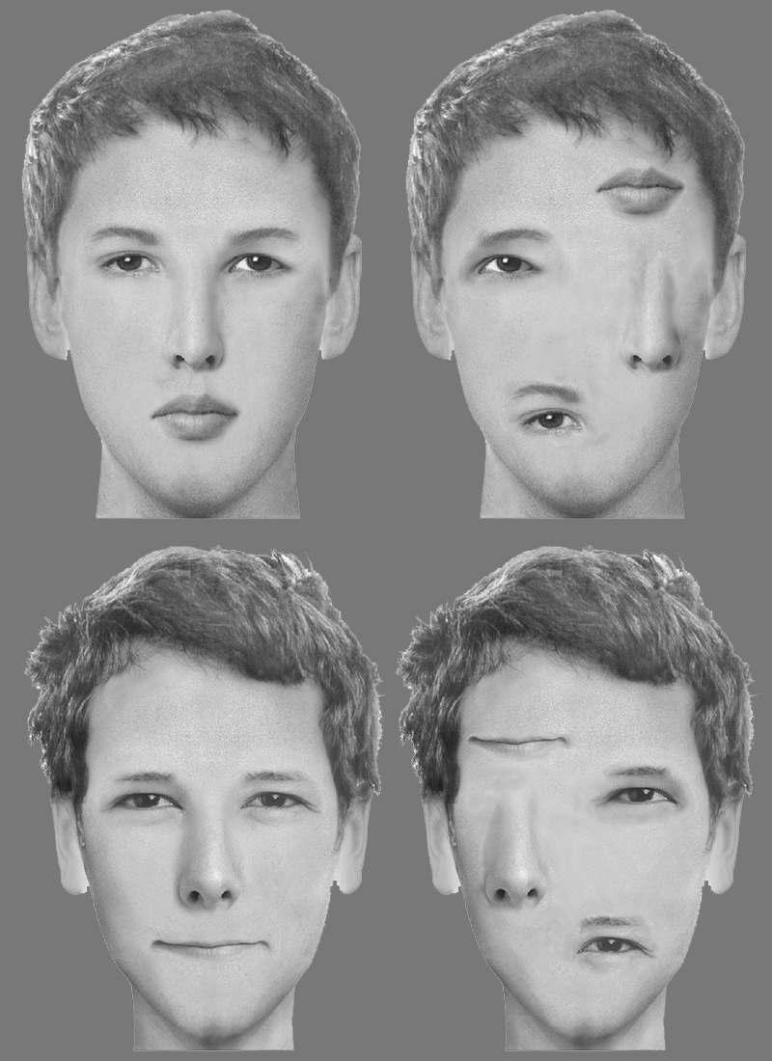

Figure 1

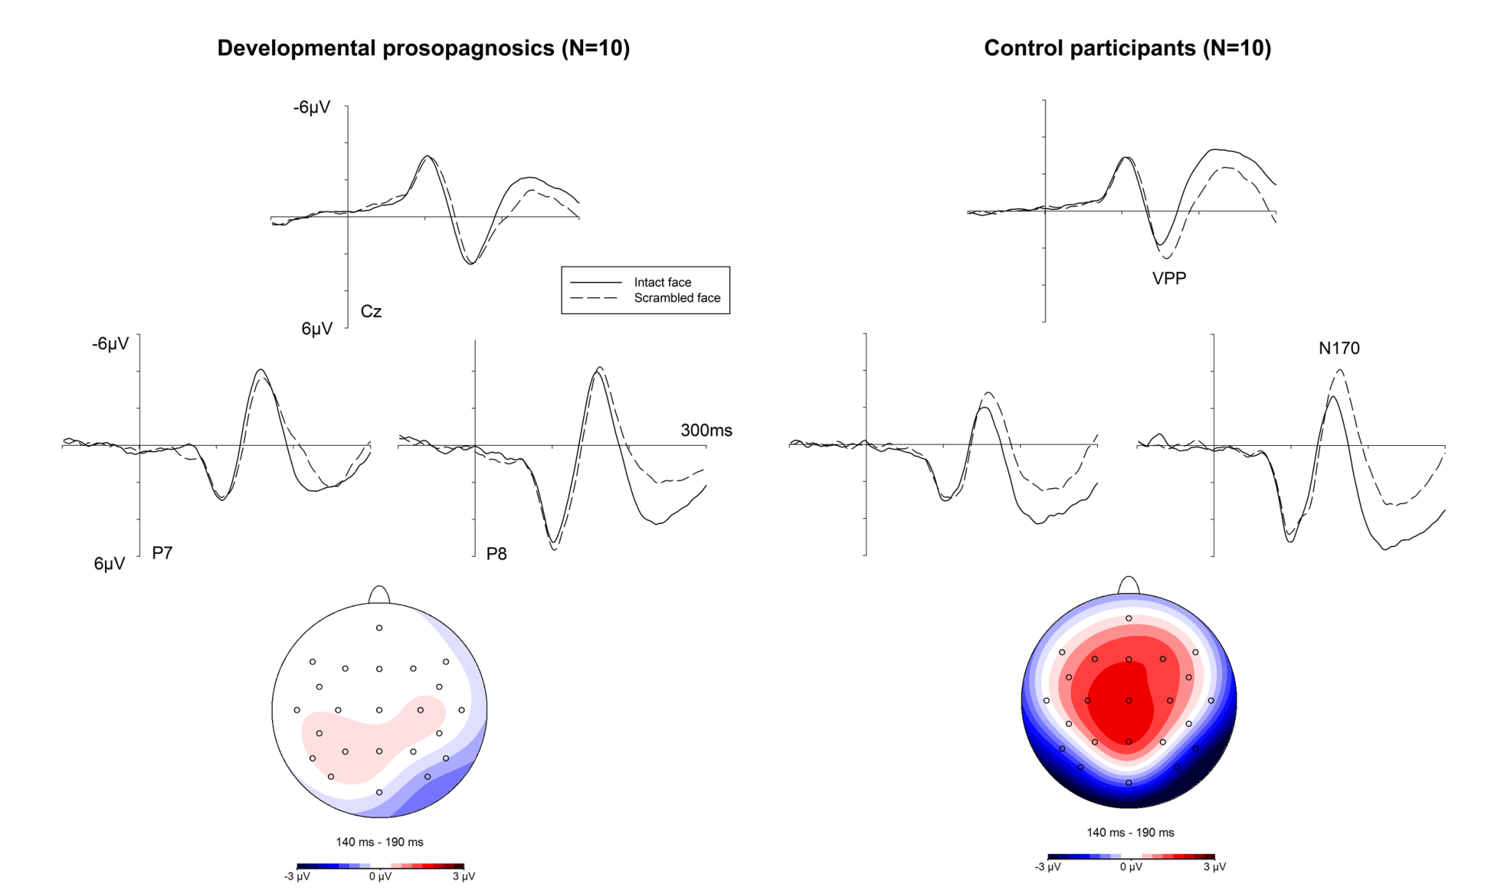

Figure 2

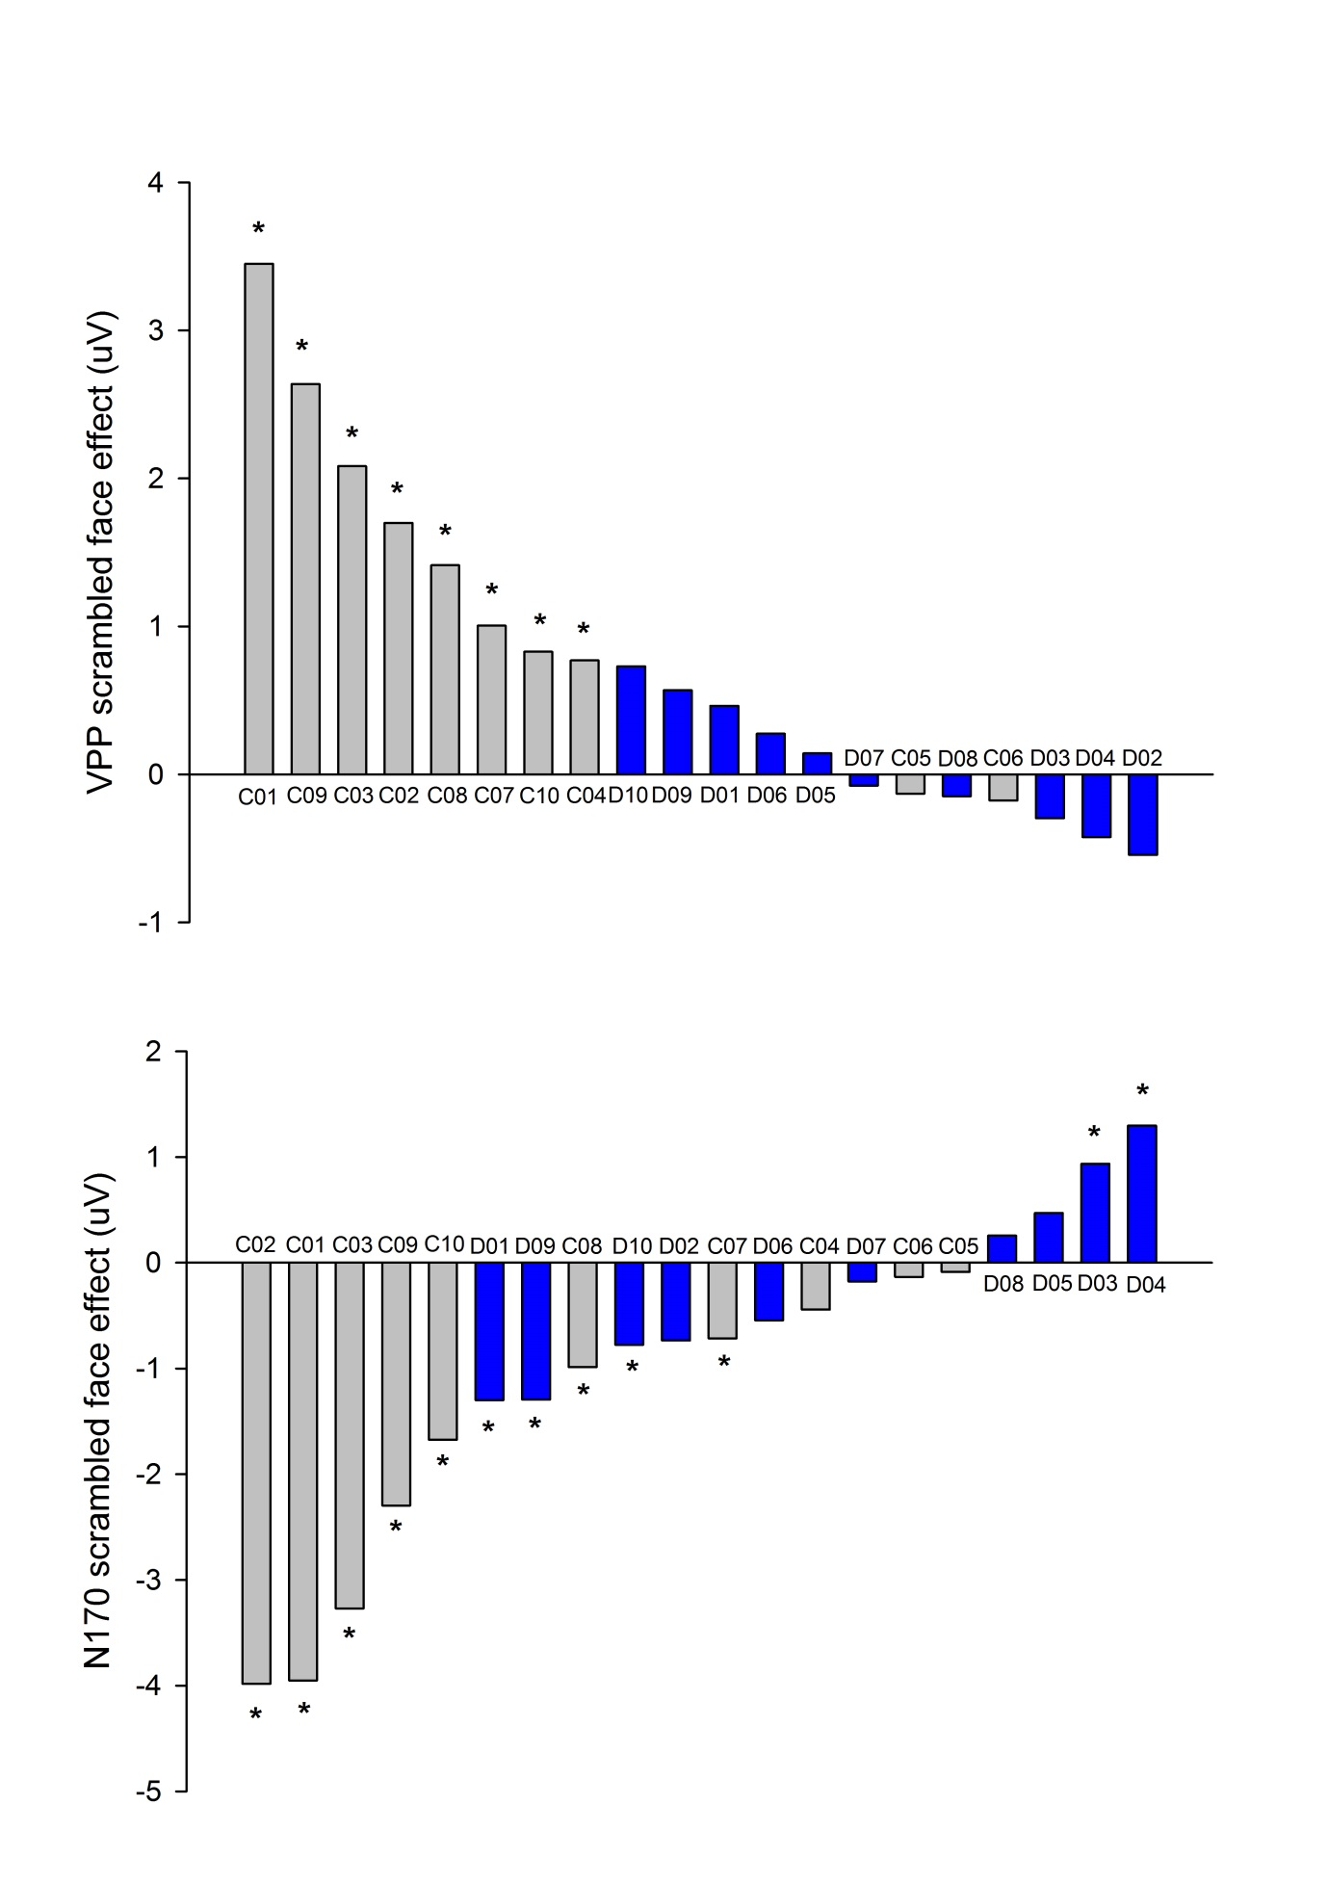

Figure 3

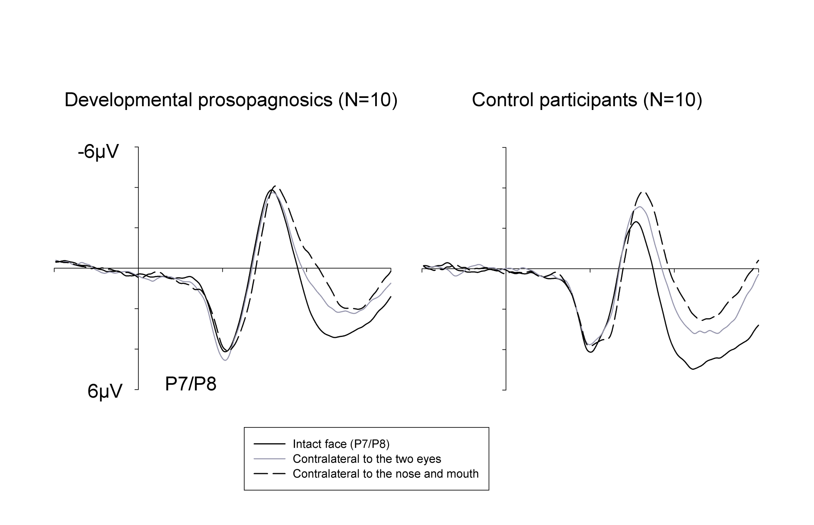

Figure 4