DOCUMENTATION OF SPSS FILE

The data for this study were collected as part of the research project Implicit Triggers, Identit(ies) and Attitudes to the European Union: An Experimental Approach, funded by UK Economic and Social Research Council (RES-000-22-4348). The project involved an online survey experiment (8 - 13 April 2011). Participants were drawn from a non random online sample (from the YouGov panel of British respondents, and its affiliate in Ireland). YouGov recruits members for its opt-in panel (currently containing over 350,000 respondents) via a variety of methods, such as advertising campaigns on non-political websites and recruitment agencies. When conducting a survey, YouGov draws a relevant sub-group from its panel of respondents by emailing them and asking them to follow an Internet link to the survey. In this case, the national samples used in this project (total N=8599) are not representative of the respective regions (Scotland, England, Wales, Northern Ireland, and Britain).

Participants that agreed to participate in this project were exposed to implicit images of a key European symbol: the EU flag (treatment condition) and then asked a series of questions relating to their attitudes to the European Union. The responses of participants exposed to the EU flag were compared to the responses of participants who saw similar images that had the EU flag removed (control condition).The SPSS file includes contextual information (exposure to images) and survey responses of these participants. Each respondent saw either a control or a treatment (EU related) version of the same photograph (variable name: ‘image’). We used two different photographs, and also used one of these photographs in combination with a short text. The Appendix contains details about the presentation of the visual cues to respondents.

Design

The online survey included participants who identified themselves as: English, Scottish, Welsh, British or Irish. Participation in each of the five samples was determined by individual responses to a previous online questionnaire (YouGov omnibus survey, March 2011), which included a national identity question. The screening identity questions asked:

[If resident in the UK:] “If you had to choose just one, which of the following words best describes the way you think of yourself?” [British/English/Scottish/Welsh/Other]

[If resident in Ireland:] “Many people think of themselves as being part of a particular nationality, for example as French or American or whatever. Do you think of yourself as Irish or as belonging to some other nationality, or do you not think of yourself in this way? I think of myself as…”[Irish/Another nationality/I don't think of myself in this way]

Based on responses to the above question, participants were initially assigned into one of the five identity groups/samples: British, English, Scottish, Welsh, and Irish (variable name: ‘countryish’). Using this stratification by national identity, during April 2011 we conducted a series of online survey experiments. Respondents from each of the five national identity samples were randomly exposed to different versions of a photograph. The surveys were administered by YouGov (and its affiliate in Ireland).

Variables are documented in the order in which they appear in the dataset. The stratification and contextual variables (national stratification question based on March 2011 survey, and exposure to image based on actual survey experiment) appear first.

The data set was constructed by YouGov and edited and documented by Stratos Patrikios, School of Government and Public Policy, University of Strathclyde.

Laura Cram
School of Government and Public Policy
University of Strathclyde
VARIABLE LIST

1. RecordNo
Record number (case)

2. starttime
Interview Start Time

3. endtime
Interview End Time

4. image
Image type

1 A
2 B
3 C
4 D
5 E
6 F
7 G
8 H

5. countryish
$National identity (as screened on MARCH 2011)

1 English
2 Scottish
3 British
4 Welsh
5 Irish
997 Missing

6. nation
$Nation

1 the UK
2 Ireland
997 Missing

7. country
$Country

1 England
2 Scotland
3 Britain
4 Wales
5 Ireland
997 Missing

[Online questionnaire starts here]

8. q0
In general, does the European Union conjure up for you a very positive, fairly positive, neutral, fairly negative or very negative image?

1 Very Positive
2 Fairly Positive
3 Neutral
4 Fairly Negative
5 Very Negative
997 Missing

9. q1
Generally speaking, would you say that <$nation> benefits or does not benefit from being in the European Union?

1 Greatly benefits
2 Largely benefits
3 Somewhat benefits
4 Benefits only a little
5 Does not benefit at all
997 Missing

10. q2
In your opinion, which of the following is the most effective action against the effects of the financial and economic crisis?

1 EU Member States should support each other economically
2 EU Member States should support only certain Member States
3 EU Member States should look after themselves
997 Missing

11. q3
To what extent do you think people from the richer countries in the European Union should be allowed to come and live here?

1 Allow many to come and live here
2 Allow some
3 Allow a few
4 Allow none
997 Missing

12. q4
And should people from the poorer countries in the European Union be allowed to come and live here?

1 Allow many to come and live here
2 Allow some
3 Allow a few
4 Allow none
997 Missing

13. q5
To what extent do you think people from the richer countries outside the European Union should be allowed to come and live here?

1 Allow many to come and live here
2 Allow some
3 Allow a few
4 Allow none
997 Missing

14. q6
And should people from the poorer countries outside the European Union be allowed to come and live here?

1 Allow many to come and live here
2 Allow some
3 Allow a few
4 Allow none
997 Missing

15. q7_q7_1_q7_grid
To what extent do you agree with the following statements? “When I think about being a European Union citizen, I tend to think of…”
…a common civilization (q7_grid)

1 Strongly agree
2 Agree
3 Neither agree nor disagree
4 Disagree
5 Strongly disagree
997 Missing

16. q7_q7_2_q7_grid
…membership in a European society with many languages and cultures (q7_grid)

1 Strongly agree
2 Agree
3 Neither agree nor disagree
4 Disagree
5 Strongly disagree
997 Missing

17. q7_q7_3_q7_grid
…common ancestry (q7_grid)

1 Strongly agree
2 Agree
3 Neither agree nor disagree
4 Disagree
5 Strongly disagree
997 Missing

18. q7_q7_4_q7_grid
…a common history and a common destiny (q7_grid)

1 Strongly agree
2 Agree
3 Neither agree nor disagree
4 Disagree
5 Strongly disagree
997 Missing

19. q7_q7_5_q7_grid
…the European Union institutions and an emerging common political and legal system (q7_grid)

1 Strongly agree
2 Agree
3 Neither agree nor disagree
4 Disagree
5 Strongly disagree
997 Missing

20. q7_q7_6_q7_grid
…common rights and duties (q7_grid)

1 Strongly agree
2 Agree
3 Neither agree nor disagree
4 Disagree
5 Strongly disagree
997 Missing

21. q7_q7_7_q7_grid
…a common system of social protection within the European Union (q7_grid)

1 Strongly agree
2 Agree
3 Neither agree nor disagree
4 Disagree
5 Strongly disagree
997 Missing

22. q7_q7_8_q7_grid
…the right to free movement and residence in any part of the European Union (q7_grid)

1 Strongly agree
2 Agree
3 Neither agree nor disagree
4 Disagree
5 Strongly disagree
997 Missing

23. q7_q7_9_q7_grid
…an emerging European Union defence system (q7_grid)

1 Strongly agree
2 Agree
3 Neither agree nor disagree
4 Disagree
5 Strongly disagree
997 Missing

24. q7_q7_10_q7_grid
…common borders (q7_grid)

1 Strongly agree
2 Agree
3 Neither agree nor disagree
4 Disagree
5 Strongly disagree
997 Missing

25. q7_q7_11_q7_grid
…a feeling of pride for being European (q7_grid)

1 Strongly agree
2 Agree
3 Neither agree nor disagree
4 Disagree
5 Strongly disagree
997 Missing

26. q7_q7_12_q7_grid
…sovereignty of the European Union (q7_grid)

1 Strongly agree
2 Agree
3 Neither agree nor disagree
4 Disagree
5 Strongly disagree
997 Missing

27. q7_q7_13_q7_grid
[ask only if ‘$country= 1 – 4’]
…a future common European Union currency (q7_grid)

1 Strongly agree
2 Agree
3 Neither agree nor disagree
4 Disagree
5 Strongly disagree
997 Missing

28. q7_q7_14_q7_grid
[ask only if ‘$country= 5’]
…a common European Union currency (q7_grid)

1 Strongly agree
2 Agree
3 Neither agree nor disagree
4 Disagree
5 Strongly disagree
997 Missing

29. q7_q7_15_q7_grid
…a set of European Union symbols (flag, anthem, etc) (q7_grid)

1 Strongly agree
2 Agree
3 Neither agree nor disagree
4 Disagree
5 Strongly disagree
997 Missing

30. q8_q8_1_q8_grid
How much do you agree or disagree with each of the following statements?
…I feel I am safer because <$nation> is in the European Union (q8_grid)

1 Strongly agree
2 Agree
3 Neither agree nor disagree
4 Disagree
5 Strongly disagree
997 Missing

31. q8_q8_2_q8_grid
…I feel we are more stable economically because $nation is in the European Union (q8_grid)

1 Strongly agree
2 Agree
3 Neither agree nor disagree
4 Disagree
5 Strongly disagree
997 Missing

32. q8_q8_3_q8_grid
…I feel we are more stable politically because $nation is in the European Union (q8_grid)

1 Strongly agree
2 Agree
3 Neither agree nor disagree
4 Disagree
5 Strongly disagree
997 Missing

33. q8_q8_4_q8_grid
…The interests of $nation are well taken into account in the European Union (q8_grid)

1 Strongly agree
2 Agree
3 Neither agree nor disagree
4 Disagree
5 Strongly disagree
997 Missing

34. q9_q9_1_q9_grid
And what about the following statements?
“If I were told tomorrow that <$Nation> had withdrawn from the European Union, I would feel…”
…safer (q9_grid)

1 Strongly agree
2 Agree
3 Neither agree nor disagree
4 Disagree
5 Strongly disagree
997 Missing

35. q9_q9_2_q9_grid
…that we would have more impact on international affairs (q9_grid)

1 Strongly agree
2 Agree
3 Neither agree nor disagree
4 Disagree
5 Strongly disagree
997 Missing

36. q9_q9_3_q9_grid
…that travel abroad would be easier (q9_grid)

1 Strongly agree
2 Agree
3 Neither agree nor disagree
4 Disagree
5 Strongly disagree
997 Missing

37. q9_q9_4_q9_grid
…that the economy would thrive (q9_grid)

1 Strongly agree
2 Agree
3 Neither agree nor disagree
4 Disagree
5 Strongly disagree
997 Missing

38. q10
If you were told tomorrow that the European Union had been scrapped, how sorry or pleased would you be?

1 Very sorry
2 Somewhat sorry
3 Wouldn’t make any difference
4 Somewhat pleased
5 Very pleased
997 Missing

39. q11
Would you say you are very proud, fairly proud, not very proud, not at all proud to be <$National identity>?

1 Very Proud
2 Fairly Proud
3 Not Very Proud
4 Not At All Proud
997 Missing

40. q12
And would you say you are very proud, fairly proud, not very proud, not at all proud to be a European Union citizen?

1 Very Proud
2 Fairly Proud
3 Not Very Proud
4 Not At All Proud
997 Missing

41. q13_q13_1_q13_grid
People may feel different degrees of attachment to their country or to the European Union. How attached do you feel to …
…<$country> (q13_grid)

1 Very attached
2 Fairly attached
3 Not very attached
4 Not at all attached
997 Missing

42. q13_q13_2_q13_grid
…the UK (q13_grid)

1 Very attached
2 Fairly attached
3 Not very attached
4 Not at all attached
997 Missing

43. q13_q13_3_q13_grid
…the European Union (q13_grid)

1 Very attached
2 Fairly attached
3 Not very attached
4 Not at all attached
997 Missing

44. q14
In the near future do you see yourself as...

1 <$National identity > only
2 <$National identity > and European
3 European and <$National identity >
4 European only
997 Missing

45. sex
Are you male or female?

1 Female
2 Male
997 Missing

46. job
Please tell us which one of the following options best describes the sort of work you do. (If you are not working now, please tell us what you did in your last job.)

1 Professional or higher technical work - work that requires at least degree-level qualifications (e.g. doctor, accountant
2 Manager or Senior Administrator (e.g. company director, finance manager, personnel manager, senior sales manager, senior
3 Clerical (e.g. clerk, secretary)
4 Sales or Services (e.g. commercial traveller, shop assistant, nursery nurse, care assistant, paramedic)
5 Foreman or Supervisor of Other Workers (e.g building site foreman, supervisor of cleaning workers)
6 Skilled Manual Work (e.g. plumber, electrician, fitter, train driver, cook, hairdresser)
7 Semi-Skilled or Unskilled Manual Work (e.g. machine operator, assembler, postman, waitress, cleaner, labourer, driver,
8 Other
9 Have never worked
997 Missing

47. paper
Which daily newspaper do you read most often?

1 The Express
2 The Daily Mail / The Scottish Daily Mail/Irish Daily Mail
3 The Mirror / Daily Record/Irish Daily Mirror
4 The Daily Star / The Daily Star of Scotland/Irish Daily Star
5 The Sun/Irish Sun
6 The Daily Telegraph
7 The Financial Times
8 The Guardian
9 The Independent/Irish Independent
10 The Times
11 Irish Times
12 Irish News
13 The Scotsman
14 Irish Examiner
15 The Herald (Glasgow)
16 The Western Mail
17 Other local daily morning newspaper
18 Other Newspaper
19 None
997 Missing

48. edu
What is the highest qualification you have achieved to date?

1 No qualifications
2 GCSEs at grades D – G / BTEC Introductory Diploma/CSEs
3 NVQ at Level 1/NFQ Level 3
4 Junior Certificate (Ireland)
5 Standards (Scotland)
6 5 or more GCSEs A* - C / BTEC First Diploma
7 OCR National / NVQ at Level 2/
8 2 or more ‘A’ levels / International Baccalaureat / BTEC Diploma
9 Highers (Scotland)
10 Leaving Certificate (Ireland)
11 NVQ at Level 3 / OCR National / BTEC national/NFQ Level 5
12 HNC/OND/NFQ Level 6
13 An undergraduate degree or Foundation Degree
14 A post-graduate qualification
15 Other
16 Prefer not to say
997 Missing

49. age
How old are you?

1 16
2 17
3 18
4 19
5 20
6 21
7 22
8 23
9 24
10 25
11 26
12 27
13 28
14 29
15 30
16 31
17 32
18 33
19 34
20 35
21 36
22 37
23 38
24 39
25 40
26 41
27 42
28 43
29 44
30 45
31 46
32 47
33 48
34 49
35 50
36 51
37 52
38 53
39 54
40 55
41 56
42 57
43 58
44 59
45 60
46 61
47 62
48 63
49 64
50 65
51 66
52 67
53 68
54 69
55 70
56 71
57 72
58 73
59 74
60 75
61 76
62 77
63 78
64 79
65 80
66 81
67 82
68 83
69 84
70 85
71 86
72 87
73 88
74 89
75 90
76 91
77 92
78 93
79 94
80 95
81 96
82 97
83 98
84 99
85 100 and over
997 Missing

50. news
To what extent, if any, do you like to keep up-to-date with current and political affairs?

1 To a large extent
2 To some extent
3 Not at all
4 Don't know
997 Missing

51. GOR
Region/Country

1 North East
2 North West
3 Yorks and the Humber
4 East Midlands
5 West Midlands
6 East of England
7 London
8 South East
9 South West
10 Scotland
11 Wales
12 Ireland

52. socgrade
Social grade

1 A
2 B
3 C1
4 C2
5 D
6 E
APPENDIX

In April 2011, participants were invited to take part in an online survey titled ‘Social Trends Survey 2011’. The title was designed to make no reference to political issues/current affairs or the EU, in order to avoid attracting participants that were either overly interested in politics or held strong opinions on the EU. Before completing a short online questionnaire, participants were presented with an introductory page. The introductory page contained the survey title, followed by a large photograph, which was in turn followed by instructions. The short questionnaire that followed contained questions on the EU and, in the end, some personal questions (group attachment and demographics).

The photograph was accompanied by this instruction: ‘Please click on the photo above to proceed to the survey’. To ensure that respondents paid at least some attention to the image, respondent could proceed to the survey only by clicking on the centre of the image. Respondents could not move backwards in the online survey.

Photo/text | Respondents
VERSION A.  Photo: EU flag outside a building | English, Scottish, British, Welsh, Irish
VERSION B.  Photo: VAGUE flag outside building | English, Scottish, British, Welsh, Irish
VERSION C.  Photo: Passport control WITH visible EU-flag | English, Scottish, British, Welsh, Irish
VERSION D.  Photo: Passport control WITHOUT visible EU-flag | English, Scottish, British, Welsh, Irish
VERSION E.  Photo: Passport control WITH visible EU-flag on the sign  Text: Threatening headline | English, Scottish, British, Welsh, Irish
VERSION F.  Photo: Passport control WITHOUT visible EU-flag on the sign  Text: Threatening headline | English, Scottish, British, Welsh, Irish
VERSION G.  Photo: Passport control WITH visible EU-flag on the sign  Text: Neutral headline | English, Scottish, British, Welsh, Irish
VERSION H.  Photo: Passport control WITHOUT visible EU-flag on the sign  Text: Neutral headline | English, Scottish, British, Welsh, Irish

Version A:

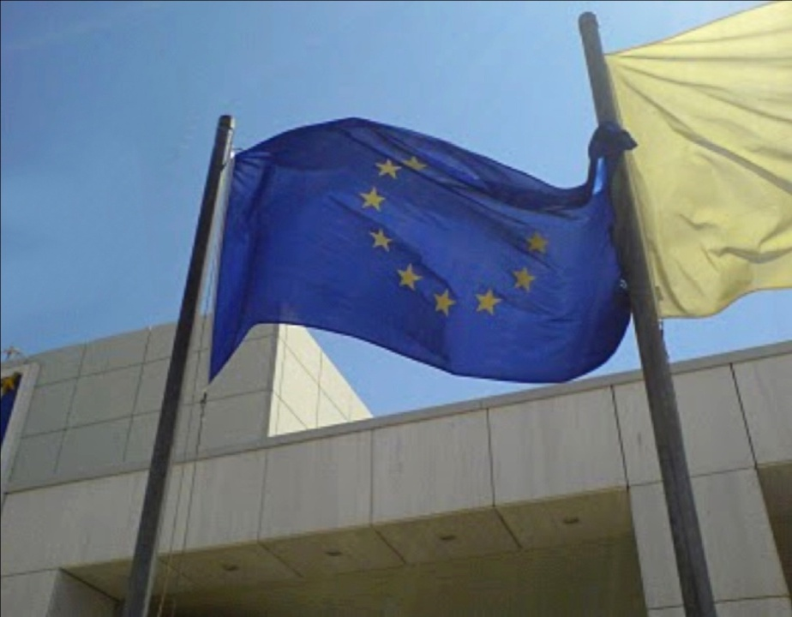

Version B:

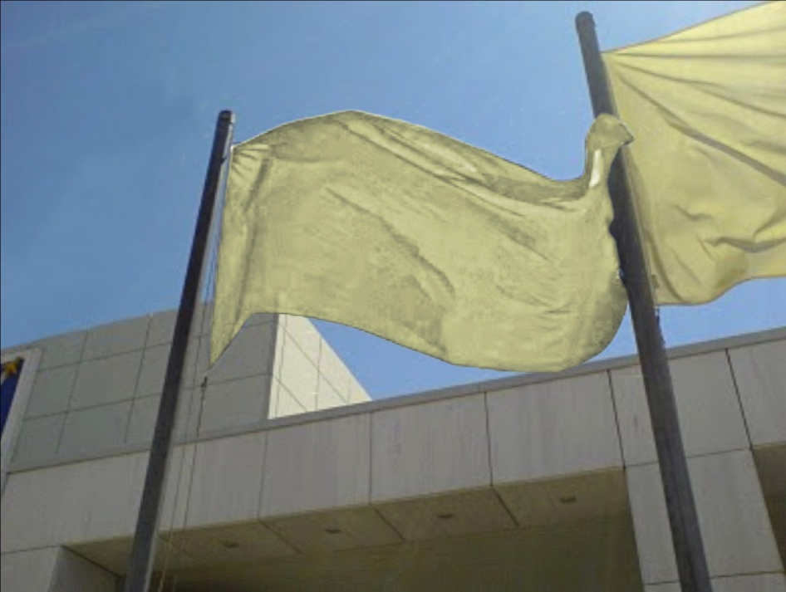
Version C:

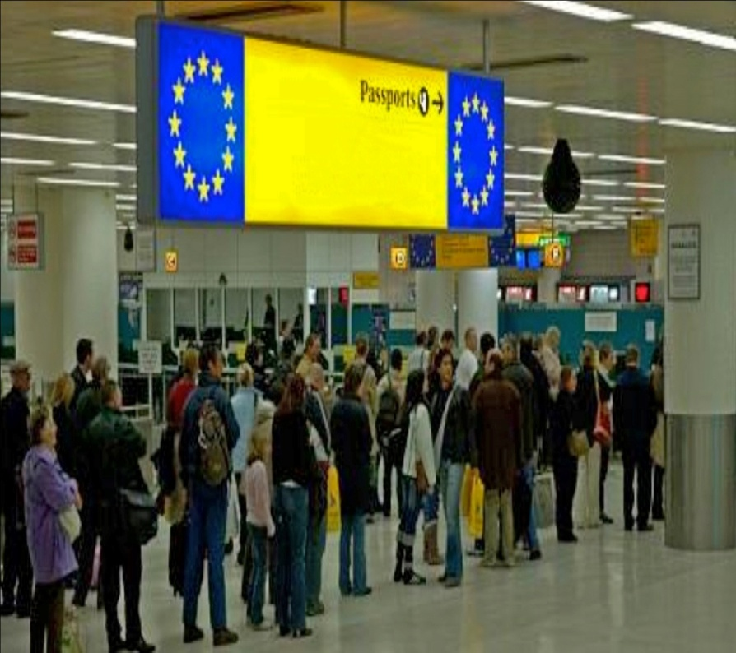

Version D:

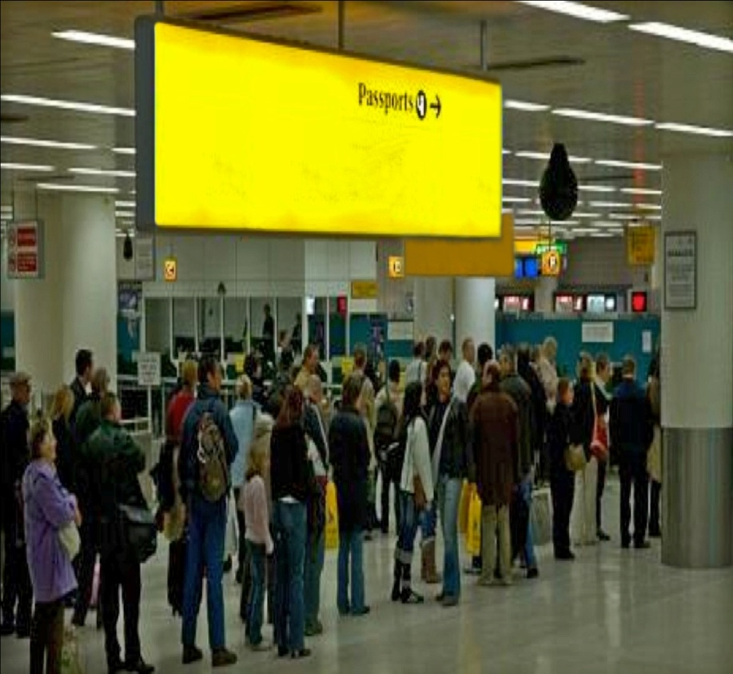
Version E:

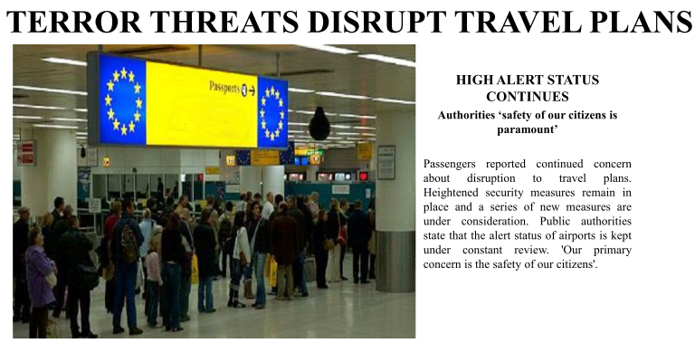

Version F:

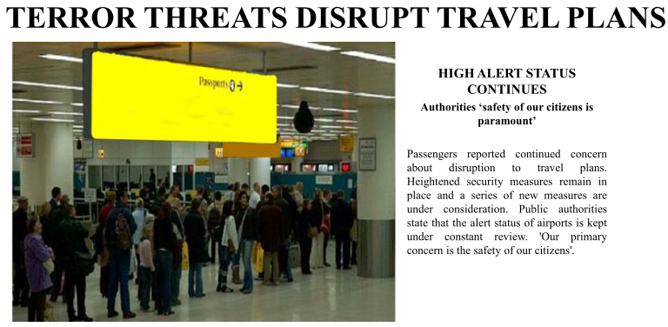
Version G:

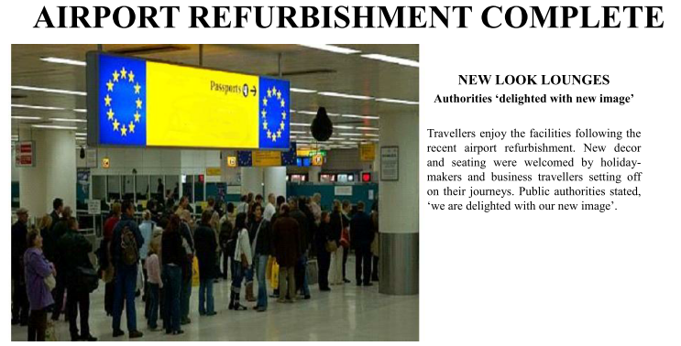

Version H:

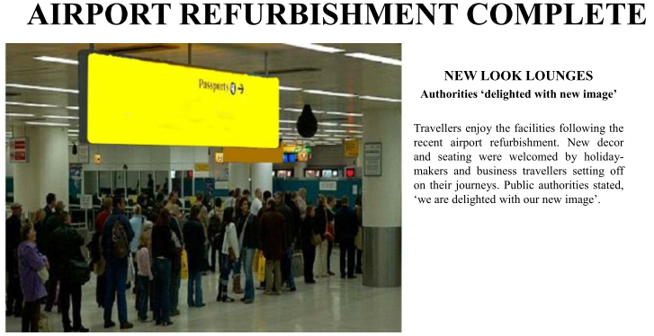

http://www.yougov.co.uk/about/about-methodology.asp
Details of the source variable appear in the Appendix at the end of this document.
The prefix ‘$’ indicates that values of the variable are used to produce nation-specific versions of questions and/or response sets that appear in the survey.
Italicised labels indicate question wording of survey items.
‘Grid’ questions with the same prefic (e.g. ‘q7_’) appear on the same online screen (as a battery).

