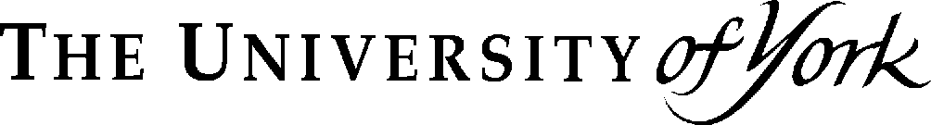 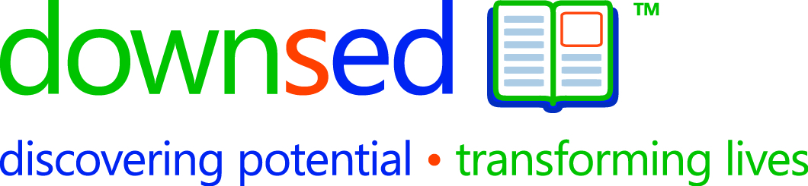 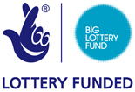

Dear Parent

Down Syndrome Education International and the University of York have recently been awarded funding from the Big Lottery Fund to support research which aims to improve reading and language outcomes for children with Down syndrome. We would like to invite you and your child to take part in this research project. By taking part in this research you will help us to evaluate a reading and language programme to enable teachers, teaching assistants and parents to help children with Down syndrome achieve their full potential. The intervention programme is expected to lead to significant gains in reading and spoken language skills in children with Down syndrome. Through planned dissemination activities, the programme will lead to improved outcomes for many more people with Down syndrome.

Project description

The project will develop, evaluate and publish a reading and language programme which combines highly-structured phonically-based reading instruction (including phonological awareness training) with oral language teaching that seeks to develop children’s vocabulary, grammar, and speech skills. Such a programme should be highly beneficial to these children’s reading skills, and should also directly benefit their oral language skills.

52 children in the York and Portsmouth areas will be recruited to take part in the research. Teaching assistants will be trained to deliver the intervention programme on an individual basis, during a 45-50 minute lesson each day. Half of the children (Group 1) will receive the intervention programme over 40 weeks (4 school terms). The remaining children (Group 2) will continue to receive their normal literacy teaching for the first 20 weeks, after which they will receive the intervention programme for the following 20 weeks (2 school terms). Children will be randomly allocated into Group 1 or Group 2. This design is necessary to evaluate the effectiveness of the programme. It is important to note that all children will eventually receive the programme that is expected to be highly beneficial to their reading and language skills, and that schools will be encouraged to continue using the intervention approach after the evaluation finishes.

Research team

The project involves collaboration between Down Syndrome Education International (Portsmouth, UK) and the University of York (York, UK). At the Portsmouth research centre, the research will be led by Dr Kelly Burgoyne and Professor Sue Buckley. Professors Charles Hulme and Maggie Snowling will be leading the research at York.

What’s involved?

Child assessment

If you decide you would like to take part in this research project, assessments of your child’s general ability, reading and speech and language skills will take place at your child’s school. Each assessment will take approximately 2–3 hours in total and will be completed over a number of sessions. Assessments will be repeated over four time points to measure progress. These will take place every 6-9 months between May 2009 and June 2011.

Teacher questionnaires

Teachers will be asked to complete a questionnaire to assess behavioural strengths and difficulties

Parental questionnaires

Parents will be asked to complete a questionnaire designed to measure the literacy environment at home, including parents’ expectations about their child’s literacy development, and involvement in literacy-related activities at home. Parents will also be asked to complete vocabulary checklists to indicate their child’s level of vocabulary.

Intervention activities

Teaching assistants will be trained to deliver the intervention programme on an individual basis, and will receive ongoing support from the research team throughout the intervention period. The intervention will target reading skills (including phonics teaching and sight word reading, book reading, and comprehension), language (introducing new vocabulary and sentence structures) and speech skills (articulation and phonology) through a variety of individualised learning activities.

Research Ethics and Data Protection

This project has been granted ethical approval from the University of York and Down Syndrome Education International. We will conduct the research in accordance with appropriate professional standards, including the British Psychological Society’s Code of Ethics and Conduct.

We would like to make video and audio recordings of your child during the assessments. All personal details, information and recordings collected during this research will of course be confidential and will be only be available to those staff involved in the research project. We plan to publish the results of the research which may involve conference presentations and articles in parent newsletters and scientific publications. The identity of individual children will not be revealed.

All personal data files and recordings will be securely stored in compliance with the Data Protection Act (1998).

Participation in this study is entirely voluntary. Furthermore, if you agree to participate in this research, you are free to withdraw from the study at any point in the future.

What next?

Please complete the attached consent forms (Research Participation Consent Form and Video Recording Consent Form), indicating whether or not you would like your child to take part in the research project. Once completed and signed, please return these forms to your child’s school who should then forward these to me.

Questions

If you have any questions about your participation in this research project please contact me on 023 9285 5330 (email Kelly.Burgoyne@downsed.org).

Yours sincerely,

Dr Kelly Burgoyne,

Research Psychologist, Down Syndrome Education International