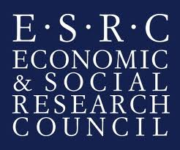 |  | 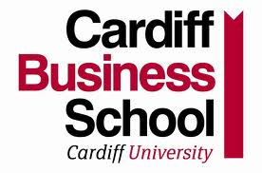

PARTICIPANT INFORMATION SHEET
Doctoral research study into Sustainable Supply Chain Management
Researcher Anthony Alexander MBA (Warwick), ESRC Research Fellow for Sustainable Supply Chain Management, Logistics and Operations Management Group, Cardiff Business School.
Contact: email: AlexanderA@Cardiff.ac.uk. or tel: 07970-593412
Project duration May 2012 to May 2015.
Overview:
Many organisations are now addressing sustainable development issues through procurement policies and supply chain management. There are government policies influencing public sector organisations, and industry groups like the Carbon Disclosure Project or Fair Trade attracting growing support. Some organisations recognise sources of competitive advantage in being pro-active on this agenda, while others are merely reactive to external pressures from investors or regulators.
The emerging field of formal research into Sustainable Supply Chain Management (SSCM) helps improve understanding of the challenges and opportunities presented. As part of strategic operations, SSCM can be central to fostering positive impacts and eliminating negative ones.
Research description and schedule
This research programme is investigating the processes of supply chain decision making in order to explore how organisations obtain the best SSCM outcomes.
Central questions in the design of the programme so far have been, i) how are different definitions of sustainability and associated social, environmental and economic outcomes addressed in management decision making? ii) how are SSCM policies perceived and implemented along the supply chain? iii) what are the main internal and external drivers and barriers to SSCM implementation? iv) what organisational characteristics and contexts appear well placed to deliver substantive action on social and environmental problems?
A number of companies are currently sought to participate in the research. Companies will be grouped into case studies covering supply chains representing different sectors in the UK economy and different social and environmental impacts.
The nature of participation
Participation in the research involves agreeing to hold conversations of between 45 minutes and 2 hours on the topic of SSCM. These conversations take the form of semi-structured interviews, where there are a number of themes related to the topic but both the interviewees and interviewer are free to steer the discussion towards areas that they feel are relevant. During the conversations, notes will be taken and the conversations will be recorded. The recordings will then be transcribed and the transcripts will then be edited to make the participants and the organisation anonymous. All details on the identity of the individual participants and the associated organisations will remain confidential.
On completion of the research, the findings will be published. It is a condition of the UK government Economic and Social Research Council (ESRC) funding the research that the findings are made publicly available via open access. In addition, research findings will be shared directly with the participants.
Agreement to participate in the research in line with the above will be discussed and confirmed in person at the meeting.

To discuss further please get in touch with Anthony Alexander, on 07970-593412 or by emailing AlexanderA@Cardiff.ac.uk. Many thanks for your interest.

