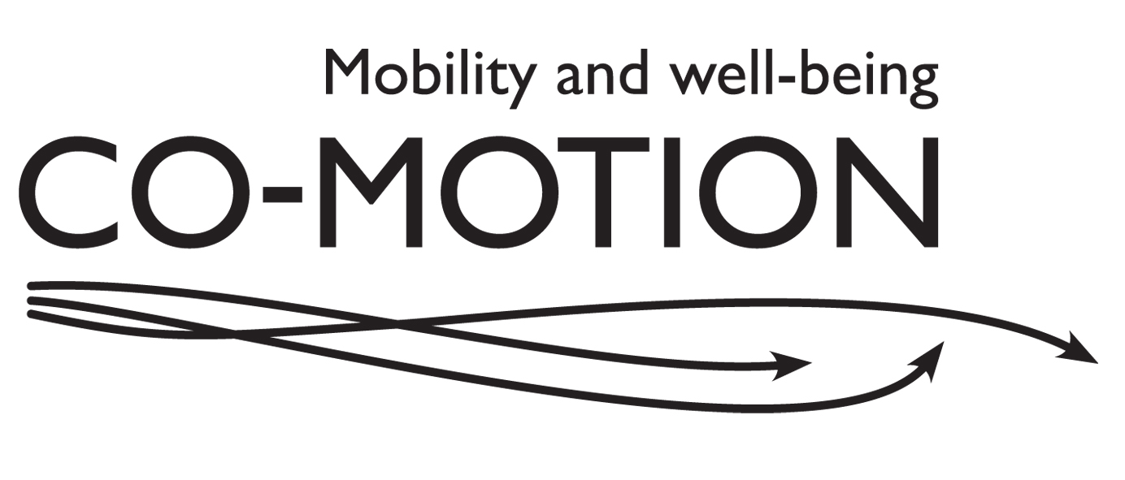
Co-Motion Questionnaire (First)
Thank you for agreeing to take part in Co-Motion research project. Please fill in this questionnaire before you are due to meet the Co-Motion researcher, and return it to us in the pre-paid envelope.

If you have any queries about the questionnaire or about meeting the researcher, please get in touch:

For Leeds -
Karen Croucher
Telephone: 01904 321473
Email: co-motion@york.ac.uk

For York -
Sophie Gibson
Telephone 01904 321486
Email co-motion@york.ac.uk

Part 1
Please tick to indicate the extent to which you agree or disagree with each of the following statements:
 |  | Strongly agree | Agree somewhat | Neither agree nor disagree | Disagree somewhat | Strongly disagree
1 | I enjoy my life overall
2 | I am happy much of the time
3 | I look forward to things
4 | Life gets me down
5 | I have a lot of physical energy
6 | Pain affects my well-being
7 | My health restricts me looking after myself or my home
8 | I am healthy enough to get out and about
9 | My family, friends or neighbours would help me if needed
10 | I would like more companionship or contact with other people
11 | I have someone who gives me love and affection
12 | I’d like more people to enjoy life with
13 | I have my children around which is important
14 | I have social or leisure activities/hobbies that I enjoy doing

 |  | Strongly agree | Agree somewhat | Neither agree nor disagree | Disagree somewhat | Strongly disagree
15 | I try to stay involved with things
16 | I do paid or unpaid work or activities that give me a role in life
17 | I am healthy enough to have my independence
18 | I can please myself what I do
19 | The cost of things compared to my pension/income restricts my life
20 | I have a lot of control over the important things in my life
21 | I have responsibilities to others that restrict my social or leisure activities
22 | I feel safe where I live
23 | The local shops, services and facilities are good overall
24 | I get pleasure from my home
25 | I find my neighbourhood friendly
26 | I take life as it comes and make the best of things

 |  | Strongly agree | Agree somewhat | Neither agree nor disagree | Disagree somewhat | Strongly disagree
27 | I feel lucky compared to most people
28 | I tend to look on the bright side
29 | If my health limits social/leisure activities, then I will compensate and find something else I can do
30 | I have enough money to pay for household bills
31 | I have enough money to pay for household repairs or help needed in the house
32 | I can afford to buy what I want to
33 | I cannot afford to do things I would enjoy
34 | Religion, belief or philosophy is important to my quality of life
35 | Cultural/religious events/festivals are important to my quality of life
36 | I can get to the places I want to go to
37 | It’s important to me to get out and about

Part 2

38. How is your health in general?
(Please tick one)
Very good
Good
Fair
Bad
Very bad

39. Are your day to day activities limited because of a health problem or disability which has lasted, or is expected to last, at least 12 months? (Include problems related to old age)
(Please tick one)
Yes, limited a lot
Yes, limited a little
No

Roughly how far are you able to walk without a break?
40 | - On a good day
41 | - On a bad day

How often do you use the following transport options?
(Please tick)
 |  | Daily | Weekly | Occasionally | Never
42 | Walking
43 | Cycling
44 | Mobility scooter
45 | Driving car
46 | Getting a lift from household member
47 | Getting a lift from someone else
48 | Bus
49 | Taxi
50 | Motorbike
51 | Community transport
52 | Hospital transport
53 | Coach
54 | Train
55 | Plane

56. Which one of the following transport options makes most difference to your life?
(Please tick one)
Walking
Cycling
Mobility scooter
Driving car
Getting a lift from household member
Getting a lift from someone else
Bus
Taxi
Motorbike
Community transport
Hospital transport
Coach
Train
Plane

57. In total, how many cars or vans are owned, or available for use, by members of this household?
(Please tick one)
None
1
2
3
4 or more

58. Do you have any of the following?
(Please tick all that apply)
Over 60s bus pass
Other bus pass
Discount rail card
Disabled parking badge

What’s the furthest you travelled from home yesterday?
(Please give a place name or a very rough estimate of the distance)
59

What’s the furthest you travelled from home last week?
(Please give a place name or a very rough estimate of the distance)
60

What’s the furthest you travelled from home last year?
(Please give a place name or a very rough estimate of the distance)
61

62. How do you get information about travel?
(Please tick all that apply)
Radio/TV
Paper timetables
Paper maps
Internet
Smartphone/tablet
Phoning up
Friends/family
No need for information

How often do you use any of the following equipment?
(Please tick)
 |  | Daily | Weekly | Occasionally | Never
63 | Glasses/contact lenses
64 | Magnifying glass or other low-vision aid
65 | Hearing aid
66 | Cane or walking stick
67 | Walker or Zimmer frame
68 | Crutches
69 | Manual wheelchair
70 | Electric wheelchair

How often do you use the following technologies?
(Please tick)
 |  | Daily | Weekly | Occasionally | Never
71 | Cash machines
72 | Ticket machines
73 | Card payment
74 | Online shopping or banking
75 | Other internet
76 | Email
77 | Skype
78 | Mobile phone
79 | Smartphone or tablet with internet/apps

Part 3

80. What is your gender?
(Please tick one)
Male
Female

81.What is your year of birth?
(Please write in)
Year

82. What is your marital status?
(Please tick one)
Never married
Married/civil partnership
Separated but still legally married
Divorced
Widowed

83. What is your ethnicity?
(Please tick one)
White
Mixed
Asian/Asian British
Black/African/Caribbean/Black British
Other (please specify)

84. Which of these qualifications do you have?
(Please tick all that apply)
School Certificate
O’ level/s and/or CSE/s
A’ levels
Professional qualification eg accountancy, nursing
Other vocational qualifications
Degree
Higher degree
Foreign qualifications
None of the above

85. What is your current employment status?
(Please tick one)
Working
Not working because retired
Not working because long-term sick or disabled
Not working because looking after home and family

86. If you are working at the moment, how many hours a week do you work?
(Please write in)
Hours

87. If you have worked but have now stopped, how many years ago was this? (Please write in)
Years

88. If you have worked, what is the job title of your main or typical job? (Please write in)
Job title

89. Do you look after, or give any help or support to family members, friends, neighbours or others because of either long-term physical or mental ill-health or disability, or problems related to old age?
(Please tick one)
Yes
No

90. If so, for how many hours a week? (Please write in)
Hours

91. Do you look after children at all?
(Please tick one)
Yes
No

92. If so, for roughly how many hours a week?
(Please write in)
Hours

93. Do you do any voluntary work?
(Please tick one)
Yes
No

94. If so, for roughly how many hours a week?
(Please write in)
Hours

95. Including all sources (eg work, pension, tax credits, benefits, investments), what is your approximate weekly income?
(Please tick one)
Up to £99
£100 and up to £199
£200 and up to £299
£300 and up to £399
£400 and up to £499
£500 and up to £599
£600 and up to £699
£700 and up to £799
£800 and up to £899
£900 and up to £999
£1000 and above

96. How satisfied are you with this area as a place to live?

(Please tick one)
Very satisfied
Fairly satisfied
Neither satisfied nor dissatisfied
Fairly dissatisfied
Very dissatisfied

97. How satisfied are you with this accommodation?

(97) Including all sources (e.g. work, pension, tax credits, benefits, investments) what is your approximate weekly or annual income?
Please tick
✓
Weekly
Up to £99
£100 and up to £199
£200 and up to £299
£300 and up to £399
£400 and up to £499
£500 and up to £599
£600 and up to £699
£700 and up to £999
£800 and up to £899
£900 and up to £999
£1000 and above

(Please tick one)
Very satisfied
Fairly satisfied
Neither satisfied nor dissatisfied
Fairly dissatisfied
Very dissatisfied

98. Does your household own or rent this accommodation?

(Please tick one)
Owns outright
Owns with a mortgage or loan
Part owns, part rents (shared ownership)
Rents from the council
Rents from a housing association
Rents from a private landlord or letting agency
Rents from an employer of a household member
Rents from a friend or relative
Lives here rent free

Many thanks for filling in this questionnaire.

Please put the questionnaire in the pre-paid envelope provided, and return to Co-Motion Project, Centre for Housing Policy, University of York, FREEPOST, YO 202, York, YO10 5ZZ.

A Co-Motion researcher will be in touch with you about arranging to meet.

