CONSENT FORM

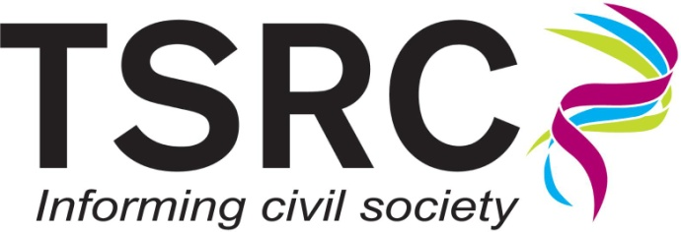
Name of project: _______________________________ _____

Name of organisation/individual: ____________________________________

Date of interview: ________________________________________________

Please tick the appropriate boxes:

1 | I confirm that the programme of research has been explained to me and I have read and understood the  Participant Information Sheet.
2 | I understand that my responses will be kept confidential.
3 | I understand that my participation is voluntary and that I may withdraw from this research project at any time, without penalty.
4 | I understand that my responses will be recorded and that my personal details will be kept anonymous.
5 | I understand that data relating to this project may be archived for use by other researchers.
6 | I agree to take part in this research programme.
7 | So that TSRC can use the information that I provide legally, I am happy to assign copyright of my responses to the TSRC. Any exceptions will be agreed with the researcher at the time of interview and will be honoured.

Name of participant: _____________________________________________

Signature of participant: __________________________________________

Name of Researcher _____________________________________________

Signature: _____________________________________________________

Contact details: _________________________________________________

