Towards a Healthier Tourism Industry

Promoting Well-being as a Destination Resource

Project Ref: ES/L00884X/1

www.destinationfeelgood.co.uk

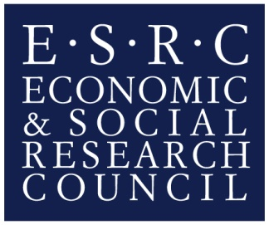

Project Outline
The importance of wellbeing is increasingly recognised as a crucial aspect of tourism and an area of strategic growth amongst tourism providers. However, in the local area of Bournemouth and Poole, although this is an emerging area of interest from a policy perspective, the tourism potential of a positioning towards wellbeing has not been fully realised, providing an ideal platform to launch new product initiatives aligned to this area.

Project Aims
This 1 year (August 2014 – July 2015) ESRC funded project, aimed to establish a network of tourism destination stakeholders, positioning Bournemouth University as a central knowledge exchange partner and the National Coastal Tourism Academy (NCTA) as a knowledge broker with the specific aim of facilitating innovation in healthy lifestyle products while contributing to a competitive local tourism economy. Through inter-stakeholder dialogue, tourism businesses will be better positioned to increase their effectiveness and develop new products and services that provide an enhanced value-added experience for visitors. The project aimed to accelerate tourism business growth via an improved understanding and implementation of wellbeing, and to facilitate the exchange of knowledge between tourism businesses, policy makers (both public health and tourism) and wellbeing academics. Tacit knowledge in particular is required for innovation and the network established through this project aimed to be a conduit, translating knowledge into action to enhance destination competitiveness.

Ideas Cafés – Qualitative data
In total, approximately 100 local businesses attended the ideas cafés across the local area, a testament to the interest in health and wellbeing of tourism, leisure and hospitality businesses.

Session 1: Marketing and Product Opportunities in Health & Wellbeing Tourism

Session overview
This session began with a project overview from the team at Bournemouth University and the NCTA. BDRC Continental, a market research company, then presented recent research around the growing importance and popularity of the health and wellness market and the opportunities this affords to tourism, leisure and hospitality businesses.

The presentations ended by asking a series of questions, encouraging participants to think about their own businesses and how a wellbeing proposition might enhance business opportunities. Breakout groups enabled further discussion around these questions.

- Do you consider wellness to be a business growth opportunity?
The groups agreed that wellbeing was a definite growth area and a business opportunity. A general shared agreement amongst participants was that the fast pace of contemporary life means that people increasingly need to take time out to relax and recuperate, and also that the tourism industry has not responded as well as it might to these growing needs. The idea that ‘investing in yourself’ has high returns is increasingly being recognised and within a tourism context, this can provide a basis for marketing and branding, even based on walks, fresh air, good food; ‘it doesn’t have to be fancy’ as one participant commented.

The opportunities afforded by such branding were discussed and promoting things that people can do, especially that families can do together, ‘without relying on technology’ (as one participant commented) was seen as important One idea generated was that this could be extended to ‘tech-free’ bars and restaurants. The group agreed that there was a growing awareness amongst customers around issues of health and wellbeing. One participant spoke about how he recently ran a wine appreciation session, which included advice from a doctor on ‘healthy limits’ for wine consumption. He noted a definite growing interest in food, drink and provenance which can be capitalised upon. This was noted to be especially important for children who ‘do not know what a cow is’ as another participant remarked. The opportunities for local businesses to work together in a joint branding exercise was also noted, so that businesses can join up their offering and add value to the tourist experience. In this sense, participants discussed the need to be ‘reactionary’, such as through using social media to build on the success of sporting events for example, where businesses can join together quickly to capitalise on opportunities.

It was generally agreed that Dorset does not have a specific brand, although its arts and crafts are a growing area. It is a popular destination for walkers and it is generally seen as bucolic, but not anything more specific. However, it was noted that it does have a high life expectancy and promoting ‘wellness’ as an ‘experience’ could prove attractive to a wide range of customers.

- What are the challenges around promoting Destination FeelGood?
The challenges of promoting a destination based around a wellbeing proposition included branding and attracting tourists from further afield. Public transport was noted to be ‘poor’ and a barrier to people accessing as much of the county and its wellness attractions and experiences as possible. The challenge of catering for all members of a family or group and finding experiences to appeal to a diverse range of customers was also raised as an issue.

Groups spoke of the challenges of a lack of financial support for small businesses and how the local authority has a responsibility to nurture such businesses and create an environment in which they can flourish.

Some concern was raised that a wellness proposition appears to be somewhat elitist and based around a high-end, luxury offering which would exclude a segment of both businesses and the tourist market. Discussion arose also around whether differences existed or should exist between offerings to ‘overnight’ and ‘day’ wellness tourists. The groups concluded that ‘wellness’ should be a flexible term which can be ‘interpreted in our own way’. However, it was also noted that some guidance at national level, such as from Visit England around these ideas would help to promote and make sense of a local brand.

Local businesses appeared to take away key messages around branding and as one commented ‘I will now use key words in my adverts to encourage people to think about the beach here as a way to enhance wellbeing; a contrast from the stressed environment they are coming from’. The importance of a joined up and strong brand was also a key message, as one participant noted ‘brand Dorset is very different from brand Bournemouth as Dorset is associated with nature and Bournemouth is more about the nightlife’.

Ideas Café 2: Food, Innovation & Legislation

Session overview
The session began with an overview of Destination FeelGood by Professor Heather Hartwell. Professor John Edwards (Bournemouth University) then talked about the growing trends for eating out and perceptions of different foods and gastronomic experiences. He also spoke about the importance of branding and innovation and what the future could hold in terms of innovation in the foodservice industry.

Professor Hartwell continued with a presentation relating to allergens, how they appear to be more prolific amongst the current population and what this means in terms of legislation and food labelling. Given the legislation changes in December 2014 and the requirements to emphasise allergenic foods on labels, this is clearly a pressing issue and one that local businesses need to be aware of and confident in responding to.

The audience were then invited to discuss these issues, using a number of questions to guide discussion.

- Are your customers interested in health and nutrition?
Participants generally agreed that food and innovation could be a business growth opportunity, although some did note that currently, many customers do not take much of an extended interest in food, except longer staying tourists who do tend to be more interested. Others disagreed and thought that many more customers are now interested in what ingredients are used and where food is sourced from. That ‘healthy options’ sell quite well is also another indicator that people are becoming more interested in what they eat.

A food retailer along the beach however, commented that ‘down on the seafront, nobody has ever asked about the food. It’s more about having a nice time and they just want big comfort food. Vegetarian dishes are the least popular’.

Participants from hotel establishments on the other hand, noted that people do want to know what ingredients are being used, particularly because of allergies. Whilst discussing innovation in menus, it was noted that ‘supermarkets are seen as the enemy as people are used to buying produce all of the time, so they see seasonal food choices as limiting’. This means that often, restaurants feel they constantly have to offer a wide choice of food, as opposed to local and/or seasonal menus.

- Has the government investigated menu practicalities enough?
The level and detail of information which can be provided on menus was discussed and the issue of ‘clutter’ on the menu was raised, for example when nutritional and calorie information is included. The reliability of this information was also questioned as retailers commented that they have to rely on information from the supply chain which can be difficult.

Participants noted that no labelling system was yet enforceable, although action can be taken if there is a problem. Interestingly, the issue was raised that while people may talk about being healthy and wanting healthy food and lots of information, this doesn’t necessarily translate into behaviour. It was generally agreed that it is a difficult balance to get the level of information right and that a lot of effort and money goes into producing menus and to have to re-do them to incorporate new legislation would be time consuming and expensive.

- What type of information should be on the menu?
All agreed that price was most important and that for some, calories might be interesting. One participant noted; ‘calories on the menu can work but other people don’t care!’ Again, people re-iterated the importance of presentation of menus and that too much information can be off-putting.

Ideas Café 3: Healthy Staff, Healthy Profit

Session overview
The third Ideas Café, began with an overview of the Destination FeelGood project by Professor Heather Hartwell. Professor Adele Ladkin and Professor Ann Hemingway then presented on the importance of a healthy workforce in the tourism industry and current issues around the subject. Participants were also given the opportunity to discuss the topic and importantly, they were encouraged to share examples of how they support their own employees’ health and wellbeing.

Discussion initially focussed on the difficulties involved for managers to invest in wellbeing, largely this is due to a perception of a low return on investment and therefore it is not a ‘high priority on the balance sheet’ as one participant reflected. It was also noted however, that by not investing in the health and wellbeing of employees, this could result in high staff turnover which is expensive and also while gaps exist in the workforce, those left behind end up overloaded.

The spin off benefits of investing in the wellbeing of employees was noted, with participants suggesting that wellbeing is part of being a good employer and the reputation of businesses can be enhanced or else damaged by word of mouth communications about employers.

Participants raised some interesting points about what constitutes wellbeing, as one noted, ‘there has been a lot of negative press about zero hours contracts but my staff love this. It means they can be flexible about when they work’. Backing staff in the event of complaints was also noted as a way that employers support staff, as one employer noted ‘they are not paid enough to take upset’.

The difficulties inherent in the industry were raised however, such as the lack of affordable accommodation in Bournemouth for hotel workers as ‘it is all used by students’. In addition, the hospitality industry does not appear to have a very positive image and it needs to attract high quality staff to ensure excellent customer service and business growth. One participant noted ‘I go to many employment fairs and whilst people do want to talk to me, their parents dissuade them and only see the negative side of our profession. Hospitality is a good career and the industry is in growth so we need more people’.

Case Study 1

Case Study: Monty’s Lounge Restaurant
Local, sustainable, ethical business

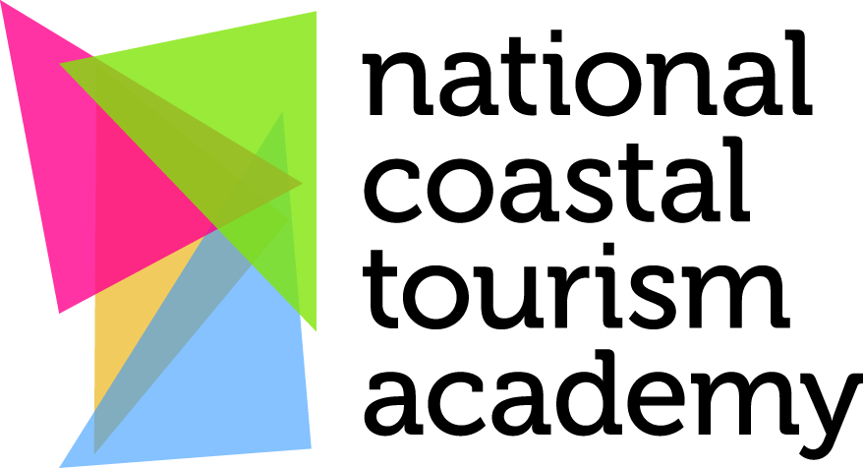
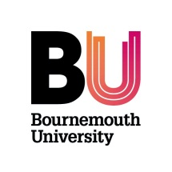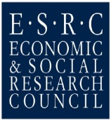

The Project
Through the creation of a network of tourism destination stakeholders, Destination FeelGood aims to establish Bournemouth University as a central knowledge exchange partner and the National Coastal Tourism Academy as a knowledge broker, sharing tourism wellbeing expertise with the local public and private sector. Thus inspiring innovation in health and wellbeing focused products and enhancing business performance and ultimately the local tourism economy.
This case study is a useful example of how sustainable wellbeing can be used as a strategy to create business networks and improve local community wellbeing.
The Background
Destination FeelGood offers the opportunity for connecting different destination stakeholders. Through inter-stakeholder dialogue, tourism businesses are in a position to increase their market through developing new products and services that will provide an enhanced value-added experience for visitors and local people alike. This project can accelerate tourism business growth via an improved understanding and implementation of wellbeing as it can facilitate the exchange of knowledge between tourism businesses, policy makers (both public health and tourism), and tourism and public health focused academics.
Through the Destination FeelGood project Ideas Cafés were run and a network established to share examples of best practice and act as a catalyst to foster innovation in co-creating destination and wellbeing products.
Case study
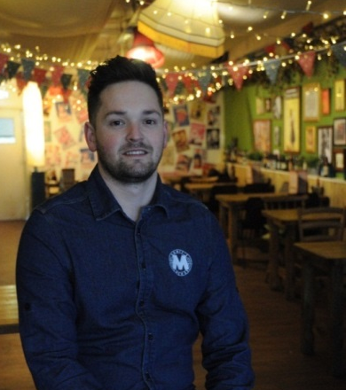
This case study is based on a local burger restaurant. Monty’s Lounge was opened by two Bournemouth University graduates in 2013. The idea behind it was to create an ethical, sustainable business that would provide a welcoming and friendly environment. Although it is a small local business that targets primarily local residents, the range of customers varies greatly across different age groups (e.g. from students to eighty year old couples). James and his business partner want Monty`s to be the type of place where customers feel at home and relaxed. Monty’s Lounge is a sustainable restaurant attempting to make ethical decisions every step of the way.
“We are trying to meet the demand… being as ethical as possible” – James.

The Action
One of the most promising outcomes of the Ideas Cafes was the ability for the University and other stakeholders such as the Local Authority to connect with the business community to create or inspire innovative products and emerging areas of commercial interest. Attending the Ideas Cafe James got useful information on current legislation which led him to adjust the menu to these standards (e.g. included information about ingredients and allergens). James also came up with the idea of creating connections between businesses and suppliers. The concept is to organise local meetings to enable contacts between suppliers and businesses with a focus on ethical and sustainable business.
Results
The needs and wants of customers are changing, as well as the way they buy food (e.g. increasing number of vegetarians and vegans, and an increasing demand for gluten free meals and more information about the source of the food we eat). Monty’s Lounge is trying to meet customers’ desires by providing healthy and high quality food. The restaurant transparently sources its products based on locality, seasonality and trustworthiness of suppliers.
The restaurants day to day `practices` are focused on sustainability. In order to achieve a high level of sustainability procedures such as recycling, water restrictors on taps and toilets and managed waste reduction are all implemented. This business has also signed up for the cycle to work scheme, which is sponsored by the government, to obtain discount on bicycles.
Furthermore, the variety of customer segments and building connections with other local businesses give a foundation to build a community that could improve the local physical environment. Friendly welcoming local businesses make people feel generally happier and more confident in their environment, and give a feeling of belonging, which can enhance psychological wellbeing for local people as well as visitors.
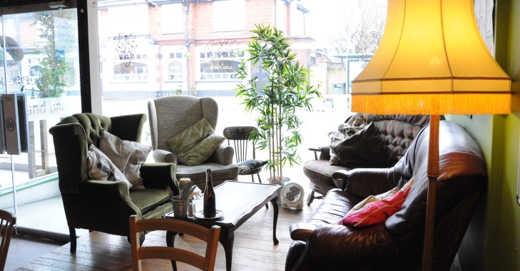
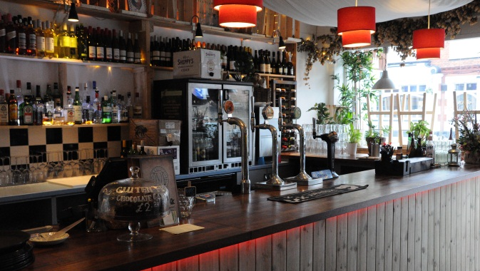
Among the reasons why people come to Monty’s Lounge are locality, a sustained high standard of quality ingredients, (e.g. locally sourced fresh ingredients) choice, staff knowledge of the products and a relaxed and welcoming place to eat.
Conclusion
This project offered the opportunity to connect different destination stakeholders, with the specific aim of innovating in relation to health and wellbeing focused products while contributing to a competitive local economy. The main impact of this project is seen as the co-creation and fusing of academic and practitioner expertise to innovate within the emerging wellbeing agenda and enhance commercial potential. This is done through providing a platform for dialogue for tacit and explicit knowledge exchange.
The connection between businesses that the project aims to help establish can benefit small, independent producers and suppliers. In turn this can help the local community, and boost the local economy, as well as creating new jobs.
Sustainable and healthy food may currently be seen as a niche market. However it is clear from the emerging evidence base that sustainable ethical approaches to business are linked to emotional wellbeing for tourists, local residents and business staff; who feel they are benefitting their local community and environment. All of which of course in the long term will benefit environmental wellbeing.

Design by:
Vira Syedova BA (Hons) Tourism Management

Case Study 2
Case Study: Pine Ridge Bed and Breakfast

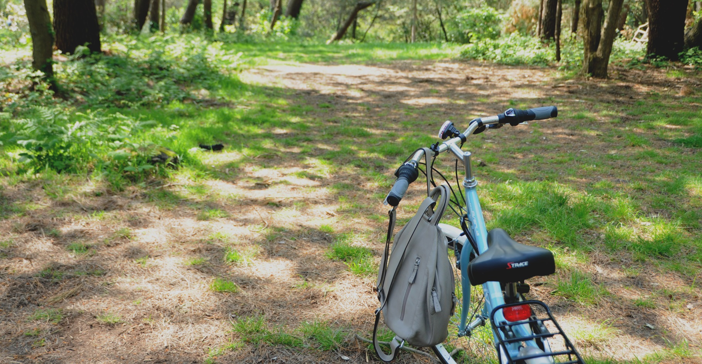
How can wellbeing enhance the customer experience?
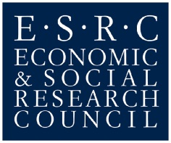

The Project

The importance of wellbeing is increasingly recognised as a crucial aspect of tourism and an area of strategic growth amongst tourism providers.

However in the local area of Bournemouth and Poole and surrounding environs, although wellbeing is an emerging area of interest from a policy perspective, the tourism potential of a positioning towards wellbeing has not been fully realised, providing an ideal platform to launch new product initiatives aligned to better population health. Through the creation of a network of tourism destination stakeholders, Destination FeelGood aims to establish Bournemouth University as a central knowledge exchange partner and the National Coastal Tourism Academy as a knowledge broker, sharing tourism wellbeing expertise with the local public and private sector, inspiring innovation in healthy lifestyle products and enhancing business performance and ultimately the local tourism economy.
This case study is a useful example of how wellbeing can be used as a marketing strategy and to competitive advantage.

The Background
Destination FeelGood offers the opportunity for connecting different destination stakeholders. Through inter-stakeholder dialogue, tourism businesses will be in a position to increase their marketing effectiveness, and develop new products and services that will provide an enhanced value-added experience for visitors. This project will accelerate tourism business growth via an improved understanding and implementation of wellbeing and it will facilitate the exchange of knowledge between tourism businesses, policy makers (both public health and tourism), and wellbeing academics.
Ideas cafés were run and a network established to share examples of best practice and act as a catalyst to foster innovation in co-creating destination and wellbeing products.

Case Study
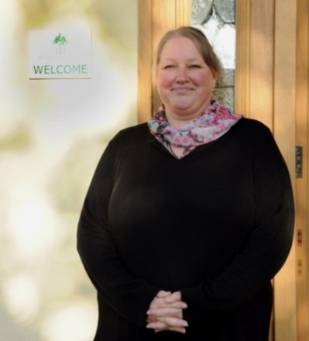
This case study is based on a local bed and breakfast operator; Pine Ridge located in Broadstone, Dorset, owned and managed by Jill Webber. Having worked as an accountant and then run a pub Jill decided to return to her birthplace and open a B&B in 2009. The business targets adults, mainly business people, and has four rooms. It is situated in the picturesque area of Poole and is ideally placed in the centre of cycle trail ways and 8 miles from the ferry to Cherbourg in France.

The Action – “Light-bulb moment”
A major outcome of the Ideas cafes was a need for the University and other stakeholders to connect with the local business community in innovative and emerging areas of commercial interest. Attending the meeting, Jill was inspired to use wellbeing as an added value to promote her business. She realised that providing secure cycling storage facilities could be a low cost investment but generate extra business especially as coastal path cycling is a growing trend in Europe.

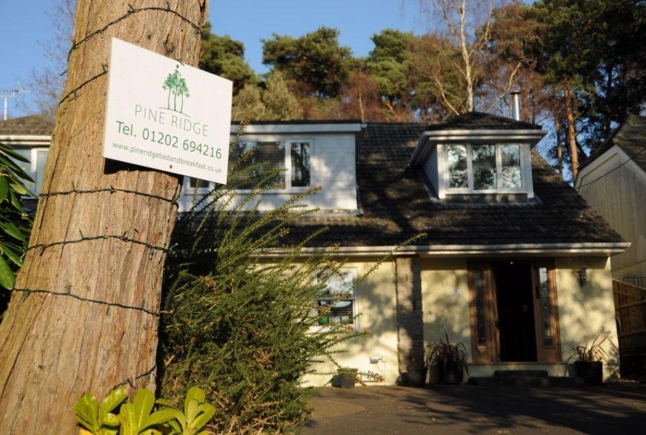
Results
The results of the case study are discussed in this section with a focus on how wellbeing can be used to enhance the customer experience.

The location of the bed and breakfast was an important factor in terms of the target market and potential customers.
Jill has noticed that over the past two years more visitors have been coming with bicycles, identifying cycling as a growing interest and therefore these consumers as an attractive mainstream market and reflective of society in general being more health conscious. She therefore decided to install bicycle racks and promote the opportunity to explore the nearby Poole Harbour and cycle trails. The next step is to connect with cycle groups and form alliances with major triathlon events in the area. Another example of Pine Ridge supporting sustainability is installation of an electric charger for cars. It was obtained through a government scheme, therefore no costs for the business arose, and on the contrary benefits to the business, customers and the environment.

Conclusion
This project offers the opportunity for connecting different destination stakeholders, with the specific aim of facilitating innovation in healthy lifestyle products while contributing to a competitive local tourism economy. Through inter-stakeholder dialogue, tourism businesses such as Pine Ridge will be in a position to increase their marketing effectiveness, and develop new products and services that will provide an enhanced value-added experience for visitors. The main impact of this project is seen as the co-creation and fusing of academic and practitioner expertise to innovate within the emerging wellbeing agenda and hence maximise commercial potential, while providing a platform for dialogue for tacit and explicit knowledge exchange. The concept of wellness tourism is an area where strategic priority is being given in many European destinations and policy documents from the World Health Organisation adds corroborating evidence of currency. This project will enable SMEs in local economies to use wellbeing to increase their global attraction, encourage more visitors, and strengthen their overall competitiveness through wellbeing led innovation, improving their income and long-term sustainability.

In conclusion, the collaboration between public health and the tourism sector will lead to the promotion of sustainability. Wellbeing as a driving concept will contribute to the development of new products while also enhancing and persevering local natural resources. To strengthen the competitiveness of a destination or a tourism business in a crowded marketplace the concept of wellbeing should be placed in a core branding position rather than viewing it as a niche product or experience. This could be achieved if the tourism sector worked together with public health as complementary actors, for example, co-branding with health care providers, food and beverage suppliers, sporting and activity associations/ societies.

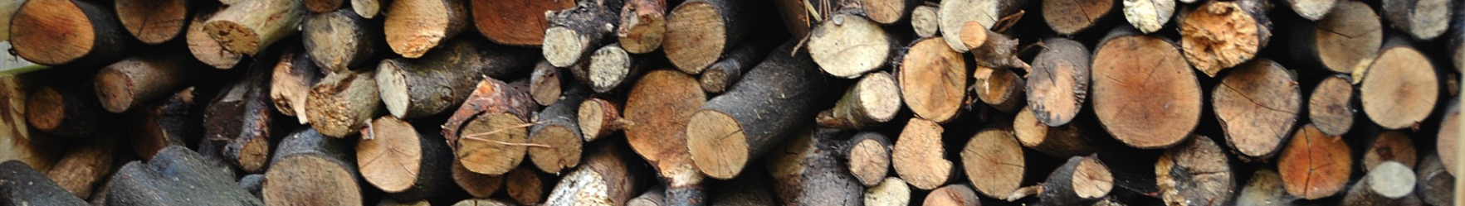
www.pineridgebedandbreakfast.co.uk

Design by;
Vira Syedova BA (Hons) Tourism Management

Case Study 3

Case Study: The Sandbanks Hotel
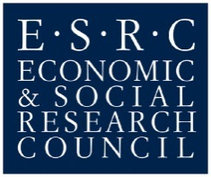
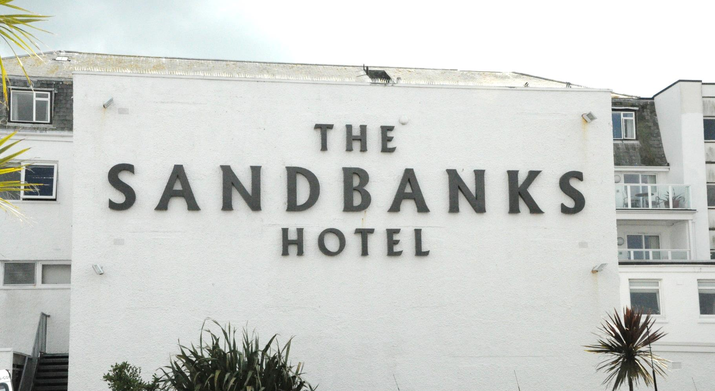

The Project
Through the creation of a network of tourism destination stakeholders, Destination FeelGood aims to establish Bournemouth University as a central knowledge exchange partner and the National Coastal Tourism Academy as a knowledge broker, sharing tourism wellbeing expertise with the local public and private sector. Thus inspiring innovation in health and wellbeing focused products, enhancing business performance and ultimately the local tourism economy.
High labour turnover rates and how to retain good employees are issues often faced by the hotel sector. This case study is a useful example of how a local hotel employer emphasises developing and retaining staff across all departments within its hotels.

The Background
Destination FeelGood offers the opportunity for connecting different destination stakeholders. Through inter-stakeholder dialogue, tourism businesses are in a position to increase their market through developing new products and services that will provide an enhanced value-added experience for visitors and local people alike. This project can accelerate tourism business growth via an improved understanding and implementation of wellbeing as it can facilitate the exchange of knowledge between tourism businesses, policy makers (both public health and tourism), and tourism and public health focused academics.
Through the Destination FeelGood project Ideas Cafés were run and a network established to share examples of best practice and act as a catalyst to foster innovation in co-creating destination and wellbeing products. In addition this case study focuses on tourism employee wellbeing, enhancing and expanding the debate through considering those on whom tourism businesses and holiday makers depend in all types of destinations and in all sectors of the industry.
Case Study
The Sandbanks Hotel is one of a group of four hotels owned and run by FJB hotels. The hotel is situated on Sandbanks beach in Poole Dorset, and focuses on providing family seaside holidays, with a wide range of activities including water sports for children and families on and off the beach. The hotel also caters for weddings, conferences and short breaks throughout the year.

The Action
One of the most promising outcomes of the Ideas Cafes was the ability for the University and other stakeholders such as the Local Authority to connect with the business community to create and inspire innovative ideas focused on the wellbeing of both visitors and staff. Attending the Ideas Cafe Andy Woodland (HR Manager) took part in a discussion themed on tourism employee wellbeing and shared ideas which the hotel had implemented to both promote wellbeing and develop and retain their staff. An informal conversation took place between staff and members of the Destination FeelGood team to gain insight into the success of measure that the hotel had implemented from the employee point of view.

Results
The following areas were identified by staff as helpful in terms of motivating them at work and encouraging them to remain with this operator.
Moving across departments: “I have worked in nearly all the teams here…I really understand how the hotel works for visitors”.
Flexibility in terms of shift times and patterns, and supportive regarding personal issues: “I appreciate being able to take a longer period of leave to go home (international employee)”, “I have had help with housing issues”, “You can always ask to leave for a doctor`s appointment, they care about us”, “the managers know everyone`s name…over 100 staff” and “I can talk about any problems I have at any time”.
Socialising inside and outside work: “ We get together to socialise, parties on the beach, bowling help us to get to know each other what we like what we don’t like”.
Promotion opportunities: “You see people go from porter to manager, I would like to be a duty manager in the future you need to aim high”, “it`s good to see other people get promoted it makes me feel I can do it”.
Learning opportunities: English courses, N.V.Q`s, management courses, human resources courses, fire training, health and safety. “Learning encourages you to stay”.
Implementing an appraisal process: “Builds confidence, build desire to work here” “I was scared but now I have a better feeling, I am improving… helps you enjoy your job we are a happy team”.
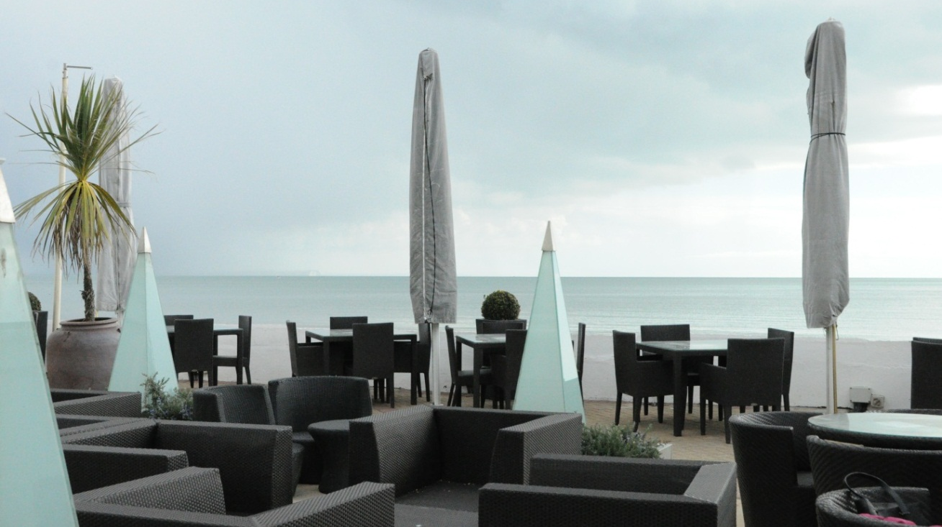

Conclusion
This project offered the opportunity to bring together different stakeholders across the business, local authority and academic sectors related to tourism. The case study presented here in particular highlights the positive effect a strategy emphasising employee wellbeing can have. Through the collaboration between commercial and academic partners the project has generated interest regarding research as well as generating additional commercial value. In addition, it is by identifying and disseminating examples of best practice developed through knowledge, innovation and creativity that the project can make its most significant impact. Through greater awareness and access to knowledge, improved skill sets, participation in events and opportunities to network and learn from peers, access to state-of-the-art podcast learning and access to students, impact across the local tourism economy has been developed.

Design by:
Vira Syedova BA (Hons) Tourism Management

