Institute for Poverty, Land and Agrarian Studies (PLAAS) |  | 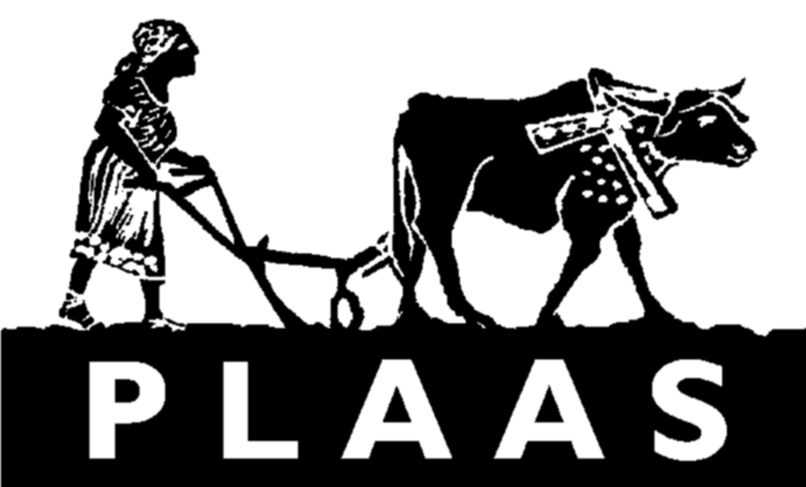  www.plaas.org.za
School of Government  University of the Western Cape  Private Bag X17  BELLVILLE  7535 | TEL: +27 21 959 3733  FAX: +27 21 959 3732  email: plaas@uwc.ac.za

Dear Participant

How can agricultural development contribute to non-farm employment in rural areas?

Please read this sheet carefully, and decide if you would like to take part in this interview around the issue of agriculture, employment and the rural economy. If you have trouble reading this, then one of our research team can read it out aloud for you, in your home language if necessary. Please ask if you would like a version of this information sheet in your home language, and one of our team will translate it for you.

What is this research about? This is a research project about employment in rural areas. It is trying to understand how agriculture and farm employment contributes to and stimulates the non-farm rural economy (i.e. all the other economic activities in rural areas). These same questions are being asked in a number of different places (countries) to see the differences between the countries.

Who is doing this research? This research, and these questions are being asked by researchers from the Institute of Poverty, Land and Agrarian Studies (PLAAS) at the University of the Western Cape (UWC) and its research partners. These include the Institute for Development Studies (IDS), in Sussex, in the United Kingdom, with country partners who are asking the same questions (viz. conducting comparable research in Zimbabwe and Malawi). If you wish to find out more about PLAAS please see www.plaas.org.za

Do I have to take part? It is your choice to decide whether or not to take part. If you decide not to take part, it will not affect any help you are getting, or affect your changes of getting help from bodies such as the government. The research team is not part of government or any of its agencies giving out grants, jobs, tenders, or agricultural inputs. You can also stop the interview at any time if you choose.
What will this involve? We will have an interview or which will be recorded. If it better suits you the interview can be structured over several visits. What you say and any information about you will be kept anonymous. This means that only the research team will know your real name, and anything that you say will be quoted under a different, made-up name. The interview will take at least an hour, and will be in your own home language. If there are parts of what you tell us that you do not wish to be recorded or written down, you can tell us this and we will omit these.

Why should I take part in this study? This study aims to help us understand how agricultural development can support rural employment (or, alternatively how particular patterns of agricultural development do not result in agricultural development). This is important because it will let us advise the relevant people in universities, research institutes and the government know how the agriculture can support employment in rural areas. This may help them improve their policies on rural areas, agriculture and employment. We will interview people in the KZN, and, and when we have finished we will let you know what we have found. We will also write a report about these findings.

What if there is a problem? If you have a concern about any aspect of this project, please speak to the researcher concerned (David Neves on 083 2480120, email: dneves@plaas.org.za) who will do his best to answer your query or address your concern. If you remain unhappy and feel your concern or query has not been addressed please contact the Principal Investigator, Prof Andries du Toit, the Director at PLAAS at the University of the Western Cape: adutoit@plaas.org.za or 021 9593733. Finally if you your concern is still not adequately addressed, please contact the Dean of the Faculty of Economic and Management Sciences at the University of the Western Cape, 021 959 2911 or info@uwc.ac.za He or she may well refer your issue to the University’s research ethics committee.
Thank you for reading this sheet. If you feel comfortable to take part in this discussion, then please sign below. The last two pages of this document contain all of the above information, in an information sheet for you to retain, if you wish.

Yours sincerely

David Neves
Institute for Poverty Land and Agrarian Studies (PLAAS)
University of the Western Cape
Cape Town

Participant’s name and address

Participant’s signature date

Researcher’s signature date

Institute for Poverty, Land and Agrarian Studies (PLAAS) |  | www.plaas.org.za
School of Government  University of the Western Cape  Private Bag X17  BELLVILLE  7535 | TEL: +27 21 959 3733  FAX: +27 21 959 3732  email: plaas@uwc.ac.za

Dear Participant

Information Sheet on Research Project

How can agricultural development contribute to non-farm employment in rural areas?

Please read this sheet carefully, and decide if you would like to take part in this interview around the issue of agriculture, employment and the rural economy. If you have trouble reading this, then one of our research team can read it out aloud for you, in your home language if necessary. Please ask if you would like a version of this information sheet in your home language, and one of our team will translate it for you.

What is this research about? This is a research project about employment in rural areas. It is trying to understand how agriculture and farm employment contributes to and stimulates the non-farm rural economy (i.e. all the other economic activities in rural areas). These same questions are being asked in a number of different places (countries) to see the differences between the countries.

Who is doing this research? This research, and these questions are being asked by researchers from the Institute of Poverty, Land and Agrarian Studies (PLAAS) at the University of the Western Cape (UWC) and its research partners. These include the Institute for Development Studies (IDS), in Sussex, in the United Kingdom, with country partners who are asking the same questions (viz. conducting comparable research in Zimbabwe and Malawi). If you wish to find out more about PLAAS please see www.plaas.org.za

Do I have to take part? It is your choice to decide whether or not to take part. If you decide not to take part, it will not affect any help you are getting, or affect your changes of getting help from bodies such as the government. The research team is not part of government or any of its agencies giving out grants, jobs, tenders, or agricultural inputs. You can also stop the interview at any time if you choose.
What will this involve? We will have an interview or which will be recorded. If it better suits you the interview can be structured over several visits. What you say and any information about you will be kept anonymous. This means that only the research team will know your real name, and anything that you say will be quoted under a different, made-up name. The interview will take at least an hour, and will be in your own home language. If there are parts of what you tell us that you do not wish to be recorded or written down, you can tell us this and we will omit these.

Why should I take part in this study? This study aims to help us understand how agricultural development can support rural employment (or, alternatively how particular patterns of agricultural development do not result in agricultural development). This is important because it will let us advise the relevant people in universities, research institutes and the government know how the agriculture can support employment in rural areas. This may help them improve their policies on rural areas, agriculture and employment. We will interview people in the KZN, and, and when we have finished we will let you know what we have found. We will also write a report about these findings.

What if there is a problem? If you have a concern about any aspect of this project, please speak to the researcher concerned (David Neves on 083 2480120, email: dneves@plaas.org.za) who will do his best to answer your query or address your concern. If you remain unhappy and feel your concern or query has not been addressed please contact the Principal Investigator, Prof Andries du Toit, the Director at PLAAS at the University of the Western Cape: adutoit@plaas.org.za or 021 9593733. Finally if you your concern is still not adequately addressed, please contact the Dean of the Faculty of Economic and Management Sciences at the University of the Western Cape, 021 959 2911 or info@uwc.ac.za He or she may well refer your issue to the University’s research ethics committee.

Yours sincerely

David Neves
Institute for Poverty Land and Agrarian Studies (PLAAS)
University of the Western Cape
Cape Town

