The Cappuccino Community : cafés and civic life in the contemporary city

Background
The release of Robert Putnam's (2000) 'Bowling Alone' just over a year ago caused quite a stir, arguing as it does that in the USA community life was collapsing. People who once bowled in official teams in leagues now go bowling alone. His research was taken so seriously in the UK that he was invited to meet the Prime Minister in March 2001. Drawing on statistical evidence, eyewitness testimony and firsthand accounts, Putnam asserted that in the West we are becoming increasingly disengaged from civic activity. Echoing the remarks of Habermas (1989) on the transformations of the public sphere, he bemoaned the lack of participation in intermediate institutions between private life-world and mass economy and the state. Taking up Putnam and Habermas's topics of community, civic life and the public sphere from an alternative and more empirically-driven but also theoretically-informed stance, we aim not to offer more precise definitions of these 'meta-topics' but to displace their epistemological frameworks (Lynch 1993).
We can find forms of community in all kinds of places; at the school gates, in the corner shop, at work, with our neighbours, and of course in cafés. In terms of this project the latter is of particular significance because not perhaps since the eighteenth century have cafés occupied such a central place in the civic society of British cities. The last five years have seen a remarkable expansion in the provision and use of cafés. In 1999, a Mintel survey reported that coffee had replaced the long-standing dominance of tea as the UK's most popular hot drink. The most dramatic growth in café venues has been in the branded sector with the ascendancy of Costa Coffee, Café Nero and Aroma, and the arrival from the US of Starbucks. From around 300 branded coffee shop outlets in 1997 with a turnover of £51 million (Mintel 1998) there have been estimates for the year 2001 of up to 1,850 outlets, which would be a sixfold increase in less than five years (Allegra Strategies 1999). The new branded cafés are expanding beyond traditional high street locations and merging into other venues by installing themselves in bookshops, DIY stores and even building societies (Costa Coffee 2000; Klein 2000). It seems clear that it is a timely moment for research into what is happening in these public places, in terms of their support of civic society, their provision and daily custom.

The historical and social significance of the café
The origin of British banking and particularly Lloyds Bank in the coffee houses of seventeenth and eighteenth Century London is well known. Coffee houses were places with a set of codes of conduct, furnishings and services that provided for the relatively secure mixing, meeting and financial exchanges of business people. Habermas (1989) points toward the café's importance not just to the commercial life of nation-states but more fundamentally to civic life. In Habermas's most renowned work he argues that they were places located between the private sphere of family life and the home and the public sphere of the state and court: places where, amongst the collected newspapers, novels and other publications stored in the coffee house, customers from various social backgrounds could openly debate civil matters, affairs of the state as well as more personal matters. (Feminist critiques of Habermas have however emphasised the gendering of such public places). As Habermas writes of coffee houses :
'(They)… preserved a kind of social intercourse that, far from pre-supposing the equality of status , disregarded status altogether. The tendency replaced the celebration of rank with a tact befitting equals. The parity on whose basis alone the authority of the better argument could assert itself against that of social hierarchy and in the end can carry the day meant, in the thought of the day, the parity of "common humanity". Private gentlemen made up the public not just in the sense that power and prestige of public office were held in suspense; economic dependencies also in principle had no influence. Laws of the market were suspended as were laws of the state. Not that this idea of the public was actually realized in earnest in the coffee houses; but as an idea it had become insitutionalized and thereby stated as an objective claim.' (Habermas 1989, p36).
Although there have been several historical studies of café life (i.e. Haine 1996) there are, somewhat surprisingly, very few comparable social studies that consider the claims of Habermas as a foil for thinking about civic life arising in more contemporary coffeehouses (or cafés), but in part this is precisely what we would propose to do in our project.
Restaurants have been the focus of attention for social researchers in terms of how they organise the work of service (Whyte 1949), the particular kind of emotional and performative labour they require (Crang 1994; Goffman 1956) and their broad place in modern life (Finkelstein 1989; Warde & Marten 2000). Despite the frequent mention in the popular press of internet and cyber cafés, however there have been very few social studies carried out in them either (Wakeford 1999). Even with these few excellent investigations the emphasis has tended to be on the provider's perspective rather than the customers (Smith 1996; Warde & Marten 2000). This project will pick up from that early work in terms of sharing their attention to provision and the staff's work but will be more fundamentally involved in the investigation of the 'communities of practice' (Wenger 1998) that are now found in cafés.
Commercial research carried out by Costa Coffee (2000), one of the leading branded coffee outlets pointed toward four important and distinct aspects of the social life of cafes: 1. they were part of a 'quick break culture' where fewer people had time for long lunches anymore; 2, they provided support for 'multi-tasking' in a way that neither restaurants nor fast food outlets could; 3, they were more welcoming places for single people and women than restaurants or pubs; 4, echoing Habermas and other cultural and critical theorists (i.e. Bhabha 1994), cafés are part of … "The social phenomena of the 'third place' is … a reason for the growth of the UK's coffee shop culture. The term refers to a space people occupy outside home and work - and is often described in terms of the continental café culture. It's a place to relax, to be alone, to socialise, to read, to gossip, to meet people, to debate, plan, organise, write, draw, think, vegetate, prevaricate, hide, chew over, swallow, digest and ruminate" (Costa Coffee 2000). It would surely be fascinating to pursue the empirical accuracy of such claims and to confront them with Habermasian (and other) conceptions of the spaces that have historically, and could in future constitute the props of civic society allowing rumination and collective practice.

One big community or proliferating communities of practice?
Both Putnam and Habermas's influential projects have been top-down approaches, one statistically testing a hypothesis about the breakdown of community and the other using historical evidence to support a totalising history of modernity. Our project draws instead on Wenger's (1998) reformulation of community and Habermasian 'lifeword' into communities of practice, where each and every community is tied to the practices that produce it. Wenger's fertile concept allows that anyone person belongs to many communities of practice, for some of which they are core members of and some they are peripheral. It allows for a fine-tuning of the categorisations of communities, so that we can investigate families, workers, students, radio amateurs, laboratory scientists etc. as different kinds of communities with different logics. Wenger's conceptual approach to communities is nonetheless weakened by his lingering dualistic framework of structure and agency. In this project we press Wenger's 'praxiological turn' a little further, leaving behind the predetermined structures that he ushers into support communal and convivial life. Where we would suggest this takes us conceptually is into social research which is inspired by Wittgensteinian 'forms of life' and the 'policies' of ethnomethodology (Lynch 1993)
As a piece of human geographical research this project is thus based in an ongoing empirically-guided concern with formal and informal places as practised phenomena (Laurier 2001; Philo & Parr 2000). Briefly expressed we take it that places are locally ordered via sequential and categorising rules and techniques (Crabtree 2000). This project will proceed by drawing on the approaches of ethnomethodology (EM) to produce descriptions of how particular communities are formed at ground level. That is, we will be concerned with explicating civic society as an ordinary, if highly skilful, accomplishment of the actors (staff and customers) within a specific setting (i.e. a café). The project will not treat the public sphere as a theoretical entity, nor as an underlying cause of the organised nature of interaction in public places, but rather as the outcome of the endless mundane worldly work and practical reasoning of ordinary people in ordinary places arriving, arguing, gossiping, leavetaking, planning, writing letters, reading newspapers, doing 'business', feeding babies, studying for exams and drinking coffee.
EM has much to offer human geography, critical theory and community studies in respecifying the investigation of public space and situated communities, but it has up until now been a programme of empirical, conceptual and post-analytic studies attached predominantly to sociology, psychology, human-computer interaction and linguistics (Button 1991; Lynch 1993). Nevertheless, although not commenting directly on human geography, two salient initiatives in the literature are: 1 an investigation into spatial practices in the use of libraries (Crabtree 2000), and, 2 a larger scale report carried out in Belgium on the use of public space - particularly city squares, markets and public transport zones (Lee & Watson 1993). In the latter study the idea that public spaces in the city are inhabited by a 'world of strangers' was taken to task. Alongside these investigations in public spaces, EM has had a productive critical engagement with Habermas's theory of communicative action (Bogen 1999; Lynch 1993) and his concept of justice (Raffel 1992). Whilst attending to Habermas's theories as they relate to the logic of conversation and the exercise of power, EM has not so far brought its empirical analyses to bear on theories of the public sphere and the logic of everyday space. We assert that there is much to be done in investigating Putnam's statistical and Habermas' historical claims about general social transformations. Habermas's descriptions of what forms and precisely how civility, tact and relatively unconstrained debate occurred in cafés remain, at best, sketchy. Equally statistical surveys of the kind that informs Putnam (2000) (and also Klein's (2000) equally renowned 'No Logo') which argue polemically against the commercialisation of civic life and the pervasive commodification of everyday existence frequently overlook just how and in what particular ways and places, such as cafes, community life now manifests itself

Detailed Research Questions
- Given Habermas's long-standing concern with the insufficiencies of the public sphere and Putnam's warnings over the contemporary disengagement from civic life, there are strong grounds in the social sciences for an investigation into one of the key sites that lies between public and private, work and home, global and local. This project will be committed to providing ethnographically rooted answers to questions surrounding the changing nature of community existence. It will explore the informal institution of the café as a place where there are forms of life recognised by Habermas as vital to the civic life of cities and overlooked by Putnam's statistical analysis of the decline of community. In its ground level inquiries it will examine the diversity of cafes that exist and their adoption by particular 'crowds', with common and divergent manners. If cafés are places for the mixing and meeting of different people, are they also places for divisions and subtle (and not so subtle) exclusions? From detailed description, we anticipate critiquing and displacing theoretically driven terms such as the public sphere and community by bringing them into contact with ongoing conjoint practices that are always locally accomplished by particular communities.
- It is clear from marketing research and firsthand experience that a diversity of activities take place in cafes. The project will record lists of these activities, their timings, location and groups involved to answer queries over just what kind of things people are doing in cafes (questions not answered by the restrictive format of market research.) Since the project is primarily concerned with social practice or 'society-in-action', it will be committed to answering questions posed by the real-time, sequential and intersubjective ways in which the (passing) inhabitants of cafés get their work, play, debate, care and conviviality done. As an optional extra (see Annex 2) it could put the UK material in a wider perspective by gathering comparative data from Italy. Of particular interest will be the social categories that are tied to the setting and how they are used: newcomers, locals, regulars, youths, eccentrics, tourists, old folks, business execs, and when and how they are made relevant and put to use for publicly available conversations. Cafés are linked to their customers as a part of their daily routines, and we aim to look at just how they are networked into their urban milieux via the travels of their customers : as office workers escape their offices in them, as mobile sales people use them as meeting places (Laurier & Philo 1998), as grandparents take their grandchildren to them and back home again, as carers bring their dependants from sheltered housing to them, as tradespeople stop off for a quick cuppa. Our inquiries will pursue cafés as generative nodes, as hetertopias, where economic, political and cultural matters run up against one another and are mutually transformed.
- Although they are relatively informal sites, cafés come with rules of etiquette and appropriate comportment which provide for displays of civility, tact, friendliness, and concern, and equally for uncivil, tactless, unfriendly and indifferent behaviour. The project will tease out these routine, background expectancies of the café as they vary between the UK and Italy and pursue their binding to the sequential and spatial features of each and every actual setting. In the project, 'the café' will be pursued both as a specific setting for communities of practice and also as a membership categorisation device (Sacks 1992) that produces collections of categories such as : staff, regular, newcomer. It will ask, how do these category-bound activities also produce the sorts of activities their occupants are entitled and/or obliged to do? In what ways do they furnish relations between inhabitants of cafes such staff/customer, staff/regular, regular/newcomer etc? Moreover they are constitutive of the café as a morally ordered place where even passing 'members' can be sanctioned should they disrupt this particular community without good account.

Methodology
In broad view the project's methodology will be to carry out a multi-site ethnography, involving place-based observational work, interviews with key-informants, in-depth participant-observations, shadowing of café users, user-participation in the generation of photographic materials, and optionally comparative fieldwork outside the UK (see Annex 2). The fieldwork tools used will be the traditional fieldwork journal for observations and preliminary analysis, tape recorder for interviews, polaroid cameras for users and most importantly and innovatively digital video recording equipment. For the latter, the BBC guidelines for filming in public places will be followed and informed-consent will be sought from those filmed where it is possible to attain it. In addition, the final videotapes will be visually anonymised where possible and access to the dataset will be restricted to project personnel. In keeping with the tenets of EM this project's emphasis is on gathering "naturalistic" (not "objective") data of café customers and staff going about their everyday affairs in the places where they normally do them (i.e. not in a laboratory or a focus group meeting).
The fieldwork will proceed in 4 stages which will overlap:
Stage 1 (Months 3-6) : Interviews with experts and managers - key actors and planners with Costa Coffee, Starbucks, Café Nero and smaller café owners. Investigation of trade magazines and histories relating to café life in UK and Italy. The interviews will mainly be formal and build up a background expertise for the researcher on the provider's view, alongside a sense of what their plans and agendas are. Further it will be used to check their sources of up-to-date knowledge of café life. Permissions will be sought for doing fieldwork in specific venues (if necessary and with a sensitivity to issues of confidentiality and trust from 'lowly' staff).
Part 2 (Months 7-13). Initial study of 12 cafés. Access will be negotiated with the broadest possible range of cafés. It is expected that each individual place will occupy several possible and sometimes cross-cutting categories of cafe : franchise, neighbourhood, greasy spoon, youth, in-store, internet, independent, Italian, theme, style, music. Moreover their 'crowd' and 'ambience' may alter between weekdays and weekends, between breakfast time, mid-morning and lunchtime and night-time. At this point records of activities and customers and early descriptions will be gathered, along with preliminary video-material.
OPTIONAL Part 3 (Months 14-15): (See Annex 2) Italian Comparative study. A short period of 2 months will be spent in Italy doing library and newspaper research along with field observation, video documentation and interviews by the project researcher. This material is not expected to be as in-depth as the core UK results.
Part 4 (Months 16-25) In-depth study of lifeworlds of 3 contrasting types of cafés. During the fieldwork the researcher will informally interview staff, gather stories of regulars, passers by, observe the café in use as a meeting place and a workplace. There will be 3 elements to this more in-depth work
4.1. Participant-observation of the customer life in the cafes, the researcher gradually becoming a 'regular' in each café.
4.2. Participant-observation of the staff's work in the three cafés - on completing element '4.1', the researcher will work alongside the staff for a couple of days a week to gain a basic competency in their 'work' of producing the café as a communal environment.
4.3. Shadowing 12 customers from each of the 3 cafes. The researcher will negotiate a day or more spent following customers from one place to another to discover how the café fits into their overall lifeworlds. This element will provide 36 'contextualised' customers and, with permission, elements of their day will be shot on video. Further, these 36 customers will be presented with polaroid cameras to record their own depictions of their week and how the café fits into it which will form the basis of discussions with the researcher on their completion. In return for successful completions of this exercise, the users will be gifted the polaroid cameras and extra film for them. Sampling strategy for participants will pursue the widest possible social array from homeless city dwellers to business executives.
Analysis of data will proceed in stages related to the outputs of the three parts of the fieldwork, beginning with 2 months spent summarising and thematicising the café provider interviews and documentation. Preliminary results from the ethnographies will be assembled in the gap before the user participation study in order that the users can comment on the results from this section (which will also be delivered to the café providers and related designers). During the final year considerable time and effort will be spent indexing, transcribing, editing down and analysing the initial provider interviews, the video-ethnography material and the user-contributed data. Video sequences will remain the primary material to which all analysis and transcription is bound; it will also be the primary material for sharing and presenting results to academic audiences (for comparable methodology and analysis of workplaces see Heath and Hindmarsh, in press). Transcription of the video will be done so as to sensitise the researchers to particular features of the interaction occurring and will to the greatest extent possible avoid becoming a technical account no longer intelligible to a general audience (see Lynch's 1993 remarks on CA transcription). Transcripts will thus use a paired down version of CA's transcription conventions which will then be linked by their time-matching to stills from the videos, and in hypermedia documents there will be clips attached to the text (for an example see Annex 1 Buscher 2001). What the transcripts will do is to assist in sensitising the analyst to features of practice and making available salient details of just how members mutually engage with one another, work-up joint enterprises and are part of communities-in-action.
Empirical material and preliminary results will also be transferred to CD ROM and the project website. The final report and press packs will be drafted during the last three months of the project timetable

Outputs
Articles for Environment and Planning A & D, Area, Urban Studies, Journal of Material Culture, Theory, Culture and Society, Sociological Research on-line, Human Studies.
Academic conference presentations in the UK, Europe and the USA.
Internet site & 100 copies of Multi-media CD Rom containing a summary of the project, working papers and datasets.
Extensive machine-readable data set of cafe from the 5 field sites. Data set will consist of 2 parts: edited and labelled video-footage (stored on DVD or CD ROM) and CA transcripts.
Press releases to BBC Radio, television news and broadsheet newspapers.
Special final report with design implications for designers of interiors, interface and new media devices and parallel report with implications for planners, architects and urban developers and policymakers.
In negotiation with a trade publisher a popular account of the cafes place in contemporary British Society with illustrations from video and photographic footage.

Bibliography
Allegra Strategies 2000. Project Café2: UK Retail Coffee Shop Market. London : Allegra Strategies Ltd.
Bhabha, H. 1994. The Location of Culture. London : Routledge
Bogen, D. 1999 Order Without Rules, Critical Theory and the Logic of Conversation, New York: SUNY
Buscher, M. 2001 Ideas in the making: talk, vision, objects and embodied action in multi-media art and landscape architecture. PhD Thesis, Lancaster : University of Lancaster
Button, G. 1991. Ethnomethodology and the Human Sciences. Cambridge: Cambridge University Press.
Costa-Coffee. 2000. Costa Coffee Media Briefing Kit. Manchester: Communique PR,.
Crabtree, A. 2000. Remarks on the social organisation of space and place. Journal of Mundane Behaviour 1, http://www.mundanebehaviour.org/issues/v1n1/crabtree.html.
Crang, P. 1994. It's showtime: on the workplace geographies of display in a restaurant in South East England. Environment and Planning D: Society and Space 12, 675-704.
Finkelstein, J. 1989. Dining out, a sociology of modern manners. Cambridge: Polity.
Goffman, E. 1956. The Presentation of Self in Everyday Life. Edinburgh: Edinburgh University Press.
Habermas, J. 1989. The Structural Transformation of the Public Sphere, An Inquiry into a Category of Bourgeois Society (trans.) Burger, T. & Lawrence, F. Oxford: Polity Press.
Haine, W.S. 1996. The World of the Paris Cafe, Sociability among the French Working Class, 1789-1914. London: John Hopkins University Press.
Heath, C. and J. Hindmarsh (in press) Analyzing Interaction: Video, ethnography and situated conduct. To appear in May, T. (ed.) Qualitative Research: An international guide to issues in practice. London: Sage.
Klein, N. 2000 No Logo. London : Flamingo
Laurier, E. 2001 Why people say where they are during mobile phone calls. Environment and Planning D: Society and Space, 19, 485-504
Laurier, E., & Philo, C. 1998. Meet You At Junction 17: A socio-technical and spatial study of the mobile office. ESRC, Swindon End of project report.
Laurier, E., A. Whyte & K. Buckner. 2001. An ethnography of a cafe : informality, table arrangements and background noise. Journal of Mundane Behaviour.
Lee, J. R. E. and Watson, D. R. (1993) Final Report to the Plan Urbain: Public Space as an Interactional Order. University of Manchester: Department of Sociology.
Lynch, M. 1993. Scientific practice and ordinary action: ethnomethodology and social studies of science. Cambridge: Cambridge University Press.
Lynch, M., & Bogen, D. 1996. The Spectacle of History: Speech, Text and Memory at the Iran-contra Hearings London: Duke University Press.
Mintel. 1998. Cafes, Mintel Leisure Intelligence. London: Mintel International Group.
Philo, C. & Parr, H. 2000 Institutional geographies : an overview. Geoforum 31, 176-196
Putnman, R. D. 2000. Bowling alone : the collapse and revival of American community, New York : Simon and Schuster
Raffel, S. 1992 Habermas, Lyotard and the concept of justice. Basingstoke : Macmillan
Smith, M. T. 1996 The Empire Filters Back : Consumption, Production and the Politics of Starbucks Coffee, Urban Geography, 15, 502-525.
Sacks H. 1992. Lectures on conversation, Oxford: Blackwell
Wakeford, N. 1999. Gender and the landscapes of computing. In Virtual Geographies: bodies, spaces and their relations (eds) M. Crang, P. Crang & J. May. London: Routledge.
Warde, A. & Marten, L. 2000 Eating out : social differentiation, consumption and pleasure, Camridge : CUP
Whyte, W.F. 1949. The Social Structure of the Restaurant. American Journal of Sociology 54, 302-310.
Annex 1 : Extract from Buscher (2001) page A - 1, showing both how transcripts with video-stills are related back to original video footage and also transcription conventions as seen in paper document form
Current clip, first frame.
Timeline showing each single frame of the current clip
Audio channel, showing talk and sound in relation to frames
Current clip, at frame highlighted in the timeline.
Frame and time counter

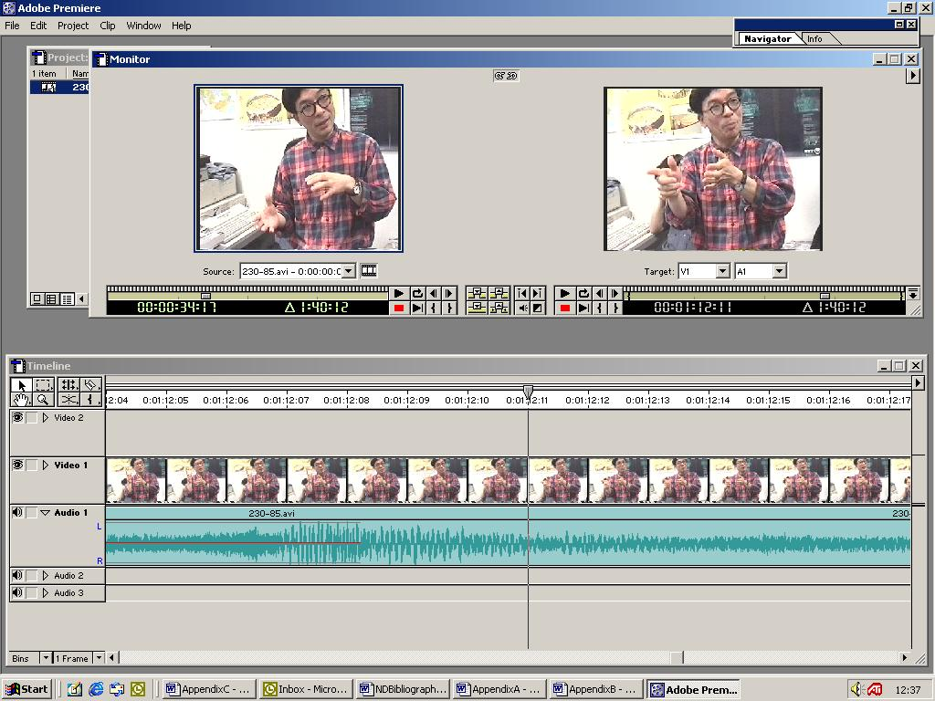
Figure 10.1 … he cannot talk with him … T 4, line 277
The end of the thick black line in the transcripts usually coincides with the end of the word spoken as the conduct shown in the picture took place.
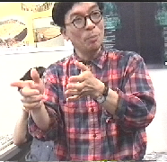
276 he cannot
277 talk with him

Excerpt 2 Buscher (2001) p200 :

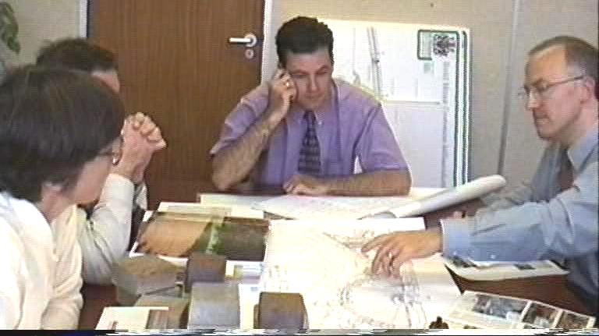
453 T: [( )]
454 L: [effect]ively
455 C: ºyeahº (.)
456 T: I think you’re best going for

457 backed seats (.) all round because
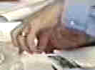
458 if if you have the benches around
459 here maybe not adults but children

Annex 2: Italian Fieldwork Option

Two of the reviewers of our first ESRC application, on researching the social and cultural life of cafes, suggested carrying out comparative research outside the UK. We remained uncertain as to whether we could carry out the kind of in-depth investigation abroad that we were doing in Britain. Nevertheless, we agreed with the broad notion that comparative material would be useful to put the UK experience in context, even if the fieldwork entailed a brief ethnography and some short documentary research. We remained somewhat concerned that reviewers of this second substantially revised application might see such work as less worthy of carrying out than the initial reviewers, and it would then become a stumbling block for the core of our project's investigation. Ultimately we decided the best solution was to leave the comparative study as an option which the reviewers and the board could choose to remove from the project should they wish, or include if they felt it would add a necessary contextual element to the project.

Its costs are included in the project's budget at just under £4000 for 2 months fieldwork. Its removal would not affect the project timetable and the two months freed up would be divided between Parts 2 and 4 of the research methodology.

