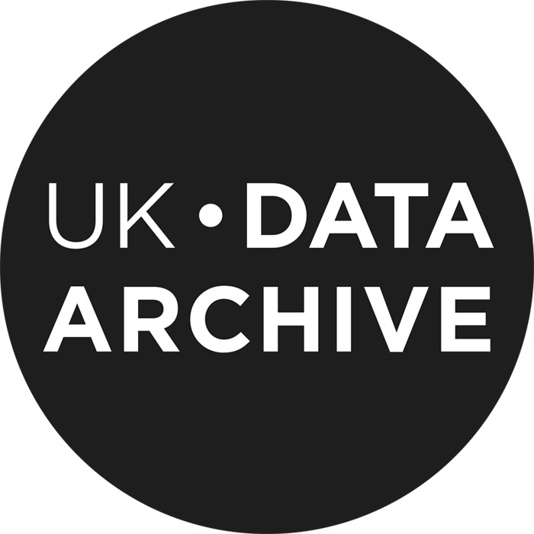

The use of incentives-case studies on current and future incentives for research data sharing
What is the project about?
This project was commissioned by Knowledge Exchange to investigate current incentives for research data sharing. KE is a co-operative effort that supports the use and development of information and communications technologies infrastructure for higher education. The research will involve qualitative interviews with five research teams in partner countries of Knowledge Exchange (Finland, Denmark, Germany, United Kingdom, and the Netherlands). The aim of this pilot study is to provide evidence and examples of useful incentives for data sharing from the researchers’ point of view to inform scientists and policy makers.
How will you be involved?
You will be interviewed by a member of our research team about your attitudes, practices and experiences with sharing research data. We will provide you with a list of topics in advance. We intend to conduct all interviews in person, but some may need to be by phone. You may choose to have the interview in English or in your nation’s language. The interview will probably take 30-60 minutes and will be recorded and then transcribed.
How will we address confidentiality and security?
We hope you will be comfortable using your real name for this research. You can indicate during the interview if you prefer certain information to be off-the-record and therefore anonymous. During the project, only the research team will access your contributed information. Any others, such as our transcriber, will be required to sign a non-disclosure agreement.
We expect to use your contributed information in various outputs, including a report and content for a website. Extracts of interviews and some photographs may both be used. We will get your permission before using a quote from you or a photograph of you.
After the project has ended, we intend to archive the interviews at the UK Data Archive at the University of Essex in the United Kingdom and with Knowledge Exchange. Then the interview data can be disseminated for reuse by other researchers, for research and learning purposes.
Can I withdraw from the project?
Your participation is completely voluntary and you may withdraw from the research whilst the project is ongoing. If you should decide to withdraw after any materials have been published, we can remove your information from any copies we control, but we cannot ensure that copies will not persist in other locations.
What are the benefits and risks?
The project benefits include better understanding of researchers’ motivations for sharing data. Such understanding will inform data policies and the design of infrastructures for sharing. We do not foresee any risks of participating in this project.
Where can I get more information?
The two researchers running the project are Libby Bishop and Veerle Van den Eynden, both at the UK Data Archive, University of Essex. You may contact Libby at ebishop@essex.ac.uk and Veerle at veerle@essex.ac.uk. The contact for the project funder, Knowledge Exchange, is Angela Holzer at angela.holzer@dfg.de.

