**Smokers’ and ex-smokers’ understandings of nicotine replacement therapies and electronic cigarettes**

**Project Summary • Centre for Population Health Sciences • May 2014**

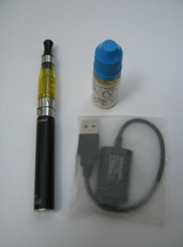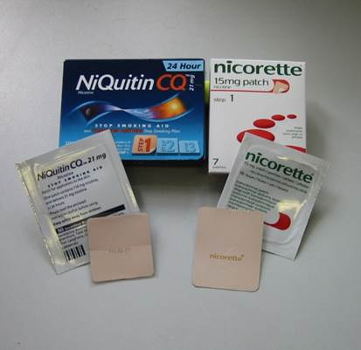

**Authors and acknowledgements**

This summary was written by Catriona Rooke, Amanda Amos and Sarah Cunningham-Burley. It is based on findings from a Cancer Research UK funded study. We would like to thank all of the participants who shared their views with us as part of the study.

**Contact Details**

Centre for Population Health Sciences

The University of Edinburgh

Old Medical School, Teviot Place

Edinburgh, EH8 9AG

Tel: 0131 650 3237

Email: [catriona.rooke@ed.ac.uk](mailto:catriona.rooke@ed.ac.uk)

<http://www.cphs.mvm.ed.ac.uk/>

**Background**

Interest in electronic or ‘e-cigarettes’ has intensified in public health and media debates in recent years. E-cigarettes are battery-operated devices that produce a vapour (usually, although not always) containing nicotine, which the user inhales. Mintel estimated that the market for e-cigarettes in the UK increased from £44 million in 2012 to £193 million in 2013. Whilst sales of e-cigarettes are escalating, there is no consensus amongst public health experts over the implications for the health of the UK population. Although there is general acceptance that e-cigarettes are likely to be much less harmful to health than smoking tobacco, there remain some uncertainties about safety, long term health effects and effectiveness for smoking cessation. Very little is known about the meanings this contested new technology has for smokers and how they understand the risks and benefits of using an e-cigarette.

**Aims**

This study explored how nicotine-containing products such as nicotine replacement therapies (NRTs) and e-cigarettes are understood and experienced by smokers and recent ex-smokers. The study aimed to answer the following questions.

**Research Questions**

1. researchs) contain. ng smokingnt when interpreting NCPsWhat understanding do smokers and ex-smokers have of the risks and benefits of nicotine-containing products?
2. How do these understandings shape their attitudes towards and experiences of short and long-term use of different products?
3. What are the implications for policy and practice?

**The project**

The study took a qualitative approach. Focus groups and semi-structured interviews were undertaken between September 2013 and February 2014 in central Scotland. We conducted 12 focus group discussions, with 2-8 participants in each, and 11 individual interviews; a total of 64 participants. Smokers and recent ex-smokers were recruited from community and interest groups. Additional interview participants were also recruited via an advert on Gumtree. Focus groups and interviews explored what sorts of products participants had heard of; experiences with products; price and sources of information; uses, advantages and disadvantages of products; and regulation. Pictures and examples of different products were used to prompt discussion (for examples see the cover page). The focus groups and interviews were recorded and transcribed. Data analysis involved repeat readings of transcripts to develop codes. Codes were then compared in order to identify cross-cutting themes and highlight common experiences, as well as considering differing views.

Of the 64 people who took part in the study, 33 were women and 31 were men. Participants were aged from 16 to 67. Twenty-four were ex-smokers and 40 were smokers.

**Findings**

***Understandings of smoking and quitting***

Participants varied considerably as to how they felt about their smoking and quitting (see ‘smoker spectrum’ in Figure 1). At one end of the spectrum were those who had been unhappy about their smoking, often for health reasons, and had quit smoking, then those who were dissatisfied with their smoking and were planning to/in the process of quitting and feeling reasonably confident about it. In the middle were those who were somewhat concerned with their smoking but had no immediate intentions to stop. Towards the other end, were participants for whom smoking played an important role in relieving stress or anxiety and did not feel they could think about quitting at the moment, and those who enjoyed smoking and had no interest in quitting- often young adult smokers.

***Understandings of nicotine-containing products***

Most participants were familiar with a range of NRTs and had some knowledge of e-cigarettes. Almost all participants had tried one or two NRTs. Around half had tried an e-cigarette. For most participants NRT and e-cigarettes were seen as belonging to different categories. NRTs were viewed as medical products for smokers who want to quit. Sold in pharmacies and prescribed by doctors, they were generally viewed as safe and trusted, but not very effective. For e-cigarettes, on the other hand, there was uncertainty over their intended purpose and correct use. Seen as less obviously about quitting smoking than NRTs, e-cigarettes were characterised as occupying an ambiguous space in between smoking and quitting smoking.

Although there was general agreement that e-cigarettes did not fit the category of smoking cessation aid, what sort of thing they were was uncertain, contested and varied depending on participants’ position on the smoking spectrum. Three key positions on e-cigarettes were identified: *not interested*, *potentially interested* and *definitely interested* in using products (see Figure 1).

***Definitely interested***

***T***hese were participants who were concerned about the impact of smoking on their health but saw themselves as addicted and previously had, and/or thought they would, find it very difficult to stop smoking. This group used (or thought they would use) e-cigarettes as a substitute for smoking or to help them cut down. They identified several advantages: healthier; saving money; a satisfying replacement because of their similarity to smoking (inhaling vapour; something to do with your hands). They had some concerns: whether e-cigarettes are as effective as smoking (particularly for stress-relief) and also about the safety of products.

***Potentially interested***

***T***his was a more diverse group. In general they were participants who were thinking about making a change to their smoking but had no immediate intentions to stop. Some thought they might use e-cigarettes in the short-term to wean them off smoking; others saw them as a cheaper alternative. They discussed several uncertainties about products: what to choose; how to use them; self-consciousness about using them; whether their similarity to smoking might make breaking the habit harder; safety of products. They also considered benefits: saving money; healthier; might be easier to switch to because of their similarity to smoking.

***Not interested***

This category contained two distinct groups of participants with contrasting views on smoking. One group comprised smokers who were unconcerned about the health effects of smoking and not interested in quitting. They tended to be younger smokers. They were not interested in e-cigarettes because they were happy smoking. They were curious about e-cigarettes but often unsure whether they were healthier than smoking.

The second group were recent ex-smokers who were concerned about the health effects of smoking. They felt that e-cigarettes were too similar to smoking, stressing the importance of willpower and the need to ‘break the habit’. They were concerned about continuing nicotine addiction, the possibility of relapse back to smoking, and the safety of products.

***Cross-cutting themes***

Overall most participants saw e-cigarettes as healthier than smoking, but had concerns about whether they could be confident in the safety of products and what they contain. Concerns about e-cigarettes were often linked to matters of oversight and trust: who, if anyone, is monitoring whether new products are harmful to health and whether or not a trusted company is selling the products. Various areas of divergence were also found: whether a product’s similarity to smoking is a benefit or concern; whether e-cigarettes should be seen as a short term quitting aid or a long term replacement for smoking; and attitudes on how problematic continuing nicotine addiction is, varied substantially across the different groups.

**Conclusions**

* Different groups of smokers may bring significantly different expectations, requirements and concerns to their evaluations of NCPs. Current feelings about smoking and quitting were especially important in shaping participants’ understanding of products.
* There was significant uncertainty amongst participants about the constituents, safety and health effects of e-cigarettes. These concerns highlight a need for wide distribution of clear, up-to-date, impartial information about e-cigarettes.
* The ambiguity around e-cigarettes in public health debates and medical practice is reflected in the positions and concerns of smokers. Stronger regulation is required to move towards greater certainty, and so that smokers can be confident in their choices and healthcare professionals in the advice they give.

**Figure 1: Smoker spectrum and positions on e-cigarettes**