**Datasets resulting from grant RES-000-22-4661 (Brown, Logie, & Allen)**

**“Encoding and interference effects on visual working memory binding in young and older adults”**

**Pilot Experiment**

*Effects of Age group (young, older) and block type (colour, shape, binding) on visual temporary memory performance*

The paradigm employed for the pilot experiment is illustrated in figure 1. The figure depicts an individual trial, which participants began by pressing the space bar.

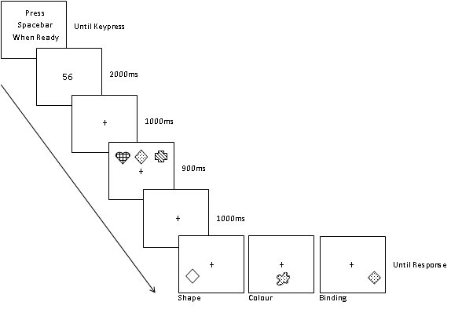

*Figure 1*: Pilot experiment paradigm.

A two-digit number was presented for 2000 ms and, for the purposes of articulatory suppression (limiting the extent to which participants may verbal recode the visual information), participants articulated this number out loud from this point until they made a response at the end of the trial. After the number disappeared there was a brief delay (1 s) – at which a centred fixation cross appeared and remained until the end of the trial. Participants were then presented with three coloured shapes to encode, for 900 ms (different colours represented by different fill effects). After a delay of 1 s, participants were presented with an item to which they were to respond ‘yes’ or ‘no’, via a keypress, regarding whether or not this appeared within the earlier array of coloured shapes.

In this and the subsequent experiments, there were 36 trials within each block, and each block varied according to memory test. Memory for colour information was tested by presenting an individual patch of colour that was either present in, or absent from, the array. Memory for shape information was tested by presenting an individual outline of a shape (with internal colour the same as the background – grey), to which participants were again to respond present or absent. Binding memory, in contrast, was measured by presenting a coloured shape, comprising a colour and a shape that had appeared within the array, but not necessarily within the same object. Thus, either the whole coloured shape was present in the array, or it was absent, with the probe item having been formed by swapping individual features across objects from the array.

The data from the Pilot experiment are included in the SPSS file named ES-J002712-1 Pilot Experiment. For this and subsequent experiments, in addition to the demographic data (sex, age, years of education), the data include performance on the Mini-mental State Examination (Folstein, Folstein, & McHugh, 1975), for the purpose of screening for unhealthy cognitive decline in the older adults, and the Test of Premorbid Functioning - UK (Pearson Assessment, 2009), for the purpose of estimating Full-Scale IQ. The data also include responses regarding the requirement for vision correction and, if so, whether or not vision was corrected, as well as whether or not participants reported a memory impairment. Administration order of the blocks of trials was also recorded, depicting the order in which the colour, shape, and binding memory blocks were administered (as well as the condition of the other variable being manipulated in the following 3 experiments).

A number of measures of memory performance were taken. The primary one for our purposes within the grant was A’, which is a measure of change detection accuracy and is derived from the hit and false alarm rates (see Stanislaw & Todorov, 1999). In addition to these three measures, response times, basic accuracy (percentage correct), and mean rate of articulation (how often the two-digit number was repeated during a trial) are included.

Across all datasets the following missing variable codes are used: 88888 (for use where data are missing, but because they are not applicable) and 99999 (reserved for when data should exist, but are missing).

**Experiment 1**

*Effects of Age group (young, older), encoding time [short (900ms) and long (1500ms)] and block type (colour, shape, binding) on visual temporary memory performance*

This experiment used the paradigm illustrated in Figure 2. The basic paradigm (short condition) was contrasted with a longer encoding time (long condition; i.e., 900 ms v 1500 ms).

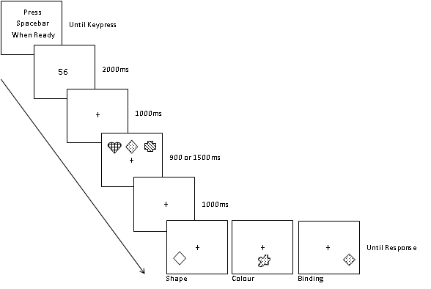

*Figure 2*: Experiment 1 paradigm.

The measures were the same as those documented for the Pilot experiment, and are included in SPSS file named ES-J002712-1 Experiment 1.

**Experiment 2**

*Effects of Age group (young, older), encoding format (simultaneous or sequential) and block type (colour, shape, binding) on visual temporary memory performance*

This experiment used the paradigm illustrated in Figure 3. The basic paradigm (with long, 1500 ms, encoding time, in order to accommodate the encoding manipulation) was contrasted with sequential presentation format, in which each to-be-remembered coloured object is presented one at a time (500 ms each).

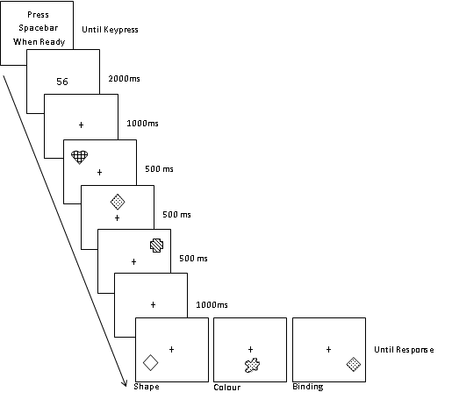

*Figure 3*: Experiment 2 paradigm.

The measures were the same as those documented for the Pilot experiment, and are included in SPSS file named ES-J002712-1 Experiment 2. Additionally, there are accuracy data in relation to the ‘present’ items, according to which serial position the item appeared in the encoding array. Only present items are analysed here, because in the binding condition the absent trials involved testing memory for features from different serial positions.

**Experiment 3**

*Effects of Age group (young, older), suffix condition (control or suffix) and block type (colour, shape, binding) on visual temporary memory performance*

This experiment used the paradigm illustrated in Figure 4. The basic paradigm (with short, 900 ms, encoding time) was contrasted with a condition in which a suffix (irrelevant item) was presented for 250 ms, shortly (250 ms) after the encoding array disappeared.

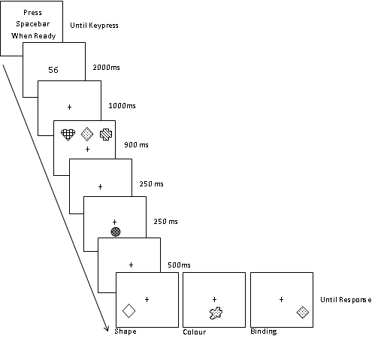

*Figure 4*: Experiment 2 paradigm.

The measures were the same as those documented for the Pilot experiment, and are included in SPSS file named ES-J002712-1 Experiment 3.

**References**

Folstein, M. F., Folstein, S. E., & McHugh, P. R. (1975). Mini-Mental State: a practical method for grading the cognitive state of patients for the clinician. *Journal of Psychiatric Research, 12*, 189-198.

Pearson Assessment (2009). *Test of Premorbid Functioning – UK Edition*. London; Pearson Education, Inc.

Stanislaw, H., & Todorov, N. (1999). Calculation of signal detection theory measures. *Behavior Research Methods, Instruments, & Computers, 31*, 137-149.