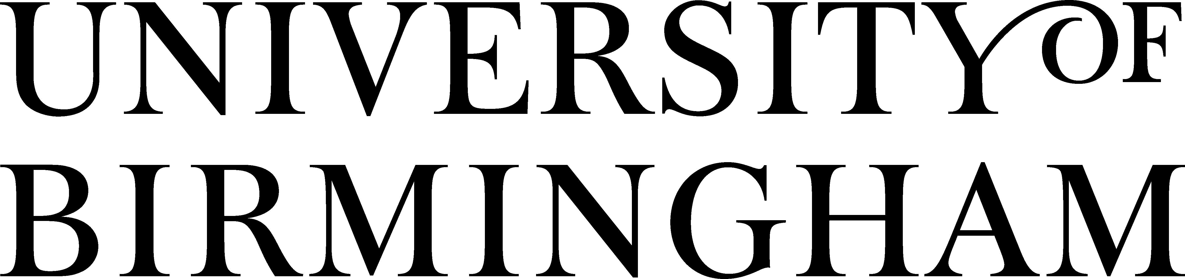
School of Government & Society
Political Science and International Studies

Institute of Local Government Studies

Paradoxes and Contradictions in EU Democracy Promotion Efforts in the Middle East
Economic & Social Research Council (ESRC) Grant Reference: RES-061-25-0075

Principal Investigator (PI) of project: Dr Michelle Pace, Senior Research Fellow and RCUK Fellow, College of Social Sciences

Background to Project:

During the 1990s and in the context of the collapse of communist rule, the EU opted for the ‘promotion of liberal democracy’ as a key foreign policy instrument in its external relations. The underlying assumption of this policy was that democratization requires a set of political institutions and processes, with a particular emphasis on regular, fair, free and transparent elections as well as a thriving civil society, a growing middle class and proper civic education. This policy has proven rather challenging in the case of the EU’s efforts at exporting the model of liberal democracy to the Middle East (ME). The project focuses on two case studies: Palestine and Egypt. Palestine has, since the inception of the Palestinian Authority in 1993, been the main focus of EU policies in the Arab world (when measured against population size). Egypt, in turn, still is the most powerful country in this region. Thus, the success of EU democracy promotion policies in the ME crucially depends on progress in these two cases. Both have witnessed, in the past few years, highly controversial elections, which threw up a number of paradoxes and contradictions in EU democracy promotion policies. First, the democratically elected Hamas government in Palestine is boycotted by the EU and, secondly, the authoritarian Mubarak-government in Egypt receives continued support, arguably for the sake of security, in spite of obvious fundamental democratic shortcomings in Egypt.

Moreover, academic research in the field of EU democracy promotion in the ME generally asserts a normative dimension which is of crucial importance in both the strategic and tactical pursuit of the policy.

In attempting to unravel the self-understanding of this normative driver of policy, the PI is carrying out field work in Brussels between March 23 – April 3, 2009 interviewing officials from the European Commission, Council, the European Parliament and Member States’ Permanent Representative Offices. Each interview will last for a maximum of one hour and in order to prepare the context, the questions below have been formulated. The questions will broadly focus on:

- Framing of democracy as a Western concept
- What is ‘normative’ about the EU’s Democracy Promotion in the ME?
- What are the cognitive fundaments on which EU Foreign Policies build?
- Framings of the Middle East in EU policy-making circles
- How the EU aims to promote pluralism in its neighbourhood?
- Systematic follow-up on security-democracy nexus

These are some of the PI’s frames of analysis for the material to be collected through the fieldwork in Brussels.

CODE OF ETHICS
As PI on this project I am bound by the academic profession’s code of practice. In order to ensure my ethical responsibility, you are guaranteed confidentiality of any information you divulge and anonymity (if you so wish). From my part and at all stages I guarantee honesty to all interviewees in regard to the purpose, methods and intended and possible uses of the research and any risks involved; as well as my independence and impartiality as researcher of this project. I would like to record all interviews. All interviewees have the right to ask me to stop the recorder at any point during the interview or not to be recorded at all.
QUESTIONS

- What do you think is the main rationale behind the EU’s democratization policy in the Middle East?

- What encourages the EU to act in the field of Democracy Promotion in the Middle East: The apparent lack of a strong commitment to democracy in the Middle East? Historical guilt (colonialism? Problem of Middle East conflict)? Sense of moral obligation? Underlying constraints such as: a) The nature of authoritarian regimes in the ME? b) Economic underdevelopment in the ME? c) Nature of rentier states in the ME? d) To develop a sphere of influence via dependency, whether via trade relations with Egypt or aid for the Palestinians?

- What exactly is the EU seeking to promote/export to the Middle East?

- Is the EU’s DP agenda in the ME conceived as a political project that must be exported and emulated by partners in the south?

- Or, is the EU’s DP agenda in the ME conceived as a political project that must be adapted to cultural peculiarities?

- How are these EU conceptualizations actually translated into policy?

- Who do you think are the real forces for change in the Middle East? Please give some specific examples in the cases of Palestine and Egypt

- Are you actively involved in an ongoing dialogue with these actors in the ME?

- What do you think political reform in Palestine and Egypt really entails?

- Do you think that the EU has been promoting liberalism rather than democracy in the Middle East?

- Have there been any limits or constraints on and challenges to the EU’s Democracy Promotion agenda in the Middle East? (Whether internal – inter-institutional, or external)?

- Do you see any flaws in existing EU democratization policies?

- Since the 2005 and 2006 elections in Egypt and Palestine respectively, would you say that Democracy Promotion is still a core external relations priority for the EU?

- Have there been any lessons learnt?

- In which ways should EU Democracy Promotion policies be rethought, revisited and reformulated, to adapt to realities and developments in the Middle East?

- EU’s policies and decisions in the Middle East have had unintended consequences. Do you think the EU holds the capacity to project norms and values in a self-reflexive manner?

- In the cases of Palestine and Egypt, would you agree that EU financial assistance has been directed at the wrong groups? (Groups with no potential for political mobilization in their societies).

- Why are Islamist groups marginalized when it comes to EU support for political reforms in the Middle East?

- Are you aware of the EU’s lack of legitimacy in the view of the peoples of Palestine and Egypt when it comes to engaging in their political affairs?

- Do you agree that conceptualizations of democracy in Europe may be different from conceptualizations of democracy in the Middle East?

Many thanks for your time and reflections on these questions! Once I transcribe the interviews, I will send you a copy of my transcript of your interview so that you can have the opportunity to acknowledge whether my interpretation of what you said is a correct version or otherwise.

