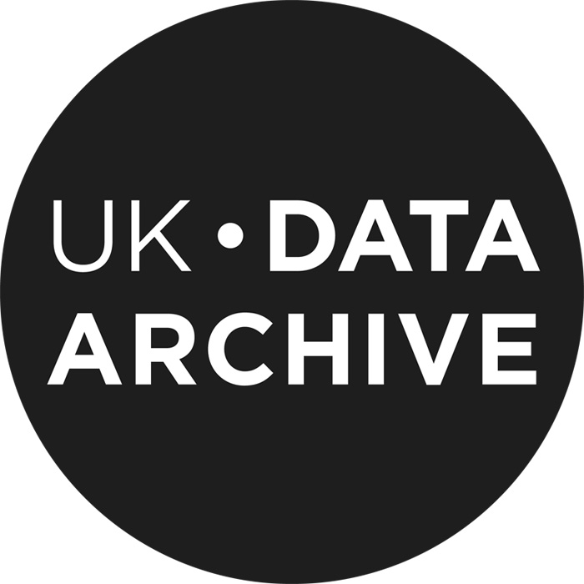

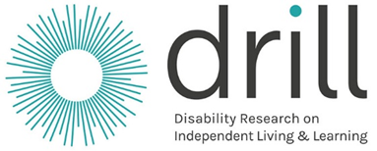

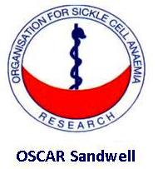

Data Deposit Consent Form for BARRIERS AND ENABLERS TO EMPLOYMENT: BLACK DISABLED PEOPLES LIVING WITH SICKLE CELL DISORDERS (SCD)

Please tick the appropriate boxes | Yes | No
Taking Part
I have read and understood the project information sheet dated 01/12/2017. | □ | □
I have been given the opportunity to ask questions about the project. | □ | □
I agree to take part in the project. Taking part in the project will include being interviewed and recorded (audio). | □ | □
I understand that my taking part is voluntary; I can withdraw from the study at any time and I do not have to give any reasons for why I no longer want to take part. | □ | □
Use of the information I provide for this project only
I understand my personal details such as phone number and address will not be revealed to people outside the project. | □ | □
I understand that my words may be quoted in publications, reports, web pages, and other research outputs. | □ | □
I understand that my real name to be not used in the above. | □ | □
Use of the information I provide beyond this project
I agree for the interview transcript I provide to be archived at the UK Data Archive. | □ | □
I understand that other authenticated researchers will have access to this data only if they agree to preserve the confidentiality of the information as requested in this form. | □ | □
I understand that other authenticated researchers may use my words in publications, reports, web pages, and other research outputs, only if they agree to preserve the confidentiality of the information as requested in this form. | □ | □
So we can use the information you provide legally
I agree to assign the copyright I hold in any materials related to this project to [Simon Dyson]. | □ | □

________________________ _____________________ ________
Name of participant [printed] Signature Date

________________________ __________________ ________
Researcher [printed] Signature Date

Project contact details for further information: .

This work is licenced under the Creative Commons Attribution-Non-Commercial-Share Alike 2.0 UK: England & Wales License. To view a copy of this licence, visit http://creativecommons.org/licenses/by-nc-sa/2.0/uk/

