Fieldwork Methods
Without any “guan xi” (network) or sufficient funding, the author’s fieldwork aspiration in China might remain no more than wishful thinking. Further, the author had never been to Guangdong Province in Southern China prior to this project – not to mention having any pre-established networks. The successful gaining of a teaching post in economics at the Guangdong University of Foreign Studies (GDUFS) offset the author’s disadvantages above. As well as offering precious teaching opportunities, the GDUFS became an invaluable platform on which the author built up connections with the enterprises in the region from the filed contacts referred by the university faculty and student bodies. They also helped in securing the research funding, in part.
During the time from September 2004 to December 2004, the author and his trained co-fieldworkers conducted first-stage face-to-face interview with 89 firms at ten major cities in Guangdong Province. Exceptionally, three firms were approached by post, through a provincial government office, and two were telephone interviewed by co-fieldworkers whose parents virtually owned the companies. By the time of February 2006 (right after the Chinese Lunar New Year), the second-stage telephone interviews were undertaken to check the survivability of the firms previously interviewed and its employment by then. Seven firms were considered out of business as informed by the contact person, or because the contact address was changed and no way to locate again, or because the contact number had become an invalid record at the local Telecom Company. In other words, 76 firms out of 83 in total have survived by the year of 2006.
This section firstly outlines the pilot project, first-stage and second stage interviews. Then the training programme for co-fieldworkers is introduced. Attention is also paid to the process of data collection and countercheck, and database construction.

Pilots
The importance of pilot work was stressed as “a dress rehearsal” by Converse and Presser (1984). Concerning the survey instrument in such a scope (106 questions), a pilot project seemed essential before the instrument was deployed more widely.

Eight firms were selected due to their proximity to the author and his referees. Meanwhile, the survey instrument was tested and amended accordingly while the interview techniques were improved.

Pilot Questionnaires
Table 4.10 below illustrates the age and size information of the pilot sample, which can at least highlights three major problems. First of all, some interviewees tended to provide a range for size measures (firm 1) for their own convenience, rather than a precise figure, which caused ambiguity. Sometimes, respondents were simply unwilling to offer any information that they believed should be confidential (firm 4). More seriously, it was possible to encounter an interviewee who did not have enough knowledge of the firm to be able to answer all the questions (firm 1). Therefore, an eligible interviewee should be the person who knows the firm well and it would be desirable to contact top management (owners or general managers). When he/she provides sales/assets data, financial statement should be accompanied at the same time for reference, in order to avoid imprecision as well as inaccuracy.

Table 4.10 Age and Size of Pilot Firms
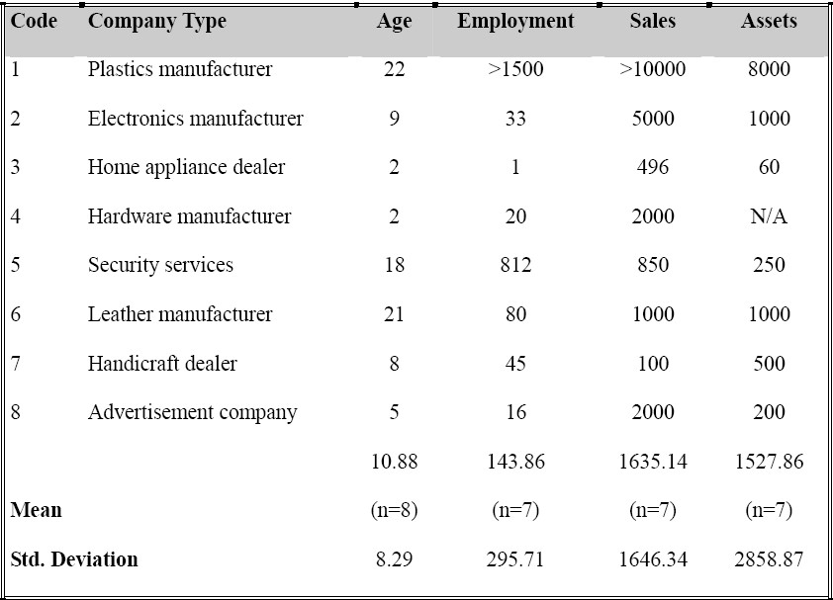
(Note: Age is calculated by the number of years. Employment refers only to the full-time equivalent employment at the time of interviews. Sales and assets relate to the nominal figures in Chinese Yuan [ten thousand ] in 2003 without CPI adjustment.)
Besides, there was a general impression that respondents had a preference for choosing answers from available options. The suggestion is to make options as comprehensive as possible. Most interviewees rarely would like to elaborate a question too deeply, knowing that more than 100 questions in total need answering. However, the option “other” should not be deleted and the additional blank for respondents to specify should always be reserved in that some interviewees do take pains to supplement the data. If so, the opinions most often can be either mistakenly ignored, or totally unconsidered before.
The proper ordering of certain questions can also make a difference. It is found too obvious to put these two questions together in terms of R&D expenditure and last year profit, shown in Table 4.11 as follows. Hence, they are separated in some distance under different main headings. It was observed that none of respondents was reluctant to confide in a way as they usually would. A possible range of profit earned last year can be thereby calculated.

Table 4.11 R&D Expenditure and Profit
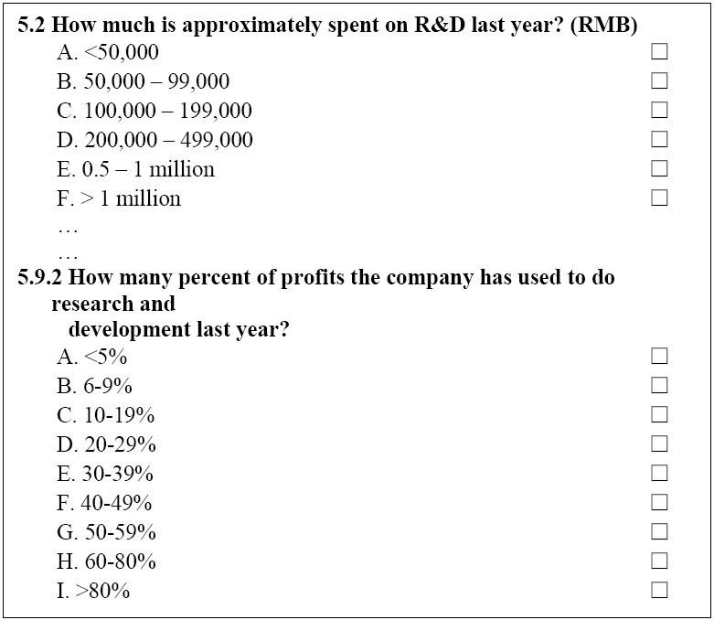
As an old Chinese saying goes, “it will be too late if the rice has been already cooked.” This pilot project offers a final chance to amend the flaws of the questionnaire. While some are unintentional minor typing mistakes, some can be crucially misleading. For instance, a seller’s market should never have “excess supply” (question 2.2). And the percent ranges of “20-39%” and “30-39%” should not coexist for selection (question 5.9.2). Apparently, there is no best questionnaire as it can always be improved.

Training Interviewees
As 89 firms in the sample are scattered across Guangdong Province (nearly three quarters of the Great Britain in terms of acreage), time, money, and full-time teaching obligations would prevent the author travelling to interview all. With the generous patronage from both the University of St. Andrews and GDUFS, the author was able to train a large number of students (nearly 180 from six third-year classes in related majors) as potential co-fieldworkers and eventually one third proceeded to conduct the first-stage face-to-face interviews in the field.
The training program consisted of various elements, such as the purpose of the interview, the detailed instruction of each question in the questionnaire AQ2004 and the questions that might arise during the procedure, the management of interview process, and interview techniques. Last but not least, co-fieldworkers were reminded of academic ethics and well informed that data countercheck would be conducted afterward.

Data Collection and Countercheck
With the experience gained from the pilot program, properly trained co-fieldworkers, and reliable references, the first-stage large scale data collection in the field occurred between October and December in 2004. And second-stage follow-up telephone interviews were conducted nearly one year and a half later in February, 2006.

First-Stage Data Collection
In the first-stage, a preletter for AQ2004 was sent to owner-managers via the author’s referees so the interview could save the time and begin straightforwardly as follows.
“Thank you for agreeing to accept our interview. As you know, this interview is a part of an academic project sponsored by Guangdong University of Foreign Studies and University of St. Andrews. Thereby, it is assured that any information you provide here will be kept highly confidential and only used for academic purposes (passing on a duplicate of AQ2004 to the interviewee for reference and keeping another one to record answers). This questionnaire consists of eight sections: basic information, firm operation, human capital, finance, technology and innovation, enterprise culture, competition, and environment, etc. Shall we start with the basic information?”
The interviewer would then read out each question under different sections in a consultative way and wait patiently for response. Once the answer was given, the interviewer was supposed to repeat it quickly for confirmation and record on file. If observing the confusion expressed by the respondent, the interviewer should initiate an explanation, where appropriate. The extra information provided by the interviewee should also be written down. The principle was to gather the data that owner-managers would like to share as complete as possible.
An interview could last from at least one hour to as long as two hours. As the average time spent on the interview was longer than one hour, time control skills would be critical for both parties. It was not unusual for the interviewee to be interrupted by phone calls and even visitors. It was the interviewer’s major principle to keep the whole process in the right rhythm or get it back swiftly to the track if being interrupted.
At the end of the interview, the interviewer would acknowledge the appreciation for the respondent’s assistance and reassure the confidentiality of the data with an end statement as follows.
“Thank you very much again for the precious time and cooperation. The administered questionnaire 2004 is successfully completed herein. Your company will simply appear anonymously in the database for the sake of strict confidentiality. Certainly, once the research project has been accomplished, the findings will be made available to you if you so desire. We wish you all the best with your business.”

Data Countercheck
In order to guarantee the quality and reliability of data collected by co-fieldworkers, the follow-up countercheck was undertaken shortly before Chinese Spring Festival in 2005. A traditional Chinese new year card was posted to respondents to thank them for completing the AQ2004, and a phone call was made a week later to enquire the receipt of the card, as well as ask the process of the interview. The conversation usually was concerned with the manner of the interviewer and the suggestions about how to make such an interview better. Most owner-managers had positive opinions towards our co-fieldworkers (e.g. politeness, the readiness to clarify, etc) whilst suggesting the minor shortcomings (e.g. not so punctual, bookish explanation, etc). The most frequently complaint was the length of the interview, which was apparently longer than expected.
As all the firms were personally recommended and the co-fieldworkers were specially trained, the forgery of questionnaires would be highly unlikely. However, it was found that five firms were not exactly interviewed by face-to-face, three of which were through a provincial government office and two of which were telephone interviewed. With regard to the government connections of the former and the family business background of the latter, the non-face-to-face method was felt to be understandable and still acceptable at this point.

The author interviewed 29 firms and the co-fieldworkers interviewed the remaining 60 firms.
Six firms were recommended by the author’s academic colleagues and the other two came from private friends’ references.
Chinese people traditionally count big numbers by the first threshold “Wan” (ten thousand), rather than one thousand.
A similar phrase in English is “don’t bolt the stable door after the horse is gone”.

