The Representatives of the Sample

Geographic Distribution
As the earliest region implementing market economy in China, Guangdong Province has enjoyed strong economic linkages with Hong Kong and Macau due to its strategic location. The sampled firms of this study come from the 10 most economically influential cities (Code 1-10) in this province (except Zhuhai), as illustrated by Table 4.1 below.

Table 4.1 Geographic Distribution
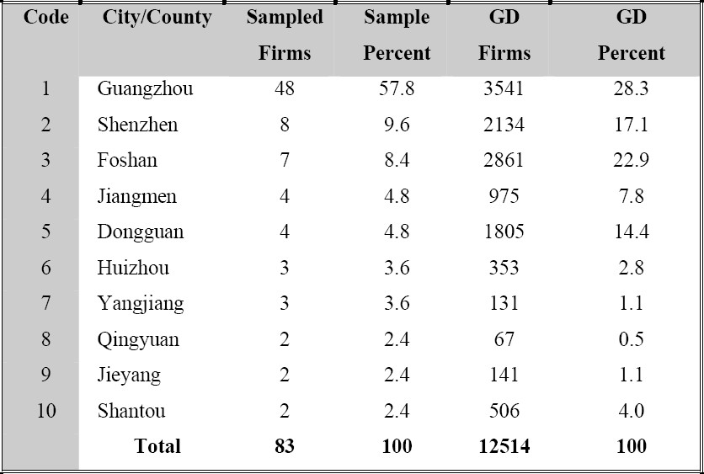
(Note: The sample here refers to 83 private firms interviewed in the fieldwork -“SAMPLE A”, whereas GD firms refer to the population of manufacturing firms in cities from code 1 to 10 in Guangdong Province – “GD A”) ⁷⁴

As the capital city of Guangdong Province and the largest economic centre in Southern China, Guangzhou firms have the highest percent (57.8%) in the SAMPLE A and 28.3% in the population of GD A. This overrepresentation of Guangzhou firms in the SAMPLE A may be due to the exclusion of non-manufacturing Guangzhou firms in the GD A. More possibly, each “gatekeeper” was asked to recommend only one or two owner-managers so that he/she might be more predisposed to introduce one in Guangzhou where the university locates. In total, Guangzhou and five other major industrial cities (Code 1-6) consist of nearly 89% of firms in the SAMPLE A in response to 93% in the GD A, which shows a high correlation: Kendall’s tau_b .754 and Spearman’s rho .877 at the significant level of 0.01 (2-tailed), and Pearson correlation .734 at the significant level of 0.05 (2-tailed). The SAMPLE A hereby seems to present a reasonable geographic distribution.

Sectoral Composition
With regard to sectoral composition, this study concentrates on a wide spectrum of industries within Guangdong Province. China’s National Standard of Industrial Classification (CNSIC) is deployed and the sampled firms are characterised by frequency and percentage on Table 4.2 as follows.

Table 4.2 Sectoral Distribution (one-digit CNSIC)
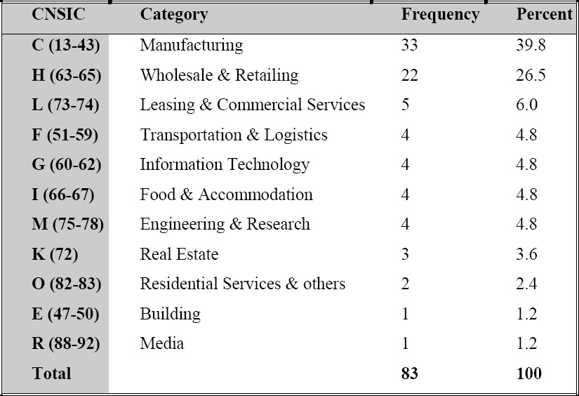

Concerning the one-digit CNSIC, the sample of this study covers 11 industry categories (55%) out of 20 in total. There are 9 industrial categories without representation in this sample but it is not entirely inexplicable. For instance, the categories of education (P84), sanitation and social welfare (Q85-87), and government and organizations (S93-97, T98) are of little interest in this privately-owned firm research. Moreover, Mining (B6-11), Electricity, Gas and Water Supply (D44-46), Financing (J68-71), and Water, Environment and Public facilities (N79-81) are heavily populated by public owned firms. As this study focuses on the secondary and third sectors of industries, the primary sector (A1-5, e.g. agriculture, forestry and fishery, etc) is left out as well. Therefore, it may be safe to say that the remaining 11 industry categories have generally served the research interest of this thesis.

Table 4.3 Sectoral Composition (two-digit CNSIC)
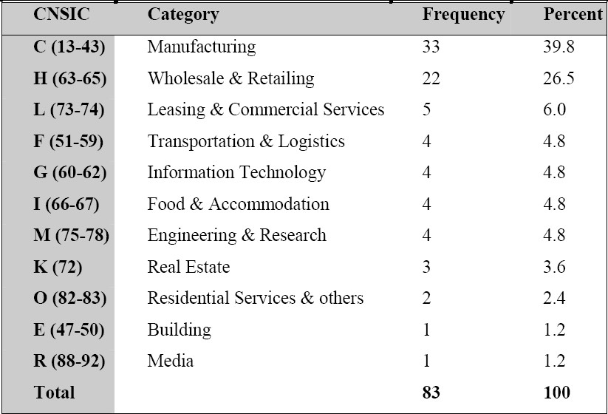

Disaggregating these 11 industry categories in terms of two-digit CNSIC, it is found that there are 66 industries, 33 among which are included in the sample (54.5%), as shown on Table 4.3 above. While four industries (E, H, K, M) are fully represented, 17 out of 31 (54.8%) manufacturing industries and 1 out of 2 (50%) information technology industries are covered, probably due to the limitation of sample size and sampling methods. The obvious underrepresentation in the categories like transportation and logistics (F51-59, 44.4% represented) and media (R88-92, 20% represented) may be attributed by the state ownership in such industries. Besides, the low percent in service sectors (44.4% in L, 25% in O) may suggest the smallness of these service firms which can be conveniently neglected by the referees. Although it is somehow underrepresent all sectors at a two-digit scale, this sectoral composition does reflect the general perception of the Guangdong province as “world workshop”
(two fifths in manufacturing) and “international trade centre” in Southern China
(more than one quarter in wholesale and retailing).

Ownership and Employment
According to the classification of ownership enacted by the NBS of China on 2nd September, 1998, there were 29 types in total. With China’s entry into the WTO, this overly perplexing division of ownership became obsolete and was replaced on 24th August, 2005. The new ownership typology consists of two broad categories: public owned (by state or collectively) and non-public owned (by domestic private, Hong Kong/Macau/Taiwan owners, or other foreigners). This thesis will specifically focus on domestic private firms. With regard to the population of manufacturing firms in 14 cities and counties of Guangdong Province (GD B), 92.7% of manufacturing firms in this special economic zone are non-public owned firms and contributing 90.5% of full-time equivalent employment. Correspondingly, 93.3% of firms are non-public owned in the sample (SAMPLE B) and creating 87.6% of jobs, as shown by Table 4.4 below. The correlation between the sample and the GD B population are as high as one, whether Kendall’s tau_b, Spearman’s rho, or Pearson methods are used.

Table 4.4 Frequencies of Ownership and Job Creation
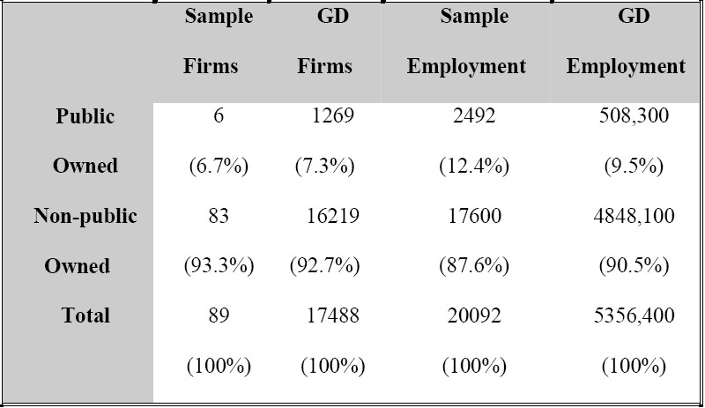
(Note: The sample here refers to “SAMPLE B”: SAMPLE A plus six additional public owned firms, whereas GD firms refer to the “above-scale” manufacturing firms in 14 cities and counties in Guangdong Province – “GD B”.)

Size Distribution
Prior to the discussion of firm size distribution, the size itself should be defined first. The NBS of China declared temporary size measurements for “above-scale firms” in only six industry categories (i.e. manufacturing, building, transportation and logistics, wholesale and retailing, food and accommodation, and postal service) on 22nd May, 2003. And within the same category, the size may be measured by multiple variables, namely employment, sales, or total assets. As the firms interviewed in this study scatter beyond those six sectors, the makeshift method of China NBS cannot suffice, but does imply in a significant way that in whichever industry that a firm operates, it will be considered as a small firm if employment is below 600 or sales are below 30 million Chinese Yuan (equal to 1.93 million British Pounds)⁷⁷. Most medium sized firms have sales between 30 and 300 million Chinese Yuan, or employ less than 3,000 full-time workers. As total assets are only used in manufacturing and building industries, in this study only sales and employment are respectively utilized to define the size, as shown on Table 4.5 below.

Table 4.5 Division of Size Classes
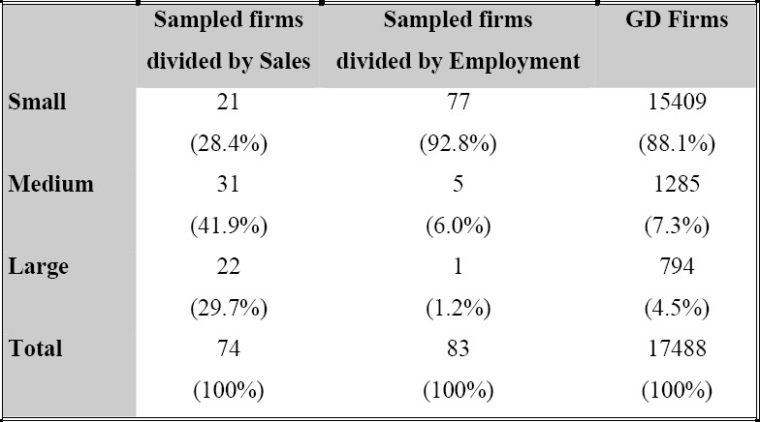
(Note: The sampled firms are exacted from “SAMPLE A” and GD firms are drawn from “GD B” due to the availability of data.)

According to the table above, size division by employment in the sample is highly correlated with the population “GD B” with Kendall’s tau_b 1.000 at the significant level of 0.01 (2-tailed), whereas sales measurement does not correlate so highly. The main reason to engender such a large percent (29.7%) of large sized firms in terms of sales may be in part attributed to the large percent (26.5%) of trading companies in the sample that tend to generate high volume of sales but hire much fewer employees disproportionately. Whilst these firms fall into the small-size category by employment, they are probably qualified to enter the medium or even large size classes in terms of sales. It also indicates that the upper and lower bounds for each size class by sales should be altered to be compatible with ever growing Chinese economy, as the firms with smaller workforce now apparently can sell more products/services. Hence, more comprehensive and scientific size division standards should be developed for either industries in general or just a specific one, considering the nature of research in question.

Probably it is because Zhuhai has more developed as a resort for old retired people, rather an industrial city. ⁷⁴ Source: Guandong Statistics Bureau. http://www.gdstats.gov.cn/tjnj/table/21_c.htm
CNSIC (GB/T 4754-2002) were updated by NBS of China on 14th May, 2003.
Source: Guangdong Statistics Bureau. http://www.gdstats.gov.cn/tjnj/table/20_c.htm ⁷⁷ Exchange rate is set at the average level in January, 2005.

