Study outline, research design, and methodology
This document provides an overview of the research design and methodology of the project ‘Survey of local perceptions of the livelihood and conservation benefits delivered by small-scale livelihood projects in eastern Madagascar’.
The objective of the survey was to document local perceptions of both the livelihood and conservation benefits delivered by small-scale livelihood projects (‘microprojects’) that had been conducted in the Ankeniheny Zahamena Corridor region (in Eastern Madagascar) from 2010 to 2014, and to examine how the type of livelihood project (e.g., agriculture, beekeeping, fish farming or livestock production) influenced the benefits obtained.
The Ankeniheny Zahamena Corridor is a forested region of eastern Madagascar and part of 370,000 ha REDD+ pilot (Conservation International 2013). The landscape is a mosaic of protected areas, forests and smallholder agricultural systems, and is important for biodiversity conservation (Critical Ecosystem Partnership Fund 2014). The main drivers of deforestation are swidden agriculture and charcoal production (Ratsimbazafy et al. 2011; Conservation International 2013). Subsistence farmers inhabit the area, cultivating rice, maize and other crops in smallholdings (typically less than 1 ha). Most farmers live below the national poverty line, lack access to basic services (clinics, electricity, potable water, etc.), experience seasonal food insecurity, and are highly dependent on forest resources for their livelihoods (Harvey et al. 2014; Poudyal et al. 2016).
Over the last decade, more than 460 small scale livelihood projects have been implemented in CAZ by Conservation International (CI, an international conservation organization) and its partners as part of forest conservation efforts and the REDD+ project (MinEnvEF 2012; Conservation International 2013). Livelihood projects have also been provided to compensate vulnerable households for restricted access to forest resources due to the creation of the CAZ protected area, following the World Bank’s safeguard policy (World Bank 2013; Poudyal et al. 2016). The microprojects have included a wide range of activities, ranging from beekeeping to agroforestry projects to providing support for teachers’ salaries. Projects were chosen jointly by community groups and project implementers, and were then designed by local NGOs, private contractors specializing in rural development or by local CI staff. The microprojects were implemented through a variety of approaches including direct implementation by CI, implementation through grants provided by CI to local partners (NGOs or associations), implementation of projects by a third-party contractor (following the World Bank’s safeguards procedure) and implementation through conservation agreements. In all cases, microprojects were implemented together with established community-forest management associations (Vondron’Olona Ifotony (VOI)). Most projects lasted less than a year, involved approximately 50 people, and cost an average (SE) of US $2,746 (246) to implement (unpublished data).

Methodology
To examine the perceived conservation and livelihood outcomes of the microprojects, we first compiled information on microprojects implemented in CAZ from 2006 to 2014 by extracting technical and financial information from technical reports, financial data sets, and project documents, and gathering information from partner organizations. To examine how perceived outcomes varied across project types, we focused on four of the most common microproject types: 1) bee keeping, 2) support to small scale agricultural production (primarily support for rice, corn and bean production), 3) livestock production (mainly chicken production) and 4) fish farming. Table 1 provides a general overview of each of the types of microprojects and their characteristics. We randomly selected microprojects between conducted between 2010 and 2014 for inclusion in the study, focusing on the most recent projects to improve local people’s recall ability. In total, we selected 61 projects (16 agriculture projects, 10 beekeeping projects, 17 fish farming projects, and 18 livestock farming projects).
For each selected microproject, we compiled a list of known project participants (both men and women) from participant lists in project reports and from information provided by village chiefs. We then used these lists to randomly select 10 people per project to participate in the household survey. In total, we surveyed 61 projects (611 participants). Table 1 provides a breakdown of the distribution of surveys between project types, while Fig. 1 shows the location of the 61 projects.
We then designed a structured household survey to explore local perceptions of microproject livelihood and conservation outcomes (see file “Participant questionnaire (MG)” for Malagasy version, and “Participant questionnaire (EN)’ for English version). Our survey collected information on the perceived delivery of livelihood benefits, the types of benefits, the importance of these benefits to people’s livelihoods, the distribution of benefits among participants and the duration of benefits, as well as information on potential negative impacts. Potential livelihood benefits included improvements in food security, market access, household well-being and community cooperation; access to salaries or stipends, and strengthened community organizations. We also asked respondents whether the microprojects had conservation goals, what these goals were, and the extent to which the projects had contributed to conservation outcomes. Potential conservation outcomes included reductions in charcoal production, firewood extraction, hunting, mining, NTFP extraction, timber extraction, and tavy (swidden agriculture), and improved forest management. The survey was piloted in the field twice and approved by the ethics committee at Bangor University, prior to implementation. All household surveys were conducted by local research assistants (in Malagasy) in either the respondent’s house or farm, from September to November, 2015.
Most of the questions were closed questions (yes/no questions, or questions with multiple choices), but the survey also included some open-ended questions to allow respondents to provide more detail on their perceptions of the outcomes of microprojects. For all open-ended questions, we first documented the responses, then categorized data into major categories, coded the categories, and then entered the coded data into the data base. Data quality was ensured throughout the survey process- with interviewers systematically checking all surveys for completeness and potential errors, and data managers cross checking data entry of all surveys.
The dataset archived here has been anonymized, with all personally identifiable information removed. Specifically, we have removed information on the name of the microproject (since this identifies the village where the microproject was conducted), the project code (since this identifies the village where the microproject was conducted), the respondent’s name, the respondent’s identifier, the respondent’s local nickname, the name of the village where the respondent lives (and village identifier), GPS and physical data on household location.

Table 1. An overview of the four types of small-scale livelihood projects which were assessed using household surveys in the Ankeniheny Zahamena Corridor, Madagascar.
Project type | Project activities | Examples of inputs provided¹ | Examples of the training provided* | # of projects of surveyed | # of people  surveyed
Agriculture | Support to participants in the cultivation of rice, beans and corn, using improved practices and improved seed varieties | Seeds,  Fertilizers,  Agricultural tools,  Mechanical weeders | Training on land preparation, soil conservation, composting, biological control, use of improved riziculture practices and cultivation of new crops | 16 | 161
Beekeeping | Development of beekeeping activities | Materials for constructing bee hives | Training on care and management of bee colonies and honey storage | 10 | 100
Fish farming | Creation of communal fish ponds for fish production | Fish fry (Tilapia)  Fish food (cornmeal) | Training on pond construction and fish production | 17 | 170
Livestock | Production of small-scale livestock, primarily chickens (but in one case, pigs) | Materials for hen houses or pig pens;  Vaccinations;  Cornmeal (for chicken feed) | Training on livestock production, including construction of hen houses or pig pens, livestock management and breeding practices | 18 | 180
Total |  |  |  | 61 | 611

*Note: the exact characteristics of inputs and training varied slightly across individual projects, depending on the implementing organization and community involved.

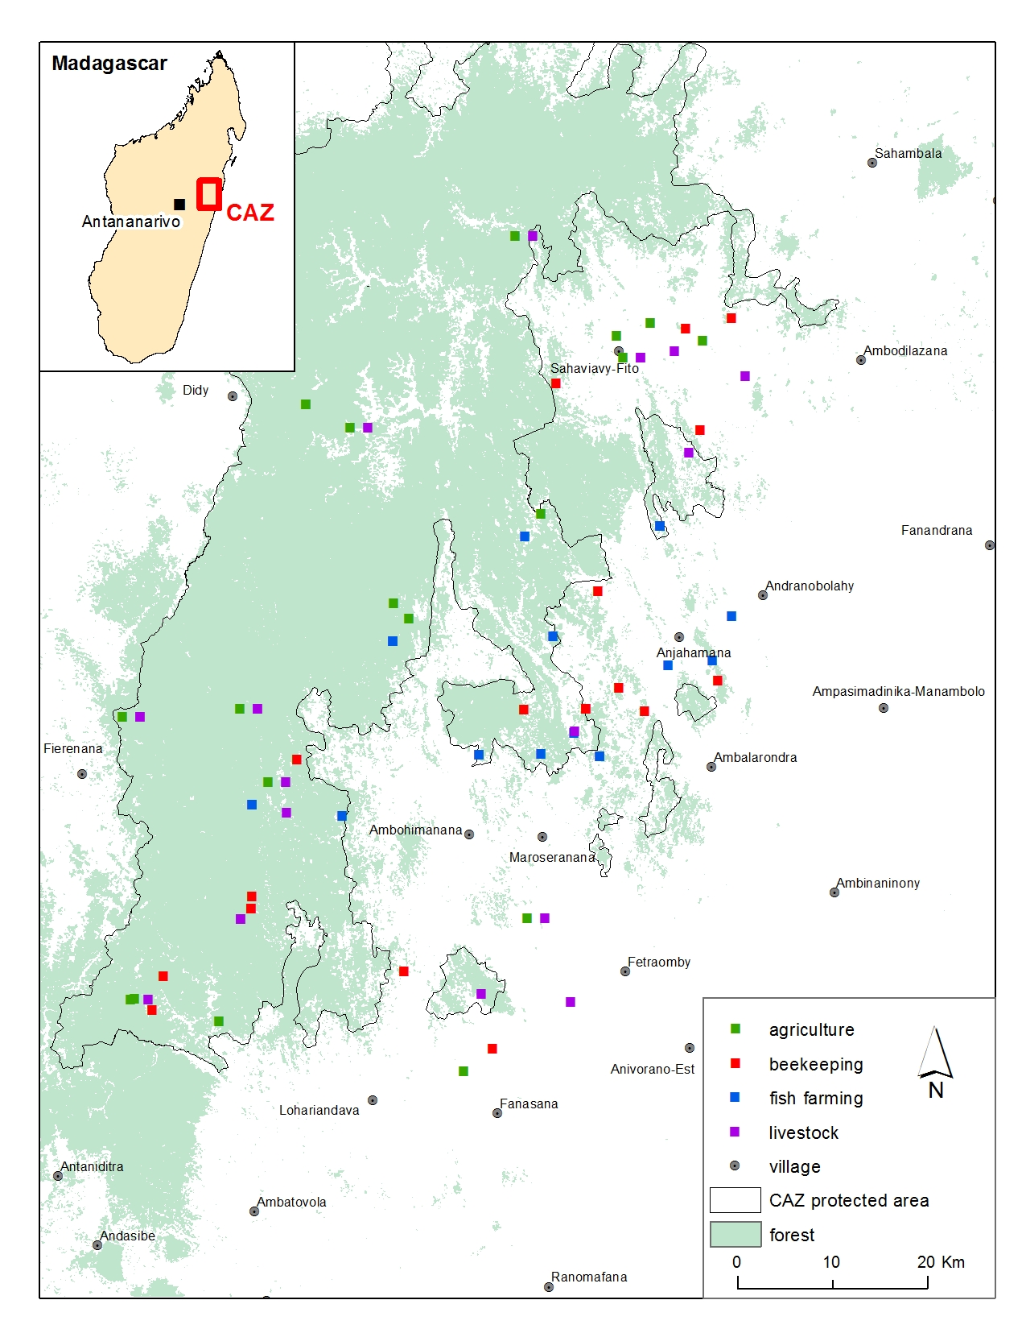 Figure 1. Map showing the approximate location of the 61 small-scale livelihood projects of four project types (agriculture, bee keeping, fish farming, and livestock) that were surveyed in the Ankeniheny Zahamena Corridor in Eastern Madagascar.

References:
- Conservation International. 2013. Reduced emissions from deforestation in the Ankeniheny-Zahamena Corridor, Madagascar. VCS Project Description: VCS version 3. Conservation International, Arlington, Virginia.
- Critical Ecosystem Partnership Fund. 2014. Ecosystem Profile-Madagascar. Critical Ecosystem Partnership Fund, Conservation International, Arlington, Virginia.
- Harvey CA, Rakotobe ZL, Rao NS, Dave R, Razafimahatratra H, Rabarijohn RH, Rajaofara H, MacKinnon J. 2014. Extreme vulnerability of smallholder farmers to agricultural risks and climate change in Madagascar. Philosophical Transactions of the Royal Society B. 369:20130089.
- Poudyal M, Ramamonjisoa BS, Hockley NJ, Rakotonarivo SO, Gibbons JM, Mandimbiniaina R, Rasoamanana A, Jones JPG. 2016. Can REDD+ social safeguards reach the ‘right’ people? Lessons from Madagascar. Global Environmental Change 37:31-42.
- Ratsimbazafy LC, Harada K, Yamamura M. 2011. Forest conservation and livelihood conflict in REDD: A case study from the corridor Ankeniheny Zahamena. International Journal of Biodiversity Conservation 3:618–630.
- World Bank. 2013.Operational Procedures 4.12. Involuntary Resettlement. World Bank Procedures Manual. Washington D.C.

